Documentation of Norwegian Polar Institute dataset for reading and processing of data from SIMB3 ice mass balance buoys
Version 1
Evgenii Salganik, 25 February 2025
- Background
This dataset is based on the measurements from SIMB3 ice mass balance buoys deployed in the Arctic Ocean during 1997–2015. These buoys measure ice surface and bottom elevation via two separate acoustic sounders and in-situ temperature of air, snow, ice, and water via a chain of thermistors with 10 cm vertical spacing. The original data is published at http://imb-crrel-dartmouth.org/archived-data/. The first version of processed data with estimates of snow and ice thickness and interface position is published by West (doi:10.5281/zenodo.3773811). Here we describe the reprocessed dataset from West (2020).
- Overview
The original dataset from West (2020) includes estimates of snow and ice thicknesses from 99 SIMB3 buoys. The estimates are based on the measurements of surface and bottom interface temporal evolution from two acoustic sounders together with manual measurements of the initial ice and snow thickness. Here we analysed temperature data from the same buoys and manually classified them into three groups: (1) 29 buoys with comparable estimates of snow and ice thickness from acoustic sounders and thermistors; (2) 29 buoys with erroneous temperature data which cannot be converted into accurate snow and ice thickness estimates; (3) 41 buoys with substantial differences between snow thickness estimates from acoustic sounders and thermistors.
Buoy group description | Buoy IDs
1. Substantially different estimates of snow and ice thicknesses from acoustic sounders (West, 2020) and from temperature | 1997E, 1997F, 2002A, 2003C, 2003E, 2004A, 2004B, 2004C, 2004D, 2004E, 2005E, 2005F, 2006B, 2006C, 2006D, 2006E, 2007C, 2007E, 2007H, 2007J, 2008B, 2008E, 2008F, 2009F, 2010B, 2010E, 2010G, 2011G, 2011I, 2011J, 2011K, 2011L, 2012H, 2012L, 2013E, 2013F, 2014B, 2014F, 2014G,2015A, 2015D
2. Comparable estimates of snow and ice thicknesses from acoustic sounders (West, 2020) and from temperature | 2015B, 2015F, 2014C, 2014E, 2014I, 2013B, 2013C, 2013G, 2012B, 2012C, 2012D, 2012E, 2012J, 2011D, 2011E, 2011F, 2011M, 2010A, 2009A, 2008C, 2008D, 2007D, 2003D, 2001A, 2000A, 1997A, 1997C, 1997D, 1993A
3. Temperature measurements do not allow to estimate snow and ice thicknesses | 2015C, 2012A, 2007I, 2015E, 2014D, 2013A, 2013D, 2013H, 2013I, 2012G, 2012I, 2012M, 2012M, 2011A, 2011C, 2011G, 2010H, 2009D, 2009E, 2007B, 2007F, 2007G, 2005A, 2005B, 2005C, 2005D, 2003A, 2000B, 1997B

The updated estimates of interfaces and thicknesses are mainly based on the values from the vertical temperature gradients following this sequence:
- The interfaces are estimated from the relative difference in the vertical temperature gradients. Snow surface and lower interfaces are lower boundaries of the area with vertical temperature gradient at least two times larger than vertical temperature gradient within ice.
- After preliminary identification of interfaces, the interface estimates from acoustic sounders from West (2020) are adjusted by a constant value to fit the temperature-based interfaces for the time close to buoy deployment.
- If estimates from temperature and from acoustic sounders are within the thermistor spacing (0.1 m), the estimates are not further processed.
- If there are substantial differences in position of at least one of the three interfaces, they are updated based on a combination of temperature and acoustic measurements.
The updated version of the interface and thickness estimates is published in the same format as in West (2020) with both original and updated values.
- Results and examples of reprocessing
An example of original and updated snow surface and bottom interfaces are shown in Fig. 1.
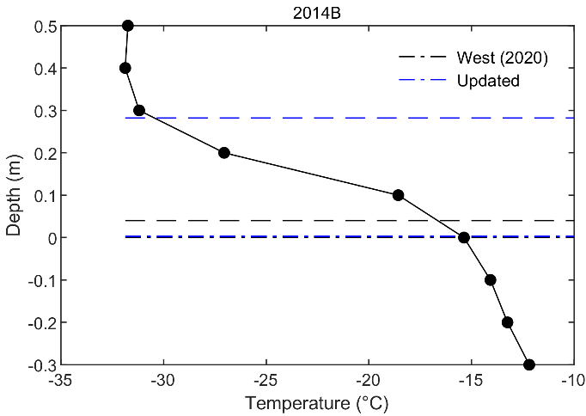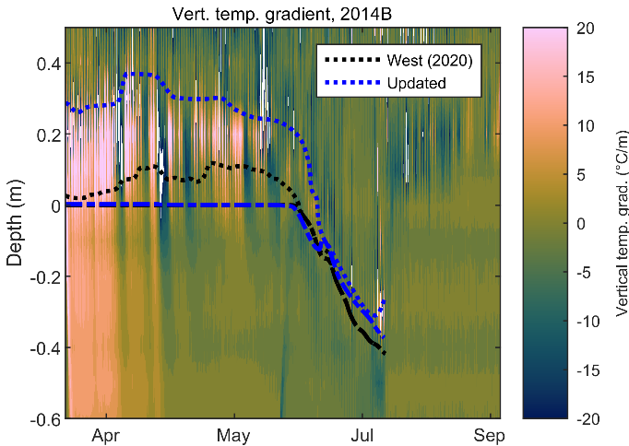
Figure 1. Vertical temperature profile at the time close to buoy deployment (left) and vertical temperature gradient evolution (right) for a selected buoy. Dashed and dashed-dotted represent surface and ice-snow interface locations for original (black) and updated (blue) datasets.
A comparison of original and updated estimates of snow and ice thicknesses is show in Fig.2, with 0.30 m and 0.18 m average snow and 1.9 m and 2.1 m average ice thicknesses, respectively.
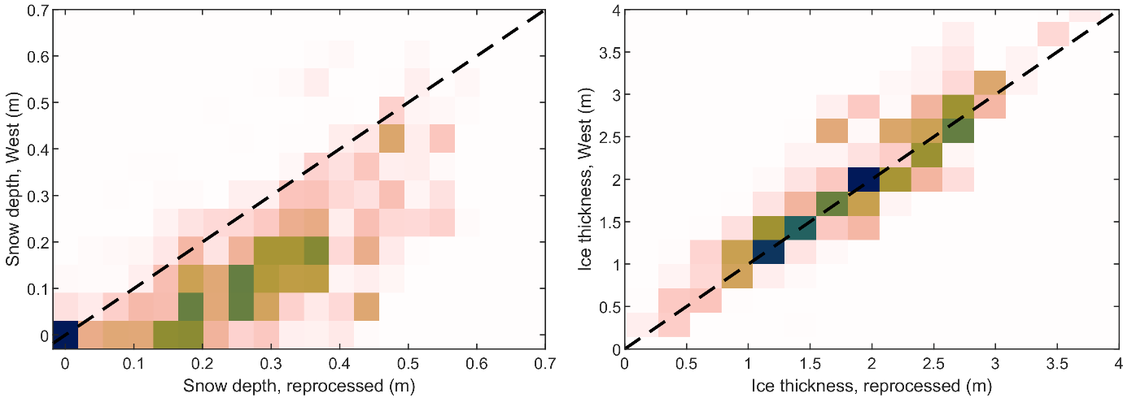
Figure 2. Histograms of estimates snow depth (left) and ice thickness (right) for all reprocessed buoy (N = 120x10³).
- The dataset
The updated dataset with the identical values of in-situ temperature, geographical location, time, as well as the original (West, 2020) and updated location of interfaces, as well as snow and ice thicknesses are published as NetCDF files in github.com/esalganik/SIMB3.

