Polhavet 2022 cruise
29-30.07.2022 Ice station 1 North Pole
Coordinates at start: N 89°53.825’; W -36° 14.901’ at 07:45 UTC
Atmospheric conditions: air about 0 to +1, water -1.3. Fog, drizzle sometimes, weak wind about 4-5 m/sec.
Ice floe:
Ice station on drift ice in central Arctic Ocean close to North Pole. The floe is about 700-800 m size. Thick first year ice 1.6-2.0 m thick, mostly level, average ice salinity of about 3 (from ice core). False bottoms detected when coring and drilling the ice, with a false bottom depth some 10 cm below the main bottom and false bottom ice being some 4-6 cm thick. See images of ice radar and drone-based orthophotos below.
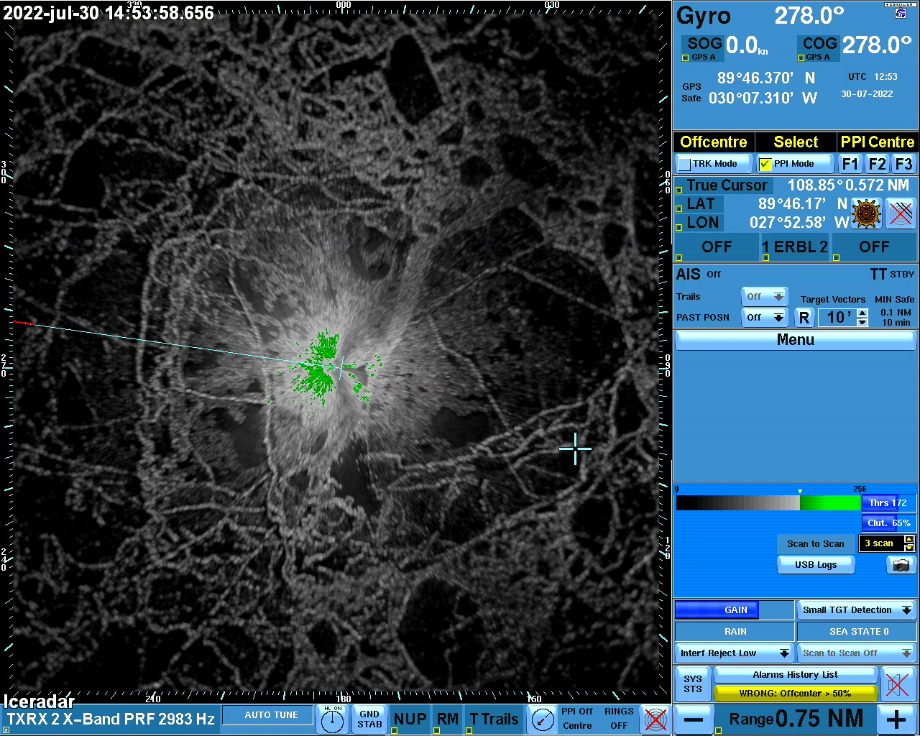
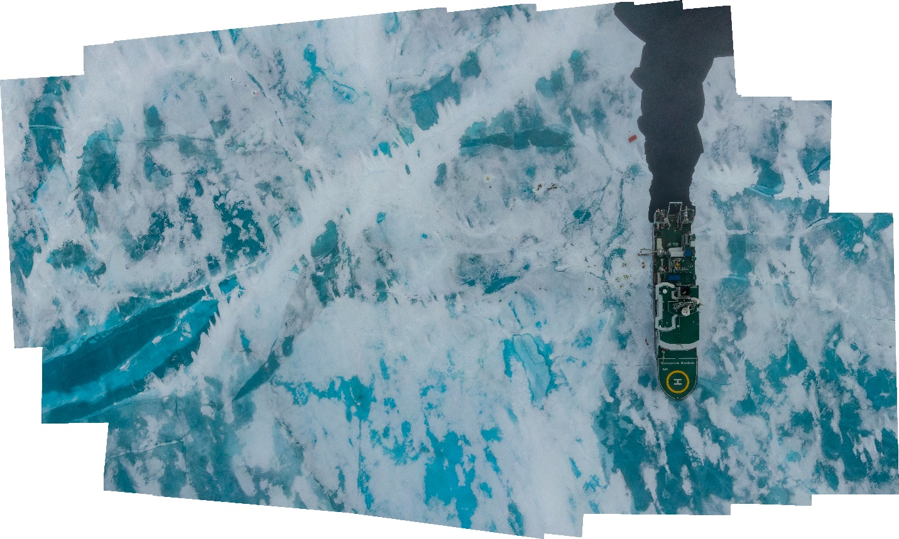

Ice surface conditions:
Ridge coverage about 10% or less; melt pond coverage up to 40% in some areas. Ponds linked, forming big pools in some areas. Melt ponds some 10-20 cm deep, smaller ones sometimes refrozen on the surface. Some thaw holes in the central areas of the ponds.
Old melting snow, large grains of 2-6 mm, thickness some 3-7 cm, deeper along the ridges.
Activities (ice physics only):
Day 1:
- opening the holes for oceanographic instruments and buoys; ice some 1.5-1.7 m thick in the areas used for deployments.
- Deploying the buoys and instruments (AZFP; 2 SIMBAs and 2 LT-ITO light buoys)
- Ice coring for physics and chemistry; complete set of ice cores recovered
Day 2
- Transect on the ice with GEM-2 and Magnaprobe
- Snow pit
For a complete list of activities see respective cruise log.

Preliminary results:
Gem-2 survey shows total ice and snow thickness along the transect some 1.5 km long, with one line some 400 m away of the ship and two parallel lines.
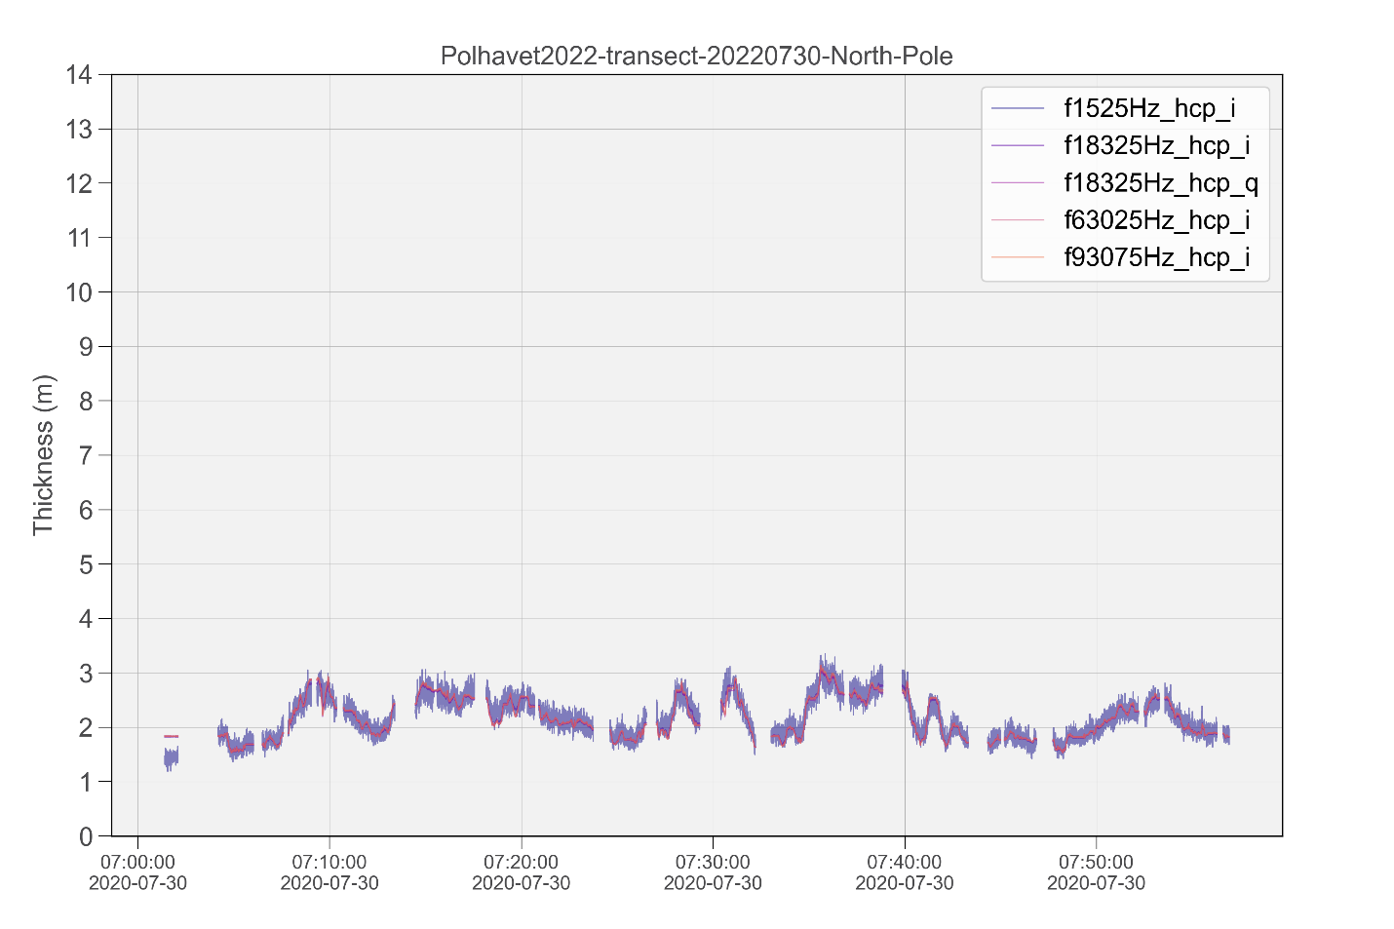
Note that the thickness drillings for the calibration of GEM2 contains the drill hole data for both the real ice bottom and false bottom thicknesses (see station xls file).
For the instrument calibration after the survey the drill hole thickness data down to the false bottom was used. Alternative use of “real” ice thicknesses should also be considered taking into account potentially very low conductivities of water between the real bottom and the false bottom due to fresh-water release from the ice. Water conductivities/salinities were measured by a small castaway ctd from the ice by K.Campbell, see respective data in the station worksheet, from KC field notebook.

Details on ice salinity measured onboard are found in the respective station spreadsheet/station report.

