Polhavet 2022 cruise
05-06.08.2022 Ice station 6 Amundsen Basin
Coordinates at start: N 86.522788°; W 5.6076476° at 07:05 UTC
Atmospheric conditions: air about 0 to +1, water -1.3. Variable visibility. From clear skies on 05.08 to fog in patches on 06.08. Weak wind about 3-5 m/sec.
Ice floe:
Ice station on drift ice in central Arctic Ocean in Amundsen Basin. The floe is about 1200 m size according to ice radar (see image). Older ice flow, most likely SYI some 1.6-2.0 m thick, mostly level. False bottoms were detected when drilling for GEM2 calibration. Ice coring site clear of false bottoms.
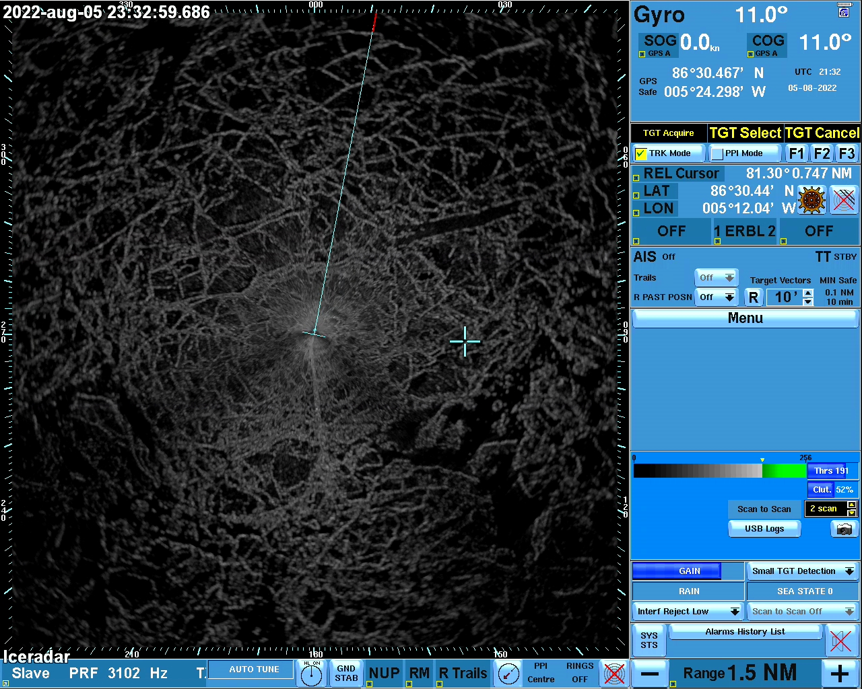

Working area some 200 by 250 m size bounded by ice ridges some 1.5 m high.
Ice surface conditions:
Ridge coverage about 10% or less; melt pond coverage about 20% in some areas. Ponds both discrete and linked. Melt ponds some 10-30 cm deep with a freeboard up to 15 cm, mainly about 10. Surface refrozen, some few mm of ice on the top, sometimes melted and refrozen snow. All ponds had a solid bottom.
Old melting snow, large grains of 1-10 mm, snow thickness some 3-8 cm, deeper along the ridges.
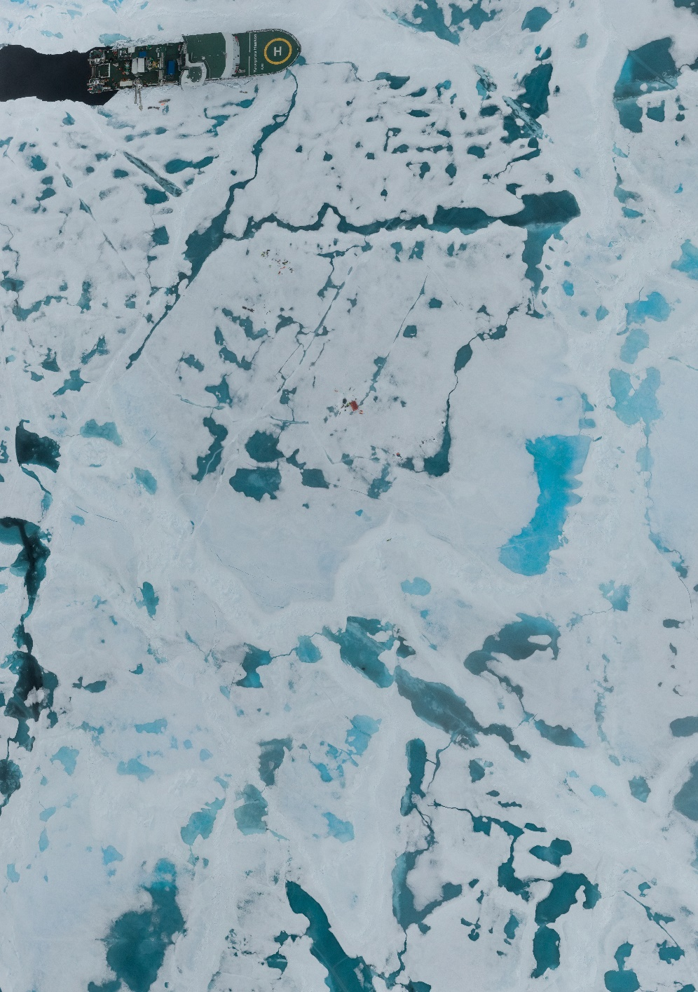

Activities (ice physics only):
Day 1:
- opening the holes for oceanographic instruments and buoys; ice some 1.4-1.8 m thick in the areas used for deployments: Larger ROV hole made in the pond with 1.4 m of ice.
- Ice coring for physics and chemistry; complete set of ice cores recovered. See respective ice station fieldnotes file.
Day 2
- Snow pit
- Transect on the ice with GEM-2 and Magnaprobe

For a complete list of activities see respective cruise log. Station details in the station xls file “Polhavet2022_Ice_Station_6_Amundsen_Basin.xlsx”

Preliminary results:
Details on ice salinity measured onboard are found in the respective station spreadsheet/station report.
Preliminary results from GEM-2 seaice and snow thickness measurements:
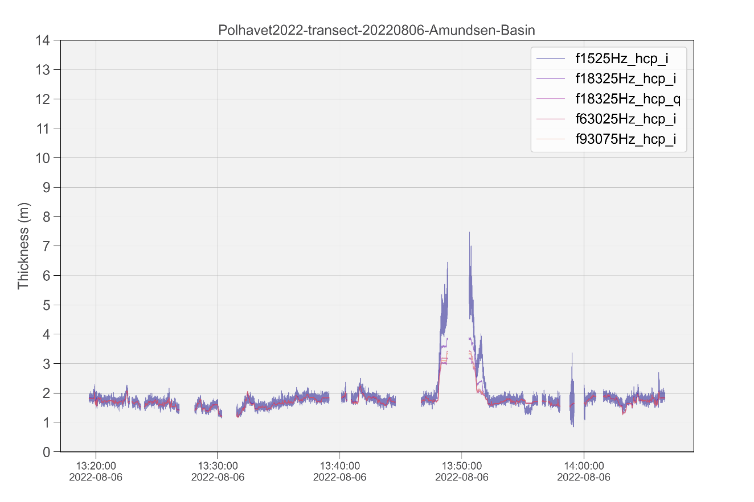
The inferred thickness of ice and snow along the transect varies between 1.5 and 2 m which agrees with thickness drillings conducted around the floe area.

