Polhavet 2022 cruise
12-14.08.2022 Ice station 8 Nansen Basin
Coordinates at start: N 83.9592968°; E 22.217669983° at 14:16 UTC
Atmospheric conditions: air about 0 to +1, water -1.6. Mostly very good visibility during the entire station time. Variable wind about 1-5 m/sec.
Ice floe:
Ice station on drift ice in the central Arctic Ocean in the Nansen Basin. The floe is about 1.8 by 0.9 km size according to ice radar (see image below). Older ice floe, most likely SYI some 1.2-1.6 m thick, mostly level.
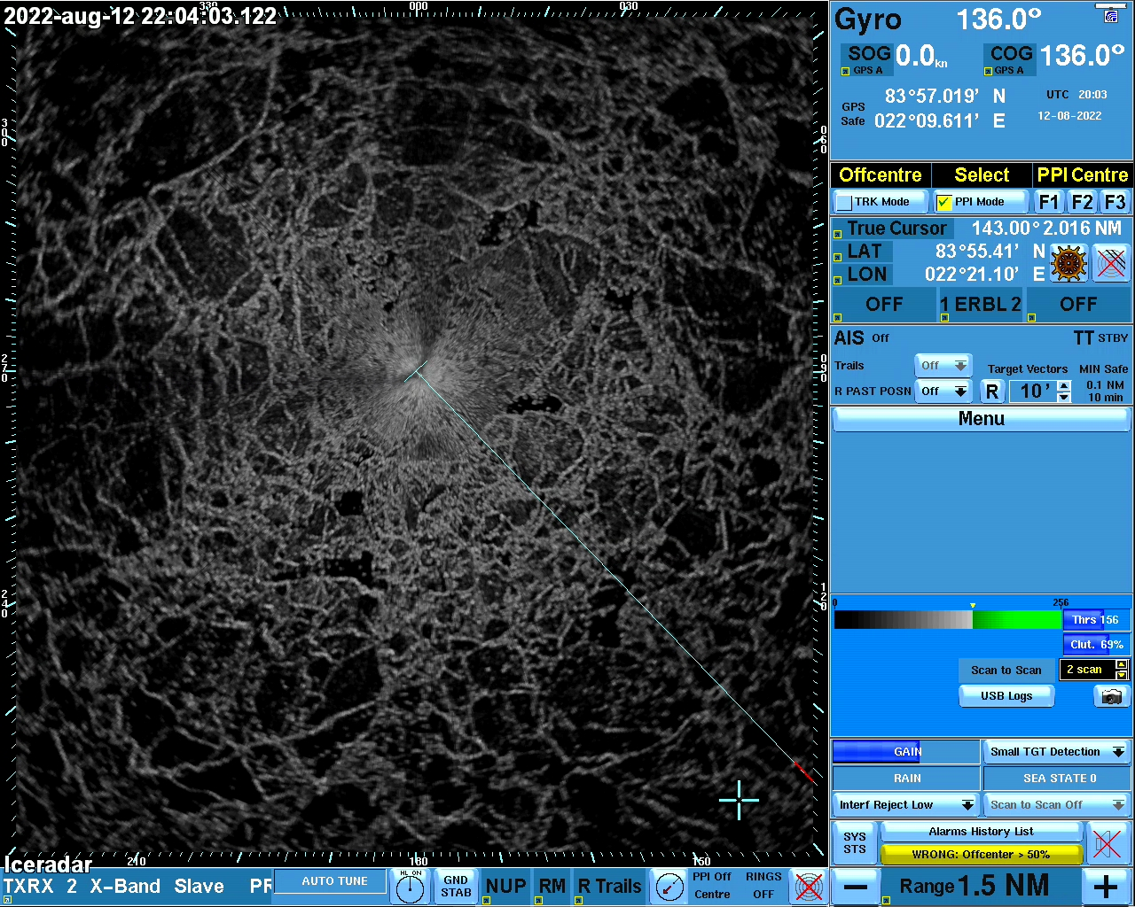

Working area consisted of two patches of melt pond free ice some 100 by 70 m size each with ponded areas next to them. Ice ridges some 1.0-1.5 m high around. Some ridges looked old from the precious summer.
Ice surface conditions:
Ridge coverage about 10% or less; melt pond coverage about 20-40% in some areas. Ponds both discrete (blue ponds next to ridges) and linked in level ice areas. Melt ponds some 10-30 cm deep with a freeboard up to 15 cm, mainly about 10-12 cm. Surface refrozen, some 10-20 mm thick ice on the top. All ponds except for those located in cracks/rifts areas had a solid bottom with 70-80 cm of ice beneath.
Old melting but refrozen cold snow, large grains of 1-10 mm, snow thickness some 3-8 cm, deeper along the ridges.
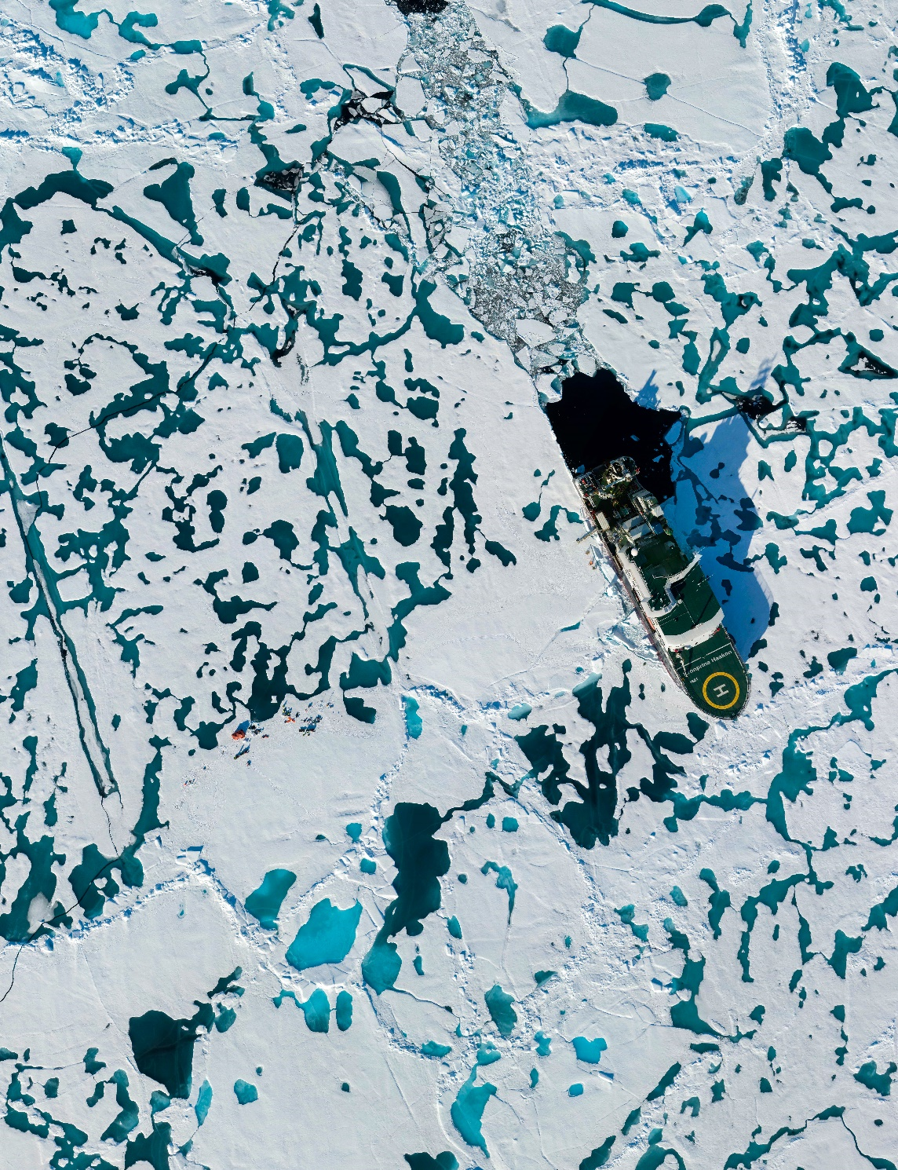

Activities (ice physics only, for more details on other activities see cruise report):
Day 1 12.08:
- opening the holes for oceanographic instruments and buoys; ice some 1.2-1.3 m thick in the areas used for deployments
Day 2 13.08:
- Morning: Transect on ice with GEM-2 and Magnaprobe
- Ice coring for physics and chemistry; complete set of ice cores recovered. See respective ice station fieldnotes file.
- Snow pit
Day 3 14.08:
- Melt ponds survey
For a complete list of activities see respective cruise log and cruise report. Station details in the station xls file “Polhavet2022_Ice_Station_8_Nansen_Basin.xlsx”

Preliminary results:
Details on ice salinity measured onboard are found in the respective station spreadsheet/station report.
Preliminary results from GEM-2 seaice and snow thickness measurements:

The inferred thickness of ice and snow along the transect varies between MM and NN m which agrees with thickness drillings conducted around the floe area.

