Supplementary Material: Morphological stability and subtle phenotypic shifts in Atlantic Forest birds across two decades of climate warming
Eduardo S.A. Santos
João C.T. Menezes
Gustavo Burin

1. Supplementary Notes

1.1 Supplementary Note S1: Macroecological Provenance and Observer Turnover
Large-scale biodiversity trait compilations aggregate measurements across numerous independent research initiatives spanning wide geographical territories and multiple decades (Rodrigues et al. 2019). In the ATLANTIC BIRD TRAITS database, 42 primary researchers coordinated field mist-netting across 139 named municipalities between 1995 and 2018 (Figure 1).
A provenance audit revealed substantial compositional turnover among active research teams over time: only 6 of the 42 primary researchers sampled birds in both the early quartile (1995–2006; 12 active contributors) and the late quartile (2013–2018; 33 active contributors; Figure 1). Furthermore, spatial sampling expanded northward and into higher-elevation montane habitats during the latter half of the time series. In avian morphometrics, inter-observer measurement differences frequently reach 1–3 mm for wing length and 0.5–1 mm for bill dimensions (Weeks et al. 2020). When observer identity is left uncontrolled, compositional turnover mimics temporal phenotypic change, accounting for approximately 60% of the apparent unadjusted wing-length decline and creating spurious trends in bill width and trait variance.
To resolve genuine biological change from sampling turnover, all primary models incorporate random intercepts for primary researcher ((1 | Main_researcher)). In addition, within-between random effects models [Mundlak REWB; Mundlak (1978); Bell et al. (2019)] definitively demonstrate that morphological traits remained stable within consistent individual researchers over time (e.g., within-observer wing slope: $−0.32$ mm/decade, 95% CI: $−1.59$ to $+0.96$ mm/decade; complete cases: $+0.03$ mm/decade, 95% CI: $−0.58$ to $+0.63$).
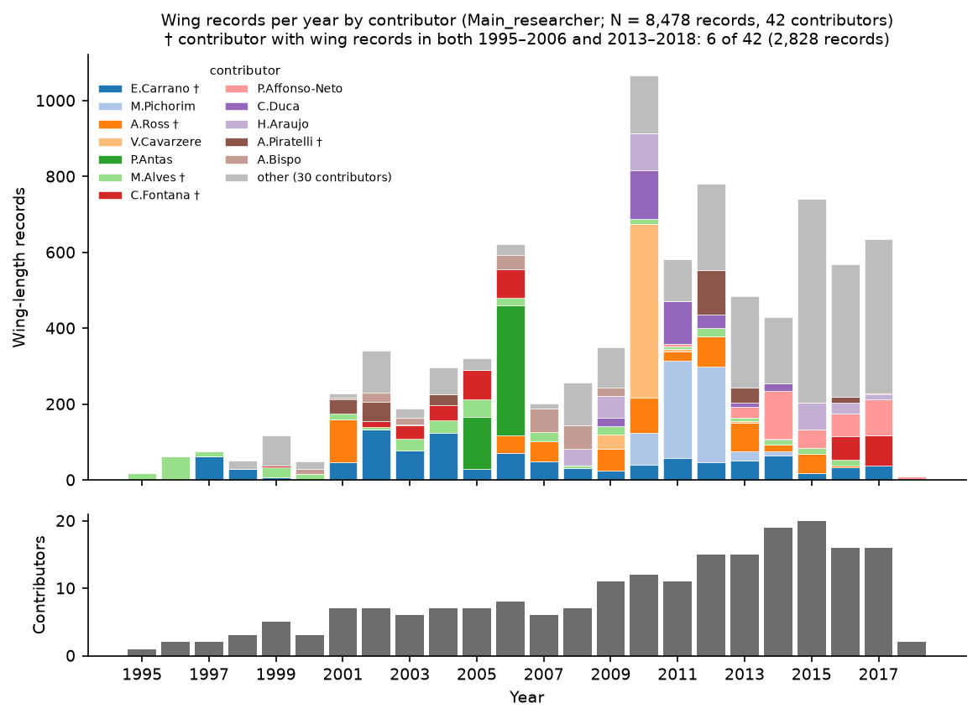
Figure 1: Supplementary Figure S1. Temporal distribution of live-capture passerine wing records across primary researchers (1995–2018). (Top) Number of wing records per calendar year, stacked by the 12 largest research contributors (and an aggregated “Other (30)” category). Daggers (†) mark research teams that continuously sampled birds across both the early (1995–2006) and late (2013–2018) periods. (Bottom) Number of active research contributors per calendar year.

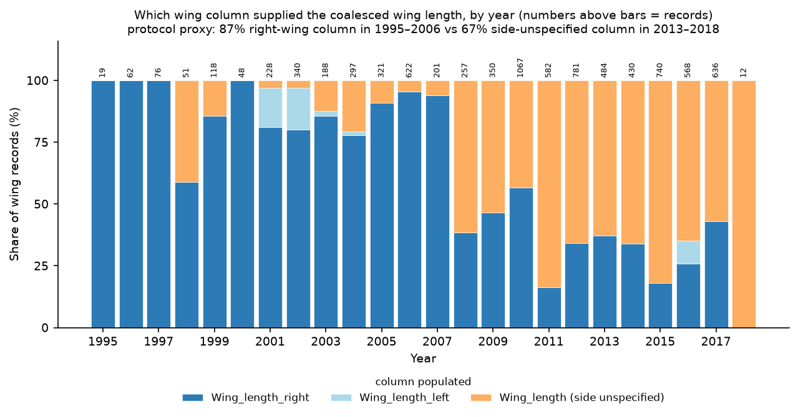
Figure 2: Supplementary Figure S2. Relative proportion of wing-length measurement columns populated in the ATLANTIC BIRD TRAITS database by year. Bars indicate the annual percentage of records reporting right wing length, left wing length, or side-unspecified wing length. Sample sizes ($n$) above bars indicate total annual captures with wing data.

1.2 Supplementary Note S2: Regional Environmental and Climatic Trends (1995–2018)
We extracted monthly climate data from the CRU-TS 4.09 high-resolution gridded multivariate dataset (${0.5}^{∘}×{0.5}^{∘}$ resolution; Harris et al. (2020)) at the 357 coordinate capture localities across the Atlantic Forest domain (Figure 3).
Across sampling localities, mean annual temperature increased significantly by $+{0.246}^{∘}\text{C}$/decade (95% CI: $+0.076$ to $+{0.415}^{∘}\text{C}$/decade, $t=2.87,p=0.005$), corresponding to an average regional warming of $+{0.57}^{∘}\text{C}$ between 1995 and 2018 (Figure 3 A). In contrast, total annual precipitation exhibited a non-significant trajectory ($−44.7$ mm/decade, 95% CI: $−123.1$ to $+33.7$ mm/decade, $p=0.25$; Figure 3 B), and the 12-month Standardized Precipitation-Evapotranspiration Index (SPEI-12) displayed no directional trend ($−0.256$ units/decade, 95% CI: $−0.617$ to $+0.105$, $p=0.16$; Figure 3 C). Regional environmental change across our capture sites was therefore characterized primarily by steady thermal warming without systematic multi-decadal changes in moisture availability.
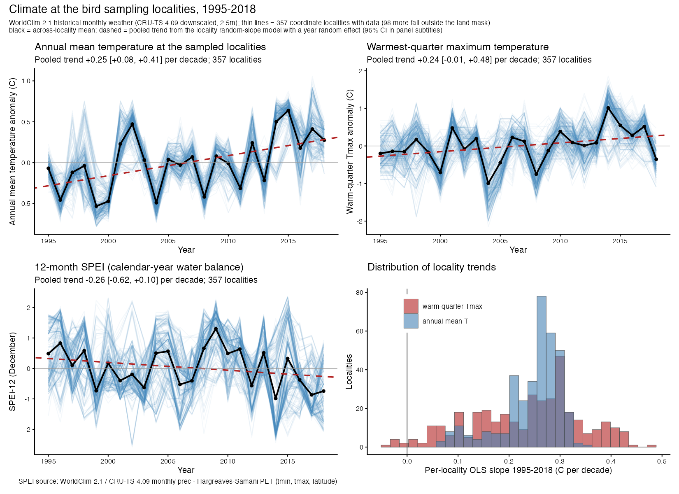
Figure 3: Supplementary Figure S3. Environmental trends across 357 avian capture localities in the Brazilian Atlantic Forest (1995–2018). (A) Mean annual temperature (°C), showing significant warming (+0.246°C/decade, $p=0.005$). (B) Total annual precipitation (mm/year), showing non-significant variation ($−44.7$ mm/decade, $p=0.25$). (C) 12-month Standardized Precipitation-Evapotranspiration Index (SPEI-12), indicating stability in drought regimes ($−0.256$/decade, $p=0.16$). Solid lines and shaded bands represent pooled linear mixed-effects model trajectories with 95% confidence intervals.

1.3 Supplementary Note S3: Century-Scale Museum Integration and Climate Breakpoint Analysis
To place the 24-year mist-netting record (1995–2018) into long-term macroecological perspective, we audited historical museum study skins ($n=3,439$ adult specimens, 1884–2017) across 142 passerine species preserved in major Brazilian collections (Museu de Zoologia da Universidade de São Paulo [MZUSP], Museu Nacional da UFRJ [MNRJ], Universidade Regional de Blumenau [FURB], and Universidade Federal de Pernambuco [UFPE]).
We evaluated secular climate warming using NASA GISS Surface Temperature Analysis (GISTEMP v4; Zonal annual anomalies for ${24}^{∘}\text{S}\text{–Equator}$, 1880–2018; Lenssen et al. (2019)), which strongly correlates with local CRU-TS capture temperatures ($r=0.744$). Using two-phase piecewise linear regression (Muggeo 2003), we conducted a grid search across candidate breakpoint years (1900–2005) to identify the structural inflection point in regional warming:
$$y_{t}=α+β_{1}min(Y_{t}−τ,0)+β_{2}max(Y_{t}−τ,0)+ε_{t}$$
The maximum-likelihood breakpoint emerged at $τ=1980±3$ years: - Pre-1980 (1880–1979): $+{0.036}^{∘}\text{C}$/decade ($t=2.05,p=0.042$), reflecting modest decadal fluctuations. - Post-1980 (1980–2018): $+{0.190}^{∘}\text{C}$/decade ($t=8.62,p<{10}^{−15}$), representing a $>5$-fold acceleration in regional warming rate (Figure 4 A).
Applying identical piecewise regressions to species-centered morphological deviations revealed that pre-1980 museum specimens exhibited strict stability or slight positive trajectories in wing length ($+0.45$ mm/decade, $t=3.71$; Figure 4 B), with zero thermal sensitivity to annual temperature anomalies ($β=+0.10$ mm/°C, $p=0.91$; Figure 4 C). Wing shortening emerged synchronously with the post-1980 warming acceleration ($−0.26$ to $−0.41$ mm/decade, $p<0.02$; thermal sensitivity $β=−1.68$ mm/°C, $p=0.005$).
Similarly, historical body mass (1962–1979) was strictly invariant ($−0.17\%$/year, $p=0.52$; thermal sensitivity $β=−1.97\%/^{∘}\text{C},p=0.86$; Figure 5), and bivariate allometry followed geometric isometry prior to 1980 ($Δ_{\text{iso}}:p=0.69$), shifting to significant stoutening post-1980 ($+2.12\%$/decade, $p=0.048$; thermal sensitivity $β=+9.32\%/^{∘}\text{C},p=0.034$; Figure 6). For 175 species continuously connecting museum skins to modern field captures, the secular wing decline was $−0.71\%$/decade ($p=0.047$; Figure 7).
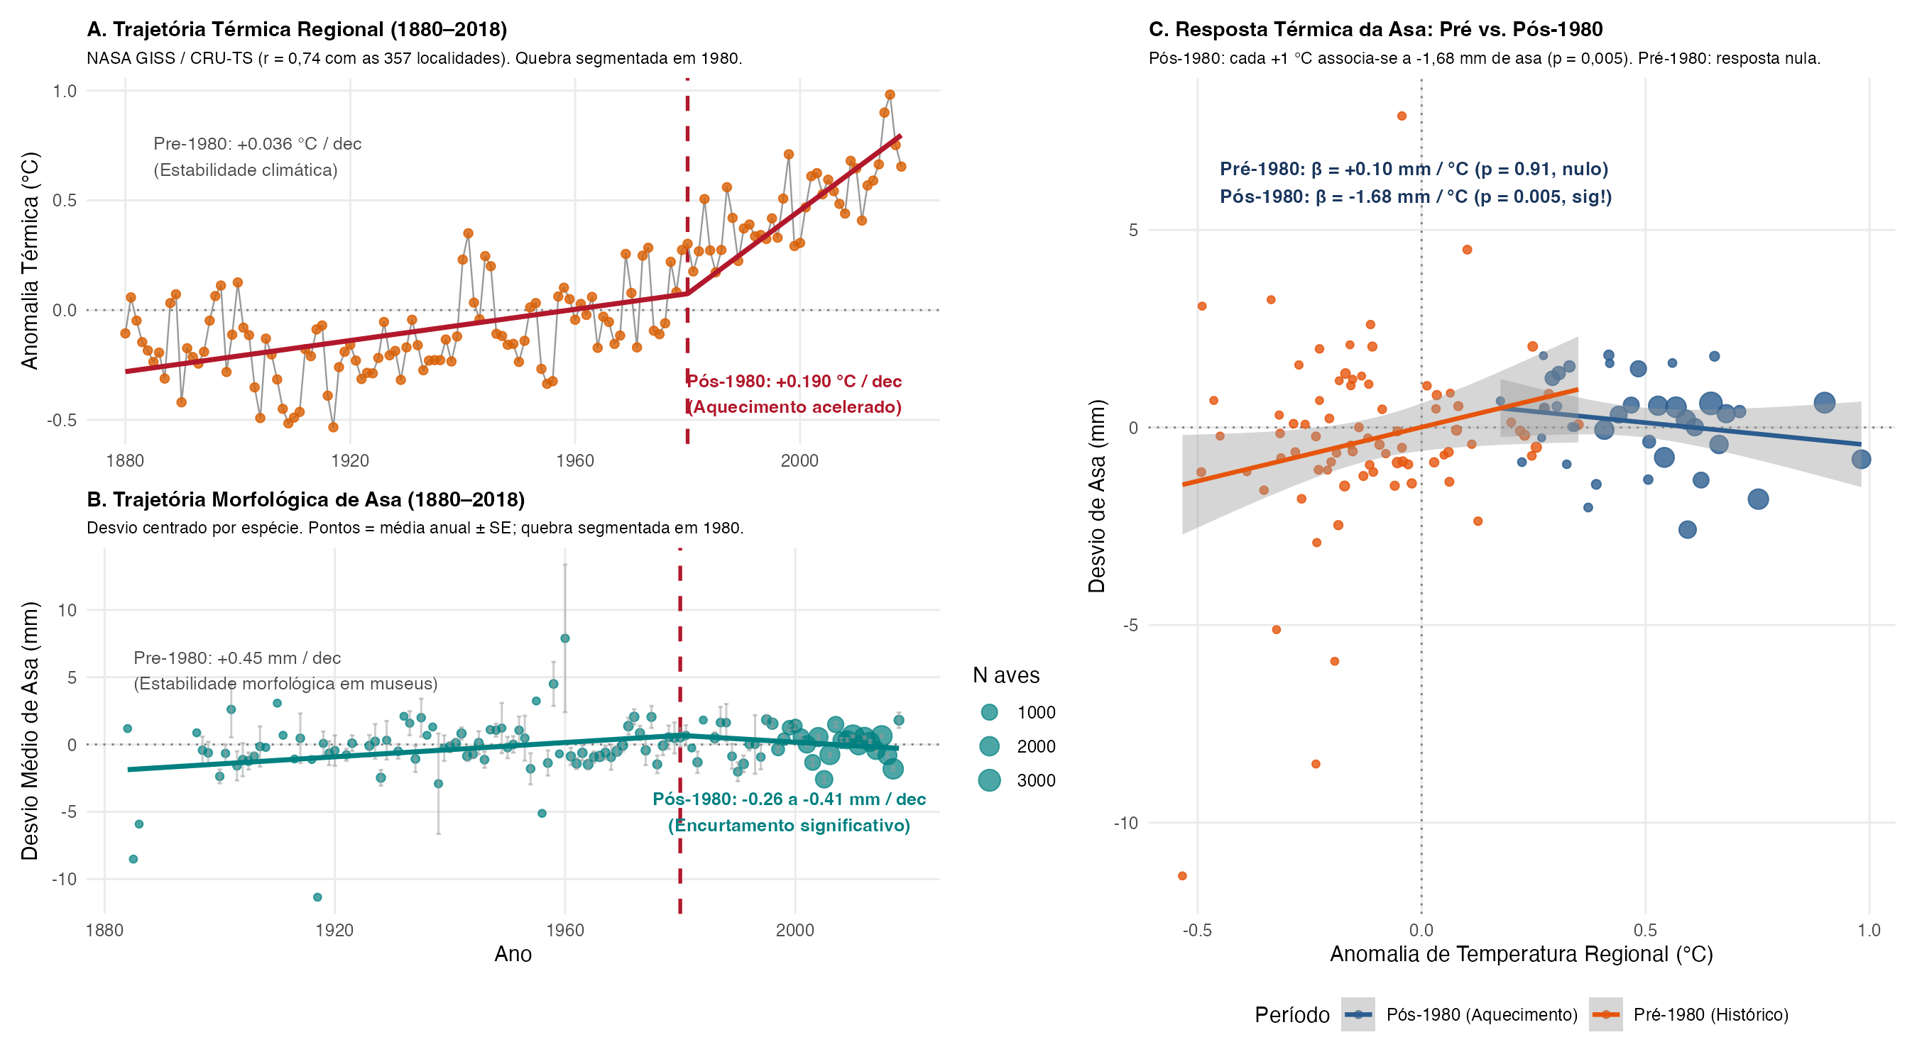
Figure 4: Supplementary Figure S4. Century-scale climate breakpoint (~1980) and morphometric coupling of wing length (1880–2018). (A) Regional temperature anomalies (NASA GISS Zonal ${24}^{∘}\text{S}\text{–Equator}$), showing the structural breakpoint in 1980 (dashed line; $+{0.036}^{∘}\text{C}$/dec pre-1980 vs. $+{0.190}^{∘}\text{C}$/dec post-1980). (B) Annual mean wing length deviations across 37,751 records (1884–2018), showing pre-1980 museum stability and post-1980 shortening. (C) Thermal sensitivity of wing length: pre-1980 morphology was decoupled from temperature ($β=+0.10$ mm/°C, $p=0.91$), whereas post-1980 exhibits strong negative thermal coupling ($β=−1.68$ mm/°C, $p=0.005$).

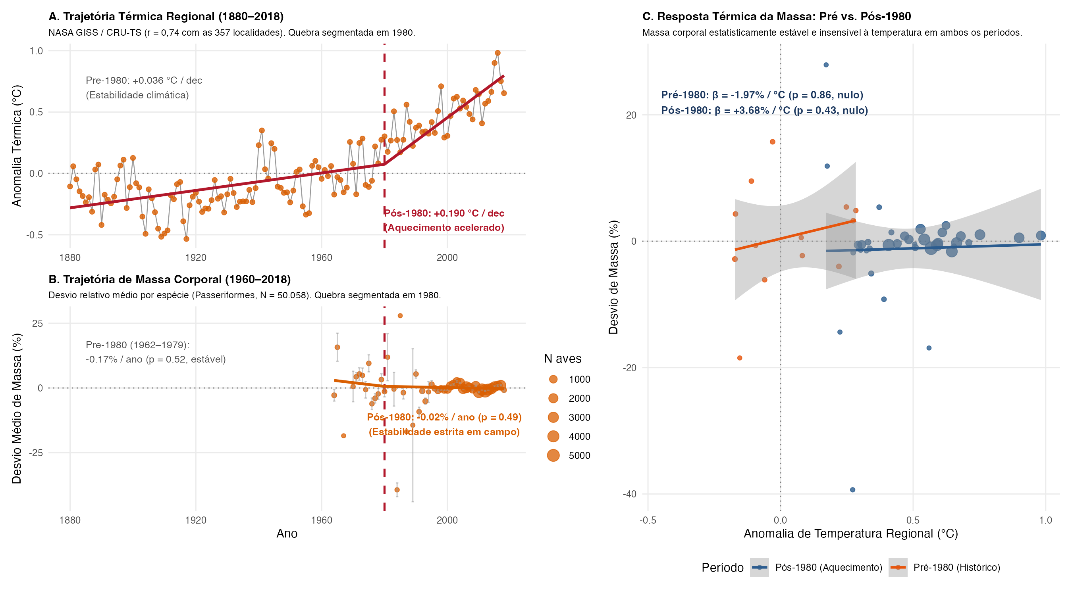
Figure 5: Supplementary Figure S5. Century-scale body mass trajectory and thermal decoupling (1962–2018). (A) Regional temperature series with 1980 breakpoint. (B) Species-centered body mass deviations across 50,058 passerine records, showing multi-decadal stability across both pre-1980 ($−0.17\%$/year, $p=0.52$) and post-1980 ($−0.02\%$/year, $p=0.49$) eras. (C) Thermal sensitivity of body mass, demonstrating complete thermal decoupling across all time periods ($p=0.86$ pre-1980; $p=0.43$ post-1980).

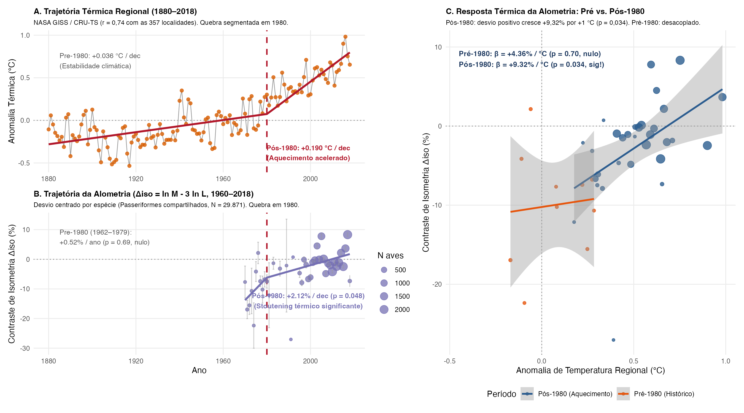
Figure 6: Supplementary Figure S6. Century-scale allometric trajectory and thermal stoutening (1962–2018). (A) Regional temperature series with 1980 breakpoint. (B) Isometry contrast ($Δ_{\text{iso}}=lnM−3lnL$) across 29,871 shared records, showing strict isometry pre-1980 ($p=0.69$) and significant stoutening post-1980 ($+2.12\%$/decade, $p=0.048$). (C) Thermal sensitivity of allometry, showing strong positive coupling to regional warming post-1980 ($β=+9.32\%/^{∘}\text{C},p=0.034$).

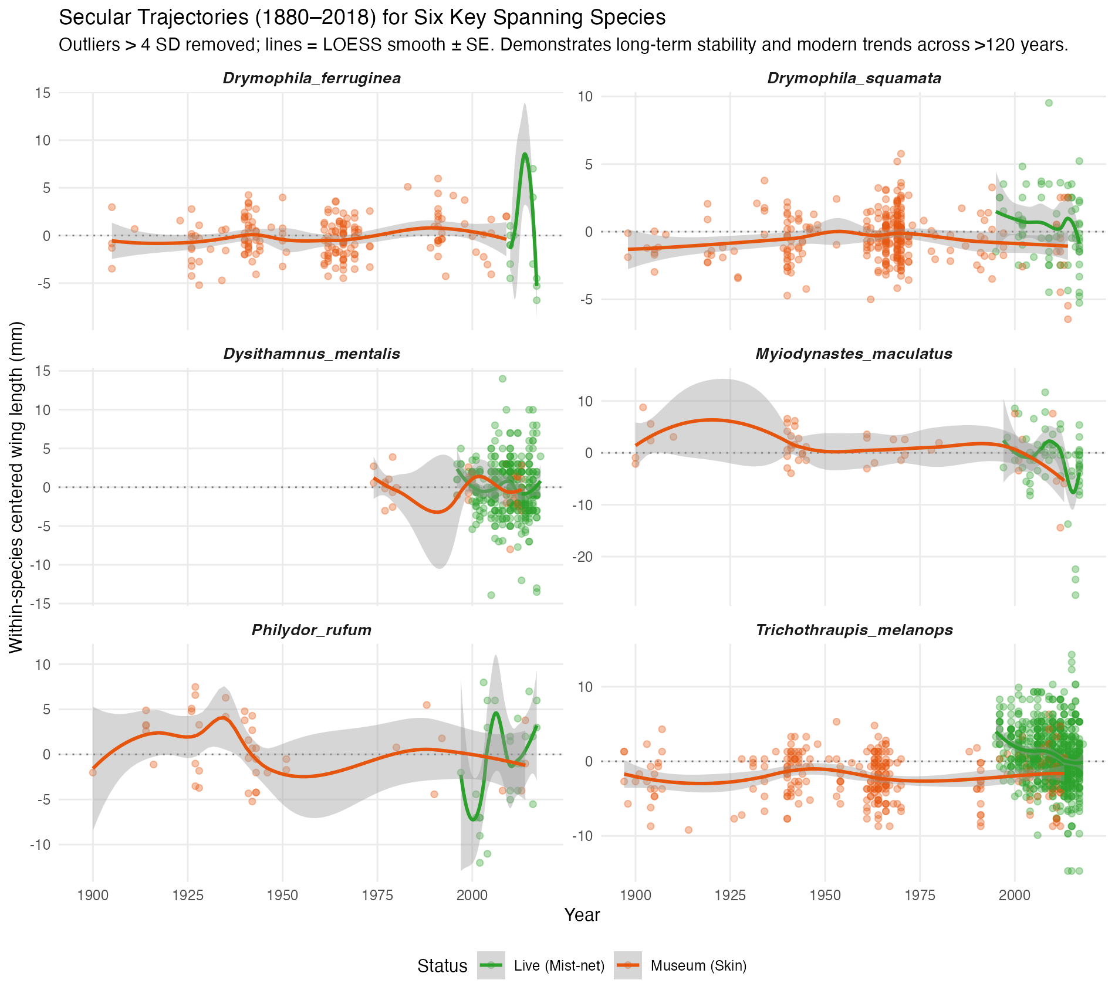
Figure 7: Supplementary Figure S8. Secular species-specific trajectories for 175 passerine species connecting historical museum skins (1884–1979) to modern field ringing records (1995–2018). Points represent annual species means sized by capture count; lines represent species-specific linear mixed-effects trajectories.

1.4 Supplementary Note S4: Community-Wide Sampling Expansion (Jirinec et al. 2021 Criteria)
To assess whether our focal sample restrictions (passerines, adults of known sex, $n≥30$, $≥5$ years span) influenced conclusions, we implemented a community-wide expansion following the less restrictive sampling design of Jirinec et al. (2021): 1. Inclusion of adult individuals of unknown sex; 2. Expansion from Passeriformes to all mist-netted understorey bird orders (Apodiformes, Columbiformes, Coraciiformes, Cuculiformes, Galbuliformes, Gruiformes, Passeriformes, Pelecaniformes, Piciformes, Strigiformes, Trogoniformes); 3. Temporal coverage criterion requiring $≥5$ captures before and after the median sampling year (2010).
This expanded dataset comprised 46,663 body mass records (243 species) and 31,888 wing records (217 species). Linear mixed-effects models controlling for species random slopes, sampling locality, and contributor demonstrated that wing shortening remained invariant at $−1.00\%$/decade (95% CI: $−2.09$ to $+0.09\%$/decade; Table 1; Figure 8). For body mass, the expanded community sample yielded a statistically detectable decadal decline of $−1.29\%$/decade (95% CI: $−2.30$ to $−0.27\%$/decade), positioning the Atlantic Forest intermediate between North American temperate migrants [$−0.68\%$/decade; Weeks et al. (2020)] and continuous Amazonian understorey [$−1.80\%$/decade; Jirinec et al. (2021)].
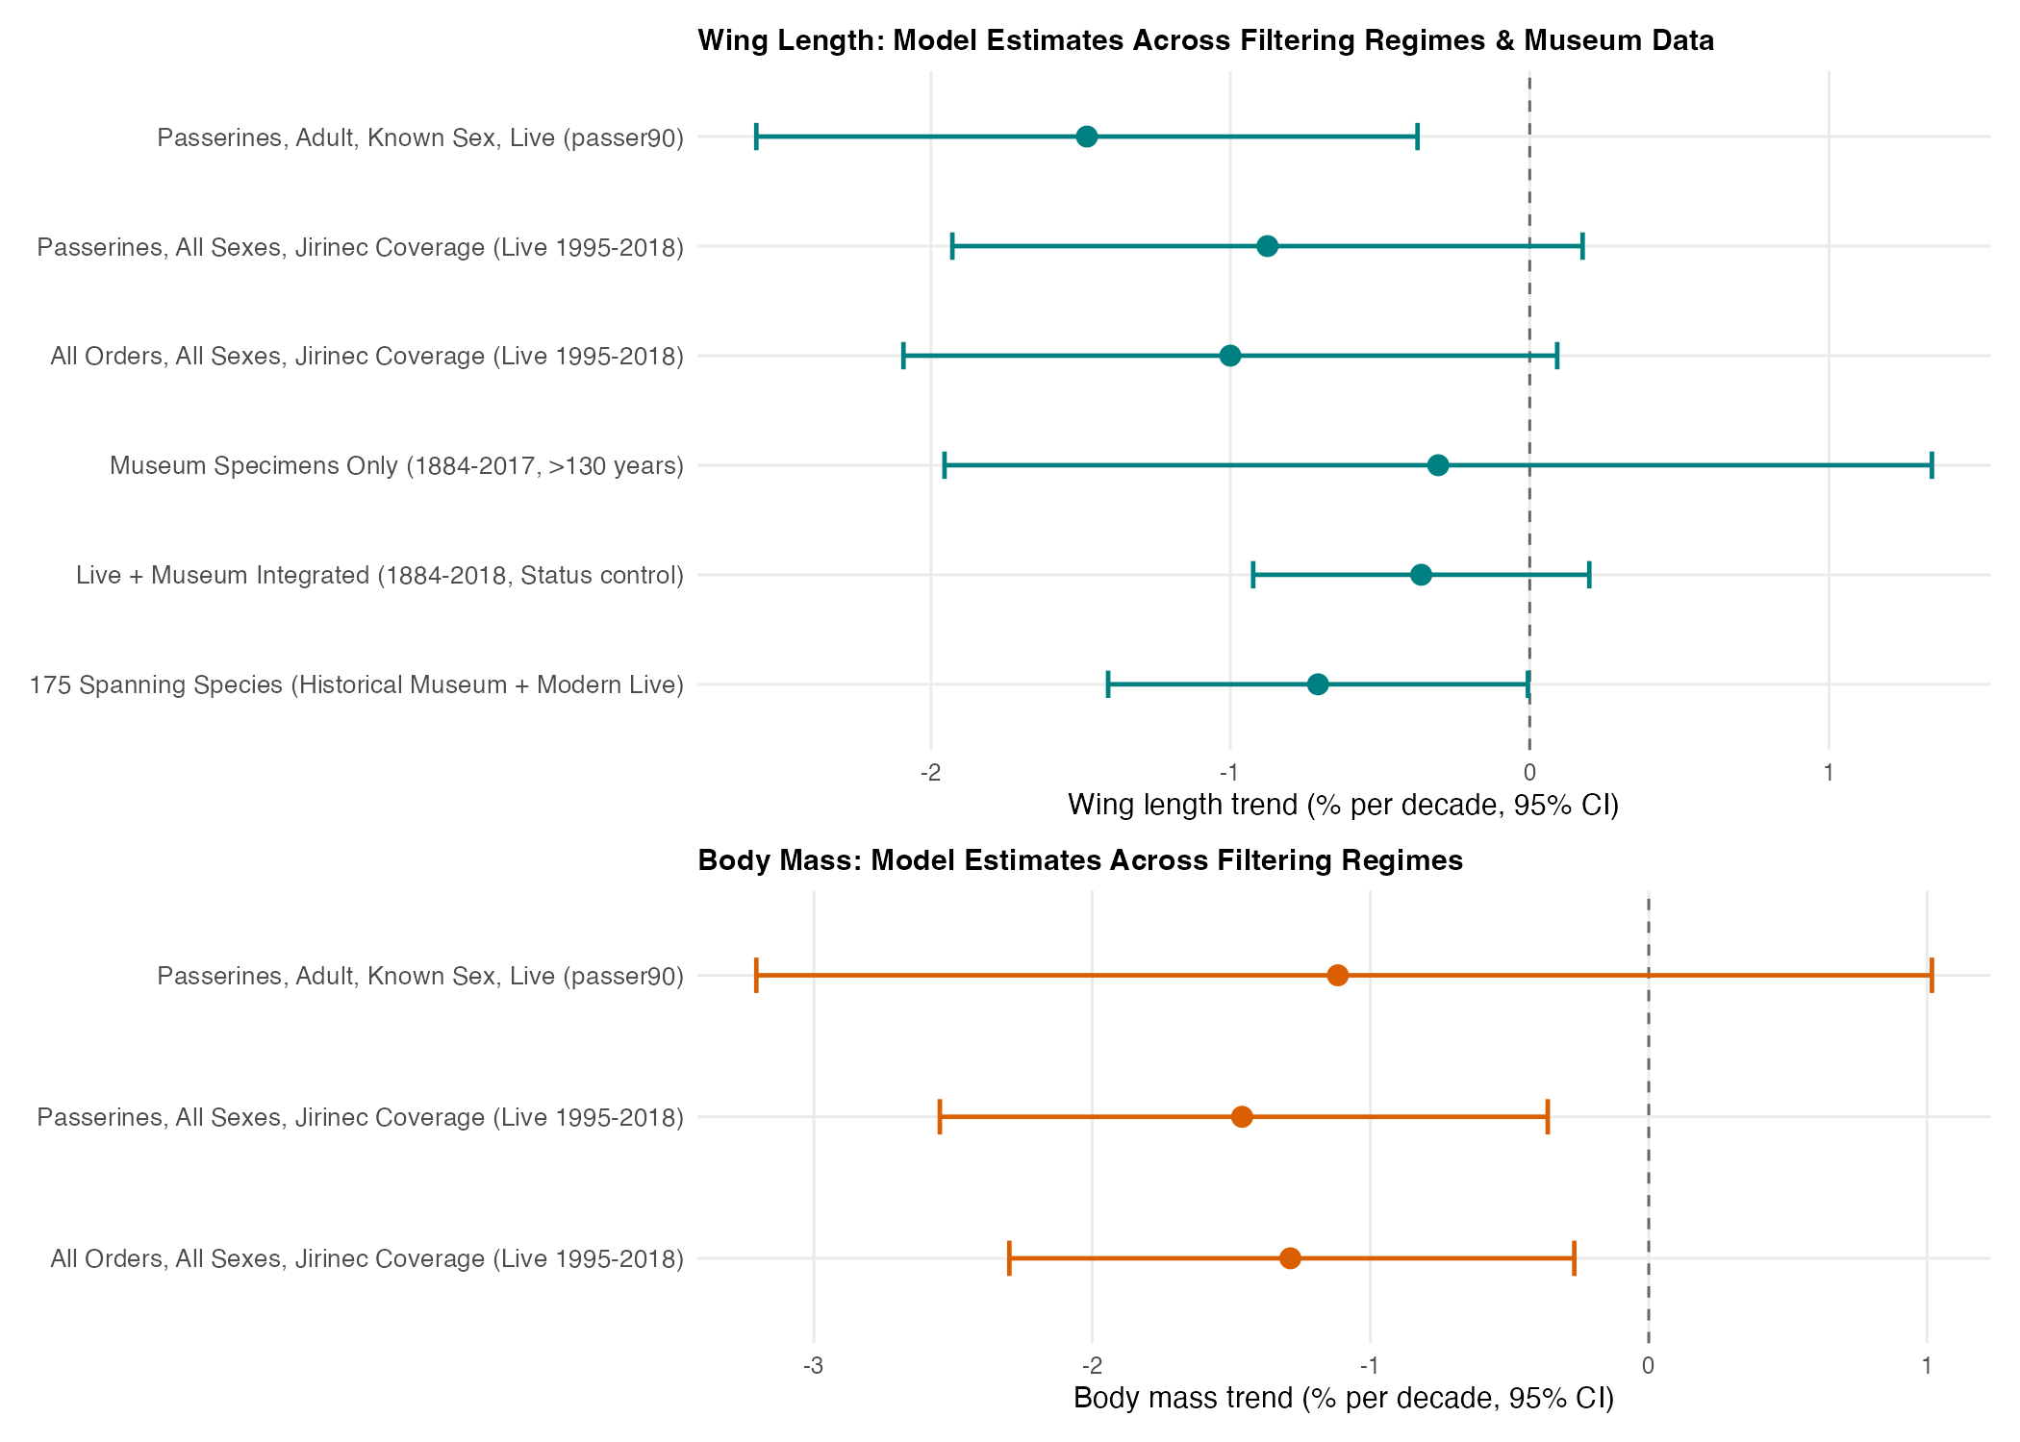
Figure 8: Supplementary Figure S7. Forest plot comparing decadal rates of change (% per decade, $±95\%$ CI) across sequential analytical tiers (T1–T6) for wing length (blue) and body mass (orange). Benchmarks from Weeks et al. (2020) (temperate migrants) and Jirinec et al. (2021) (Amazonian understorey) are displayed for comparison.

1.5 Supplementary Note S5: Exploratory Distributional Structural Equation Modeling (drmSEM)
To evaluate causal pathways connecting climate warming, potential prey availability, and avian morphometrics, we formulated a distributional causal DAG using drmSEM / glmmTMB (Figure 9). The model simultaneously estimates mean paths ($μ$) and heteroscedastic dispersion paths ($logσ$). In accordance with the main findings, direct temperature effects on wing length were modest, body mass showed complete stability, and regional prey indices (litter ants) showed no direct causal constraint on avian body condition.
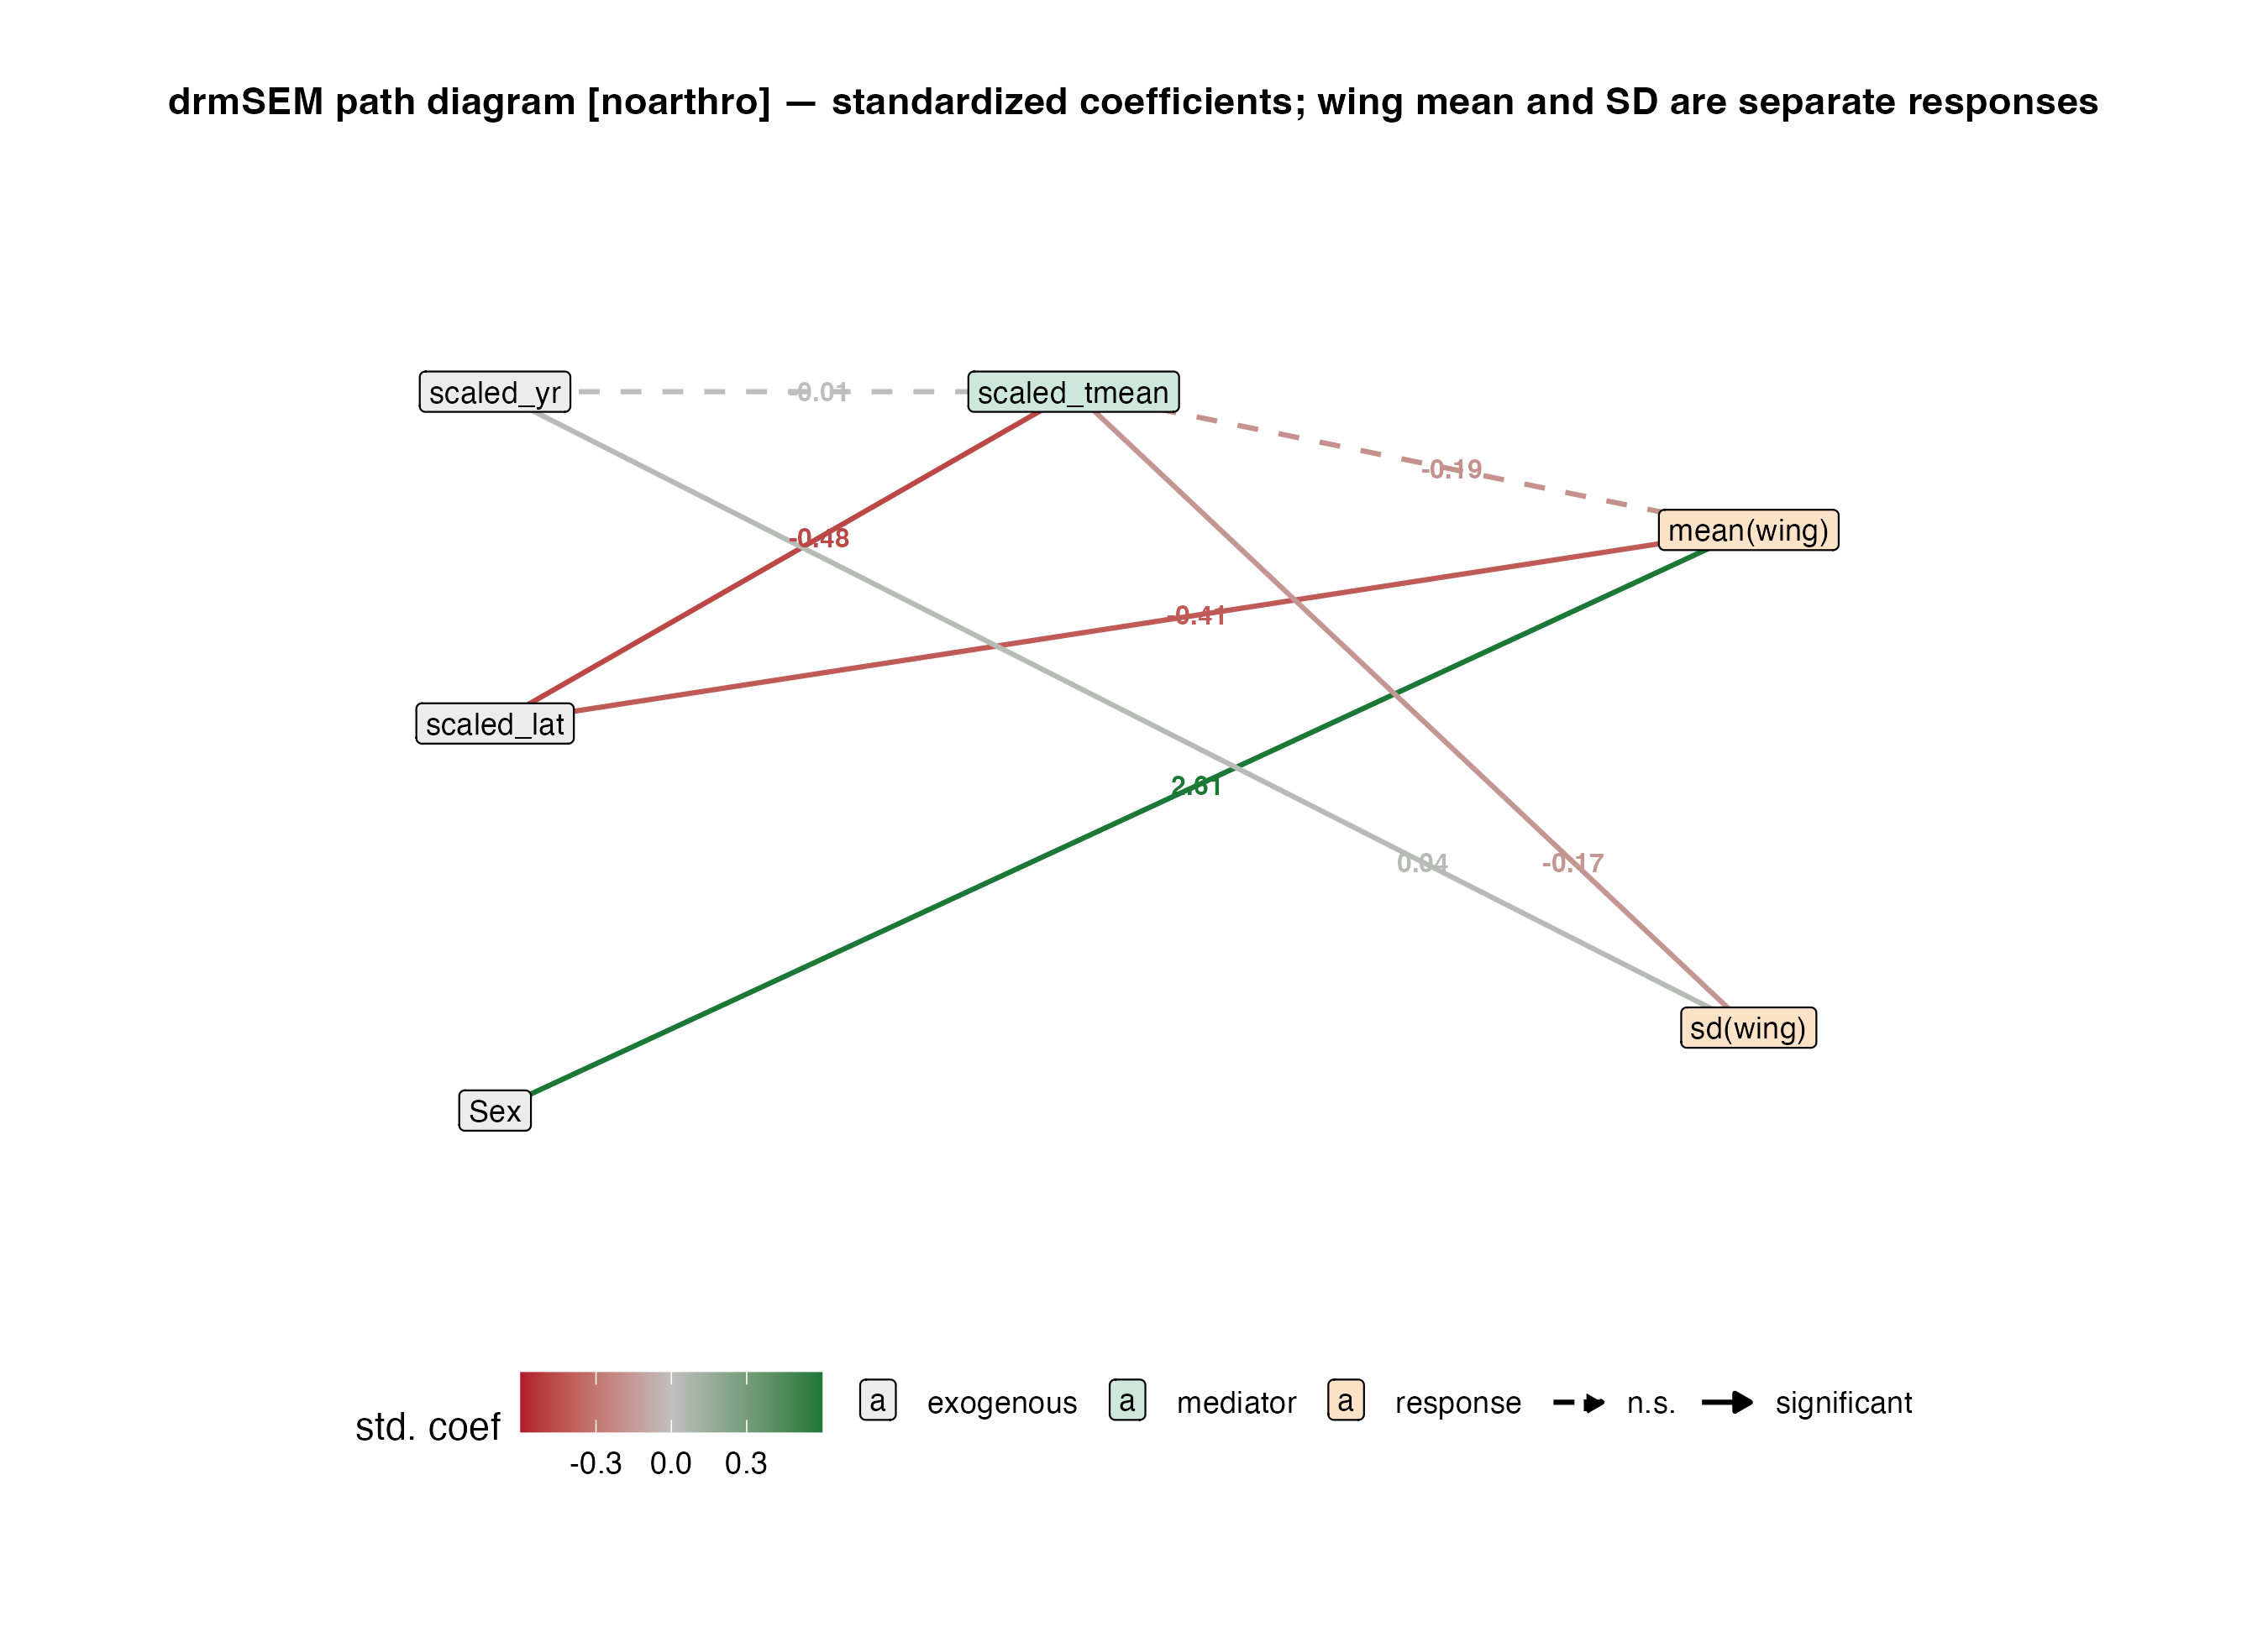
Figure 9: Supplementary Figure S9. Distributional causal directed acyclic graph (drmSEM) evaluating environmental warming, prey availability, and avian phenotypic responses. Solid arrows represent mean structural paths ($μ$); dashed arrows represent dispersion paths ($logσ$). Standardized path coefficients ($±1$ SE) are displayed alongside each path.

2. Supplementary Tables
Table 1: Supplementary Table S1. Summary of decadal morphological trajectories across sequential analytical tiers and sample filtering criteria. Models control for species-specific random slopes and intercepts, geographic locality, and contributor/collection.
Tier / Specification | Trait | Sample Description | Records ($N$) | Species ($k$) | Time Span | Decadal Rate (%/dec) | 95% Confidence Interval | Raw Unit / decade
T1. Manuscript Baseline (passer90) | Wing length | Passerines, Adult, Known Sex, Live captures | 8,478 | 72 | 1995–2018 | $−1.48\%$ | $[−2.58,−0.37]$ | $−1.05$ mm
T1. Manuscript Baseline (passer90) | Body mass | Passerines, Adult, Known Sex, Live captures | 11,256 | 73 | 1995–2018 | $−1.12\%$ | $[−3.21,+1.02]$ | $−0.011$ log g
T2. Jirinec Passerines (All Sexes) | Wing length | Passerines, All Sexes, Jirinec temporal coverage | 28,190 | 178 | 1995–2018 | $−0.88\%$ | $[−1.93,+0.18]$ | $−0.66$ mm
T2. Jirinec Passerines (All Sexes) | Body mass | Passerines, All Sexes, Jirinec temporal coverage | 41,258 | 191 | 1995–2018 | $−1.46\%$ | $[−2.55,−0.36]$ | $−0.015$ log g
T3. Jirinec Community (All Orders) | Wing length | All Orders, All Sexes, Jirinec temporal coverage | 31,888 | 217 | 1995–2018 | $−1.00\%$ | $[−2.09,+0.09]$ | $−0.76$ mm
T3. Jirinec Community (All Orders) | Body mass | All Orders, All Sexes, Jirinec temporal coverage | 46,663 | 243 | 1995–2018 | $−1.29\%$ | $[−2.30,−0.27]$ | $−0.013$ log g
T4. Museum Historical Series | Wing length | Museum Study Skins only (MZUSP, MNRJ, etc.) | 3,439 | 142 | 1884–2017 | $−0.31\%$ | $[−1.95,+1.34]$ | $−0.28$ mm
T5. Integrated Live + Museum | Wing length | Live Captures + Museum Skins (Status control) | 34,312 | 184 | 1884–2018 | $−0.36\%$ | $[−0.92,+0.20]$ | $−0.28$ mm
T6. Spanning Species Cohort | Wing length | 175 Species sampled in both Historical and Modern eras | 24,583 | 175 | 1884–2018 | $−0.71\%$ | $[−1.41,−0.01]$ | $−0.55$ mm

References
Bell, Andrew, Malcolm Fairbrother, and Kelvyn Jones. 2019. “Fixed and Random Effects Models: Making an Informed Choice.” Quality & Quantity 53 (2): 1051–74. https://doi.org/10.1007/s11135-018-0802-x.
Harris, Ian, Timothy J. Osborn, Phil Jones, and David Lister. 2020. “Version 4 of the CRU TS Monthly High-Resolution Gridded Multivariate Climate Dataset.” Scientific Data 7 (1): 109. https://doi.org/10.1038/s41597-020-0453-3.
Jirinec, Vitek, Ryan C. Burner, Bruna R. Amaral, et al. 2021. “Morphological Consequences of Climate Change for Resident Birds in Intact Amazonian Rainforest.” Science Advances 7 (46): eabk1743. https://doi.org/10.1126/sciadv.abk1743.
Lenssen, Nathan J. L., Gavin A. Schmidt, James E. Hansen, et al. 2019. “Improvements in the GISTEMP Uncertainty Model.” Journal of Geophysical Research: Atmospheres 124 (12): 6307–26. https://doi.org/10.1029/2018JD029522.
Muggeo, Vito M. R. 2003. “Estimating Regression Models with Unknown Break-Points.” Statistics in Medicine 22 (19): 3055–71. https://doi.org/10.1002/sim.1545.
Mundlak, Yair. 1978. “On the Pooling of Time Series and Cross Section Data.” Econometrica 46 (1): 69–85. https://doi.org/10.2307/1913646.
Rodrigues, Rodolpho Credo, Érica Hasui, Julia Camara Assis, et al. 2019. “ATLANTIC BIRD TRAITS: A Data Set of Bird Morphological Traits from the Atlantic Forests of South America.” Ecology 100 (6): e02647. https://doi.org/10.1002/ecy.2647.
Weeks, Brian C., David E. Willard, Marketa Zimova, et al. 2020. “Shared morphological consequences of global warming in North American migratory birds.” Ecology Letters 23 (2): 316–25. https://doi.org/10.1111/ele.13434.

