Components:

^{Batteries and charger}

Batteries
These are 4400 mAh batteries for a total voltage of 11.1V (3.7 x 3)
http://www.ebay.com/itm/SAMSUNG-Rechargeable-Li-ion-Battery-18650-22F-11-1V-4400MAH-3S2P-6pcs-cell-/220999843383?hash=item33749dfe37

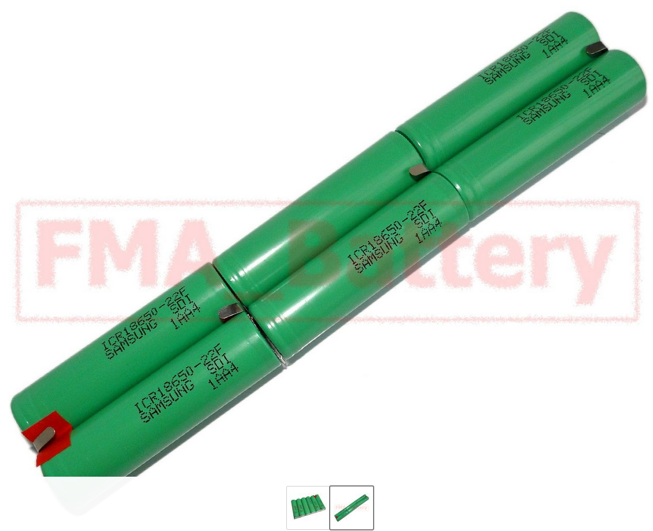
Battery charger
It charges batteries and balances battery charge so that there is no risk that a battery ends up overcharged with the other batteries undercharged. It protects the batteries from overcharge, overcurrent and short circuit.
http://www.ebay.com/itm/Balance-BMS-Protected-Module-PCM-3S-4A-11-1V-Li-ion-Li-Po-Battery-3S4W007-/221791091395?hash=item33a3c77ac3
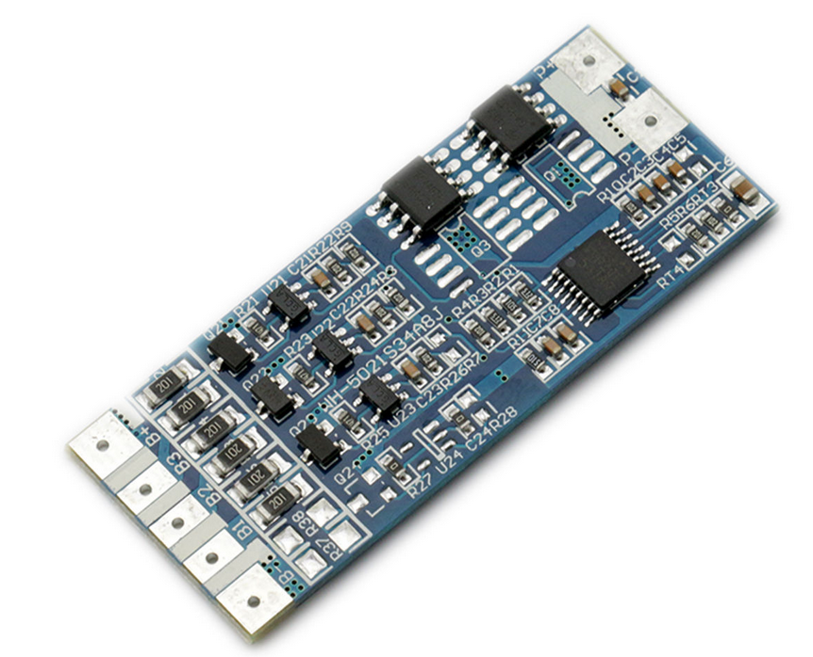
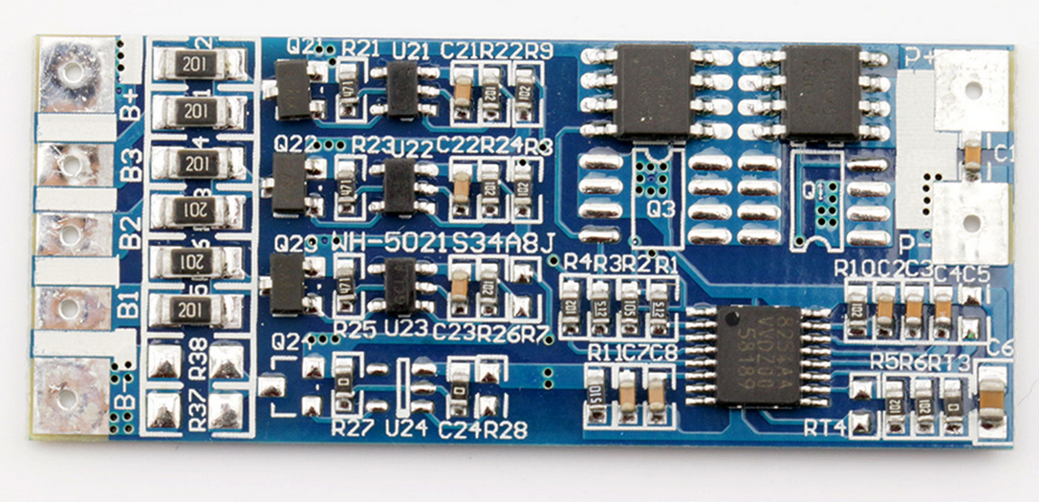

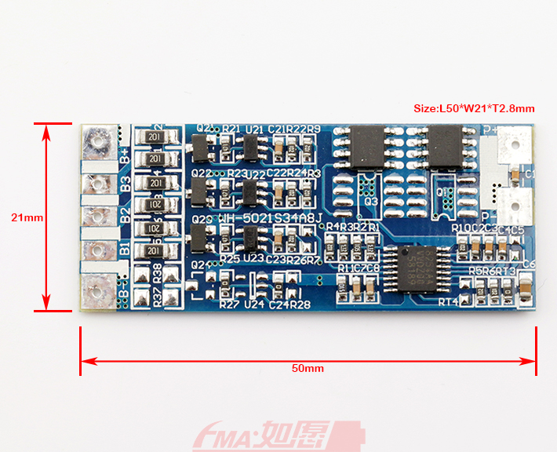
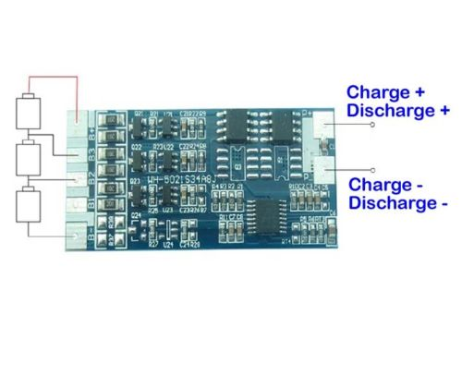

No | Test Item |  | Criterion
1 | Voltage | Charging voltage | DC:13.5-15V CC/CV
1 | Voltage | Balance voltage for single cell | 4.2V
2 | Current | Balance current for single cell | 42mA
2 | Current | Current consumption | ≤15μA
2 | Current | Maximal continuous charging current | N/A
2 | Current | Maximal continuous Discharging current | 4.5A
3 | Over charge Protection | Over charge detection voltage | 4.350±0.025V
3 | Over charge Protection | Over charge detection delay time | 1S
3 | Over charge Protection | Over charge release voltage | 4.15±0.05V
4 | Over discharge protection | Over discharge detection voltage | 2.7±0.08V
4 | Over discharge protection | Over discharge detection delay time | 100mS
4 | Over discharge protection | Over discharge release voltage | 3.0±0.1V
5 | Over current protection | Over current detection voltage | 200±25mV
5 | Over current protection | Over current detection current | 17±3A
5 | Over current protection | Detection delay time | 10ms
5 | Over current protection | Release condition | Cut load
6 | Short Circuit protection | Detection condition | Exterior short circuit
6 | Short Circuit protection | Detection delay time | ≤600us
6 | Short Circuit protection | Release condition | Cut load
7 | Resistance | Protection circuitry（MOSFET） | ≤15mΩ
8 | Temperature | Operating Temperature Range | -40～+85℃
8 | Temperature | Storage Temperature Range | -40～+125℃

Test results
FIXME I'll have to say how it goes

