Components:

^{DC socket}
Got from Maplin.
http://www.maplin.co.uk/p/21-x-55mm-dc-socket-plastic-ft96e
This is needed to plug the DC PSU in. See ComponentsPSU.odt
2.1 x 5.5mm DC Socket Plastic
A plastic-bodied 2.1mm DC power socket with break contact. Suits 2.1 X 5.5mm DC plugs. Fixing centres: 15.5mm, hole diameter: 2.5mm.

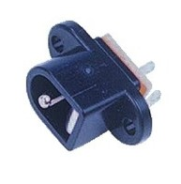

It's interesting that there are three pins in this DC socket.
You may expect two pins only: positive and negative.
The third one tells you if the power supply is plugged in the socket or not.
In this way you can create circuits that work differently when the power supply is plugged in.

Testing results
It works.

