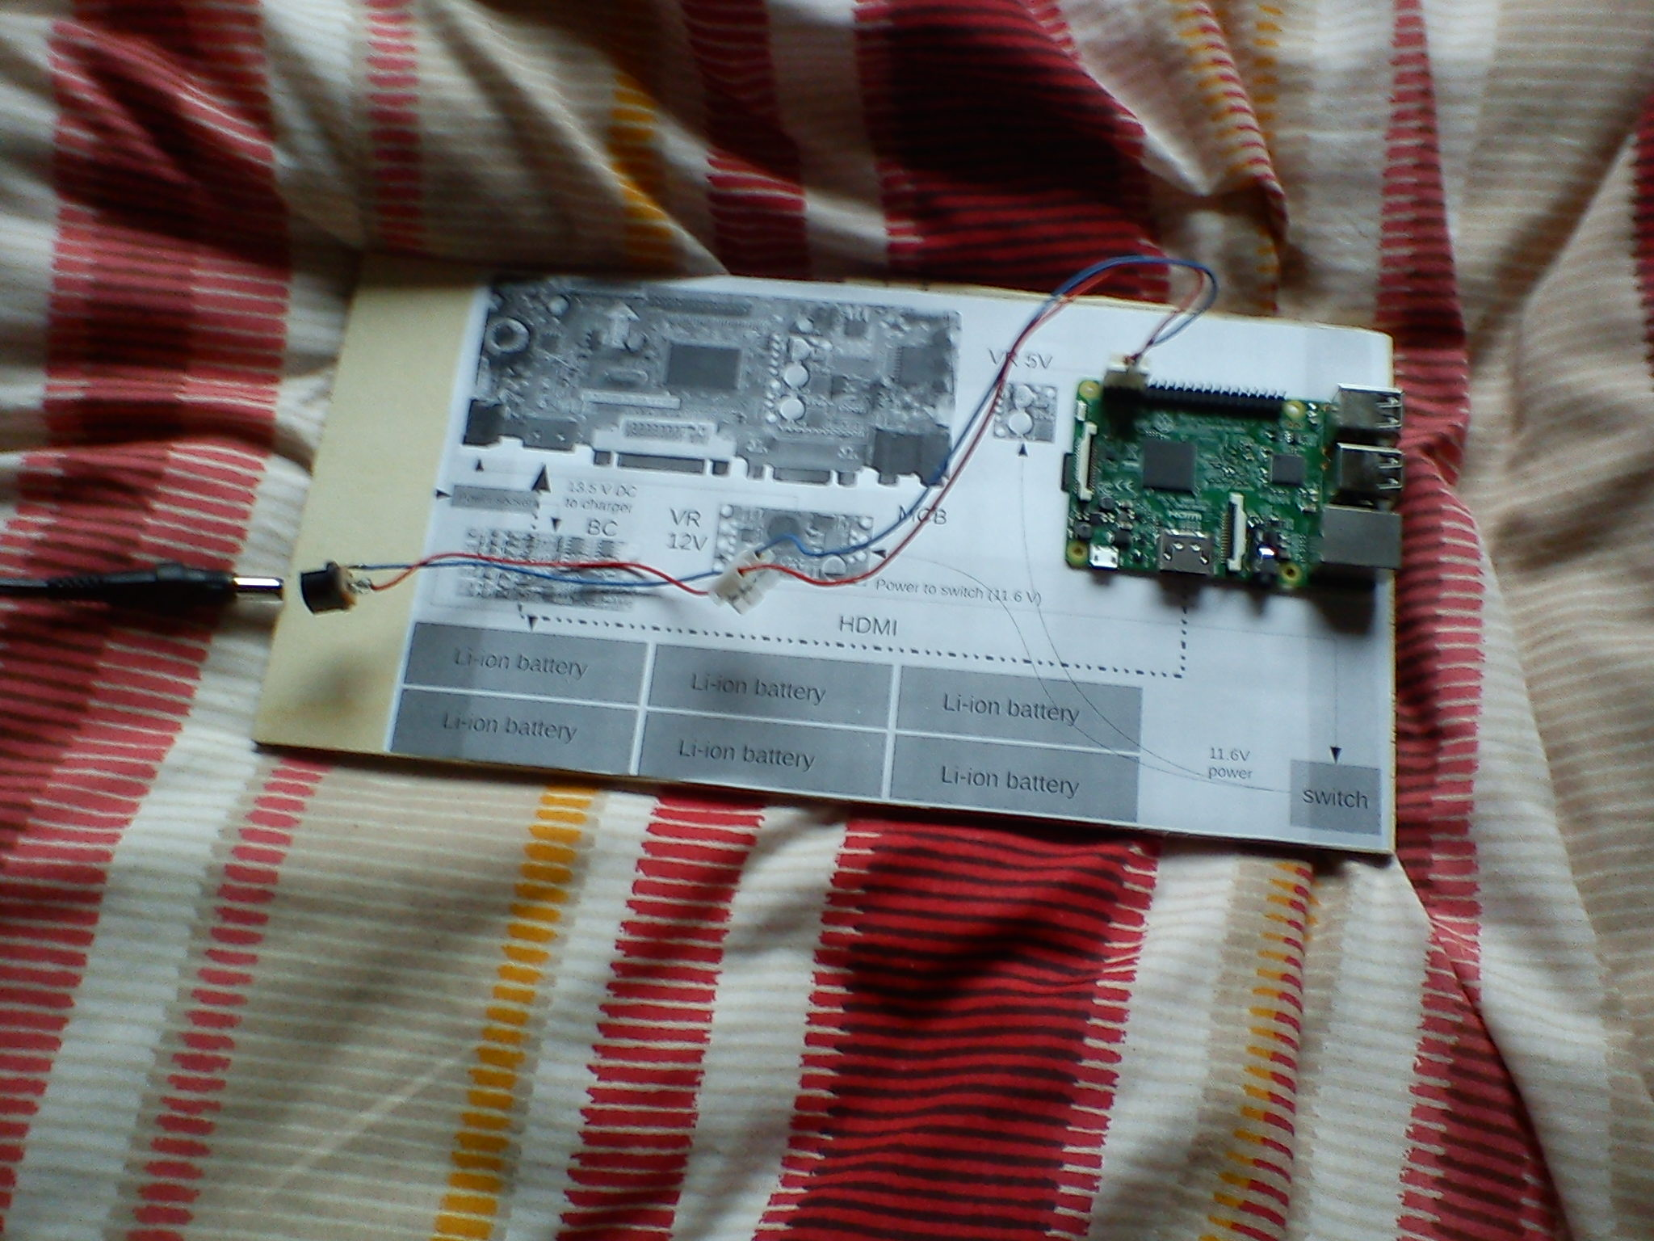
On the left you see the power supply. I set it to 5V and I used it to power Raspberry Pi.

An USB voltage is needed, which is 5V with a maximum of 5.25V and a minimum of 4.75V. The minimum voltage is 4.75V instead of 4.40V because Raspberry Pi operates at full load (500 mA and more).

The power supply was giving 5.21V with no load and 5.15V when powering Raspberry Pi. So, no voltage problems.

It worked perfectly.

I soldered the DC socket to the wires.
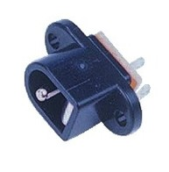

In an another test I measured that Raspberry Pi consumes 0.8 A max when CPU is 100%.

