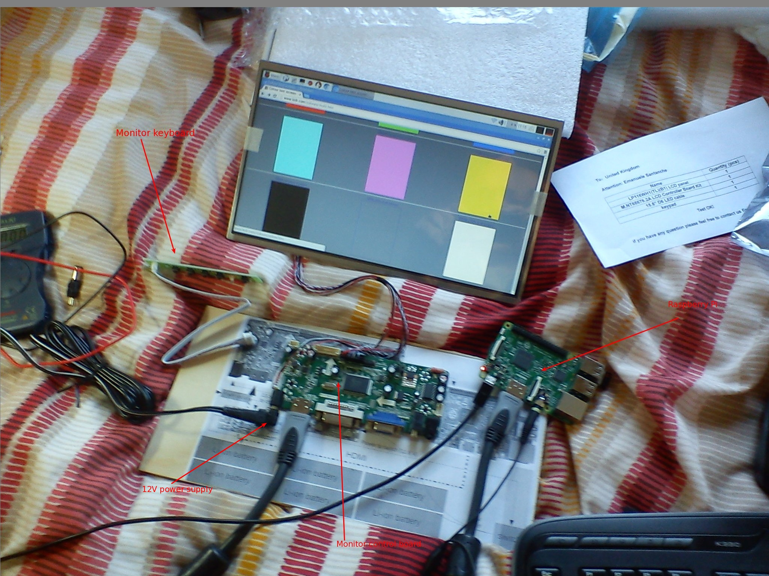

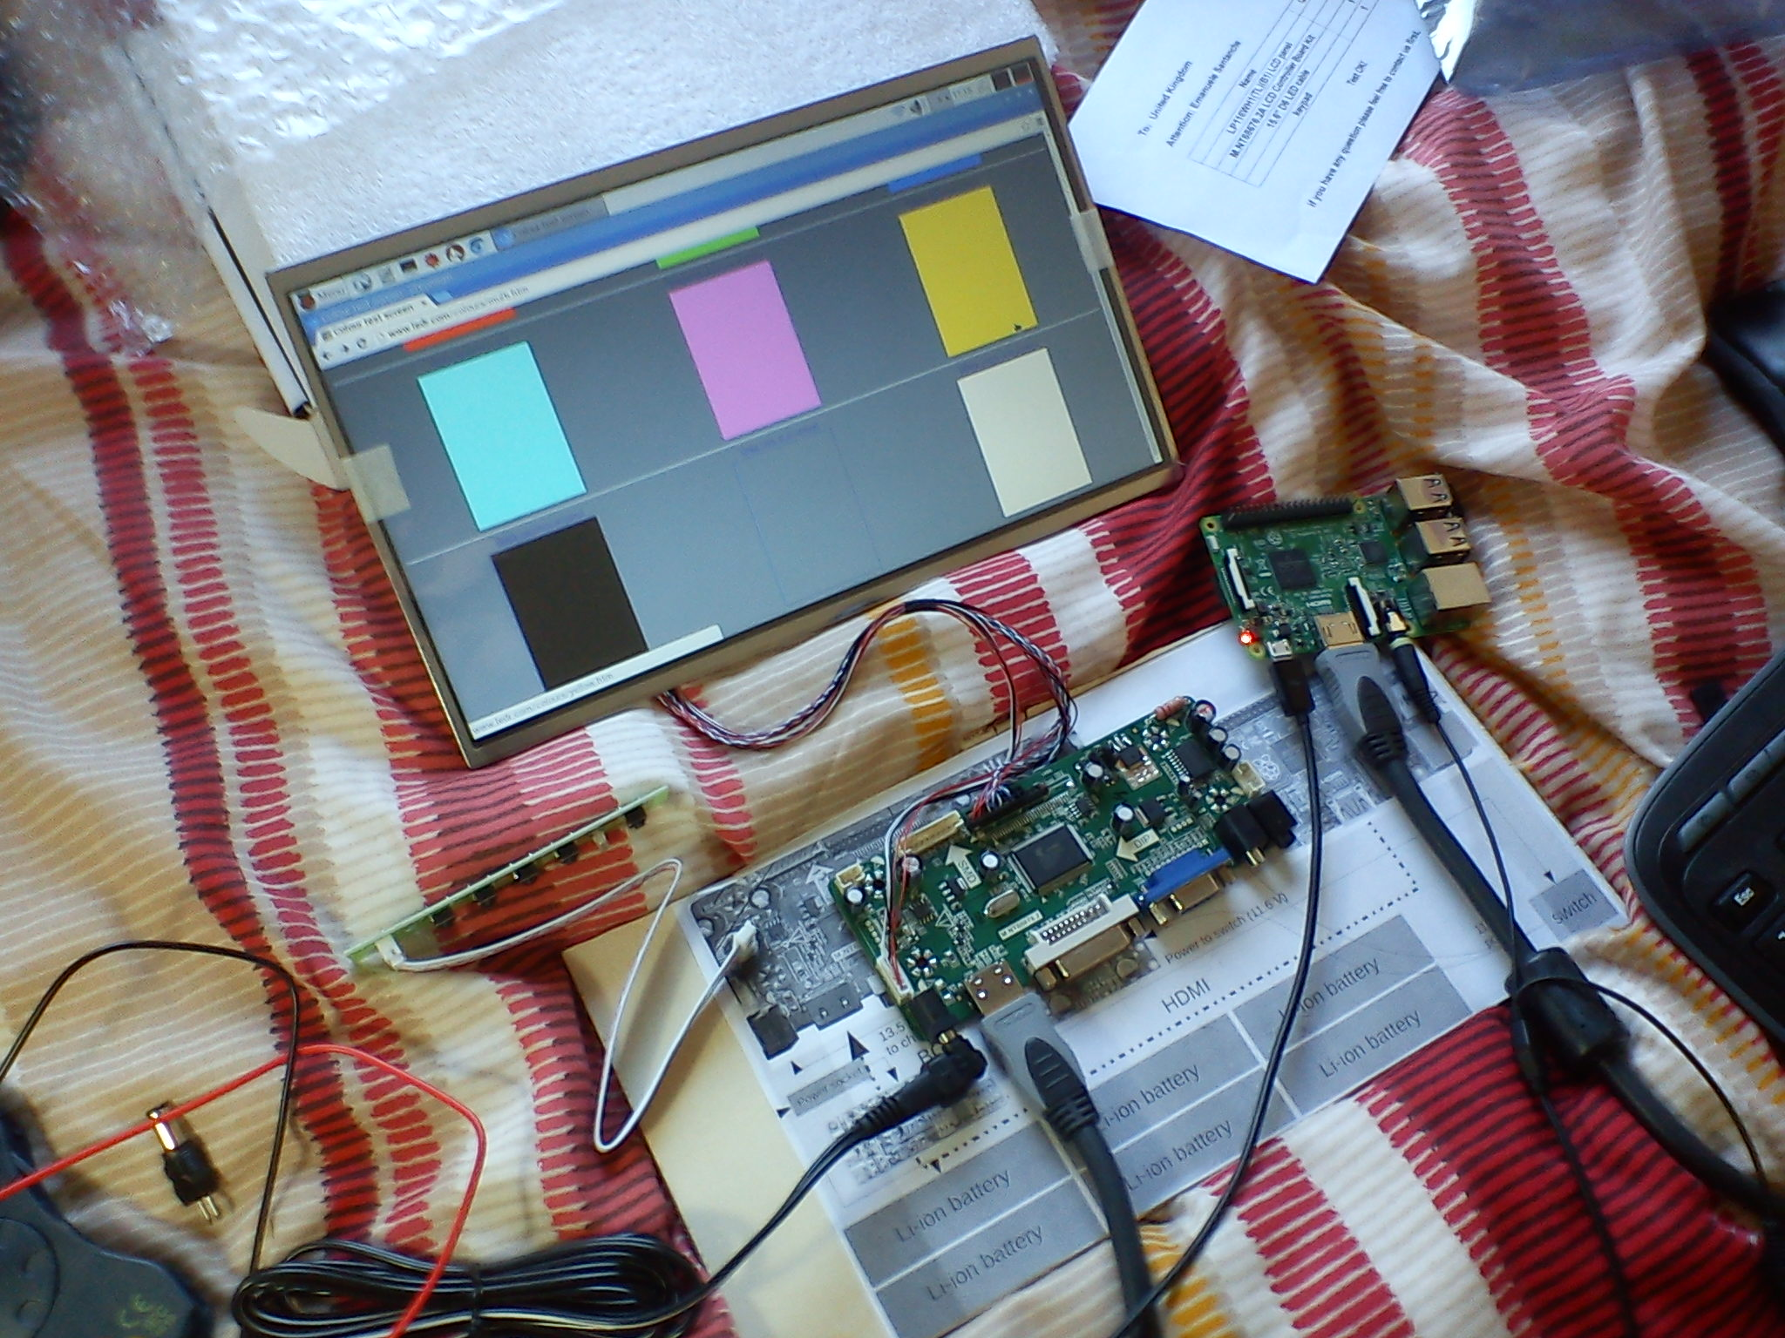
I got the monitor and its control board. I was testing them.

I almost fried the control board because the power supply socket has no indication of polarity.

Is the inner pin the positive pole or it's the negative?

In this case the inner pin is the positive pole.

I plugged the PSU (see ComponentsPSU.odt) the wrong way and its blue light begun to blink. There was some smoke smell as well.

I unplugged the PSU immediately and everything was fine with the opposite polarity.
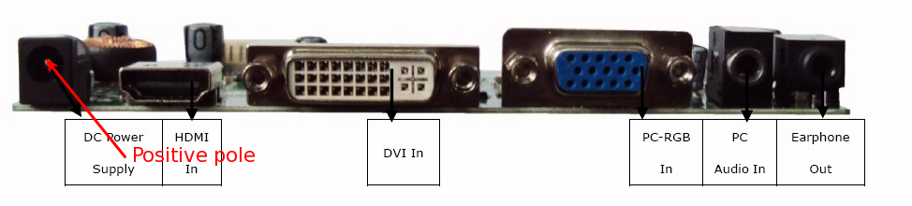
I had some problems when I tested the key board. I mean that small board on the left labelled “Monitor keyboard”. Anyway, I'm not going to use it at all, so there is no need to describe the problem.

It was just a matter of checking pin labels and match them.

If you want to use the monitor keyboard, consider that the monitor menu is in oriental language. Or maybe I could have changed the language, I don't know. I wasn't interested, so I didn't investigate more.

Before starting the test, I measured the PSU voltage, which I set to 12V (The PSU has many possible voltages to set)

It was 12.28V which is reasonably near 12V.

