Components:

^{Plywood box}

6.4 mm and 3.2 mm plywood
Initially I wanted to use 6.4 mm and 3.2 mm plywood.
This is the product I wanted to use:
http://modelshop.co.uk/Shop/Raw-Materials/Wood-Sheet/Item/Plywood-304-304mm/ITM3996
I got a single 6.4 mm sheet just to mount components on and test them.
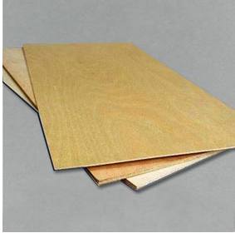

The problem is that this plywood is not suitable for laser cutting.

Laser quality plywood
So I used laser quality plywood.
This is the product:
http://modelshop.co.uk/Shop/Raw-Materials/Wood-Sheet/Plywood/Item/Plywood-800-450mm/ITM4013

Drawings
Drawing filename | Type of file | Description
2d-drawing-to-cut-box-parts-4-mm-plywood-sheet.dxf | LibreCAD | This is the drawing sent to Modelshop.co.uk for them to cut the parts I needed to build the box
2d-drawing-to-cut-box-parts-4-mm-plywood-sheet (red lines).dxf | LibreCAD | This is the same with red lines for another laser cut service I didn't actually use
wandbox-wings3d.wings | Wings3D | 3D model of the box with 6.4 mm and 3.2 mm plywood. I didn't build this box eventually
wandbox-wings3d-4mm-plywood.wings | Wings3D | 3D model of the box I actually built

Other laser cutting services
http://www.cutlasercut.com

