Components:

Small parts

Screws
I need these sizes:
- length 5 mm (this are used for components that are directly screwed to plywood)
- length 8 mm (to mount the raspberry pi; these have to be longer because the raspberry pi needs space underneath, it can't be mounted directly to plywood)
I got these screws from a local modelling shop.
I got 9.5 mm and 6.4 mm ones.
I got as well 8 mm screws needed for 4mm plywood.
I got them here: http://www.ebay.co.uk/itm/272176439778?_trksid=p2057872.m2749.l2649&ssPageName=STRK%3AMEBIDX%3AIT

DC Power Plug
http://www.hobbytronics.co.uk/cables-connectors/misc-connectors/dc-power-plug
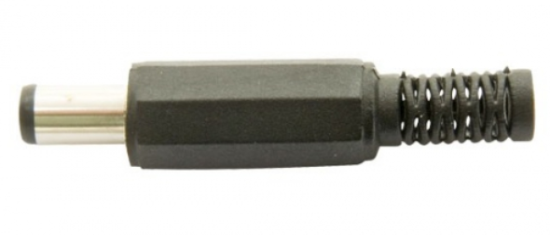
This is to power the monitor control board.

Spacers
I'm going to use these spacers to make space between Raspberry Pi and the plywood box. I'll use them for all other boards.
http://www.hobbytronics.co.uk/hardware/spacers-washers/nylon-round-spacer-4mm

Washers
I used washers for the monitor control board.
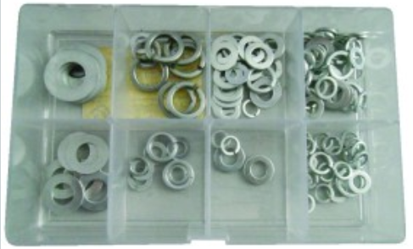

These are metallic washers, but for the monitor control board it's fine.
I had to use them because the monitor control board has quite large mounting holes and my screws are small.
I got these metallic washers from Maplin.

I got more washers, smaller ones, here: http://www.modelfixings.co.uk/washers.htm#Flat washers
These are M2 washers I needed because my screws are small and the washers I already had were too big.
Other examples
- http://www.hobbytronics.co.uk/hardware/spacers-washers/nylon-washer-m25
- http://uk.rs-online.com/web/p/products/0528154/
- http://www.ebay.co.uk/itm/M3-M4-M5-M6-M8-M10-M20-Nylon-Washer-Plastic-Washer-Nylon-Insulation-Soft-Gasket-/171983814762?var=&hash=item6da20af9c4

Cable
It has to be 0.8 or 1 mm of diameter.
I got a 0.6mm one that should be OK anyway because it's rated 4A. I got it from Maplin.
It's a rigid cable that has a single core.

Jumpers
Jumpers 1x2 to power Raspberry Pi via GPIO and to use to connect boards.
http://www.hobbytronics.co.uk/crimp-conn-housing-2
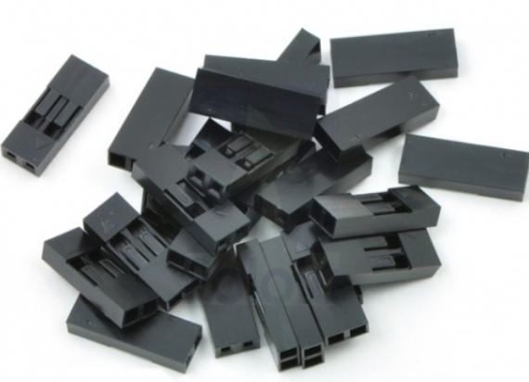

Pins to be inserted in the jumpers above:
http://www.hobbytronics.co.uk/crimp-conn-pins
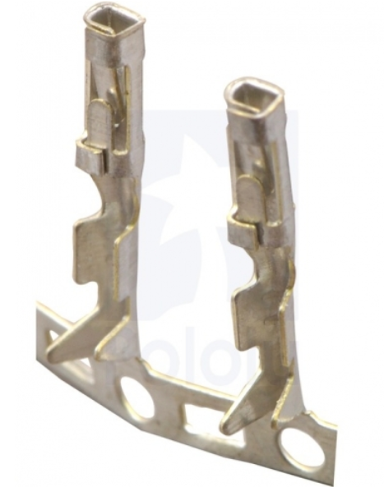

Other products:
- http://uk.rs-online.com/web/p/products/7916450/#
- http://www.maplin.co.uk/p/jumper-wires-raspberry-pi-40-way-ribbon-male-female-tear-off-strips-n75de
- http://www.hobbytronics.co.uk/cables-connectors/crimp-connectors/crimp-conn-housing-22
- http://www.hobbytronics.co.uk/cables-connectors/jumper-wires-mf-6in
Other ideas:
How to make your own jumpers: http://www.basicxandrobotics.com/tutorials/jumpers/
How to make custom connectors: https://www.youtube.com/watch?v=M84VcMeAzzw

Cable tie bases
Now I'm not using these cable ties.
Maplin has them.
Useful to tie small cables.
This is just an example to show what I'm talking about:
http://www.ebay.co.uk/itm/SELF-ADHESIVE-CABLE-TIE-BASE-MOUNTS-STICKY-BACKED-BLACK-WHITE-19mm-25mm-28mm-/181011054666

Crimp terminals
I used crimps only to connect the batteries. To distribute power I used terminals.
I used crimps like these:
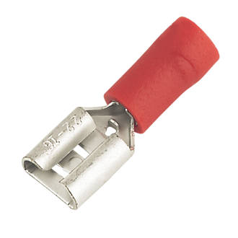

I got some other crimp terminals with the crimper, but I haven't used them.

Eventually I used a lot of terminals to distribute power.
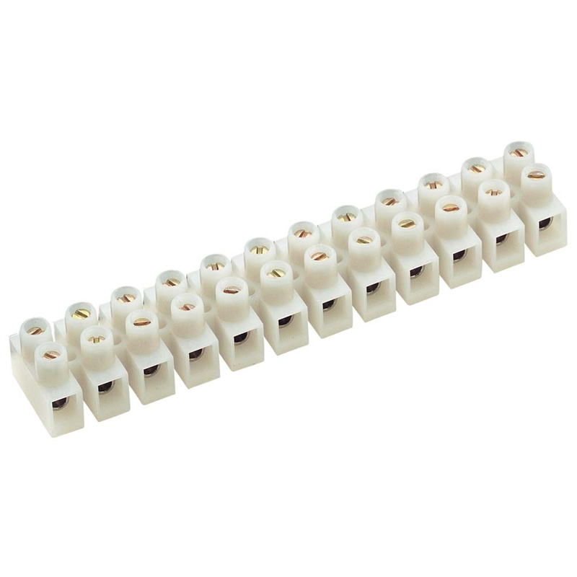Terminals

Fasteners
I'm not going to use these.
These cable ties are used to fasten the batteries:
http://www.cabletiesonline.co.uk/cable-ties-screw-mount/screw-mount-cable-ties-110-x-2-5mm/prod_961.html
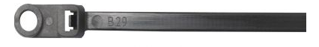

Crocodile clips
I got a couple of crocodile clips from my old stuff.
http://www.hobbytronics.co.uk/crocodile-clips?keyword=clip
Useful information:
How to attach an alligator clip to a wire
https://www.youtube.com/watch?v=DrEzG1gwYOg

Plastic profiles
I used plastic profiles for the box. They allow me to place screws not too near the borders. If I put a screw near a border, it damages the wood.
