I tested the 5V voltage regulator (Components5V_VoltageRegulator.odt), the one that powers the Raspberry Pi from the battery or from the PSU.

You find it in this image:
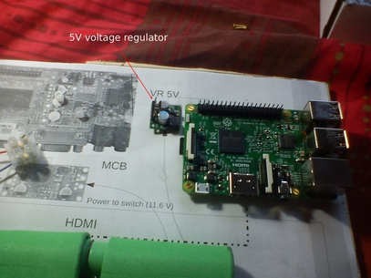

Here you see the 5V voltage regulator and the socket I plug the PSU in.

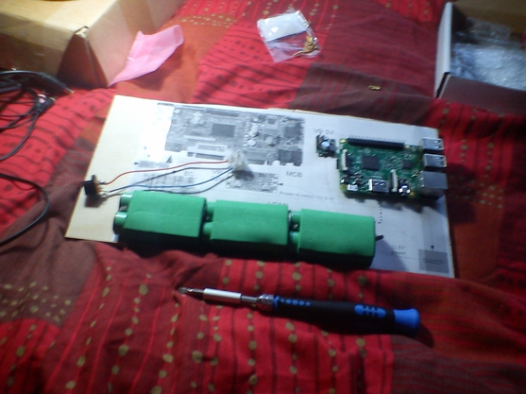

In this photo you see the black connectors that bring the PSU voltage to the regulator and take the regulated 5V that will power the Raspberry Pi.

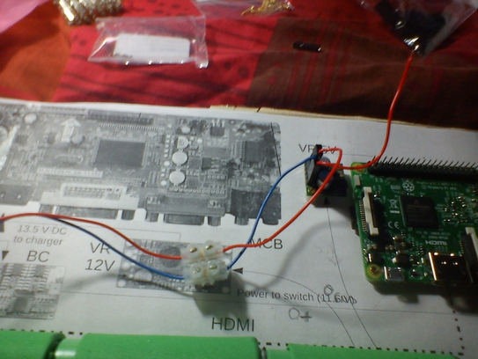
Now the 5V voltage regulator is working and powering the Raspberry Pi.

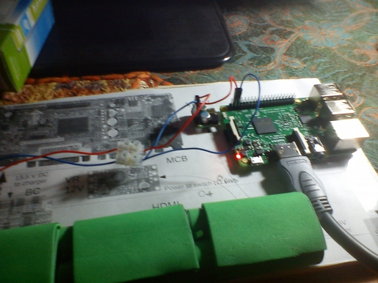

Just another photo of the Raspberry Pi being powered by the 5V voltage regulator.

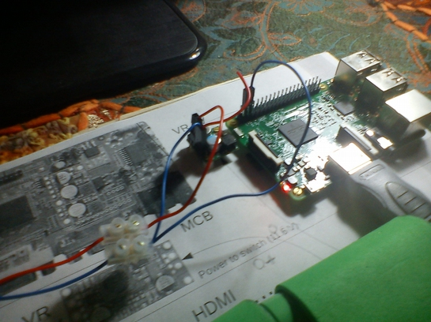

I tried to measure the 5V voltage the Raspberry Pi gets from the regulator from software, but I got only the 1.2V of the core.

I used the command vcgencmd to measure the 1.2V core voltage.

Precisely the command is:

vcgencmd measure_volts

It returns the voltage of the core of the processor, which is 1.2V. Or at least it's expected to be 1.2V.

So, from software, we don't know the actual level of the 5V produced by the regulator, but we know that it's good enough to produce the 1.2V the core needs.

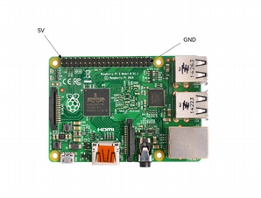
I measured the 5V produced by the regulator by applying my multimeter to a couple of GPIO pins.

Precisely these ones:

I was powering the Raspberry Pi by using the two GPIO pins you see in the images above, the ones that show the regulator, and the 5V and the GND were replicated by the Raspberry Pi on the two pins I used to measure the 5V.

Let's recall the use of the GPIO pins:
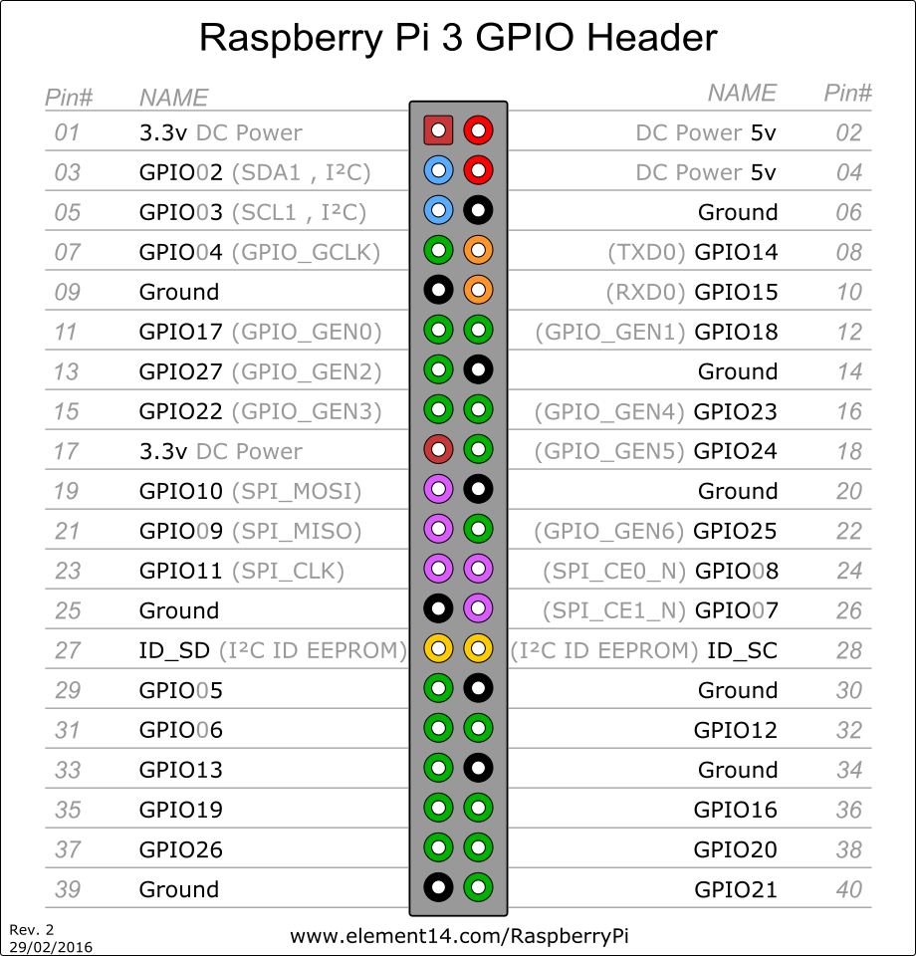

I used pins 04 and 06 to apply 5V and GND coming from the regulator and I used pins 02 and 39 to measure the actual voltage produced by the regulator. Pin 02 has the same voltage as pin 04 and pin 39 has the same voltage as pin 06.

With my multimeter I measured 4.92V and this is a good approximation of 5V. We need at least 4.75V and no more than 5.25V. So, 4.92V is fine.

The Raspberry Pi worked with no problem.

If you want, you can power the Raspberry Pi by connecting the 5V voltage regulator to pins 02 and 06 or 02 and 39 or 04 and 14. Any 5V and any Ground will do.

The voltage regulator needs three connections:

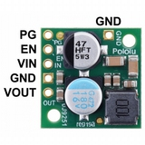

VIN, GND and VOUT. GND goes to ground. Ground means the negative pole of the batteries changer or the one of the external 12V PSU. VIN is the voltage from the batteries charger or from the PSU. VOUT is the 5V output that goes to the Raspberry Pi.

