Testing the power switch

Now I'm testing the power switch. It's the switch that powers Raspberry Pi and monitor from batteries and PSU.

You see it below.

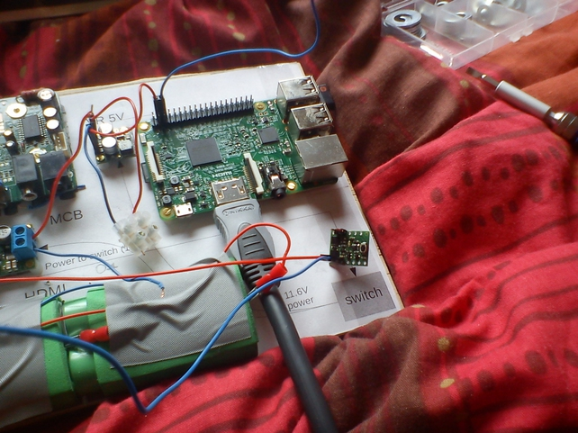

This is a zoom of the power switch and the red arrow points to the button you push to send power to Raspberry Pi and monitor.

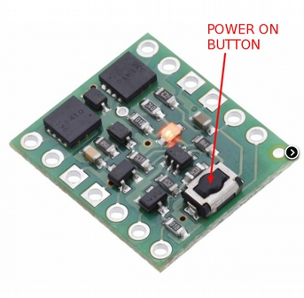

Still working on the power switch here:

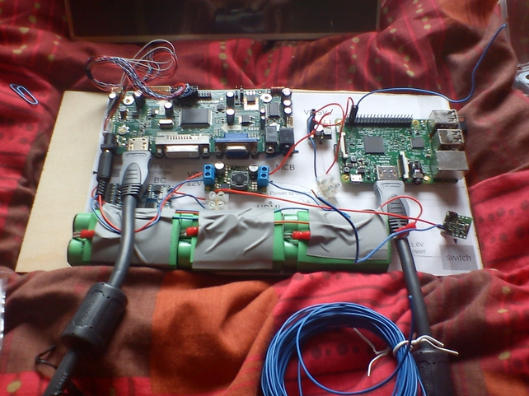
Now the power switch is connected to the batteries (or to the PSU if in use) and to Raspberry Pi and monitor:

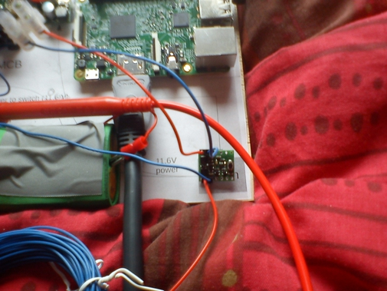
When testing the power switch I took advantage to measure the current Raspberry Pi and monitor use.

They typically use 0.8A.

With monitor off and Raspberry Pi idle, the current is 0.17A.

The power switch needs the pins the arrows point at connected.

On the left side you apply positive and negative poles from batteries (or PSU if used). On the right side you take the output positive and negative poles that give power to Raspberry Pi and monitor.

Of course power flows only if you push the button, and if you push it again power stops flowing. Do the latter only after you shut Raspberry Pi down.

