Raspberry's CPU was getting hot. When playing Youtube videos with Chromium browser, the cpu reaches temperatures as high as 80-85 °C.

I added a heat-sink, but cpu's temperature still is high.

Anyway, I'm not going to use this laptop so much for videos and, if I play videos, I'll use Firefox or “Web” (the browser you find pre-installed), which consume much less cpu.

Over-Temperature Warning Icon
In this article you can see the icon that warns that cpu temperature is too high.

https://retroresolution.com/2016/03/24/overclocking-the-raspberry-pi-3-pragmatism-and-optimising-for-single-vs-multicore-performance/

I get this icon displayed when I play videos on Chromium.

Heat-sinks don't make much difference
It's shown on this video: https://www.youtube.com/watch?v=e6okZKRwnTQ

You need a fan. A fan does make a difference: https://www.youtube.com/watch?v=5Ud-grj4Zl0

I may add a fan later.

Adding the heat-sinks

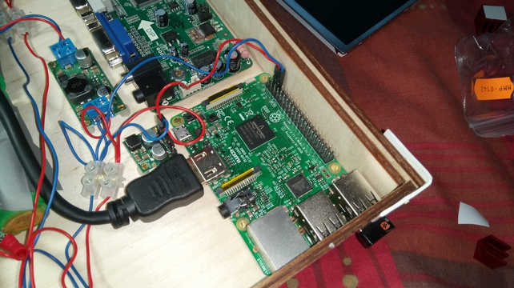





You can see here the panel applet that shows cpu temperature, 53 °C, which, to be Raspberry's cpu, it's very low.
