Components:

5V Voltage regulator

This voltage regulator is for the Raspberry Pi.

FIXME still researching

this looks good:
http://www.hobbytronics.co.uk/electronic-components/voltage-regulators/voltage-regulator-5v/d24v22f5-5v-step-down-regulator
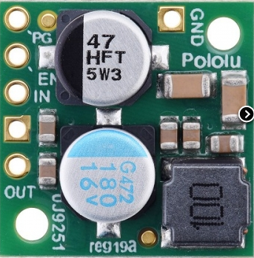

http://www.dx.com/p/hobbywing-5v-6v-3a-switch-mode-ultimate-bec-ubec-15149#.VuCzLeinxJ8
http://www.dx.com/p/8s-5a-switch-mode-ultimate-bec-ubec-45214#.VuFjIjp6elN

This should be OK as 5V voltage regulator: http://uk.rs-online.com/web/p/products/0633026/

