Components:

12V Voltage regulator
This voltage regulator is for the monitor.
I'm using this one:
http://www.hobbytronics.co.uk/s18v20f12-12v-regulator

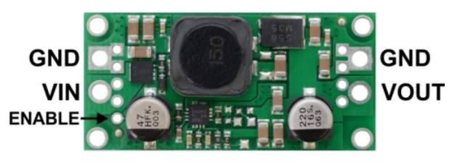
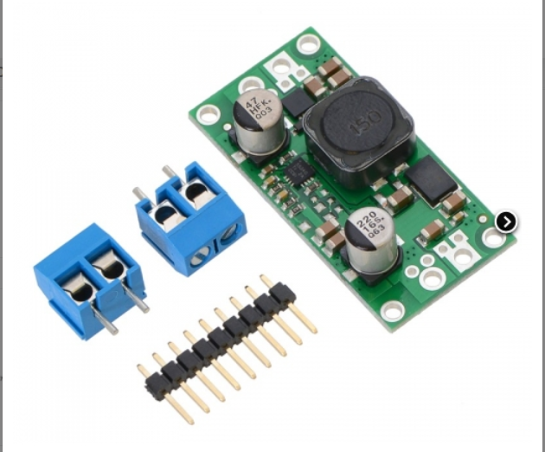

How I used it
I just soldered the blue terminals you see above to the pins GND, VIN and VOUT. VIN has to be connected to the positive pole of the batteries charger or of the PSU. VOUT goes to the monitor. The GND pin on the input side has to be connected to the negative pole of the batteries charger or of the PSU. The GND pin on the output side goes to the monitor. No need to use the ENABLE pin.

12V Step-Up/Step-Down Voltage Regulator S18V20F12
This powerful step-up/step-down regulator efficiently produces a fixed 12 V output from input voltages between 3 V and 30 V while allowing a typical output current of up to 2 A when the input voltage is close to the output voltage and offering typical efficiencies of 80% to 90%. Its ability to convert both higher and lower input voltages makes it useful for applications where the power supply voltage can vary greatly, as with batteries that start above but discharge below the regulated voltage.
The flexibility in input voltage offered by these regulators is especially well-suited for battery-powered applications in which the battery voltage begins above the desired output voltage and drops below the target as the battery discharges.
The no-load quiescent will typically be between 1mA and 5mA for all possible combinations of input and output voltages (e.g. the quiescent current is approximately 4mA with 3V in, 1.5mA with 12V in, and 1mA with 30V in). The ENABLE pin can be used to put the board in a low-power state that reduces the quiescent current to between 10 and 20µA per volt on VIN (e.g. approximately 30µA with 3V in and 500µA with 30V in).
This regulator has built-in reverse-voltage protection, over-current protection, thermal shutdown (which typically activates at 165°C), and an under-voltage lockout that causes the regulator to turn off when the input voltage is below 2.5 V (typical).
Features
- Input voltage: 2.9V to 32V (32 V is the absolute maximum operating voltage; the recommended maximum operating voltage is 30 V, which is the limit of the reverse voltage protection.)
- Fixed 12V output with 4% accuracy
- Typical maximum continuous output current: 2A (when input voltage is close to the output voltage; the Typical Efficiency and Output Current section below shows how the achievable continuous output current depends on input and output voltages)
- Integrated reverse-voltage protection (up to 30V), over-current protection, over-temperature shutoff, and under-voltage lockout
- Typical efficiency of 80% to 90%, depending on input voltage, output voltage, and load
- Four mounting holes for #2 or M2 screws.
- Compact size: 1.7″ × 0.825″ × 0.38″ (43 × 21 × 10 mm)
- Smaller holes for 0.1″ header pins and larger holes for terminal blocks offer several options for connecting to the board.
Connections
This step-up/step-down regulator has four connections: input voltage (VIN), ground (GND), and output voltage (VOUT), and ENABLE.
The input voltage, VIN, should be between 2.9 V and 32 V. Lower input voltages can cause the regulator to shut down or behave erratically; higher input voltages can destroy the regulator, so you should ensure that noise on the input is not excessive. 32 V should be treated as the absolute maximum input voltage. Our recommended maximum operating voltage is 30 V, which is the limit of the reverse voltage protection.
The regulator is enabled by default: a 100 kΩ pull-up resistor on the board connects the ENABLE pin to reverse-protected VIN. The ENABLE pin can be driven low (under 0.7 V) to put the board into a low-power state. The quiescent current draw in this sleep mode is dominated by the current in the pull-up resistor from ENABLE to VIN and by the reverse-voltage protection circuit, which will draw between 10 µA and 20 µA per volt on VIN when ENABLE is held low (e.g. approximately 30 µA with 3 V in and 500 µA with 30 V in). If you do not need this feature, you should leave the ENABLE pin disconnected. Note that the SEPIC topology has an inherent capacitor from input to output; therefore, the output is not completely disconnected from the input even when the regulator is shut down.
Output Current
The maximum achievable output current of the board varies with the input voltage but also depends on other factors, including the ambient temperature, air flow, and heat sinking. The graphs below show output currents at which this voltage regulator’s over-temperature protection typically kicks in after a few seconds. These currents represent the limit of the regulator’s capability and cannot be sustained for long periods, so the continuous currents that the regulator can provide are typically several hundred milliamps lower.

Other ideas
- https://www.coolcomponents.co.uk/adjustable-4-12v-step-up-step-down-voltage-regulator-s18v20alv.html

