Components:

Keyboard
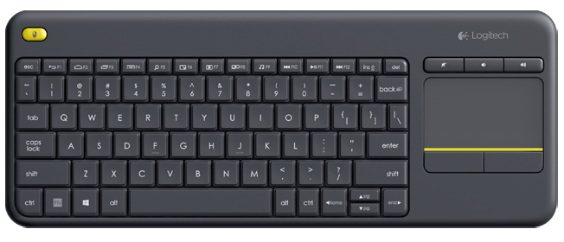
I got a Logitech K400 Wireless.
Eventually I didn't use a bluetooth keyboard because they are more difficult to find and to install in Raspberry Pi.
This one, instead, is plug and play.

