Components:

^{PSU (Power Supply Unit)}
I got this one:
http://www.maplin.co.uk/p/worldwide-36w-acdc-multi-voltage-power-supply-l48bq
With 13.5 V output, the one I need, the PSU supplies 2.4A.
It's fine in my case because the battery has a capacity of 4400 mAh and shouldn't be charged too fast. The maximum current used to charge the battery should be 4.4 A. So, since the PSU provides no more than 2.4 A, it should be OK.
Specifications:
Switched Mode Supply: | Yes
Output Power (Max): | 36W
Regulated Output: | Yes
Output Voltage Type: | Variable
Output Current: | 3.0A (3000mA) Maximum depending on voltage
Input Voltage: | AC 100 - 240V, 50Hz
Input Power Plug: | UK, EU, USA & Australasian
Number of Tips or Sockets: | 8
Output Tips/Socket Type:
2.35 x 0.75 x 8mm | 5 x 2.1 x 12mm
3.5 x 1.35 x 10mm | 5.5 x 2.1 x 12mm
4 x 1.7 x 10mm | 5.5 x 2.5 x 12mm
4.75 x 1.75 x 10mm | 6.3 x 3 x 12mm
Output Voltage: | DC 5, 6, 7.5, 9, 12, 13.5, 15V
Input / Output Power Cord Length | 1.6m / 1.6m
Polarity: | Centre Positive
Reversible Polarity: | Yes

I tested this PSU and it works. See PhotoGallery folder for examples of tests done with the PSU.

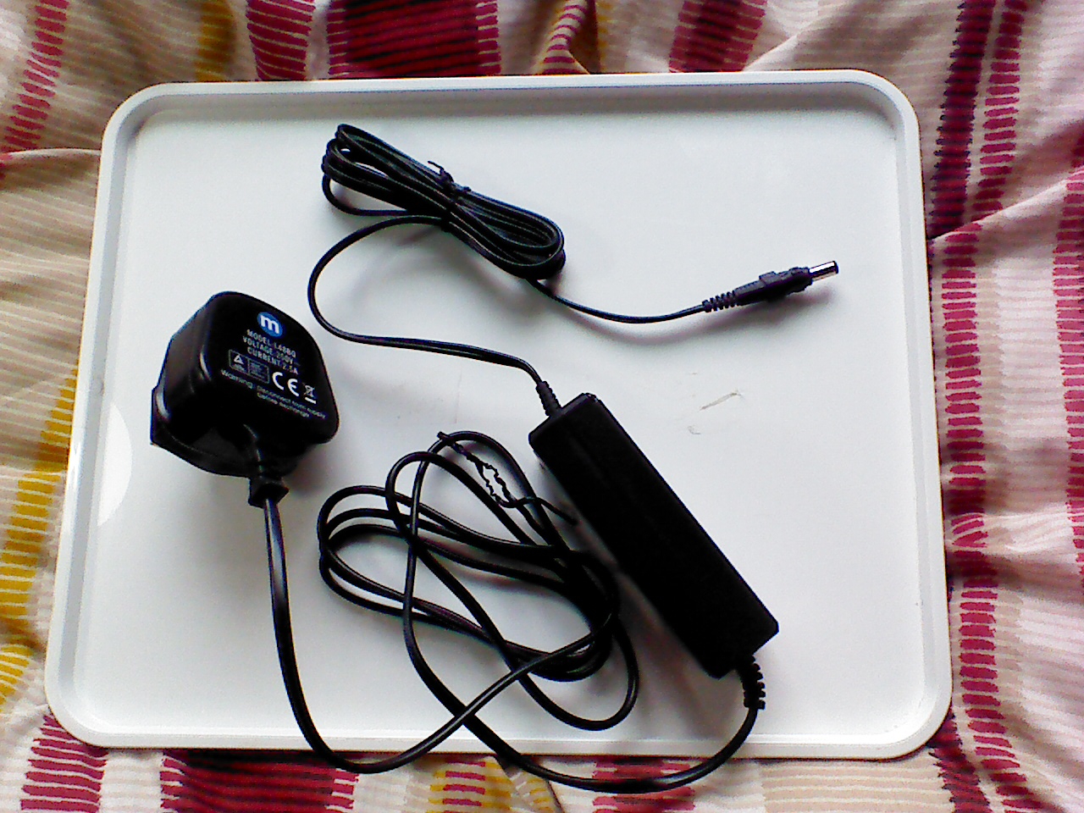
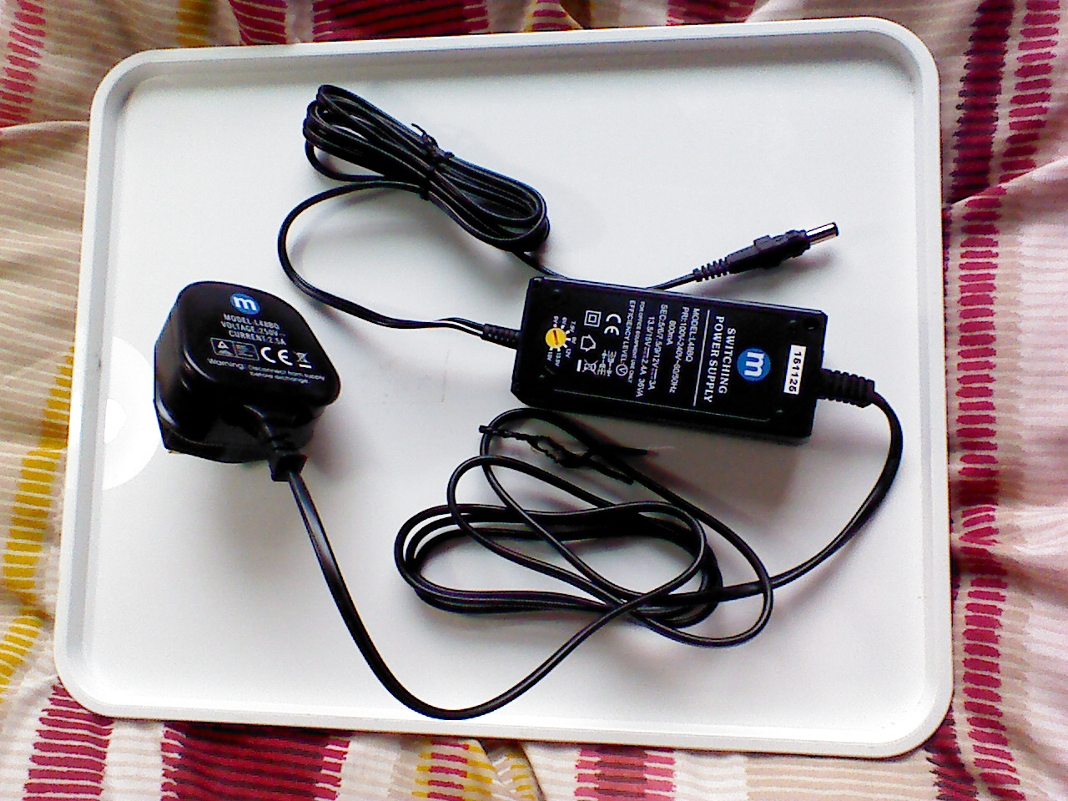

Additional PSU
I got a 12V PSU from an old PC. It supplies 4A. It can't charge the batteries because they reach 12.6V when fully charged, but it has enough power to be used when the Raspberry Pi is on. Instead the PSU above may be not powerful enough to work when the Raspberry Pi is on.

Other ideas
http://www.conrad-electronic.co.uk/ce/en/overview/2110221/Adjustable-External-PSUs?filterOutput+voltage=13%2C5+Vdc

