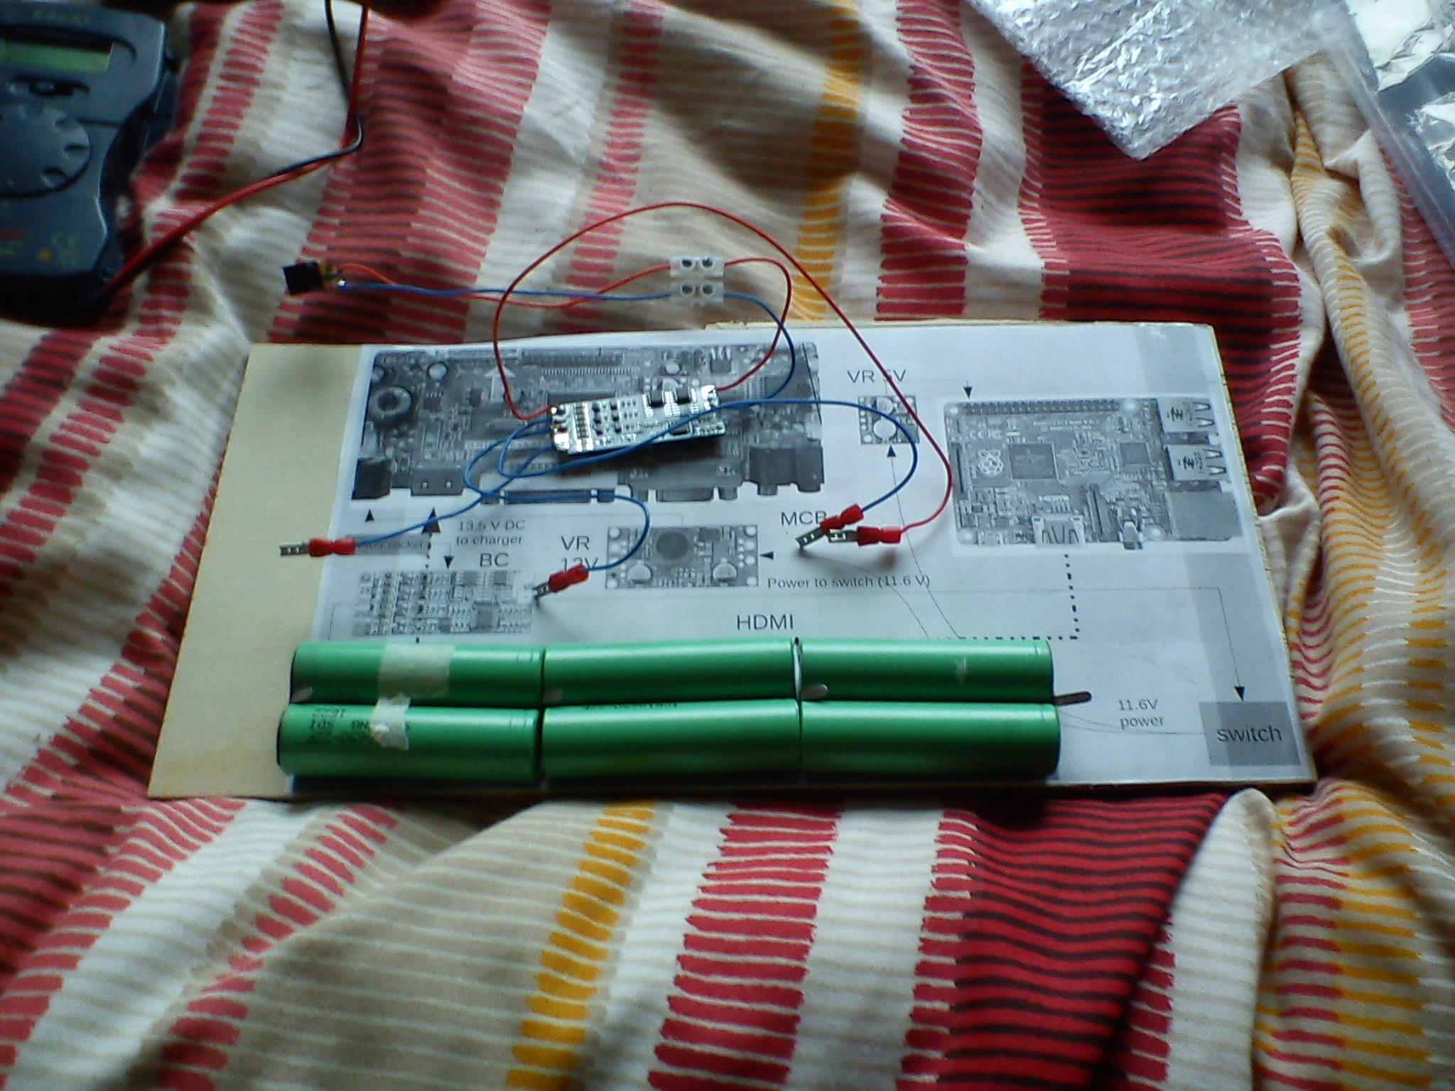
Here I'm testing the circuit that charges the batteries.

I had to make the soldering a couple of times because it wasn't working. One of the crimps that connect the charging circuit to the batteries wasn't making contact as well.

You can see these crimps in the photo above. They have red insulation.

I used the PSU (ComponentsPSU.odt) to charge the batteries through the charger board.
I set the PSU to 12V and I got 2A of current. The current decreased to 1.7A quite soon and kept decreasing. I'm concerned that the PSU may not be enough when it will have to power the Raspberry Pi and the monitor as well.

The good news with using 12V power supply from the PSU is that I won't need the 12V voltage regulator.

The problem is that with 12V power supply the batteries can't be charged fully because they get to 12.6V when changed fully. I need at least 13.5V to charge the batteries up to their full voltage of 12.6V.

