Now it's the turn of the 12V voltage regulator that powers the monitor.

I may use a 12V power supply and in this case no voltage regulator is needed.

But I may use a 13.5V or 15V PSU. And if there is no PSU and the batteries power everything, they produce a voltage that can be as low as 9V and as high as 12.6V.

That's why I need a 12V voltage regulator for the monitor.

The 12V voltage regulator is at the centre of this photo:

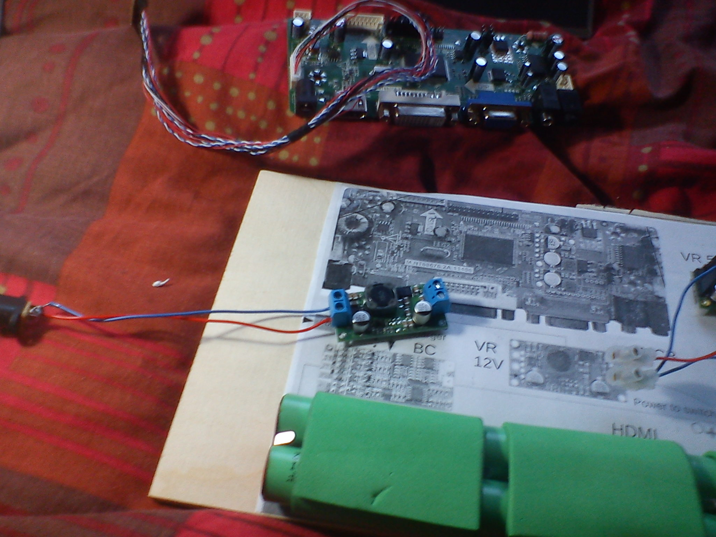

Here you see it soldered and powering the monitor:

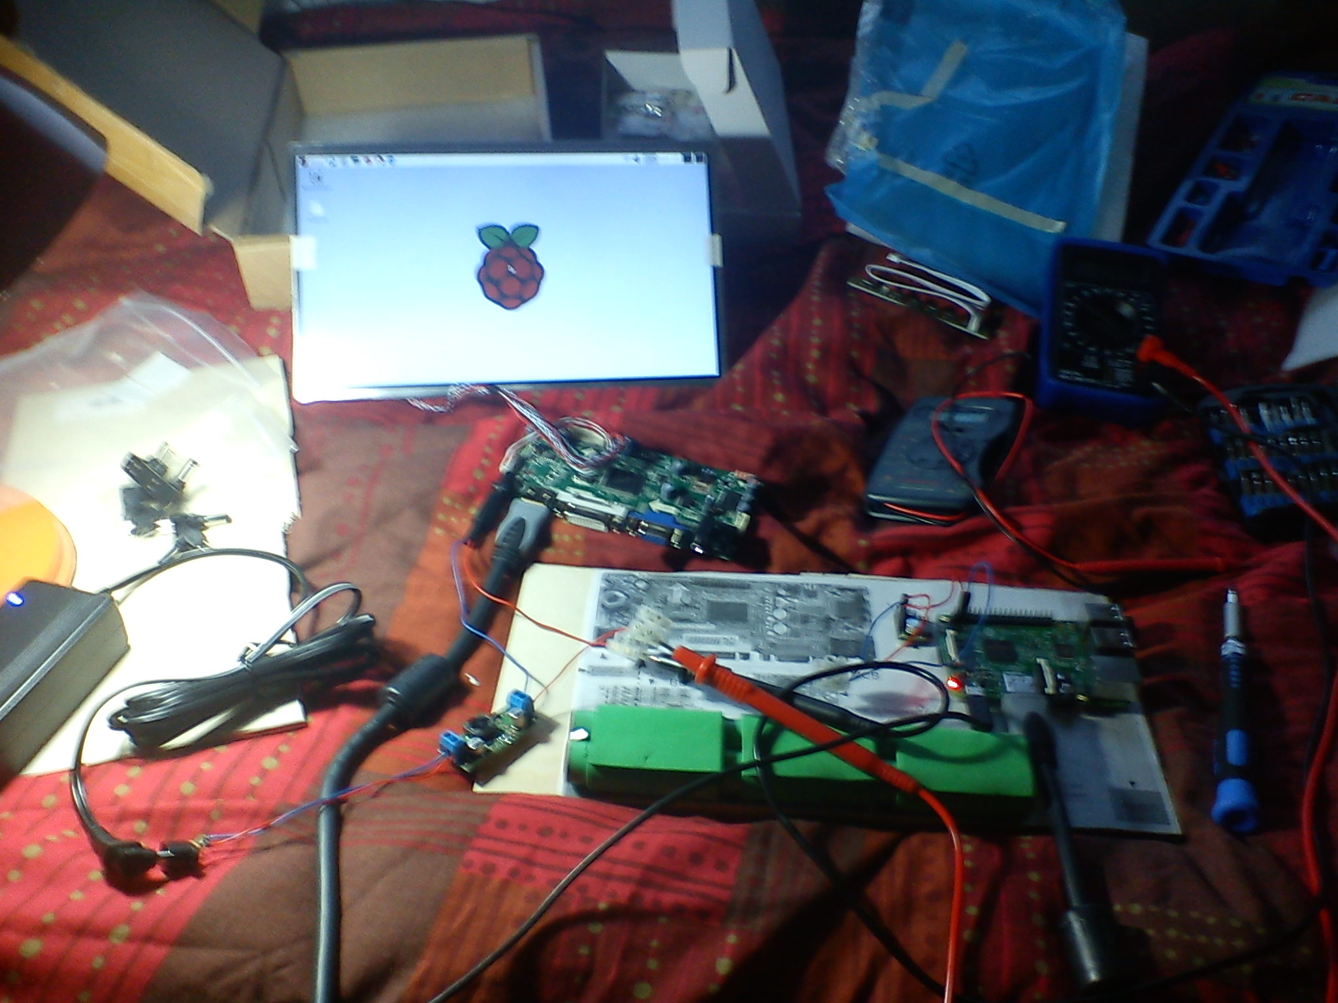

I measured the current consumed by the monitor.

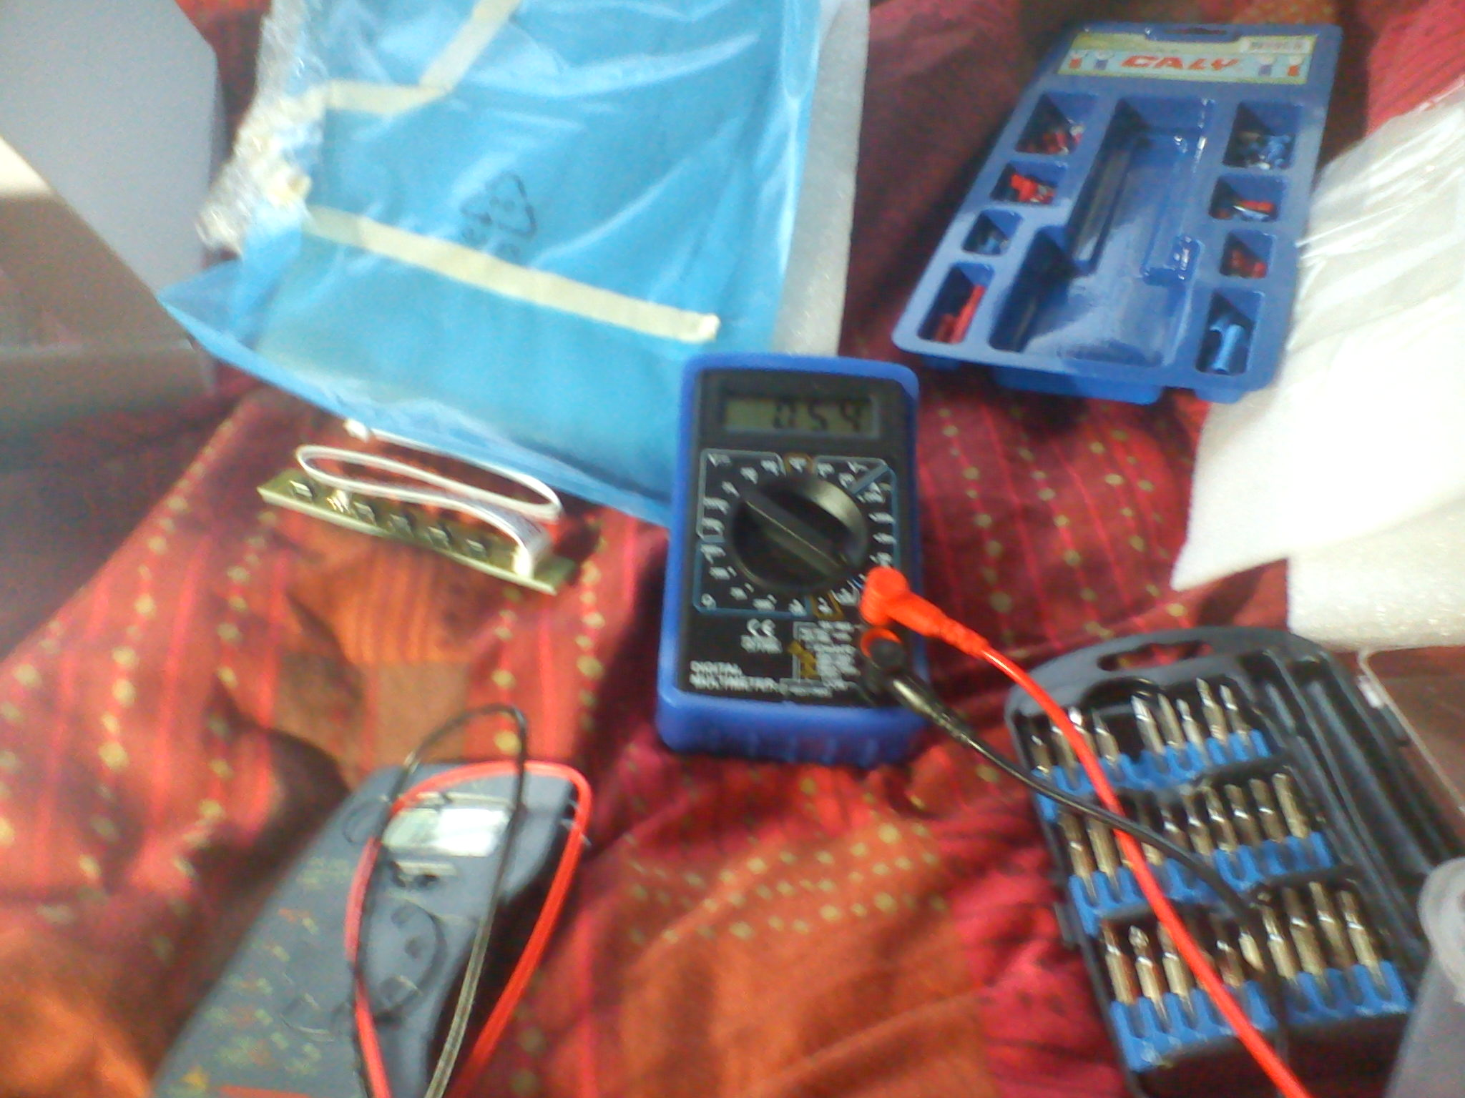

It's 0.52A when the monitor displays a white background. It's 0.58A when the monitor displays a black background.

It may seem strange, but the monitor needs more power when it displays a black image.

So, if we have 12V voltage and 0.6A current, we have 7.2W of power consumed by the monitor.

I also played minecraft and the current was between 0.55A and 0.56A.

I tested the regulator with 12v, 13.5 and 15v input voltage from the PSU.

The regulator outputs 12.03V, which is very precise.

For more information about black images needing more power than white ones: http://electronics.stackexchange.com/questions/30541/lcd-led-panel-power-consumption

