Tools: Coping Saw
I got a coping saw from Wilko.

See http://www.wilko.com/all-hand-tools/wilko-coping-saw-pptpr-blades-5-astd/invt/0344229
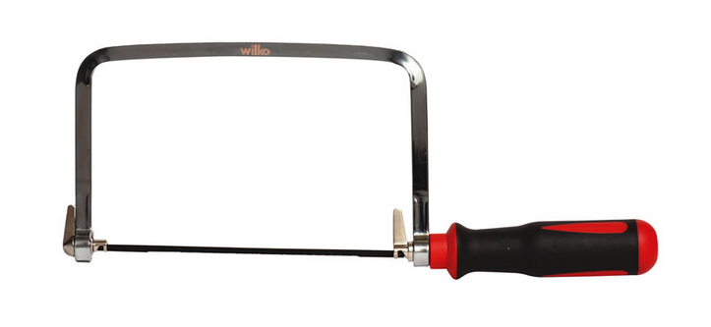
I tried to cut some plywood, then I decided to have it laser-cut.

It's quite a hard job for me to cut plywood manually and results are poor.

Certainly it has to be said that this coping saw is too cheap and a better one could have given better results.

