Tools: Crimper

Got a crimper from Maplin.

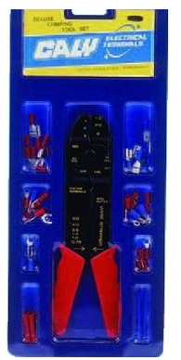

Since my wire has a 0.6 mm diameter and this crimper cuts as small wire as 0.75 mm one, I thought that this crimper wouldn't be good.

Instead it works because 0.6 mm is diameter of the core of the wire.

The wire, when including the insulation, is bigger and the crimper can crimp it.

Just you have to use the crimper diagonally to the wire.

It means that, when crimping the crimper forms a smaller angle than 90º to the wire.

