Lung Cancer Stages Prediction

In this project we are employing Deep Learning Convolution Neural Network algorithm to predict various stages of lung cancer such as Normal, Stage1, Stage2 and Stage3. All existing algorithms were able to predict weather given image is normal or contains cancer cells but no algorithm able to predict stages so we are enhancing CNN algorithm to predict stages.

To train CNN we are using CT SCAN images which contains 4 different types of lung images such as Normal, Stage1, Stage2 and Stage3. Propose CNN algorithm can detect stages with an accuracy between 98 to 100%.

Below screen showing dataset details

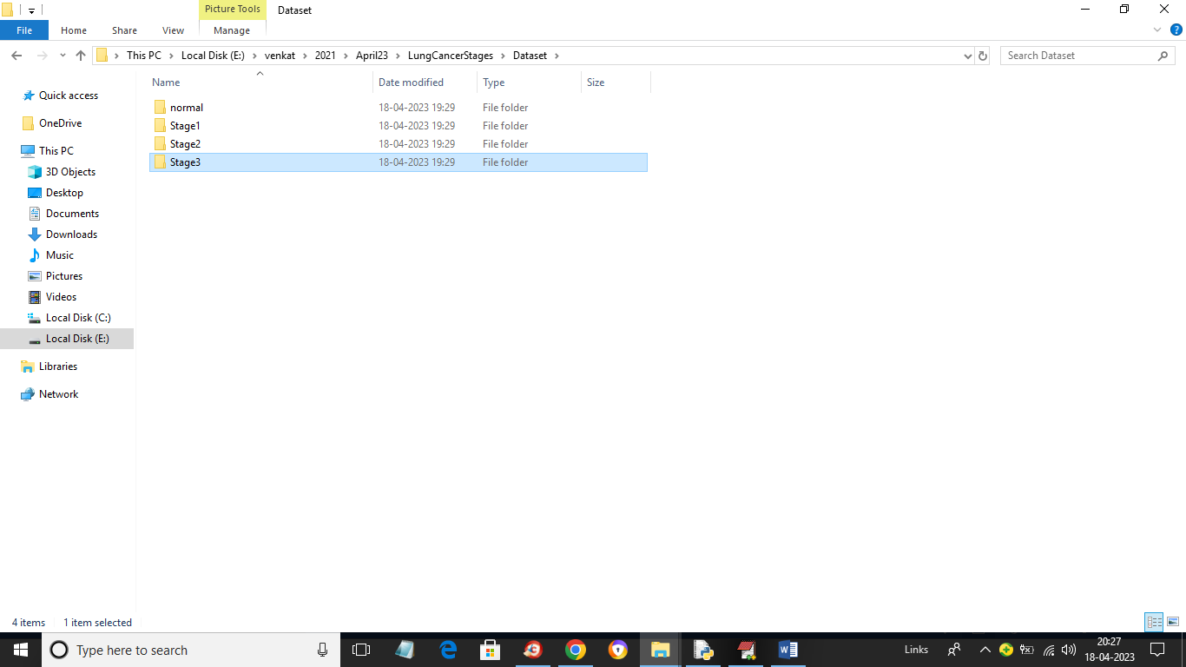

In above screen we have 4 different folders and just go inside any folder to view its images like below screen

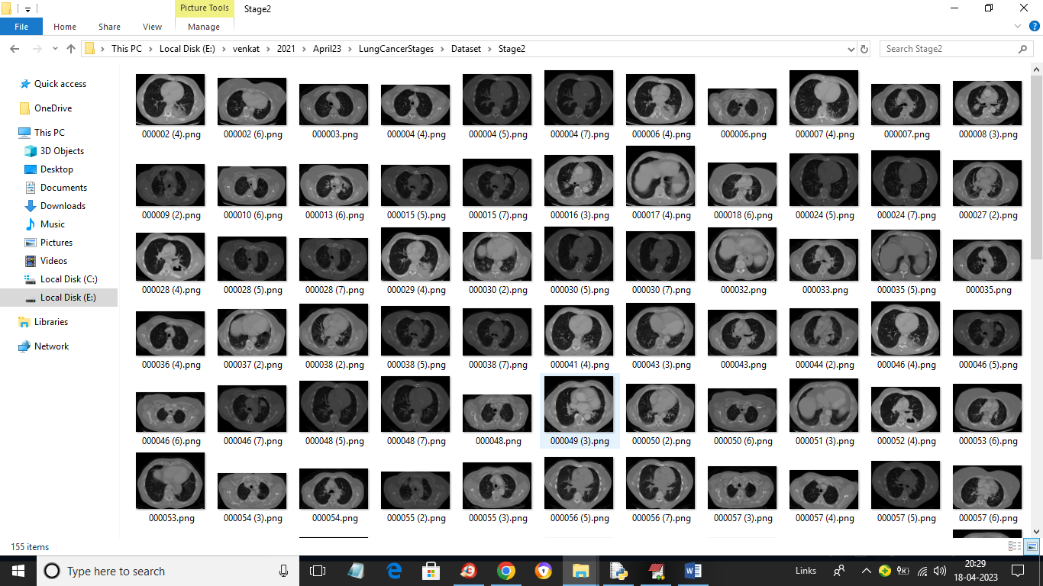

So by using above images we will train CNN and evaluate performance in terms of accuracy and confusion matrix

To implement this project we have designed following modules

1. Upload Lung Cancer Stages Dataset: using this module we will upload dataset to application
2. Preprocess Dataset: using this module we will read images and then normalize, shuffle and resize images
3. Split Dataset Train Test: using this module we will split dataset into train and test application where 80% dataset images will be using for training CNN algorithm and 20% dataset images to calculate prediction accuracy
4. Run CNN Algorithm: using this module we will train CNN algorithm and then calculate its prediction accuracy
5. CNN Training Graph: using this module we will plot CNN training accuracy and loss graph
6. Predict Lung Cancer Stage: using this module we will upload test image and then CNN will predict cancer stages

SCREEN SHOTS

To run project double click on run.bat file to get below screen

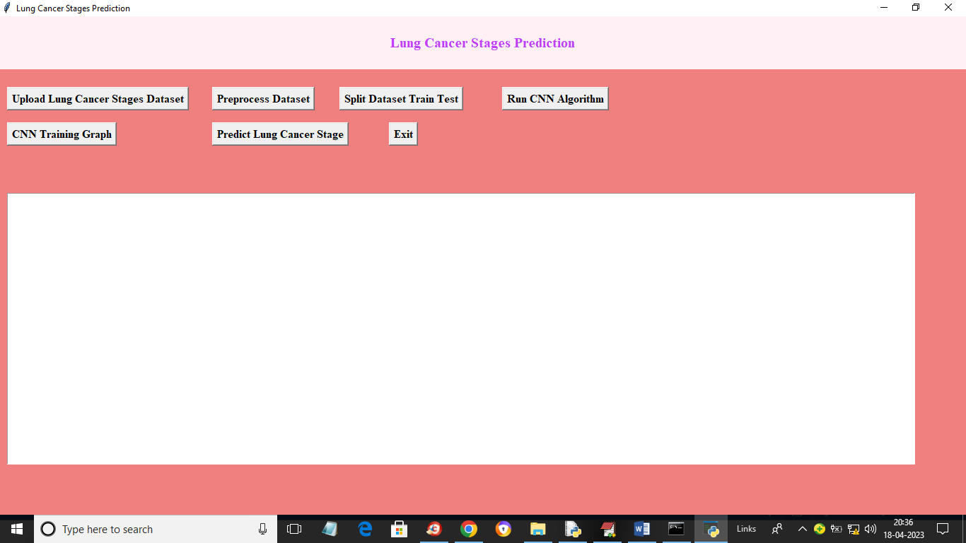

In above screen click on ‘Upload Lung Cancer Stages Dataset’ button to upload dataset to application and get below output

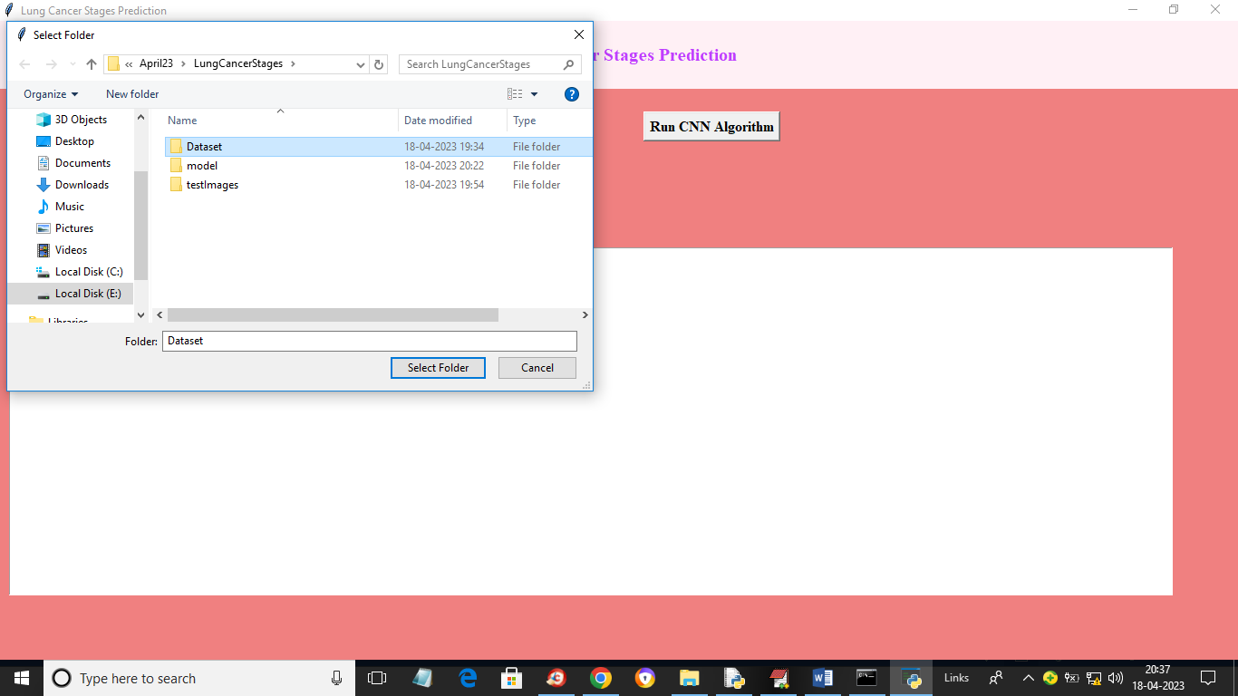

In above screen selecting and uploading dataset folder to application and then click on ‘Select Folder’ button to load dataset and get below output

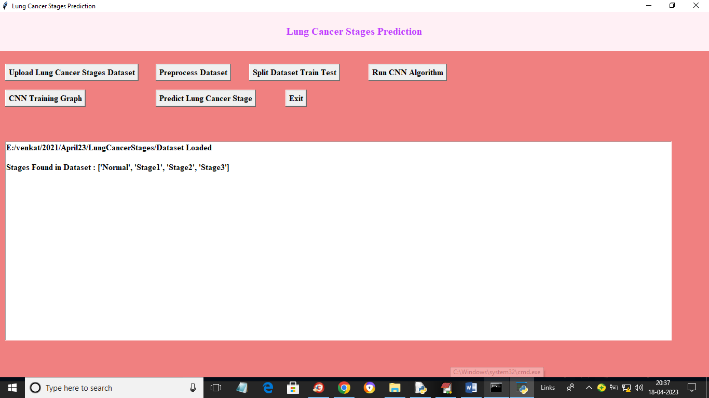

In above screen dataset loaded and displaying stages found in dataset and now click on ‘Preprocess Dataset’ button to normalize, shuffle and resize images and get below output

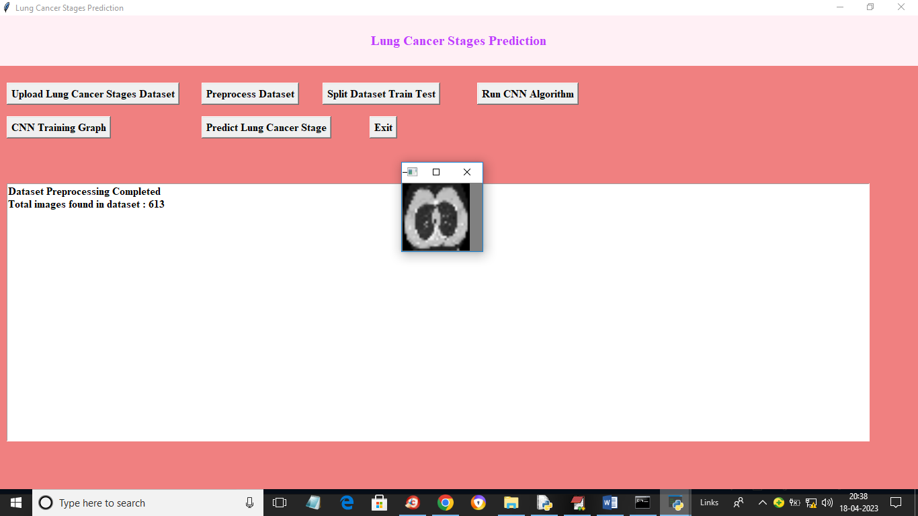

In above screen dataset contains 613 images and we can see processed images and now click on ‘Split Dataset Train Test’ button to split dataset into train and test and get below output

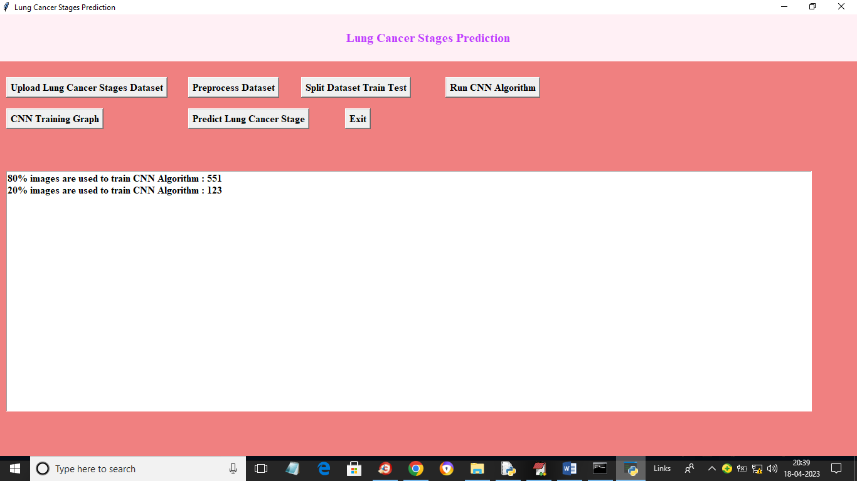

In above screen application using 80% (551) images for training and 20% (123) images for testing. Now click on ‘Run CNN Algorithm’ button to train CNN and get below output

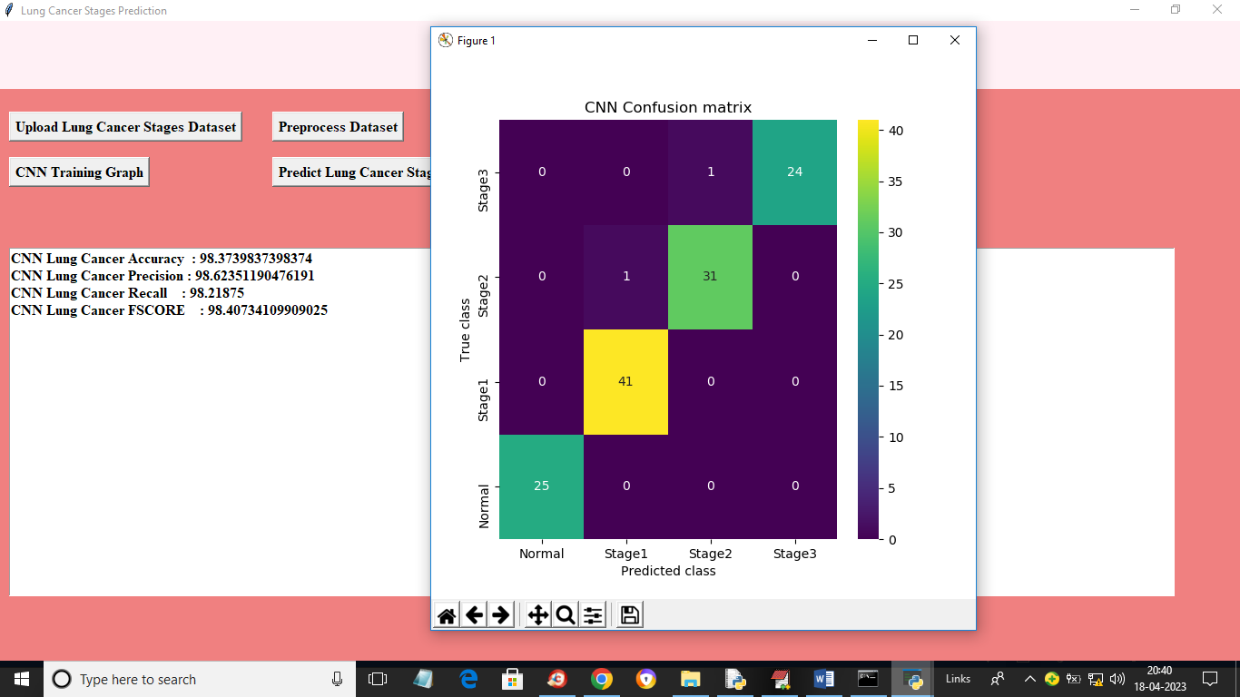

In above screen with CNN we go 98% accuracy and we can see other metrics such as precision, recall and FSCORE. In above confusion matrix graph x-axis represents Predicted Labels and y-axis represents True Labels. All different colour boxes represents correct prediction count and all blue boxes contains incorrect prediction count which is only 2. Now close above graph and then click on ‘CNN Training Graph’ button to get below graph

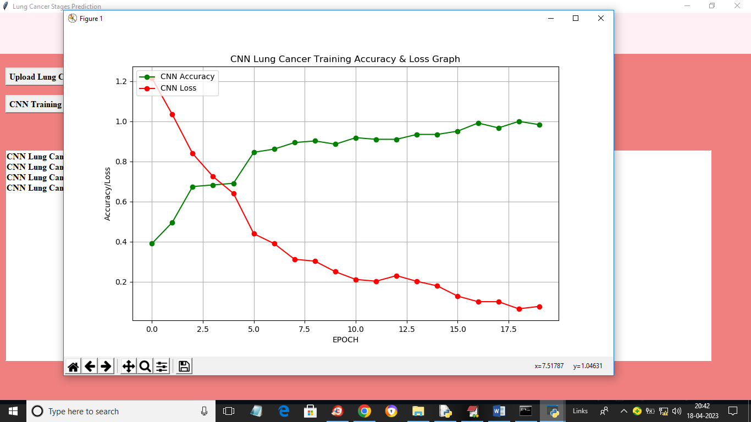

In above graph x-axis represents training epoch and y-axis represents accuracy and loss. Red line represents loss and green line represents accuracy and we can see with each increasing epoch accuracy got increase and loss got decrease. Now close above graph and then click on ‘Predict Lung Cancer Stage’ button to upload test image and get below output

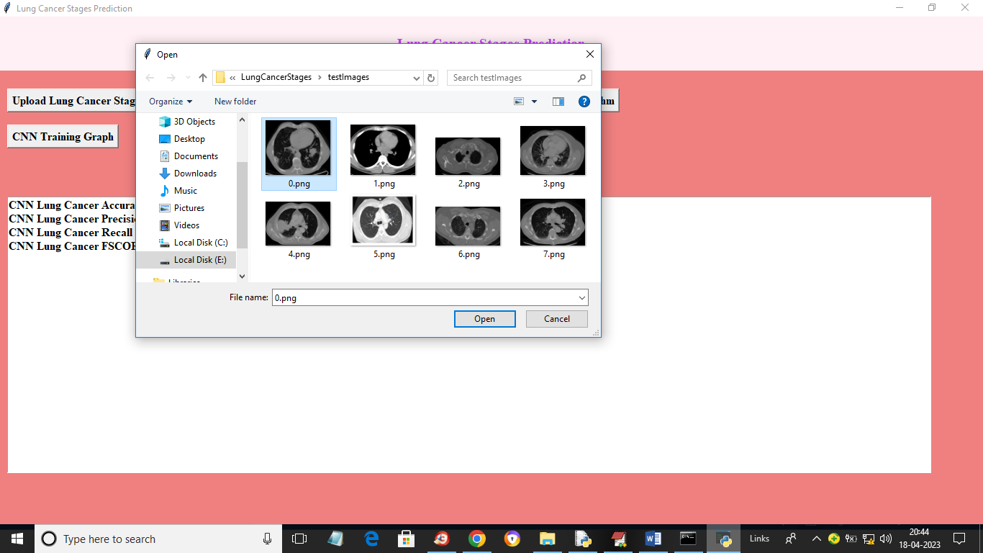

In above screen selecting and uploading ‘0.png’ and then click on ‘Open’ button to get below output

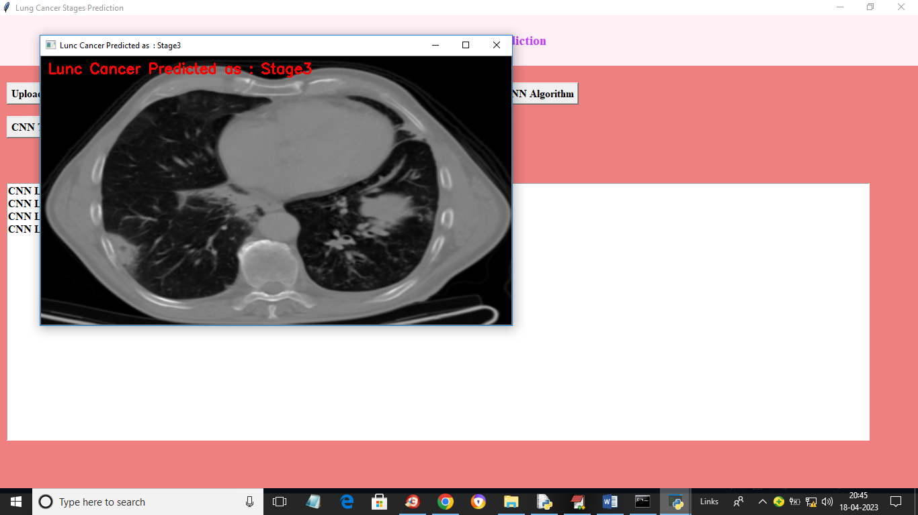

In above screen in red colour text we can see cancer in image predicted as ‘Stage 3’. Similarly you can upload and test other images

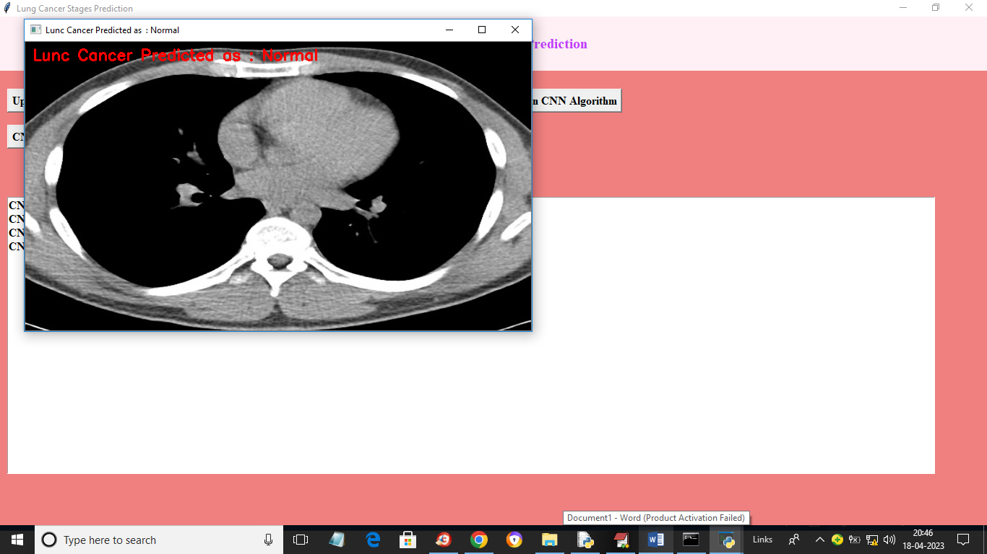

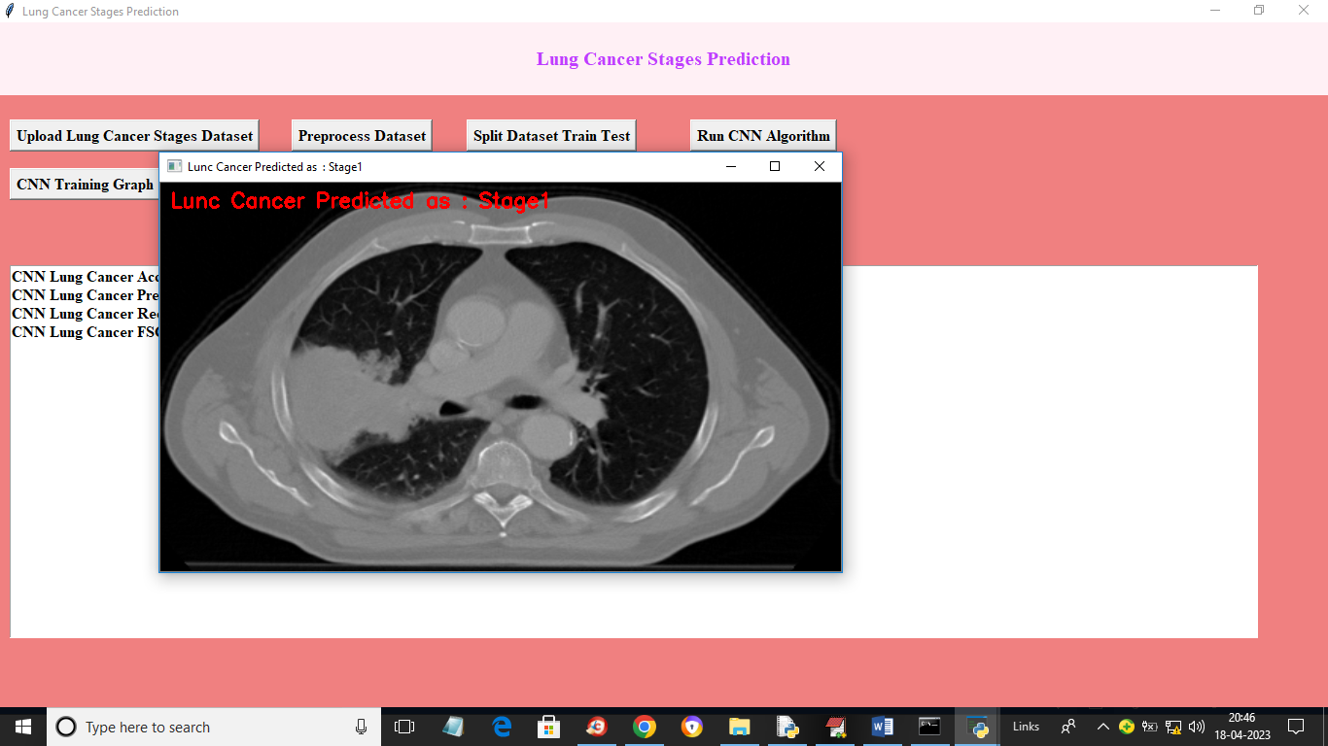

In above screen cancer detected as Stage 1

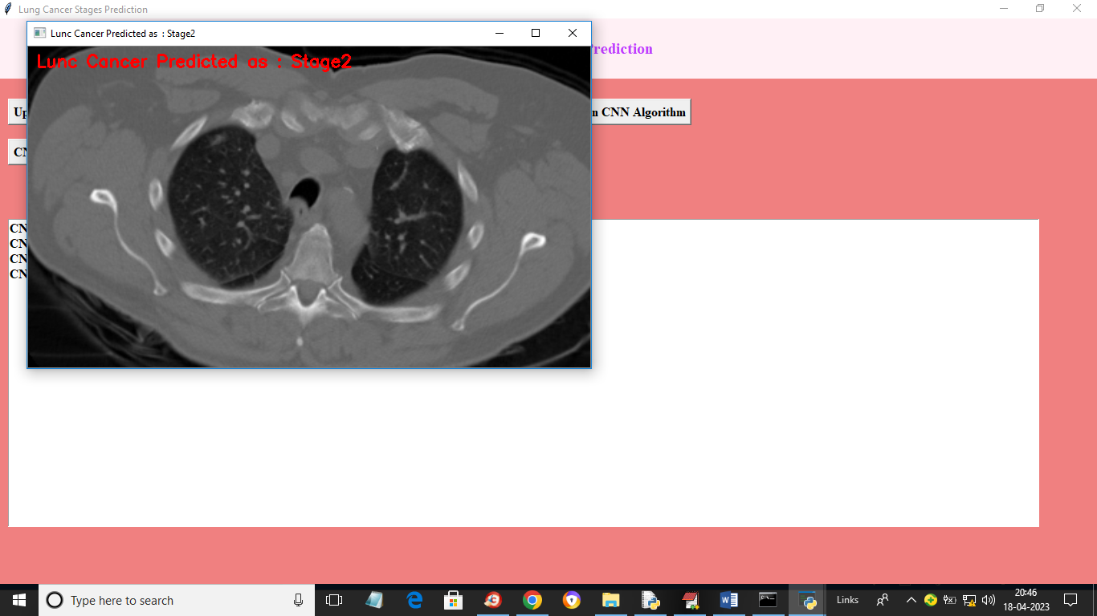

In above screen cancer stage detected as 2