Guia1

**Introducción a los estándares y métricas de calidad del software**

**Estándares y métricas de calidad del software**

**Andres Vasquez  
Edwin Cubides**

**Olga Luica Martinez**

**Universidad Manuela Beltrán**

**Bogotá 2021**

1. **Describe features of PSP model:**

* **Define your own processes.**
* **Plan and follow up on your own work.**
* **Manage the quality of your own work products.**

**Personal software process (PSP) is a process designed to help users software engineers to control, manage and improve their work. PSP is based on a motivation.**

**PSP can be applicated in:**

* **Programs development.**
* **Definition of requirements.**
* **Documentation.**
* **Systems test.**
* **Systems maintenance.**

1. **Describe features of TSP model:**

**Provides an emphasis on processes, products and teamwork. The TSP is based on principles of PSP to realize the processes and principle of engineering of software in a teamwork environment.**

**The TSP emphasizes teamwork because:**

* **Teams are nit magically formed.**
* **The steps to form a team are not obvious.**
* **The strengths/weakness of each team member must be understood and how these supporting the performance of it.**

**Each member of the team, in a TSP development plans their activities, gives follow up on their work and report their progress, control their owns processes, is involved in planning, decisions of the entire team, has roles and explicit responsibilities.**

1. **Features PSP/TSP**

|  |  |  |
| --- | --- | --- |
| Características | PSP | TSP |
| Ventajas | Advantages that we can find:   * Improves the productivity of the people involved in the development of the software. * Coding errors are reduced. Time management when keeping track of times * Better control of individual work is kept. * Facilitates the identification of strengths and weaknesses to enter improve them. * Quality is improved. | * Raise quality in the projects. * Helps organization stablish and * engineering practice mature and disciplined * Reduce the number of defects. * Reduction in testing cost an time. |
| Desventajas | * The emotional tension from feeling controlled. * Time management when keeping track of times. * must fill out all the required documentation that includes your records, planning, templates or forms. | * Members must have commitment, discipline to follow the plan. * Must fill out all the required documentation. * Must have a good set of metrics and quality parameters. * Each member must be trained in   Psp. |
| Diferencias | * Individual work. * Documentation * Data use for define project schedule | * Team work. * Ágil development. |

1. **Architecture Diagrams**

**4.1 Functional architecture diagram.**

* 1. **Information architecture diagram.**

1. **Requirements**

REQUERIMIENTOS PROYECTO ESTÁNDARES Y MÉTRICAS DE CALIDAD DE SOFTWARE.

-Crear una interfaz de registro para usuarios nuevos, que almacene sus datos.

-Crear una interfaz de ingreso a la plataforma que valide las credenciales del usuario ya creado previamente.

-Crear un dashboard que permita visualizar los productos con los que se cuenta actualmente.

-Crear un carrito de compras para almacenar los productos elegidos por el usuario.

-Crear una interfaz unicamente para el administrador que sirva para agregar productos, modificarlos o eliminarlos.

**[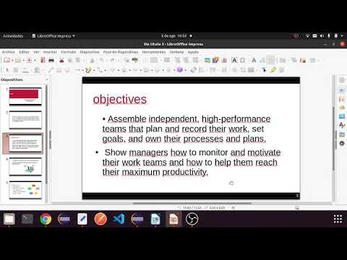](https://www.youtube.com/embed/qs8ocqXuZkQ?feature=oembed)**