BUSINESS BACKGROUND

WATSON’s – the clothes shop
Is a clothing company that specializes in both retails and e-commerce clothing sales (tops, bottoms, shoes, accessories), operating through physical stores and an online e-shop.

Purpose of the report
The report analyzes the end-to-end sales process across both distribution channels - retail (physical stores) and e-commerce. It covers product performance, revenue and profitability, seasonal demand patterns typical for the apparel industry, employee and store performance, payment method usage, and customer purchasing behavior.
Its purpose is to give management a fast, self-service way to assess the state of current business state from an executive level down to product/category, channel, store, employee, and customer level, without requiring manual data pulls or SQL queries against the data warehouse.

end user
End users include sales and operations managers, category/merchandising managers, regional store managers, and executive stakeholders who need recurring insight into sales performance, margin, and seasonality.

Business questions and problems
This report has insights and collected information that help in answering questions such as:
- How is total revenue and profit margin trending, and how does it compare to the past performance?
- Which product categories/subcategories are the strongest and weakest performers in terms of sales volume and margin?
- How does demand vary by season (spring/summer/autumn/winter) - critical for apparel collection planning?
- How does the retail channel compare to e-commerce in terms of contribution to revenue?
- Which stores/zones and which employees are top performers?
- What payment methods are most used, and how does customer demographic profile (gender) relate to purchasing patterns?
- Which products/categories combine low margin with high volume (cost/pricing risk) versus high margin with low volume?
The report addresses the previously identified data management problem (fragmented, hard-to-analyze transactional data across two source systems) by enabling fast, accurate, and consistent self-service reporting.

Report creation process
First, the data was loaded form PosgreSQL source – connection was established, and subsequently, the DM layer tables were imported into the report with their relationships.
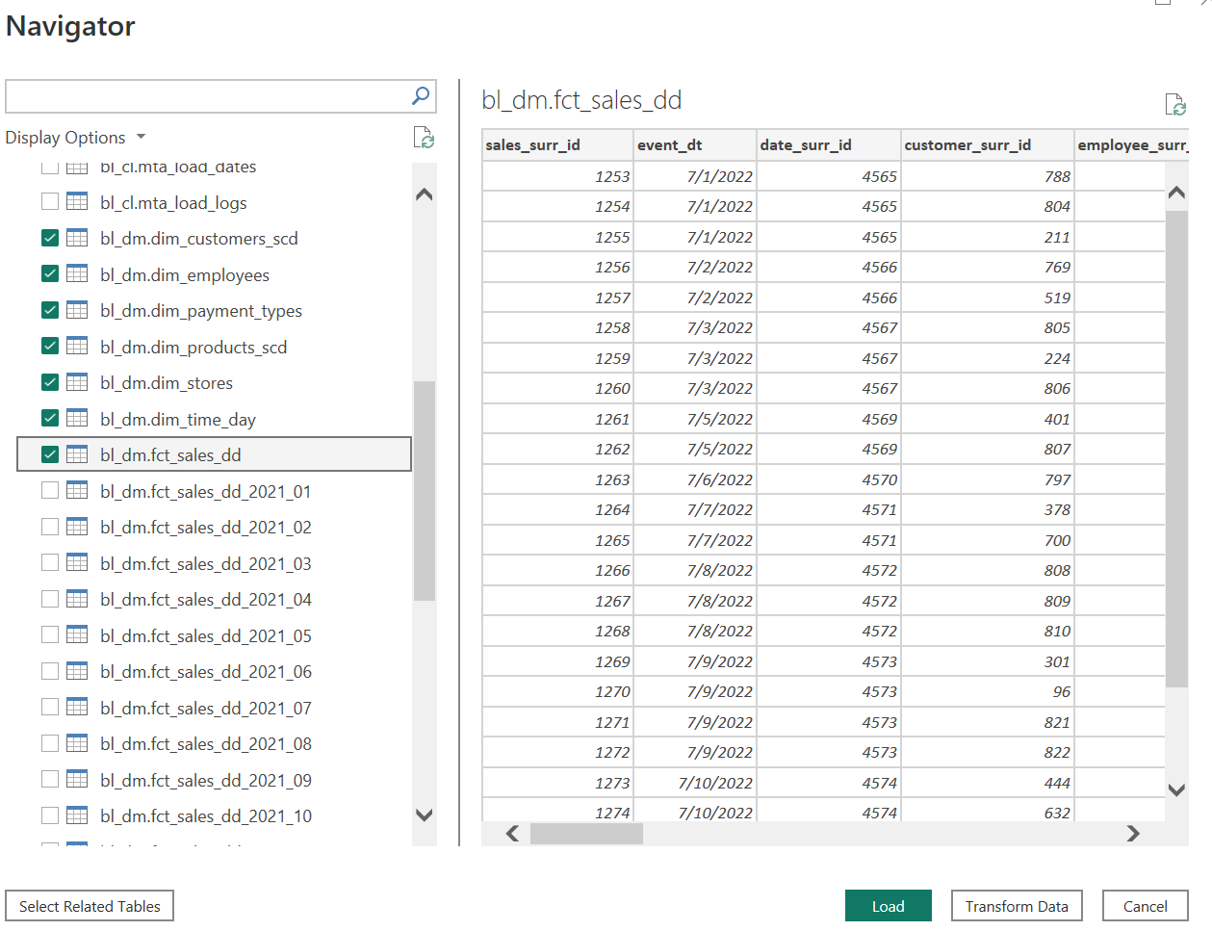
Relationships were included in the data model – from foreign keys in BL_DM layer in data warehouse. All of them are considered active (one relationships per pair of tables), all of them are one to many (one key in dimension, many related records in fact table) and cross-filter direction set to single:
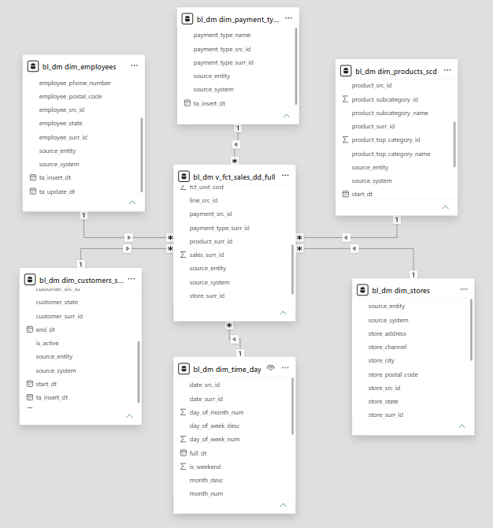
Then, the data was transformed. Firstly, the table bl_dm.dim_time_day was declared as a date table (in order to do that default row was filtered out due to gaps in dates):
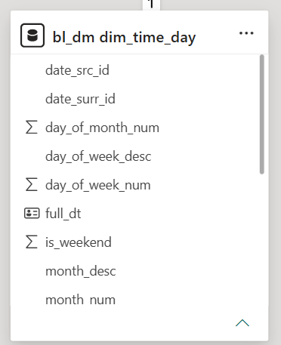
Subsequently, the product hierarchy and store hierarchy were created:
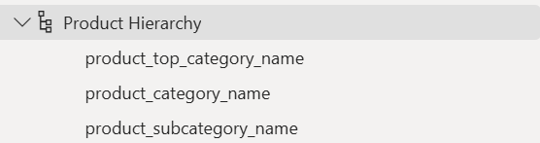
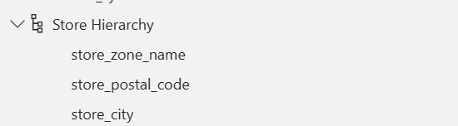
A calendar hierarchy was added as well:
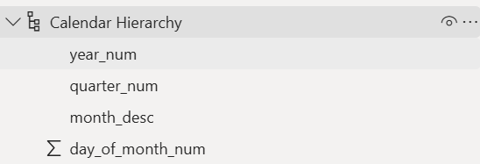
Other initial data transformations included f.e. getting the full address into one additional column for map visuals and renaming columns used in figures.
Then, the table Measures was created, and it was set to store measures for statistical analysis and other columns that were needed for aesthetic purposes (such as conditional titles and rankings):
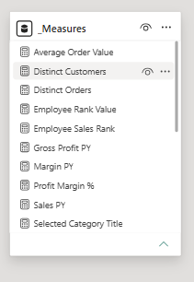
Report structure:
3 visible pages were created:
- Sales Overview - KPI cards with trend indicators, net sales trend vs. prior year, Retail vs. E-commerce channel split, sales location map, top 5 product categories.
- Product & Category Analysis - category hierarchy matrix with conditional-formatted margin, treemap, seasonality column chart, quantity-vs-margin scatter plot.
- Channel, Employee & Customer Insights - sales by store zone, employee ranking, payment method donut, gender distribution, Average Order Value and unique customer KPIs.
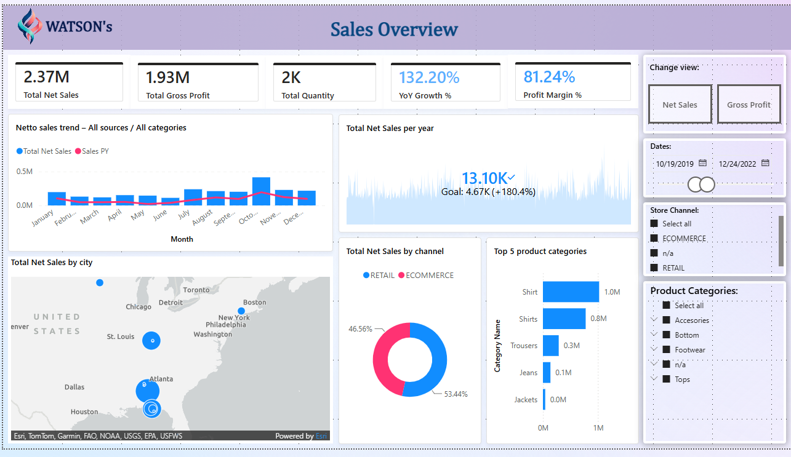
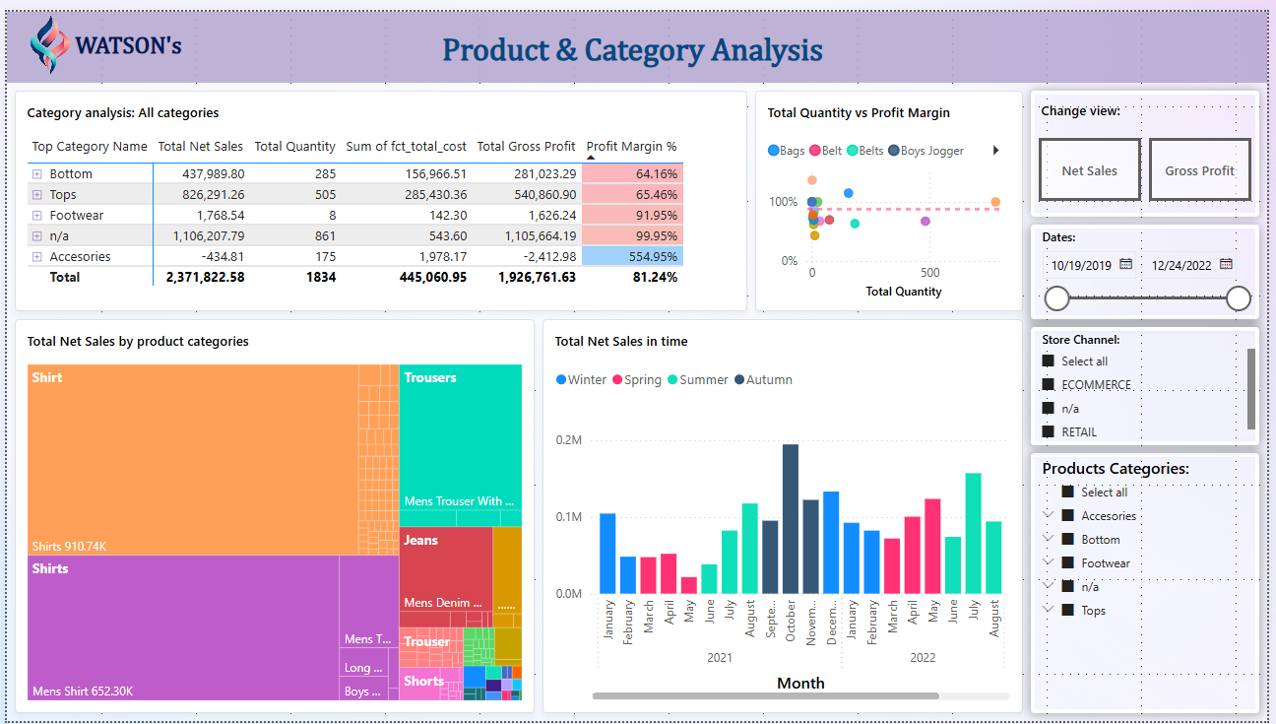
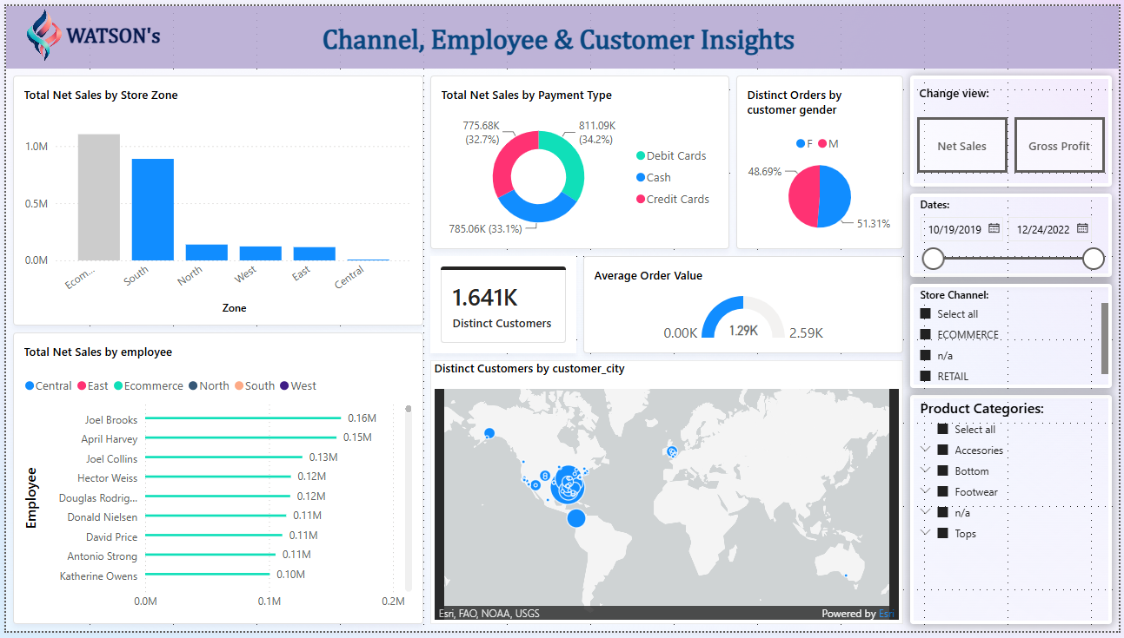
Furthermore, 3 hidden pages were created: Drillthrough targets (Product Detail, Store/Employee Detail) and a custom tooltip page (Store mini-KPI tooltip – used in maps where stores are displayed).
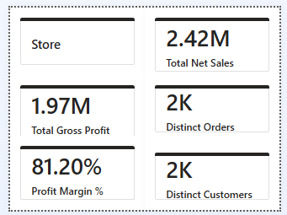
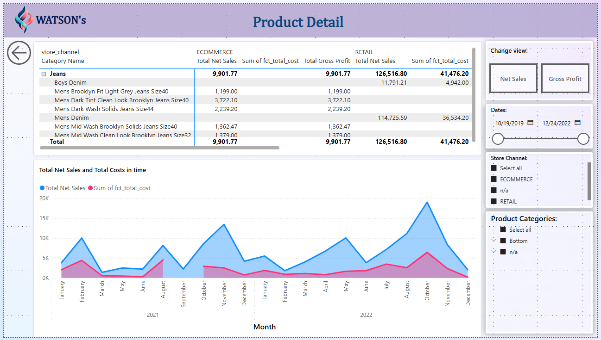
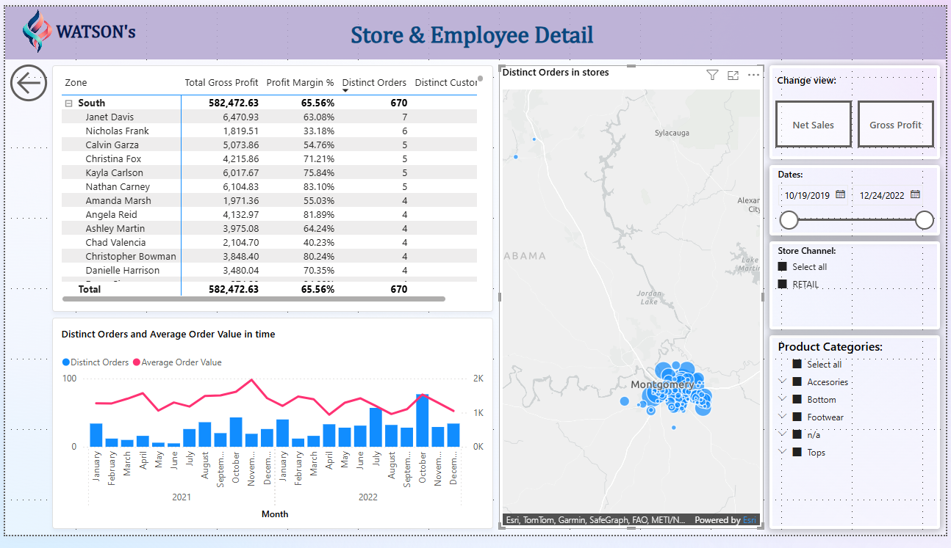

Moreover, two buttons are displayed on every page – those are in control of bookmarks which change visuals between different KPIs – Net Sales and Gross Profit – they only work on visuals containing those metrics:
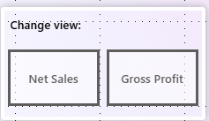
On every page 3 slicers are also available – they enable filtering the data for various end user needs. They are kept whilst switching pages:
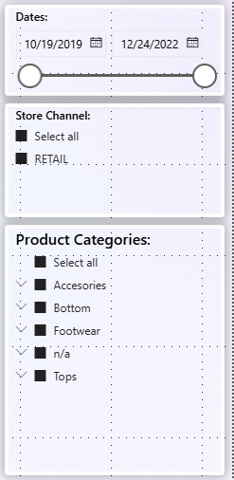
The entirety of the report uses common color theme and heading. In a few field conditional coloring and titling in used. Drill-throughs including product detail or Store & Employee Detail are available in all of the figures containing such information, on the details page there is a “go back” button available. While hovering over store bubble on maps containing store sales data a tooltip with corresponding KPIs appears.

PUBLISHING THE REPORT IN POWER BI SERVICE
Lastly, the report was published in PowerBI Service:
