DWH Refresh Improving
The BL_DM layer of the Clothes Shop DWH is populated from the BL_3NF layer through two independent ETL paths. The first path handles the CE_SALES fact table in BL_3NF (script 10_load_bl3nf_tables.sql), while the second loads the DIM_ dimension tables and the FCT_SALES_DD fact table in BL_DM (script 15_load_bldm_tables.sql). Both paths apply the same two-object pattern: a dedicated function extracts and transforms the data, and a dedicated procedure iterates over the function results through a FOR LOOP and writes the data to the target table.

Loading CE_SALES (BL_3NF Layer) – Incremental Load
Incrementality is implemented through the metadata table bl_cl.mta_load_dates (script 04_mta_load_dates.sql). The table stores the timestamp of the last successful load (last_load_dt) for each target table. Two helper objects manage watermark read and write:
- bl_cl.fn_get_last_load_date(table_name, schema_name) - returns last_load_dt or 1900-01-01 when no entry exists (first run)
- bl_cl.prc_update_load_date(table_name, schema_name, timestamp) - upserts the watermark after a successful load
As a result, on each subsequent execution prc_load_ce_sales fetches from SA only rows added after the last load, without reprocessing the full history.

Loading FCT_SALES_DD (BL_DM Layer) – Partitioning and Incrementality
FCT_SALES_DD is a range-partitioned table (PARTITION BY RANGE (event_dt)) with monthly partitions. Each partition stores data for one calendar month. The partition is first created as a standalone table, loaded with data, and only then attached to the parent via ATTACH PARTITION. This ensures that loading does not block access to existing partitions. Partitions are retained permanently – source data is not sorted by date, so it must insert into all the partitions while loading.

Tests
In screenshots below logging table rows are shown – all data is loaded during the first run, when procedures are being run the second time on the same data nothing is inserted or updated:
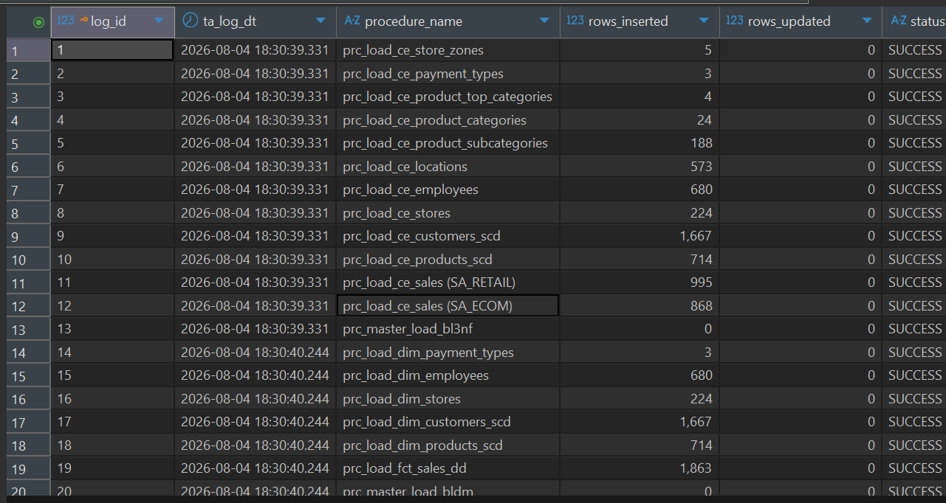
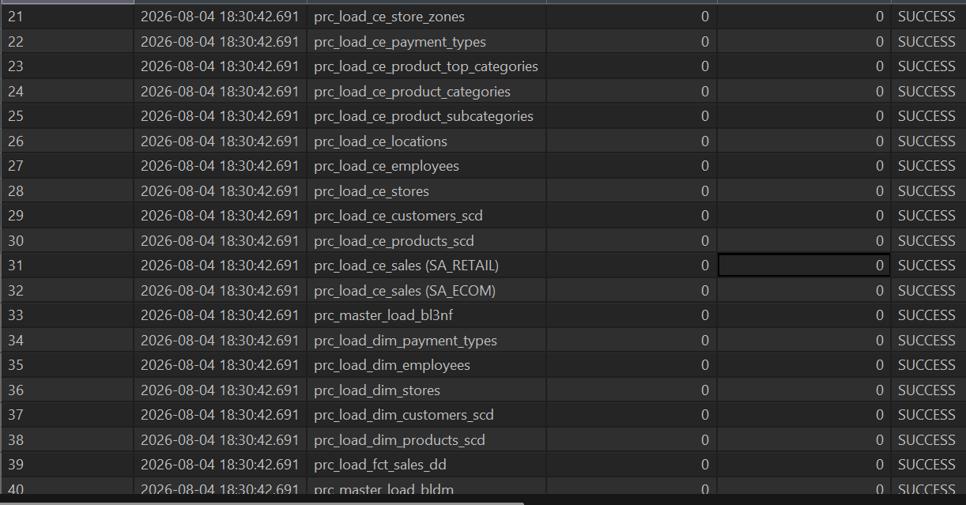
In screenshots below, there are shown results of the test scripts (in one table each instead of multiple checks and raising errors/warnings). Tests were implemented in 5 files, each corresponding to one test group:
Tests 1 – no duplicates in bl_3nf:
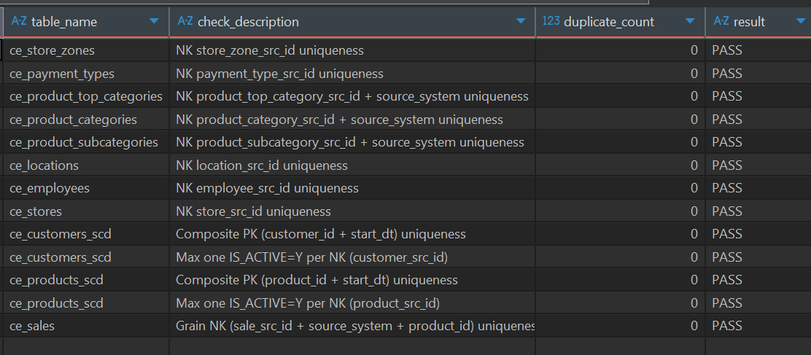
Tests 2 – SA data coverage in bl_3nf:
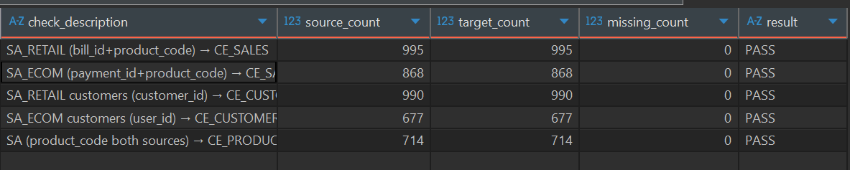
Tests 3 – no duplicates in bl_dm:
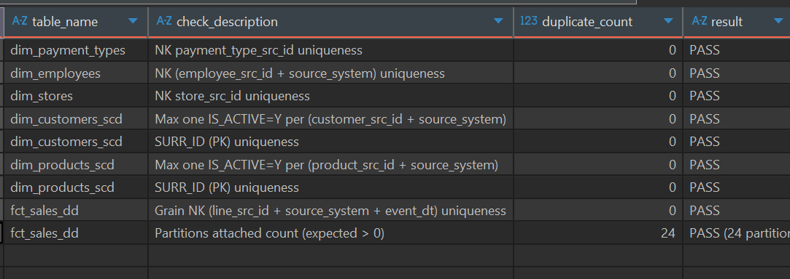
Tests 4 – 3nf data coverage in bl_dm:
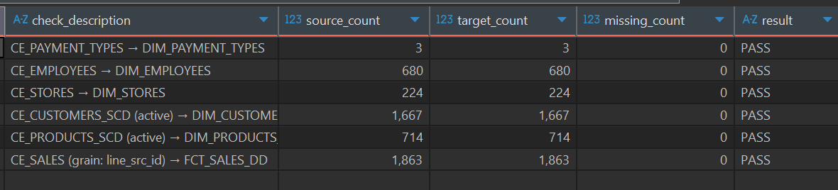
Test 5 – row counts before and after restarting procedures:
