SQUARE WHEELS

It is possible to convert a perfect wooden cube into a wheel. Simply drill a hole diagonally through its corners as shown below. Stick four such cubes on two axles, and you’ve got a car with square wheels. This gives a pretty bumpy ride of course. As you see in diagram 1a, the end view, the result of using cubical wheels is actually six-pointed hexagonal wheels.

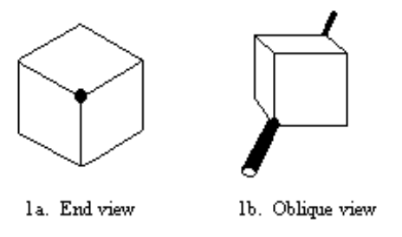

We can do better. Shave the corners off the cube as in figure 2 below. The cube is now round, and the wheels will roll perfectly smoothly. But the wheels are no longer cubical, so this misses the whole point of having “square wheels.”

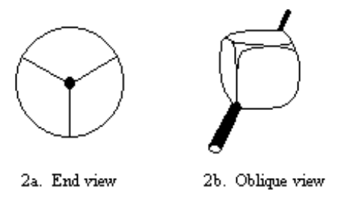

All is not lost. If we shave ALL the corners off of the cube, then grind the faces down so new corners are formed, the cube will still be cubical, yet still perfectly round. The result looks like a cubical beachball which has been overly inflated. It’s a slightly swollen cube. The edges of the cube are slightly curved (they are actually sections of an ellipse.) These curved edges trace out the surface of a cylinder. When this “square wheel” is viewed from the end, it appears to be circular. But pull out the axle and drop it on the table, and it looks nearly cubical.
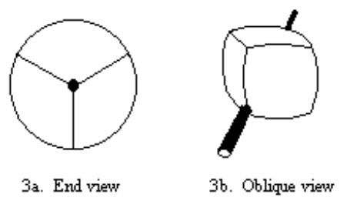

I made several of these “square wheels” of wood, mostly by hand grinding with a belt sander. Eventually I built a couple from plexiglas. The plexiglas version was really cool - when left without axles on my desk they looked like decorative glass paperweights, but stick a metal rod through them and they would roll smoothly along in eerie silence.

BUILDING THE WHEELS

Start with large dowel stock. Cut the initial blank to have the same length as its diameter. If you use 1-1/2” dowel, then cut each cylinder to 1-1/2” long to start. (The finished object is a bit shorter than the diameter, but this is close enough to begin.) I first used a lathe to drill a perfect hole through the center of the cylinder. Later this hole will be used to mount the wheel on an axle.

To aid in grinding the shape, I marked the cylinder surface with a special zigzag having six lines and six corners. Getting this zigzag right is the hardest part. I marked the cylinder with six equally spaced lines parallel to the axis, drew one line perpendicular to the first six, circling the exact center of the cylinder, then drew two more circles with .246X spacing on either side of this center circle. (If your cylinder is 2” dia. and 2” long, then the spacing between the center line and the two guide lines will be 2” x .246 = .49”.) The diagram below was made on Microsoft Paintbrush for a 1-1/2” cylinder. If your printer maintains correct aspect ratio, you might be able to print it out and glue it onto your wood cylinder. Otherwise, use the diagram as a guide and mark the zigzag as shown.

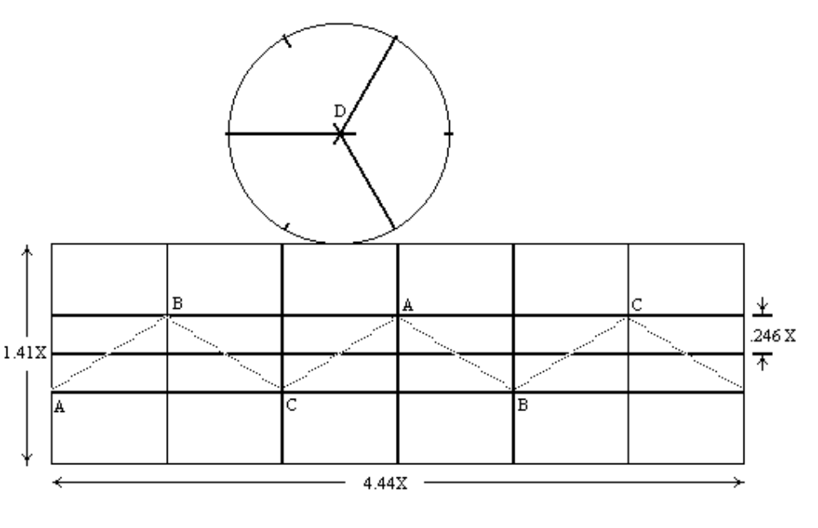

Working by hand, use a belt sander to grind several cylindrical surfaces into the wood blank. To grind each one, hold the wood so two opposite points on the zigzag line act as the “axle,” and hold this “axle” a constant distance from the sander and parallel to the sander. Rotate the wood blank like a wheel, so that the belt sander removes the excess. For example, grab points “B” and “B”, hold this line parallel to the sander, then rotate it slowly in order to grind a new cylinder surface into the wood. While grinding, you must keep the imaginary “axle” line through opposite points parallel to the surface of the belt sander. The goal is to rotate it smoothly so this “axle” doesn’t move nearer or farther from the sander as you turn the block. Grind it down until just before the point that you being to grind off the colored line. Try very hard not to sand away the zigzag line, since that line provides the rolling surface for the finished wheel.

It might help things if you drive tiny nails part way into the diagonally opposite points, in order to give yourself small handles to hold.

This whole procedure is done three times using the three (A,B,C) different axes on the zigzag. When finished you will have a polyhedron with 24 square facets, along with a paper fragment containing the zigzag line still glued to the wood.

Can you see the bulging cube hiding within the faceted shape? Color its edges with a marker, then grind the extra material off the faces of your cube. Work slowly and avoid sanding off the marked lines. The end result is a smooth, bulging cube-wheel with dark lines along the edges.

Make two of these, stick them on a metal rod (I used a drill bit), and see how it rolls on a polished tabletop.

HINT: if you don’t want to spend big bucks for thick acrylic stock, you can instead get some scraps of 1/2” acrylic sheet and make your own. Cut and deburr several disks, add acrylic cement, stack them up, and clamp with one large c-clamp. Wait a couple of days for the cement to be totally absorbed, and you’ve got a nice acrylic cylinder.

Where does the number .246 come from? I started with a theoretical cube of edge length one. This cube has a length of √3 between opposite corners. After the points are ground off, it fits inside a cylinder of diameter √2. I then “sanded down” the tips of the cube by shrinking it by √3/√2, then projected the new vertex positions outwards onto the √2 diameter cylinder. If my math is right, this gives a position of vertices from the centerline of :

.5[(√10 - 2√3 +3)/√30] = .246

Using these measurements directly will give you a cylinder that’s √2, or 1.414” diameter and 1.414” length, with six marks around the circle spaced at 0.74”,with a zigzag that goes up and down by .246” from the center line circling the cylinder. For other sizes of cylinder you’ll have to grab a calculator and scale these numbers up or down.

