MATTER UNIFIED CD-ROM
”Matter Unified” kan erhållas på CD för 150 kronor på mitt postigirokonto 124 98 26-7
”Matter Unified” can be delivered on CD for 20USD cash by letter to Ove Tedenstig Idungatan 37, 19 551 Maersta Sweden.
MAUNGIF.GIF
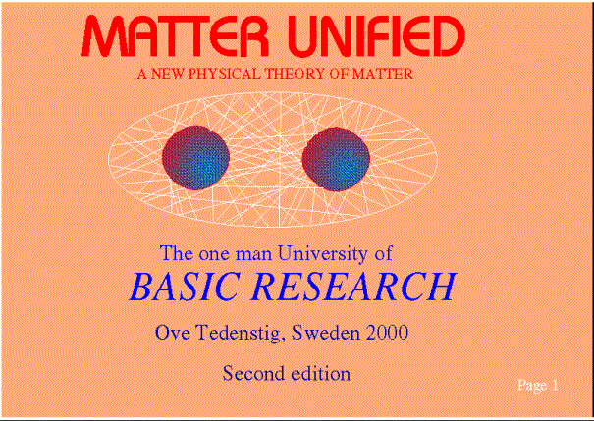

You also get a CD which can be accessed by ADOBE search motor making it more easy to read Designer of this CD is Gianfranco Lazzaretti, Italy
ADOBEGIF.GIF
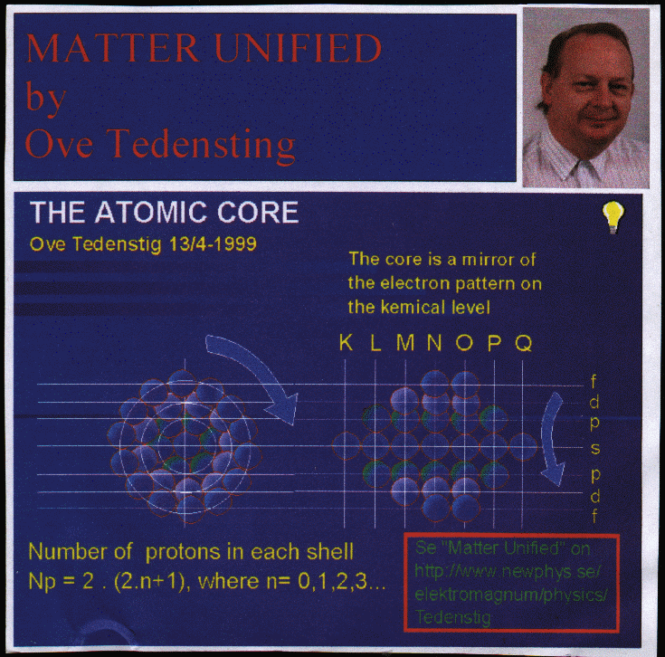

Email to me : ove.tedenstig@swipnet.se

