The inherent structure of the neutron
Ove Tedenstig/Sweden 1999
See my book "Matter Unified" or associated separate papers
The neutron, electrical uncharged, as seen from an outer point, has internal charge which experiments performed shows. When probe particles is sent towards the core, first a slightly positive charge appear, then a negative charge, and very near the core, a positive charge force. The model, where the neutron consists of a proton as core and an electron as orbit (on a very high energy level compared with the hydrogen atom), in a very good way satisfy experimental findings.
picture neushape.gif
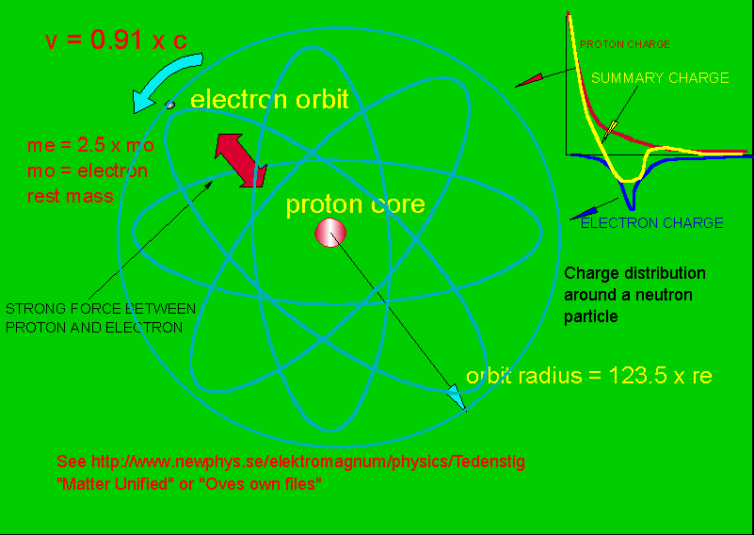
End of file neushape

