BASIC PRINCIPLES BEHIND THE STRONG
NUCLEAR FORCE
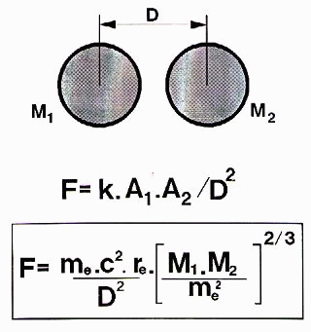 | When two elementary particles come very closed together, the strong nuclear force act between them. This force is a "shadow force" created by the vacuum mass pressure towards the surface area limiting these particles. This force is approximately 3E29 Newton/Square meter, calculated by :  F = q x C(2) = (1/Eo) x (Kt x c )(2) , where Eo is the dielectricity of vacuum constant, c the light velocity and Kt = 5.3557 as calculated from our electromagnetic theory.
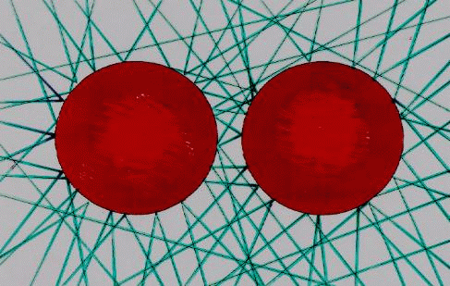 |  | By aid of the enclosed formula the strong nuclear force between two particles approximately can be calculated , where :  me is the electron rest mass  c is the light velocity  re is the classical electron radius
See more about all that in my book "Matter Unified" on the webb site :
http://www.newphys.se/elektromagnum/physics/Tedenstig/own
Email: ove.tedenstig@swipnet.se

