THE ELECTRIC UNIT CHARGE
A special and partial issue of

MatterUnified
“The one man University of BASIC RESEARCH”
Ove Tedenstig ISBN91-973818-4-5
Idungatan 37 19 551 Märsta/Sweden
Tel 08-591 16 0 16
Email ove.tedenstig@tele2.se

Doc. name Charge.doc
Date of issue : 20/12 200

Absract

An electron, a proton or any similar very basic particles are regarded as having vortex form were matter rotate around a main axis and also having an internal spin movement. Electrical and magnetic fields and their forces are assumed being caused by that spin movement.

By introducing 3 special parameters of area (Ka), for volume (Kv) and for spinning time (Kt), then all formulae of the electromagnetism is derived. In these results in this way achieved, these parameters appears as a “tail” to these expressions as commonly known in electromagnetic theory.

In all these relationships the achieved “tail expression” will be equal to=1 if the area parameter is equal to 4.π, the volume parameter is equal to 4.π and the time parameter is equal to 2.π, hence disappear from the expression, givning the common expression as result.
These parameters of 4.π.r² for area and 4.π.r³ for volume, not directly is associated with any known geometrical shape or body, but are due to an area and volume compression mechanism of matter, when matter spinning from the outer parts of the particle surface to the inner parts of it. The less area and volume of the inner parts of the particle creates a difference which create an in/out flow process which is the electrical field of it.

These parameter factors of Ka, Kv and Kt are here calculated in the last part of this note. For other parts of the calculations are referred to my entire work of MattrerUnifed as published on the web or registered on the “REGINA” data base of the Royal Låbrary of Sweden.given above,

The calculation show that the electron unit charge is uniting, meaning
there exist no fractional parts of charge as proposed by the standard theory of elementary particles (quarks).
In this view there exists no quarks and the standard theory is wrong.
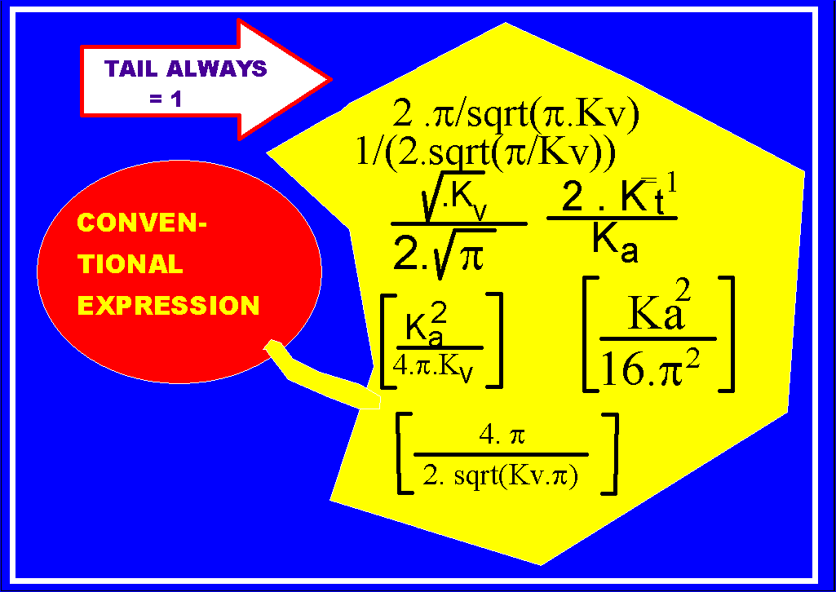
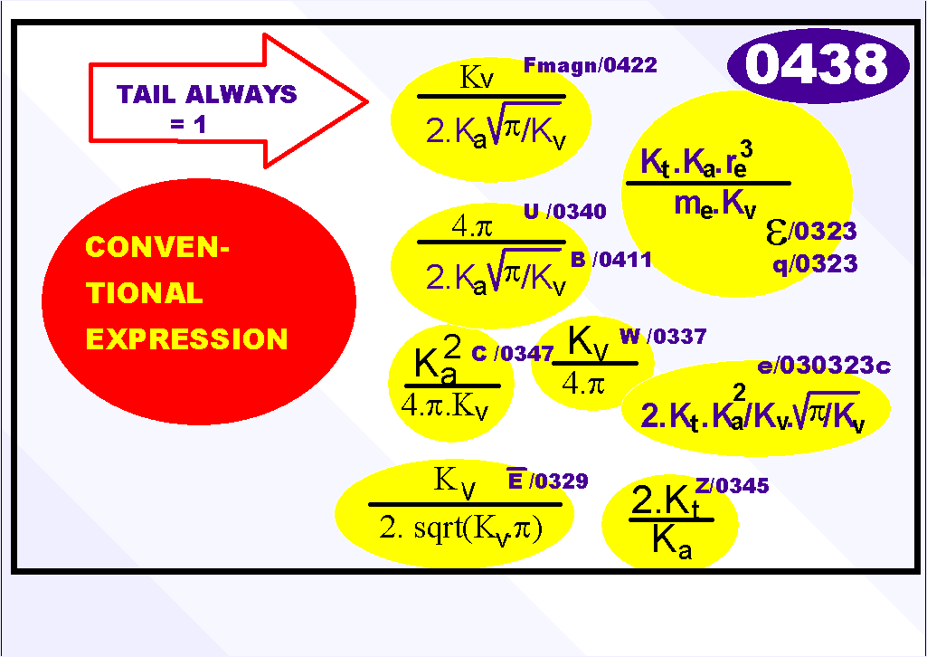

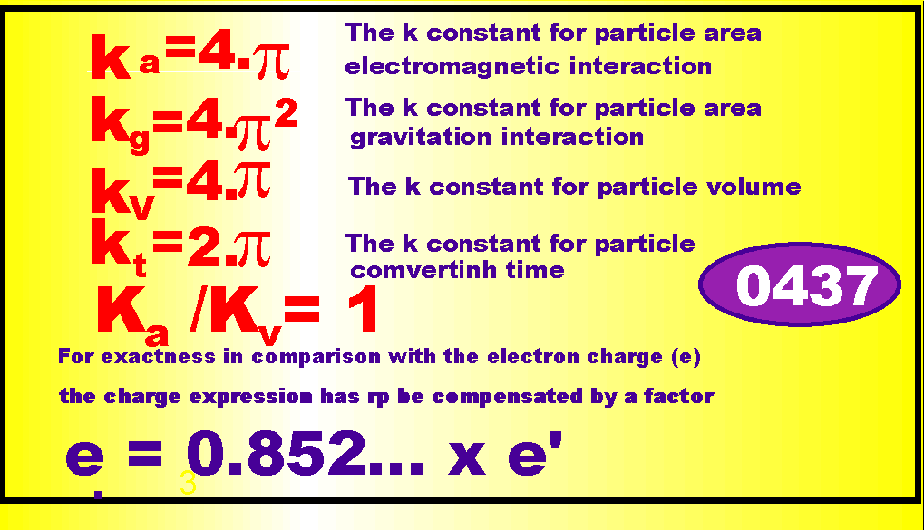

The reason to the values of Ka and Kv in association to elementary particles
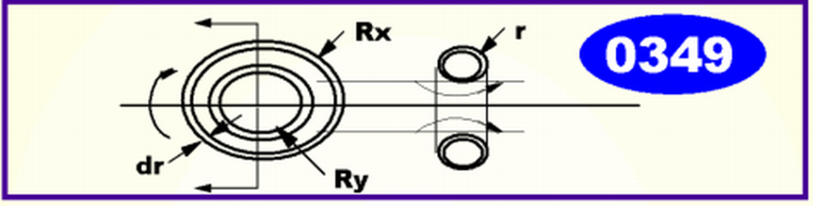
The constants Ka and Kv respective, are not directly associated to the particle’s area/ volume’s geometry but are associated to a flow in surface /volume with a given velocity.

The outflow of matter is depen-ding of that this part that moves towards the particle’s center get less volume compared with the particle’s outer parts. This compression occur an outflow of matter from the particle.

We shall calculate these factors with start from this idea- See figure above, where the particle’s maximum radii is Rx and the minimum radii Ry. The particle is assumed consisting of a shell with thickness dr.

When the mass of the particle rotates towards its center point, the more narrow volume causes matter to flow out from the par-ticle. This outflow is compensa-ted by the infloe from space.

Firstly the area of the maximum radii with thickness dr is calculated. Then is calculated the corresponding area for the minimum radii with thickness dr. The difference is related to the mass outflow.

At first we do a calculus of the area associated to Rx:

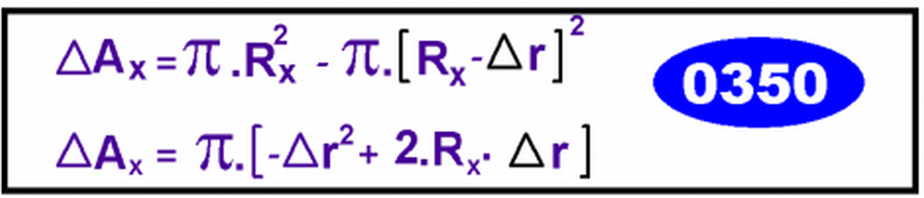

The same calculation is performed for the min radius:

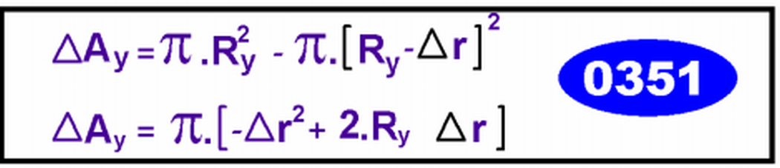

We calculate the difference between these entities, hence being equivalent to an area:

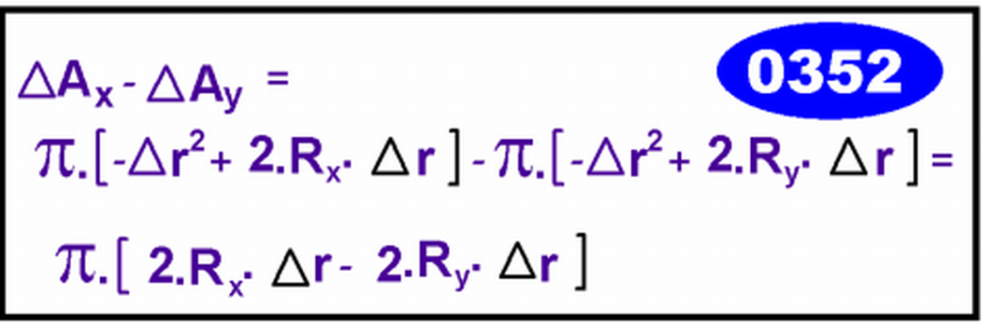

But the radius Ry is a function of th radius Rx, hence:

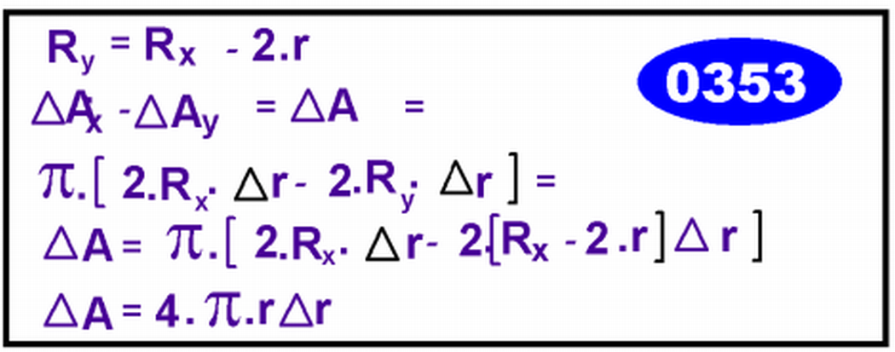

But r is here the electron radius and if the electron radius is massive, also dr is equal to the electron radius, hence:

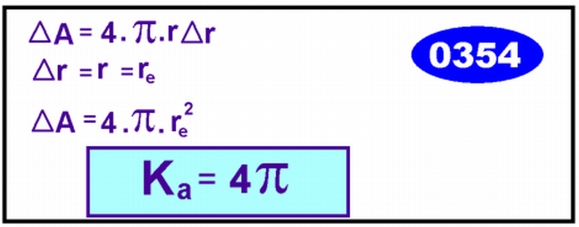

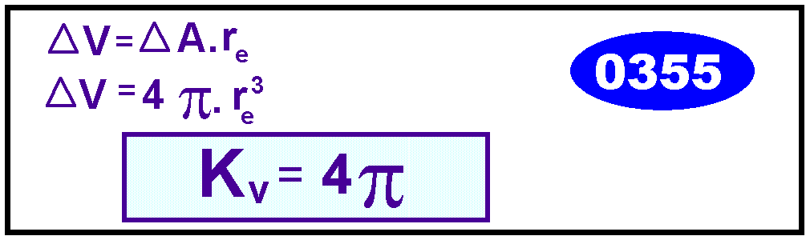

For the proton, having a different radii than the electron, we get:

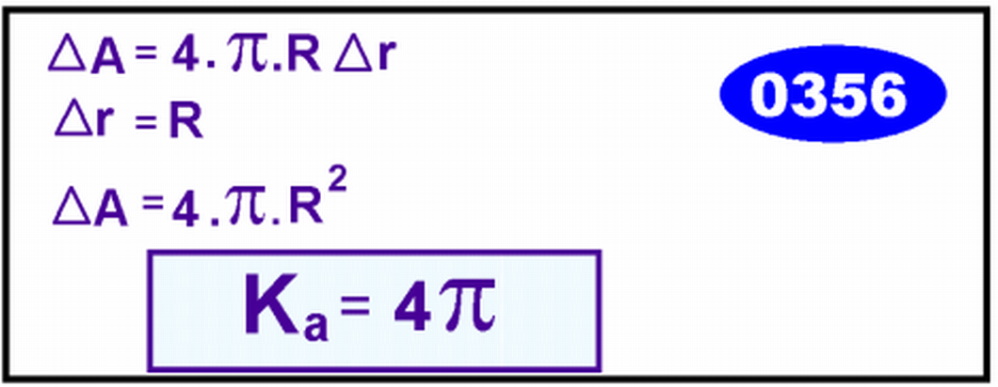

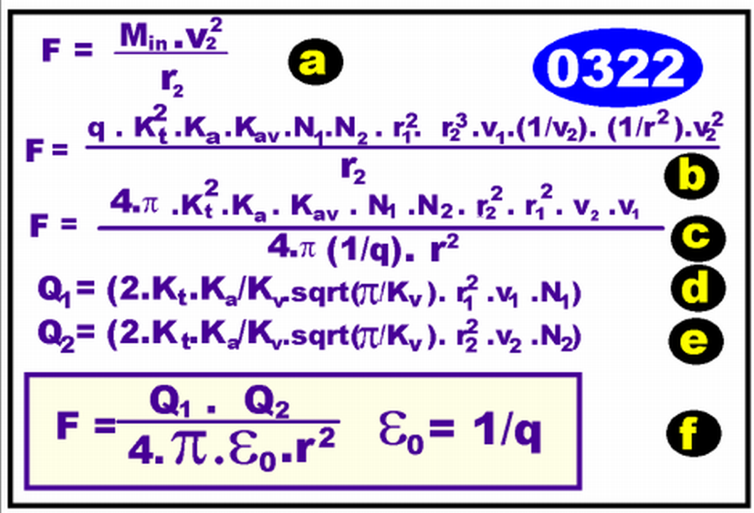

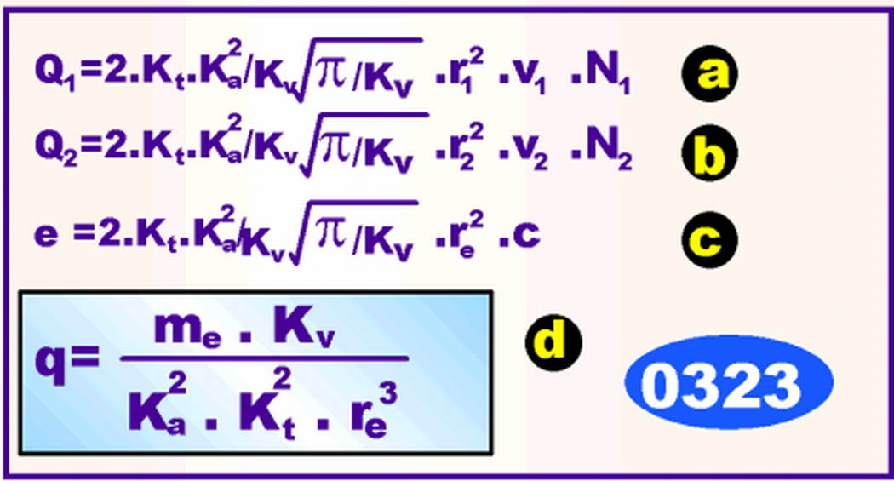
The Coulomb law is derived with aud of Newton’s law of revolving movement as start. The ε_{o} universal constant is the mass density of vacuum (q) creversed, hence 1/ε_{o}, The revolving time 2.π.r_{e}/c for electron is exact in all electro magnetic processes but differ a small amount for the charge parameter, 0.852.. od derived value in 0.323a,b,c.

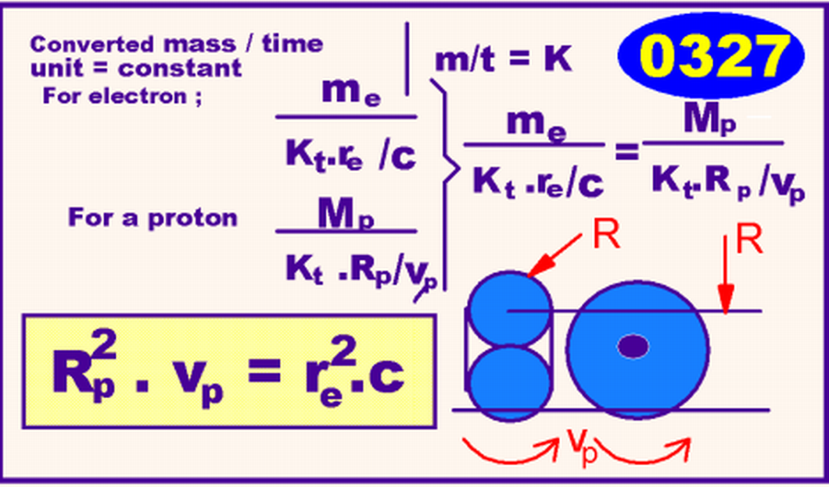

Electric charge is action of space represented by area times velocity or volume flow of density q per time unit. Electromagnetic units can all be converted to units of Mass, Length and Time in the MKS(A) unit system, not possible in any established physical theory

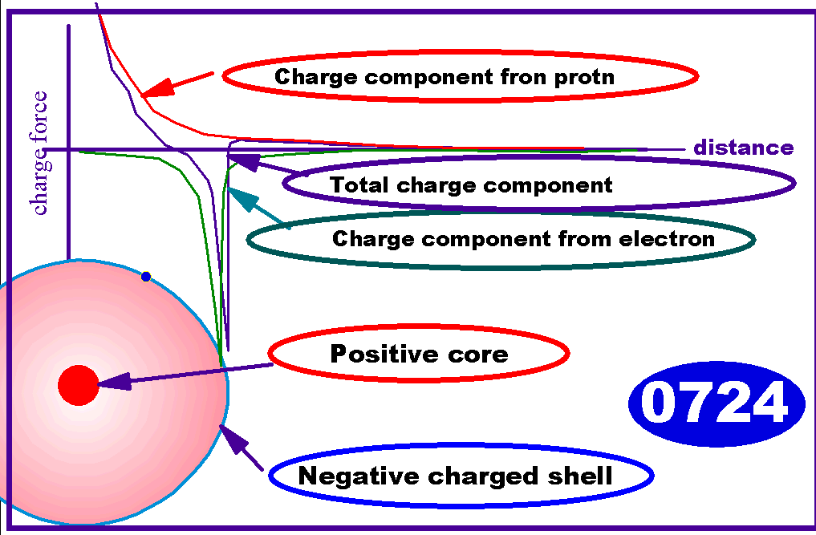
The neutron contain charge and is built up by a proton and an electron
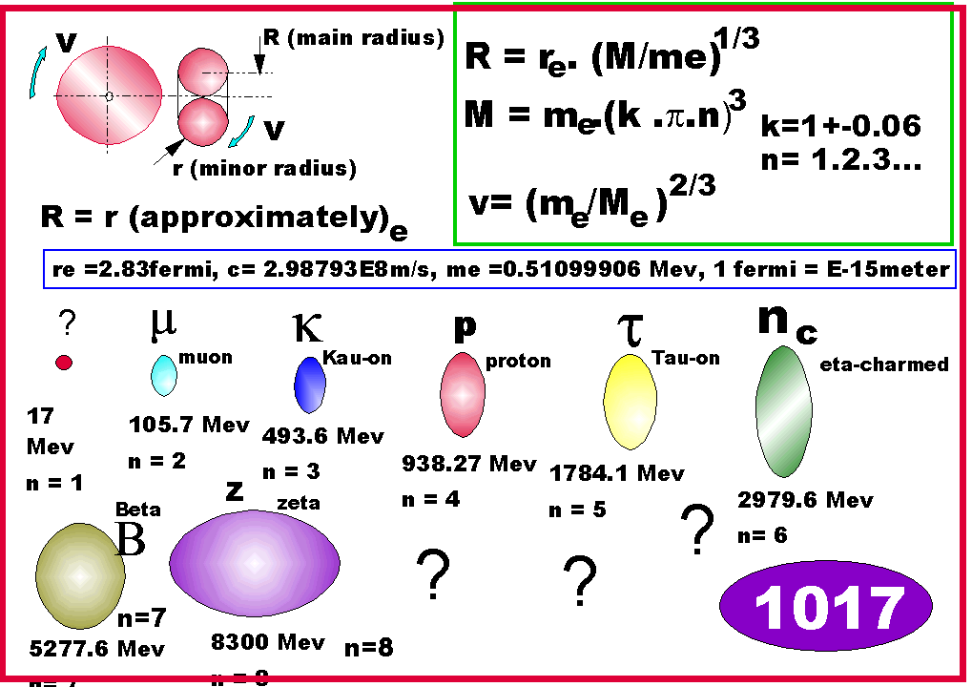

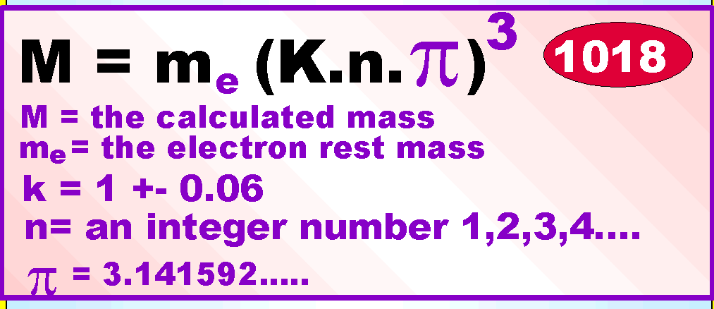

Basic elementary particles, like muons, K-ons, protons, Tauons are created in a resonance proces in matter, in accord with formula above, A quantum integer number n determinung the different mass of different particle forms.

COMMENTS OF RESEIVED RESULTS
n | Mass from experiments or predicted mass | Unit | Value of k | Comment
1 | 16 | Mev | predicted | WIMP (1)
2 | 105.65839 | Mev | 0.941127 | u, muon (6)
3 | 493.646 | Mev | 1.051727 | k, kaon (6)
4 | 938.2723 | Mev | 0.974450 | p, proton (6)
5 | 1784.1 | Mev | 0.965783 | T, Tauon (6)
6 | 2.976 | Ge v | 0.954871 | n, eta charmed
7 | 5.26 | Gev | 0.987142 | B, ”B-meson” (2)
8 | 8.3 | Gev | 1.007657 | z, zeta (5)
9 | 11.5 | Gev | - | Reg. JETS V (5)
10 | 15.8 | Gev | - | Reg. JETS (5)
11 | 21 | Gev | - | Reg. JETS (5)
12 | 27.4 | Gev | - | Reg. JETS (5)
13 | 34.8 | Gev | - | Reg.. JETS (5)
14 | 43.4 | Gev | 0.997973 | Reg. (4)
15 | 53.4 | Gev | - | Reg JETS (5)
16 | 64.8 | Gev | - | Regi JETS(5))
17 | 81.0 | Gev | 1.013342 | W, registered (6)
18 | 92.4 | Gev | 0.999883 | Z, registered (6)

(1) See New Scientist 11th february/p14,15 1995
(2) B-meson, see CERN data booklet
(3) zeta, see New Scientist 16th august 1984
(4) 43.4 Gev, see 25th of may 1984
(5) See statistics from reports Physics Review Letters below
(6) Se CERN Particle Data Group booklet

Some of my own production since 1981
- Absolute space and particle theory 1981 no number
- Absolute space theory 1982-1984 ISBN 91 9707750x
- Absolute rymd teori 1985 no number
- En ny väg till fysiken 1985 ISBN 91 97077526
- Absolute space theory 1984-1986 ISBN 91 97077542
- A new way to the physics 1987 ISBN 91 97077569
- A new way to the physics 1988 ISBN 91 97077585
- Komplement, "A new way to the physics 1988" ISBN 91 97077518
- En ny väg till fysiken/a new way to physics ISBN 91 97077534
Some published articles in scientific journals:
- Amatörfysiker, Enmansuniversitet med eget universum, FOF 744-8
- The fundamental nature and behavior of light, TMR, Volume 5, 2, July 1986, pp. 2517-37
- Fundamental constants and the laws of the atom derived from new hypothetical properties of elementary particles, TMR, Vol. 8,2, July 1989, pp.4067-73.
- On gravitation, TMR vol. 7,4,January 1989, pp. 3895-900.
- Vetenskap eller kvalificerad bluff Fakta/Forum p4, 2/88
- Modern fysik i kris, Fakta/Forum p4, 9/88
- Ljuset- en våg av partiklar, Fakta, p73 8/87

Web addresses for more info new/old:
http://www.newphys.se/teden/mu/MatterUnified
http://www.newphys.se/elektromagnum/physics/Tedenstig/own
Muntligt information kan erbjudas vid anmodan
Extra kopior kan erhllas (+CD) för insättning av 250 kr på giro 124 98 26-
Delgives :
Kungl. Biblioteket
Lunds Universitetsbibliotek
Göteborgs Universitetsbibliotek
Linköpings Universitetsbibliotek
Stockholms Universitetsbibliotek
Uppsala Universitetsbibliotek
Umeå Universitetsbibliotek

