BEYOND
THE
LIGHT-RAYS

Explanations of
the Oscillations
of Radiant Energy
by
T. H. MORAY

Beyond the Light-Rays

In writing this very short account of the oscillating theory of the Moray "Radiant Energy" discoveries, one can only touch the high spots as many large books would have to be written to even in a small way cover the subject.
All who may read this may not understand me, as I may fail to explain myself as fully as I might desire. There have been truly great men who were unable to express themselves so that men of their time understood their inner meaning. Franklin, Faraday, Cavendish and others gave to the world, their ideas in a form unintelligible to many learned ones of their day, yet their theories have since become known facts. It is hard to rid ourselves of inherited ideas which so completely, although perhaps unconsciously control our line of thought. Another difficulty which has hindered man in forming a true picture of the objective world is that mixed blessing — egotism. In early centuries he could not escape from the false assumption of his own preeminent importance, and these same shackles are still prejudicing the observations of most persons.
In reference to electrons, protons, and ions: It is my theory in using these terms that they are portions of ether, that by some unknown means have become dissociated here and there and become electrically charged, and these innumerable infinitesimal particles of electrified ether constitute (by the forces they exert and the disturbances they originate) the substratum of what our senses term as matter.
Matter is susceptible to motion. Ether is susceptible to stress. All energy appertains either to matter or ether, and continually passes from one to the other, thus producing kinetic energy. There at its very foundation matter consists of electrical charges which governs the very motion of celestial bodies.
There are ample writings acknowledging that there is unlimited energy in the Universe but to say one is able to tap this supply is another matter. If I tell you there is water, good cold water, in a glass on your table, but you cannot drink it for a million years, what would you think? You know how to get the water out of a glass. Well, it is as easy to tap this energy now out in space as it will be a million years from now. If it can be done then, it can be done now. An electric generator pumps it out of the great store house. Why not syphon it?
For me to go into a technical account of how to syphon, would mean the writing of volumes. The whole thing might be said in the few words of Nikola Tesla: "Throughout space there is energy. Is this energy static or kinetic? If static our hopes are in vain: if kinetic and this we know it is for certain, then it is a mere question of time when men will succeed in attaching their machinery to the very wheelwork of nature."
This I have been able to do through the use of certain oscillators that I have made and of which doctors of science have said are the most powerful devices known to science today. With the use of these oscillators and the oscillating effect of condensers which I have sometimes explained in the following way to those who are not acquainted with the back-rush effect of condensers, and which may serve to make my point now. When an elastic substance is subjected to strain and then set free, one of two things happens. The substance may slowly recover from the strain and gradually attain its natural state, or the elastic recoil may carry it past its position of equilibrium and cause it to execute a series of oscillations. Something of the same sort may also occur when an electrified condenser is discharged. In ordinary language there may be a continous flow of electricity in one direction until the discharge is completed, or if proper use of the condensers are made an oscillating discharge may occur. That is, the first flow may be succeeded by a back-rush, as if the first discharge had over run itself and something like a recoil set in. The condensers thus become more or less charged again in the opposite sense, and a second discharge occurs accompanied by a second back-rush, the oscillations going on until the energy is either radiated or used up in the heating of the conductors. And if your device will oscillate in harmony with the oscillations of the Universe, or in other words, if the device is capable to synchronization with the vibrations of that energy through space then the oscillations will go on forever. No one can call such an arrangement perpetual motion any more than one can call the motion of the earth perpetual motion. My device oscillates because of the oscillations of the Universe.
For those who do not happen to agree with me on the back-rush effect of condensers I will go into the matter in detail later in this booklet, although in so doing will repeat some of the matter given here. I cannot give a technical account of my device without disclosing too much, but it has been pronounced as scientifically, electrically and mechanically sound and correct by noted men of science, and the device will do all that has been claimed. I can use it on any home with the regular system of wiring. No change of wiring being necessary.
It might not be out of place to now give a few notes taken from my diary of the year 1918, but first I will add that in explaining this theory to a well known and noted American scientist, he said, "You go in your theory back of the law of gravitation."
We may readily take it for granted that a perpetual light, like perpetual motion, is an impossibility. I say that because I do not believe in perpetual light or motion, which, in a sense, is one and the same thing as getting something for nothing.
In this day and age it is not well to say anything is impossible, but getting something for nothing goes beyond my conception of thought. What I have done in my work has been and perhaps rightfully called "radical." Nevertheless, of the great number of learned men who have seen and heard of my work, not one has been able to disprove my claims, theories or discoveries. Among those in question have been some of America's foremost in science, although they have spent hours, even days on my theory and claims. Hence this further explanation of the Moray theory, on which Moray has spent his time from boyhood.
Extracts from the notes follow, although they may in a way repeat what has already been given, but are repeated in order not to break the line of thought.
I fully realize that whatever the difficulties in discovering new truths, there are still greater difficulties in getting them recognized, for as Mark Twain said, "it takes twenty years to get a new idea fixed in the human mind," and I should be armed with scant philosophy if I remained for long surprised at the attacks of some, or the exasperation of a certain number of worthy people, and at the silence of the greater number of scholars, who have heard of my experiments.
The theories herein contained are not new in the main, nor are they contrary to ideas that science has accepted today. They are, however, original with me in their practical adoption, and when 1 first advanced them years ago they were "killed," as it were, by those who heard them before they got very far. Be that as it may, I have taken energy from space and found a means of using it. Heat, light, etc., are not things in themselves, but sensations or effects produced by this mysterious energy directly or indirectly.
Electricity is vibrations of radiation. Where ether (or if you do not like that name "ether" call it what you will) is quiescent, we see nothing. Light causes vibrations of this "ether" and it is these vibrations which cause our eyes to detect. All substances are really combinations of one primordial substance, i. e., electricity, or, in other words, electricity is specifically modified ether. Electrons in motion go to constitute an electric current. Ether waves in motion go to constitute an electric current. What electricity is to matter, so is electric force to common mechanical force, and electrical inertia to common inertia — I mean the ratio of force to acceleration. Perhaps electric inertia might be defined as the ratio of electric motive force to the acceleration of electric displacement.
Could it be that ionic charges in a concentrated and an individual form are performing vibratory excursions, propelled by some great generator out there in space, this great generator being the reservoir of colossal energy, sending out vibrations of electrical energy in every direction? These vibrations being picked up by another planet or star, or call it what you will. We will call it "B," referring to the great generator as "A." "B" in turn acting as both a receiver and retransmitter of these rays of energy to another body, star or planet, which we will call "C." This "C" we will refer to as the distribution point to other worlds, suns and stars of this Universe or group to which our world belongs, it being this energy generated from "A," directed to "C" by "B" that gives energy to our sun and makes our own earth rotate and move in its orbit with other bodies of our group.
The suns, in and of themselves, have no power or energy, being nothing more than what the electrodes are to the arc lamp without the power from the generator. These waves of energy coming from "A" I have proven have a regular beat note of time, coming and going as the waves of the sea, but in a very definite mathematical order of time, coming to the earth from every direction, stronger in the day time than at night, but always coming with a regular beat note that might be referred to as the Father of Time, the Sire of Gravitation.
This energy has a definite elastic rigidity and density, which is subject to displacement and strains. When the strain is removed, this medium will spring back to its old position and beyond, surging back and forth as the waves of the sea, and will continue to oscillate until the original pressure is used up. If the internal impedence is too great, there will be no oscillations, but it will merely slide back in a dead beat to its unrestrained state. By cutting down the resistance to the minimum and by synchronous actions of a device with the actions of the Great Generator of the Universe, recovery will be quicker and quicker until inertia will assert itself and lengthen out the time of final recovery by carrying the recoil beyond the natural oscillation and thus prolonging the vibrations by oscillation. When the recovery is distinctly oscillatory and harmonics set in the oscillations will go on forever because of the potential obtained from the Great Generator. As I said, these electric oscillations are not simple oscillations, but surgings with a definite beat note, the surgings being of a very high frequency, and if we knew of a speed greater than that of light, I would say their speed exceeds that of light (based on 186,000 miles per second).
Now, one will ask, how can you get a steady light from such surgings having so great an amount of energy at such a terrific potential? Could not a steady flow of water be obtained from the surgings of the sea?
Electricity in its primitive form or natural state is deprived of all affinity.
We speak of generating electricity: To be exact, we only transfer it from one place to another (pump it, if you please). We cannot generate it because we can neither create nor destroy it. After we have used it to light our homes or do other work, it is like water over the wheel — no less water, only the lowering of potential. The electricity has only sunk back from whence it came, ready and waiting for nature or man to raise its potential, when it again is ready to do man's bidding, or in other words in the evolution of energy it gradually sinks back into the ether from which it came as it is naturally very slowly but steadily being liberated from the ether. Man may by proper means make the process of liberation rapid rather than the natural slow way of nature.
I fully realize elements maintain an equilibrium by rotations, attractions and repulsions but this does not interfere with a transformation of equilibrium, which when the transformations of equilibrium are rapid enough become heat, light and electricity.
There can be no production of current electricity without an interruption of equilibrium. Whatever the quantity of electricity it will produce no energy if there is no disturbance of equilibrium, that is to say change of potential or electrical level.
When one thinks of the oxygen and nitrogen molecules of the air all about us are moving with the speed of bullets and striking us and every thing with this speed one can form some idea of the agitation taking place in the ether. The oscillations of the Universe are a part of this acitation.
These oscillations of these electrons, protons, etc., out there in space are emitting electro magnetic waves of many wave lengths and frequencies. All I have been able to use have been in their unchanged state of very short wave length, and of a very high frequency. In the Moray device we have one frequency on the high voltage or primary side, and for commercial purposes the device is so constructed that the frequency is very much lower on the secondary side.
I will now go on the account promised above on the back-rush effect of condensers and electromagnetic radiation.
But first let me state that all radiant energy is now believed to possess mass or something equivalent to it. Mass and radiant energy are even considered to be interchangeable.
And in my attempts to measure the wave length of the current obtained the diffraction gratings which are used to determine wave length of other radiations were of no use.
This booklet is getting too long so I must close with the account promised above.
Electromagnetic Radiation

Ether demanded by Electric Phenomena — an Electric Charge a Charge of Energy and an Electric Current a Flow of Energy: To account for the propagagtion of heat and light — that is, of radiant energy — we have postulated the existance of a medium filling all space. But the transference of the energy of radiant heat and light is not the only evidence we have in favor of the existence of an ether. Electric, magnetic, and electromagnetic phenomena (and gravitation itself) point in the same direction.
It is a matter of common observation that attractions and repulsions take place between electrified bodies, magnets, and circuits conveying electric currents. Large masses may be set in motion in this manner and acquire kinetic energy. If an electric current be started in any circuit, corresponding induced currents spring up in all neighboring conductors; yet there is no visible connection between the circuit and the conductors. To originate a current in any conductor requires the expenditure of energy. How then is the energy propagated from the circuit to the conductors? If we believe in the continuity of the propagation of energy — that is, if we believe that when it disappears at one place and reappears at another, it must have passed through the intervening space, and therefore have existed there somehow in the meantime — we are forced to postulate a vehicle for its conveyance from place to place, and the vehicle is the ether.
When a body is electrified, what we must first observe is that a certain amount of energy has been spent; work has been done, and the result is the electrified state of the body. The process of electrifying a conductor is therefore the storing of energy in some way in, or around, the conductor in some medium (the ether). The work is spent in altering the state of the medium, and when the body is discharged the ether returns to its original state, and the store of energy is envolved. Similarly a supply of energy is required to maintain an electric current, and the phenomena arising from the current are manifestations of the presence of this energy in the ether around the circuit. Formerly an electrified body was supposed to have something called electricity residing upon it which caused the electrical phenomena, and an electric current was regarded as a flow of electricity travelling along the wire, while the energy which appeared at any part of the circuit (if considered at all) was supposed to have been conveyed along the wire by the current. The existance of induction, however, and electromagnetic actions between bodies situated at a distance from each other, lead us to look upon the medium around the conductors as playing a very important part in the development of the phenomena. It is, in fact, the storehouse of the energy.
Upon this basis Maxwell founded his theory of electricity and magnetism, and determined the distribution of the energy in the various parts of the field in terms of the electric and magnetic forces. The ether around an electrified body is charged with energy, and the electrical phenomena are manifestations of this energy, and not of an imaginary electric fluid distributed over the conductor. When we speak of the charge of an electrified conductor we refer to the charge of energy in the ether around it, and when we talk of the electric flow or current in a circuit we refer to the only flow we know of, viz., the flow of energy through the electric field into the wire.
Polarisation of the Ether — Electric Waves: The work spent in producing the electricification of a conductor is spent on the ether and stored there, probably as energy of motion. To denote this we shall say that the ether around the conductor is polarised, this word being employed to denote that its state or some of its properties have been altered in some manner by the work done on it — that is, by the energy stored in it. In the case of a conductor possessing what is termed a positive charge, the ether around it is polarised in a certain manner and to a certain extent depending on the intensity of the charge. If the charge be negative the polarisation is in the opposite sense, the two being related, perhaps, like right-handed and left-handed twists or rotations.
Now consider the case of a body charged alternately, positively and negatively, in rapid succession. The positive charge means a positive polarisation of the ether, which begins at the conductor and travels out through space. When the body is discharged the ether is once more set free and resumes its former condition. The negative charge now entails a modification of the ether or polarisation in the opposite sense. The result of alternate charges of opposite sign is that the ether at any point becomes polarised alternately in opposite directions while waves of opposite polarisations are propagated through space, each carrying energy derived from 'the source or agent supplying the electrification. Here, then, we have a periodic disturbance of some kind occurring at each point, accompanied by waves of energy travelling outwards from the conductor.
The phenomena of interference lead to the conclusion that light is the result of a periodic disturbance, or vibration, of the ether, but as to the nature of the vibiration — that is, as to the exact nature of the periodic change — or what it is that changes, we possess no knowledge. From the foregoing we see that alternating electric charges are accompanied by corresponding changes of state, or vibrations of the ether, and if the charge be varied periodically and with sufficient rapidity, we have a vibration at each point analogous to, and perhaps indentical with, that which occurs in the propagation of light.
This, then, is the electromagnetic theory of the luminous vibration. In the older or elastic-solid theory, the light vibrations were supposed to be actual oscillation of the elements of molecules of the ether about their positions of rest, such as takes place when waves of transverse disturbance are propagated through an elastic solid. Such a limitation is, however, unwarranted. All we know is that the change, disturbance, vibration, polarization, or whatever we wish to term it, is periodic and transverse to the direction of propagation. The electromagnetic theiry teaches us nothing further as to its nature, but rather asserts that whatever the change may be, it is the same in kind as that which occurs in the ether when the charge of an electrified body is altered or reversed. It reduces light and heat waves to the same category as waves of electric polarization; the only quality of the latter required to constitute the former is sufficient rapidity of alternation. These speculations have received the strongest confirmation by the important experiments of Professor Hertz. Before describing them we shall consider the mode of discharge of a condenser. The theoretical investigation was given by Sir William Thomson (Lord Kelvin) as early as 1853.
Oscillating Discharge: When any elastic substance is subject to strain and then set free, one of two things may happen. The substance may slowly recover from the strain and gradually attain its natural state, or the elastic recoil may carry it past its position of equilibrium, and cause it to execute a series of oscillations. Something of the same sort may also occur when an electrified condenser such as a Leyden jar is discharged. In ordinary language there may be a continuous flow of electricity in one direction till the discharge is completed, or an oscillating discharge may occur — that is, the first flow may be succeeded by a back-rush, as if the first discharge had overrun itself and something like recoil had set in. The jar thus becomes more or less charged again in the opposite sense, and a second discharge occurs, accompanied by a second back-rush, the oscillation going on till all the energy is either radiated or used up in heating the conductors.
Let Q be the charge of the jar at any instant, C its capacity, R the resistance of the circuit, and L its coefficient of self-induction. Then if I be the intensity of the current and E the electromotive force, we have the equation —
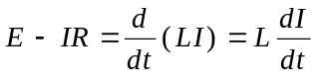,
In this case 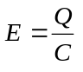, and 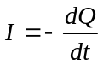. Therefore
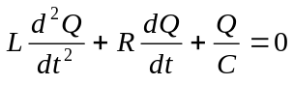.

The solution to this equation is
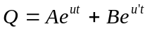,
where u end u' are the roots of the equation
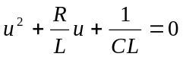,
or
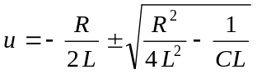.
Writing
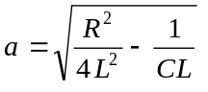,
so have
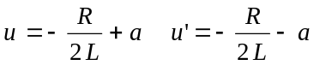
and
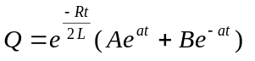,
where A and B are constants determined by the initial conditions, viz. that initially we have Q = Q₀, and I = 0, which give
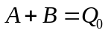, and 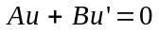,
or
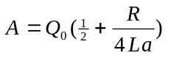, and 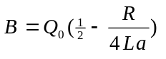.
Hence at any time we have
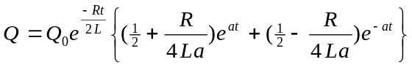.
Consequently the current at any instant is
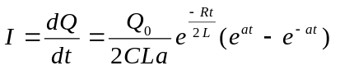.
Hence if a be real — that is, if we have 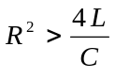 - the quantity Q will gradually diminish to zero as the time increases.
If, however, we have 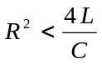, then a will be imaginary, and writing
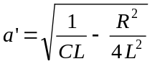,
the above formulas become at once
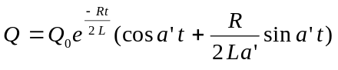,
and
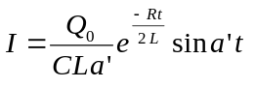.
In this case the current starts from zero and rises to a maximum; it then falls to zero and becomes reversed, after which 1t passes through a series of oscillations. The discharge therefore does not take place in a single flow from one coating to the other, but a back-rush sets in, and a series of currents, or oscillations. occur alternately in opposite directions.

The current attains its maximum intensity when
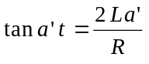 (maximum current)
The zero value of the current is reached when
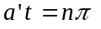 (zero current)
and consequently the charge at the same time is at its maximum, for we have 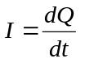. Thus the charge oscillates backwards and forwards, attaining positive and negative maxima after the lapse of equal intervals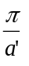, the time of a complete oscillation being
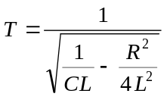
If the resistance be small compared with the reciprocal of the capacity we may use the approximate formula
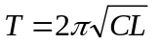.
The successive maximum charges occur when I = 0, or , they are therefore
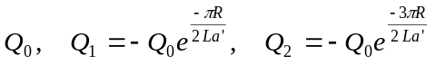.
The quantities therefore diminish in geometrical progression, and the energy of the charge diminishes correspondingly on each oscillation, being lost by radiation into space, or in heating the circuit, or both.
Whether the discharge is continuous or oscillatory therefore depends on whether 4L is less or greater than CR², and an oscillatory discharge may be obtained either by increasing L or sufficiently diminishing C and R.
These predictions of analysis have been confirmed, as Thomson suggested, by examining the spark, during discharge, by means of a revolving mirror. In Feddersen's experiments the image of the spark in a revolving mirror was viewed through a telescope. When the resistance of the circuit was high the spark was merely drawn out in width , that is, at right angles to its length; but when the resistance was sufficiently reduced, so that the oscillating discharge might occur, the band was reduced to a broken image consisting of a series of strips, each strip corresponding to a discharge.
In closing let me say to the scientific men who are, should we say, skeptical but not antagonistic to the Moray presentation and demonstrations. Do you believe that the demonstrations claimed to have been made by Moray have been made? If you do, why are they not enough to convince any man? Can you point out one way that they could have been faked that has not been overcome in the demonstrations? If you do not believe the demonstrations have been made as claimed, go and talk with those who have written the letters. There are too many reliable men who will tell you that they saw what is claimed and that the thing is as claimed. Now if you do accept the letters as genuine, what is the question? Moray fooled those for whom he has demonstrated? Man alive, Moray must be some fake to fool such electrical engineers and other electrical experts together with the one hundred or more intelligent men for whom this thing has been demonstrated more than one hundred times.
Every demonstration has been the same, and unless one is so prejudiced that he is bound he won't believe, how are you going to get around what has been done? If you won't believe, in fair mindedness you ought to be willing to point out why you do not. If you say because it is not in harmony with science, what does that prove? Nothing. What is Science? Is the world not every now and then forced to change its law on science, as we know them, to agree with proven facts? Saying a thing won't work when it has been working for many years is a rather strange way to answer a question. The fact remains these demonstrations have been given. No sane man can say they have not. Now then if they are not faked then they are what is claimed for them. If they are fake, should not the type of men who have made such detailed investigations been able to detect the fake? The accounts of these demonstrations have been stated in such clear, plain language that you who have any scientific training can see the demonstration just as clearly in your mind's eye as if you had the machine before you. Here are two poles, one wire for an antenna with insulators at each end. A ground is driven and one wire run over from that. The antenna wire and the ground wire are connected to the Moray device. All is complete; every part of the device is tested: no energy is there. The device is tuned and the antenna and ground in connection become alive with a very high frequency current and the things are done that the letters claim. What are you going to do about it? Do you not think that in fairness, unless you can point out one way in which that energy could have gotten there except as claimed for by Moray, that it is your duty to say, "The demonstrations as given establish this thing as a fact in spite of all our own ideas." If this thing has been done in such a way that it is impossible for a man to fake, then is it not a fact? And if no man can point out one way that it could be fake then what? Moray's answer is that as soon as any man can give one point that has not been covered, that leaves any room for doubt, then will he be willing to overcome that point. But if you cannot point out any weak points, and no one can, then there are none. Every point has been covered is the claim of the inventor. Why should he give "side shows" to any one unless they can point some new point which they can see has not been covered by what has been done? Just to satisfy each man by letting him see with no objective in sight is worse than wasted effort.
Men of science, if you will deal in facts, Moray will welcome your objections, but he can demonstrate until Dooms Day, he can write until the same and talk theory until we come to the point one Doctor of Science did when said that one hundred divided by one hundred fifteen equals three. All of that will not overcome the fact that these demonstrations have been given. They are facts and doubt will not overcome facts. It takes more facts. The facts required are drawings and explanations on some possible way these demonstrations could be anything but what is claimed by the inventor. And gentlemen, until this is done you cannot in reason expect Moray to take you seriously as he has looked in vain for a certain few to okeh this. When an instrument is in every section of this world of ours, maybe these last Thomases will have to give in. But, gentlemen, if you have no foundation for your claims that it can't be done, why try to build without a foundation? Doubt is no foundation upon which to build against a foundation of facts upon which a house of facts is built.
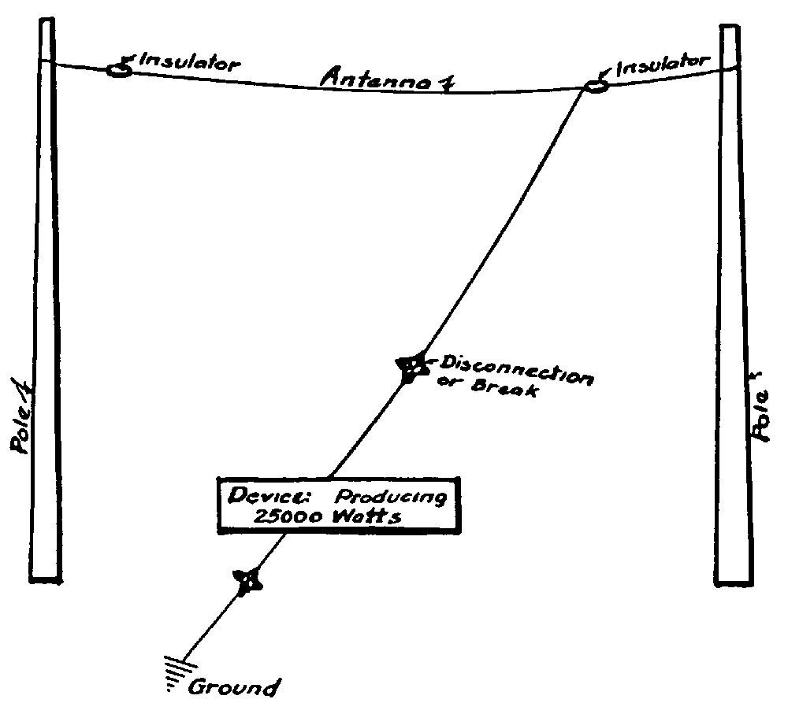

Stars give idea of where the antenna and ground has been disconnected in the accounts gives of the demonstrations, and in each case the lights go out and a heavy brusb discharge leaps many inchs between the points of disconnection. It the connection is again made at once, the light again appears, but if the connection is meat nude at same the device becomes electrically dead, and must again be tuned in and the oscillations started before the device will operate. Standard light globes and beating appliances are used. No change of house wireing being necessary. Such demonstration, have been made mils away from all power lines, and on antennas sod grounds erected by those for whom demonstrations were being made.
2484 South Fifth East Telephone Hyland 868

Moray Scientific Laboratories
Dr. T. H. Moray
SALT LAKE CITY, UTAH

Gentlemen:

At the time of this writing another year of research is about to close on my efforts with "Radiant Energy." During the year the capacity of this discovery has been increased over 2000 times what it was a year ago and greatly simplified. During the past five years many men of Science have come from foreign countries and from the east and west and have been given demonstrations and not one of them has been able to find any fault with what they have heard or seen. Names of these Doctors of Science will be furnished upon request. These men have had the device opened for their inspection and have pronounced the demonstrations wonderful, that the current is high frequency, the color of the light different, that the device carries over six times as much current without even getting slightly warm as any other electrical device of like construction known to man today could do without bursting into flame. That the tubes used are far more powerful than anything known to science today. The drawings, circuits and theory have been pronounced by leading men of science as scientifically, electrically, mechanically sound and correct.
I welcome and invite any man or group of men to meet me and dispute my claims or show even any slight inconsistencies in my discoveries or the theory upon which they are based. All have stood the severest tests o f inspection and being based on facts will stand every test that can be devised. This statement is made without reservations of any kind whatsoever.

Very truly yours;

(Signed) T. H. MORAY.

© Verzió: 1.01 (2004-05-14)

Sir William Thomson, Phil. Mag. June, 1853.
If the capacity be expressed in electrostatic measure and the self-induction in electromagnetic, this expression takes the form 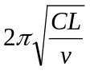where v is the velocity of light.
For an account of the researches made in this department see Wiedemann's Elektricitat, vol. iv. pp. 177, etc.
Ó Minden jog fenntartva az elektronikus verzióval kapcsolatban! Szerkeszti: Varsányi Péter (Pepe) E-mail: varsanyi@axelero.hu Külön köszönet Tax Istvánnak <tixi58@yahoo.com> az OCR munkáért!

