Challenging viewpoint
November 1991 Electronics Wireless World
By Ove Tedenstig Maersta/Sweden
Anyone trying to call the invariant velocity-of-light dogma into question, is invariably attacked be Einstein's supporters who will use any method to defend the prevailing view. The fact that light is a physical phenomenon, behaving as it does independently of Einstein's theories seems to make no difference.
Light travels very fast and that is one of the problem behind performing measurements with high accuracy, especially if moving light sources or moving observers are involved. So Doppler shift measurement are used, whereas in fact distance/time measurement would be the most suitable.
Doppler wavelength/frequency shift measurements are indirect methods and can be rejected as invalid by Einstein's supporters who say that the product of frequency and wavelength is always equal to c.
But distance/time measurement would be possible using satellites.
Picture psatelli.gif
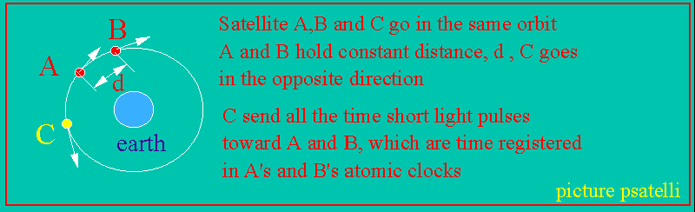

Consider satellites A,B and C moving in the same orbit around the earth. A and B moving in the same direction with constant relative velocity and C moving in the opposite direction. C satellite emits radio or light pulses continuously and A and B catch these signals and register their arrival time in computer data registers.
The local time registrations of each pulse in each satellite is continuously transmitted to Earth and the time difference of received data is calculated.
When C satellite approach A and B, the time A-B will be : t1 = S/(c+k.v) and when receding t2=S/(c-k.v), where k=0 if Einstein's invariant light hypothesis is valid and k=1 of the emission theories (c'=c+-v) is valid. S is the relative distance between A and B.
Calculated time difference will be t1-t2 equal to: dt=2.S.k.v/(c(2)-k(2).v(2)) or dt = 2.S.k.v/c(2) approximately. ((2) stands for rised to exponent 2 editor limitings)
Inserting figures- where v= 30.000km/hour or 8333m/s, c = 3E8 m/s and S=100km, k=1, gives approximately 18.5ns (nanoseconds). If the distance is increased to 1000km, the difference will be 185ns, or nearly 0.2us, easy to detect and establish. As everyone can see, if Einstein's hypothesis were true, the time difference would be zero.
Who will believe that ?
By this experiment, the question of the velocity of light and the velocity of radio wave propagation would be solved once and for all, relegating this tiresome question and Einstein's theories to the lumber room of failed scientific ideas where it belongs.
Ove Tedenstig, Maersta Sweden
=====================================================
Science and Einstein's dogmas
This text was presented in Electronics Wireless World 1988
In EWW for March, 1988 J.C.G. Field comment on Einstein's theory of relativity on the basis of physical effects of moving bodies and clocks. Referring to such effects is a common method when defending this theory instead of answering the criticism.
The mass-increase phenomenon was initially discovered by Kaufmann in 1901 in cathode-ray experiments, and not predicted by Einstein's theory. It is known that H.A.Lorentz and Abraham Pais had suggested a theoretical formula for it, the formula which the particle physicists uses today (hence not Einstein's origin formula, my comment)
The relation E=mc.(2) was also known and suggested by Poincare', Hasenöhrl and Langevin independently of Einstein and before him. It is even known that the time-dilation effect was suggested by Larmor in 1900 and the hypothetical length-contraction effect by Lorentz and Fitzgerald some years before. Poincare' was the inventor of "the principle of relativity" as reported from an international congress of Physics at St.Louis, USA, in 1904. The mathematics of space and time was developed by Lorentz.
Obviously the adduced effects as referred to in the theory of relativity can be deduced from other starting points having nothing with to do relativity and not necessarily erroneous. Hence, we may ask: "What have these physical effects to do with relativity?
The theory of relativity has been criticized mainly on the basis of its variant light hypothesis, the hypothesis constituting the base of the theory. Einstein himself said: "If the speed of light is in the least bit affected by the speed of the light source, then my whole theory of relativity and theory of gravity is false". Dedicated relativists try to muddy the water by talking about other things when this criticism appears, neglecting what the critics are trying to say: if the base hypotheses of a theory are not correct, the predicted imaginary physical effects of the theory cannot be correct. Dedicated relativists seems to have real difficulties in accepting this simple and obvious fact.
Ove Tedenstig Maersta/Sweden 1988
==============================================

