By Ove Tedenstig/Sweden
Date 4/6 1999
For further information, see:
http://www.newphys.se/elektromagnum/physics/Tedenstig/own

The basic principles of gravitation
Picture GSIDAN1.gif
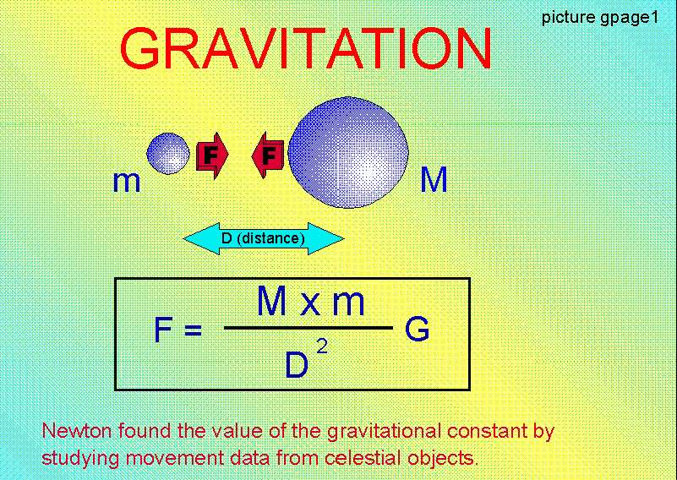

Picture GSIDAN2.gif
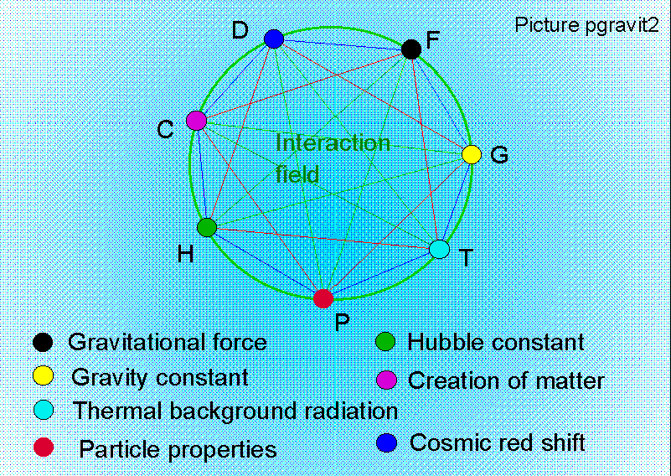

Picture GSIDAN3.gif
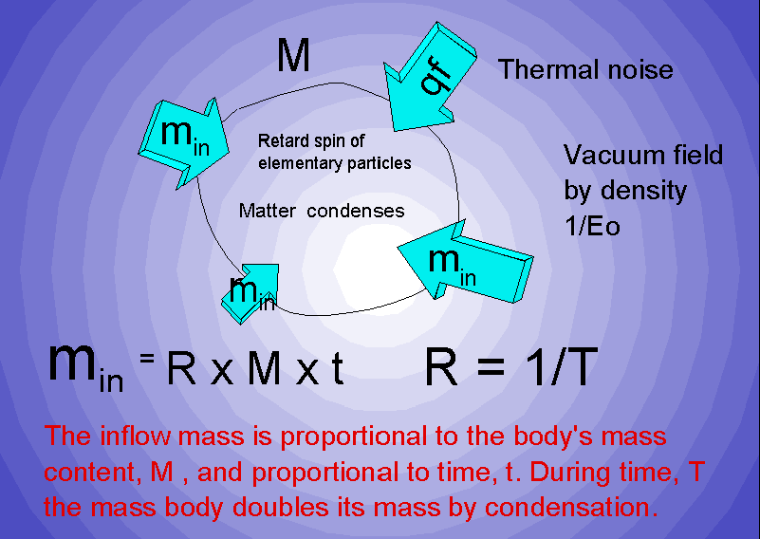

Picture GSIDAN4.gif
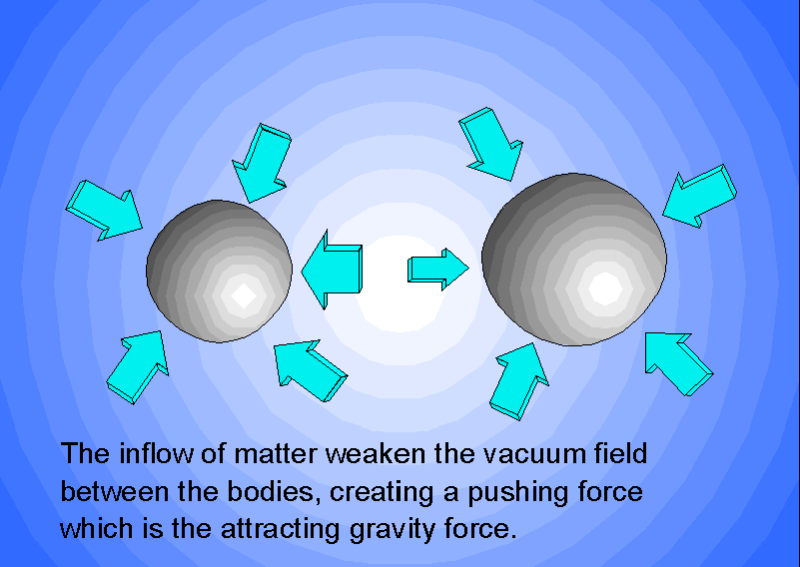

Pictyure GSIDAN5.gif
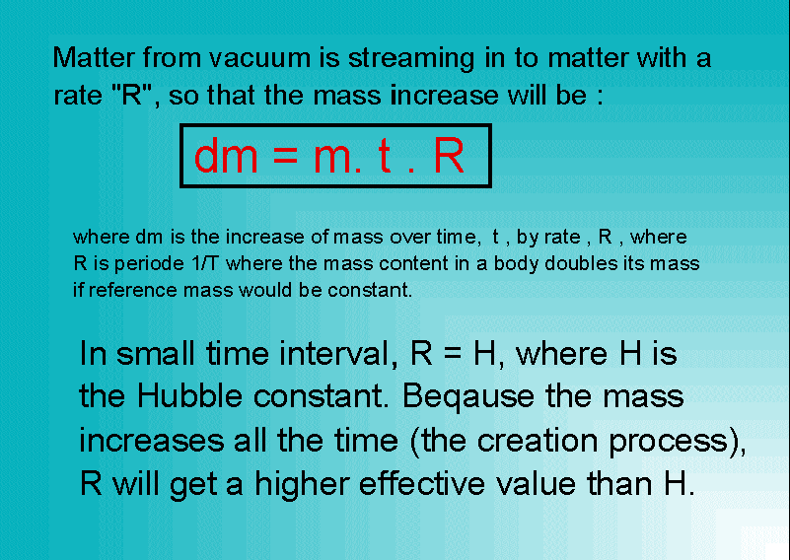

Picture GSIDAN6.gif
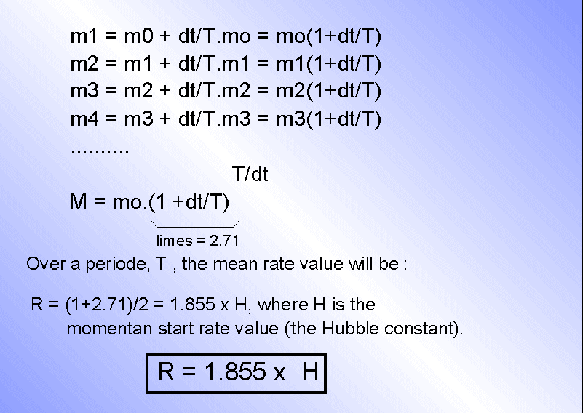

Picture GSIDAN7.gif
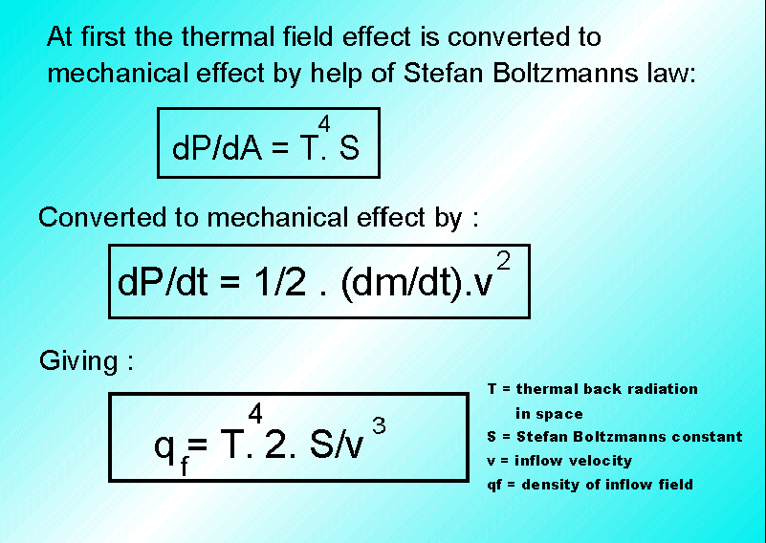

Picture GSIDAN8.gif
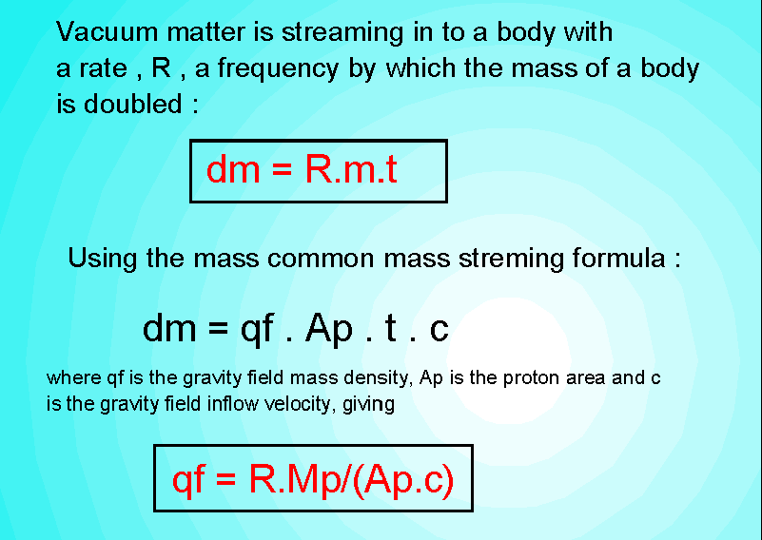

Picture GSIDAN9.gif
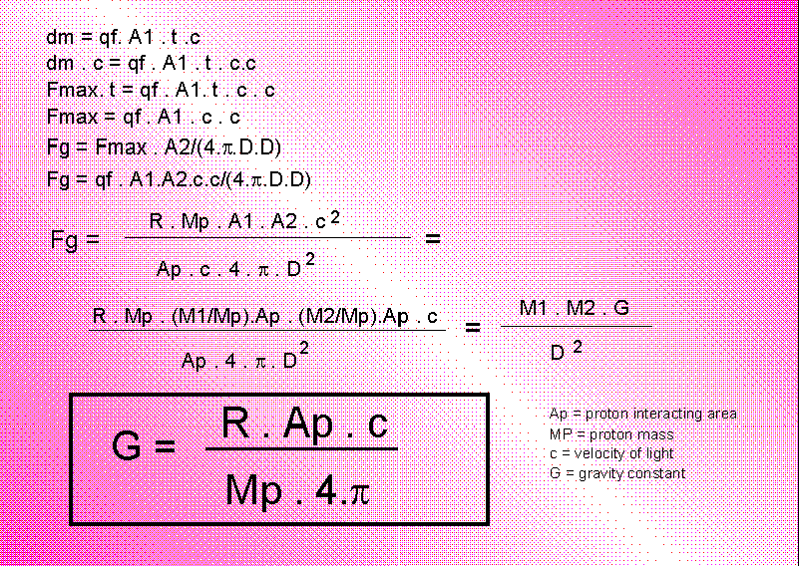

Picture GSIDAN10.gif
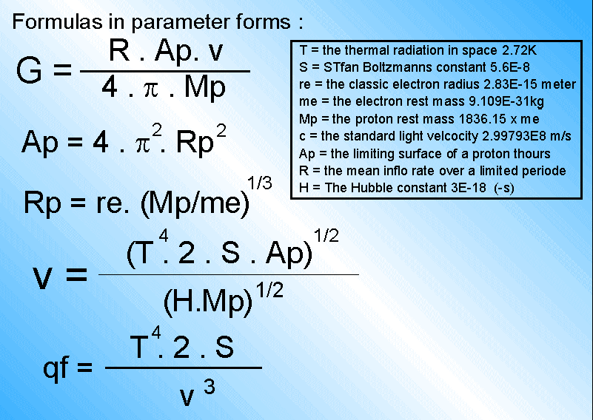

Picture GSIDAN11.gif
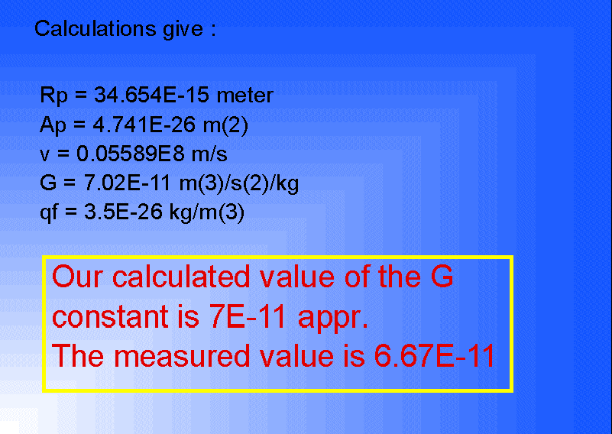

End of file

