Picture Wimps.gif
New Scientist 11 February 1995
n=1 M=m_{e}.(n.π)³
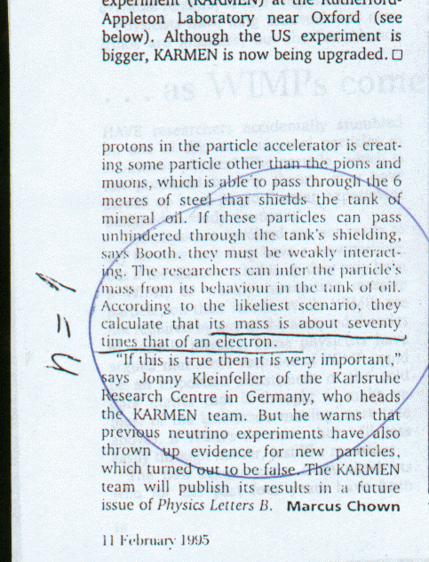

Picture Muon.gif
Cern1 Data booklet
^{n=2 M=me.(n.π)}3
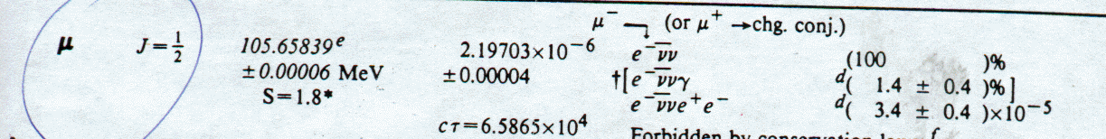

Pictrue Kaon.gif
Cern Data Booklet
^{n=3 M=me.(n.π)}3
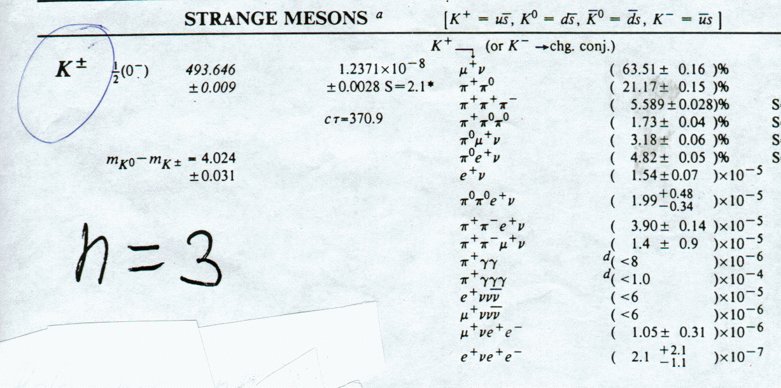

Picture Proton.gif
Cern Data Booklet
^{n=4 M=me.(n.π)}3
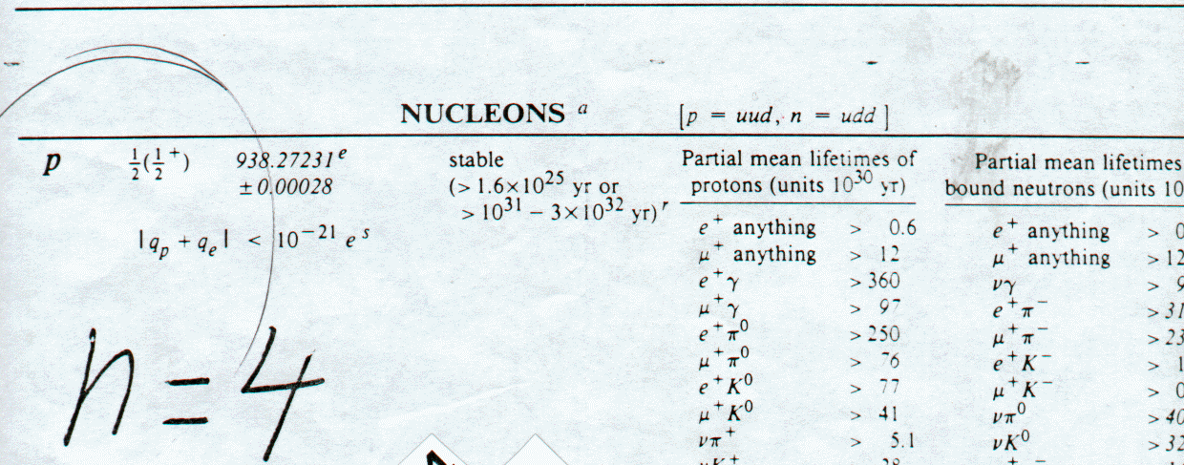

Picture Tau.gif
Cern Data
^{n=5 M=me.(n.π)}3
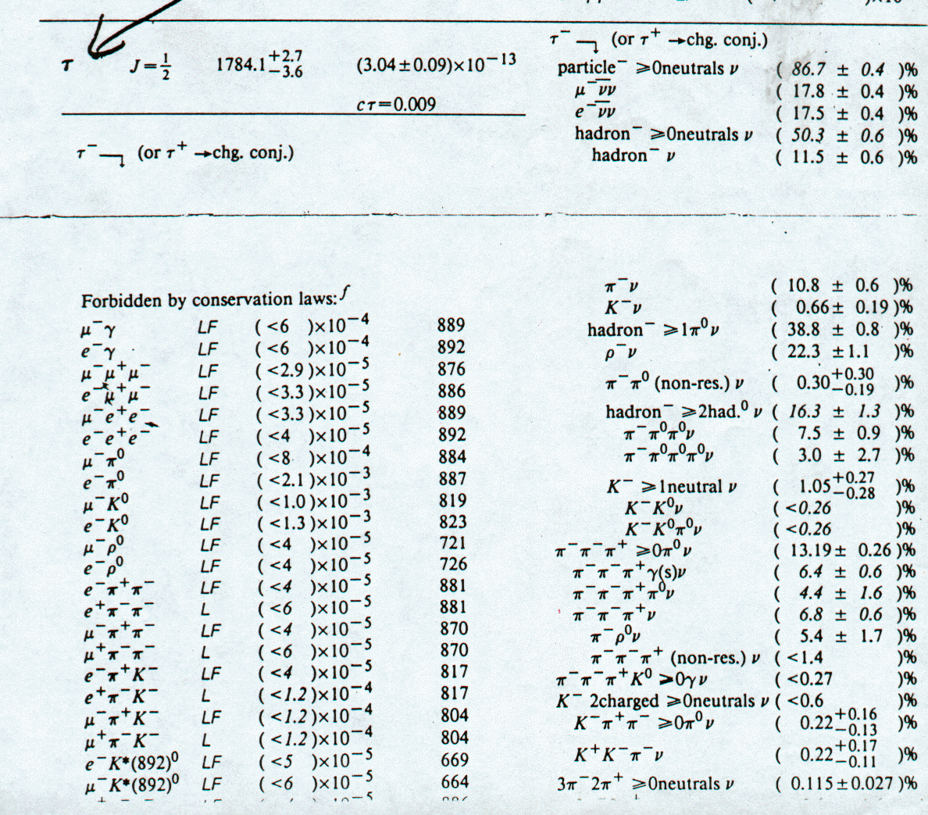

Picture Kosmos1.gif
Kosmos Sweden
n=6 M=m_{e}.(n.π)³

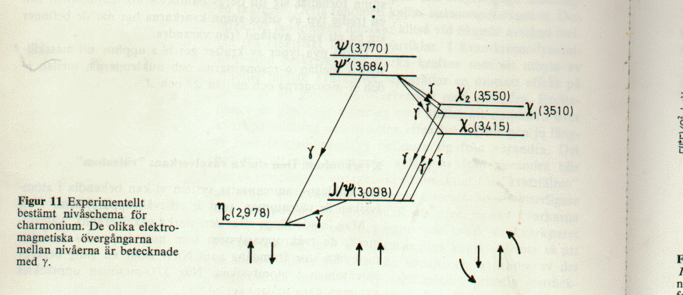

Picture Kosmos2.gif
Kosmos Sweden
^{n=6 M=me.(n.π)}3
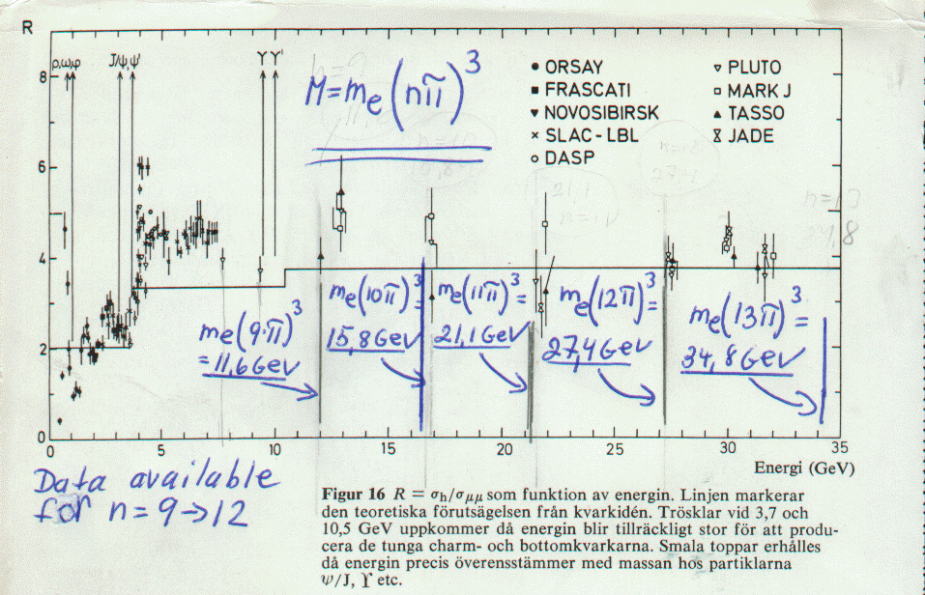

Picture Eta.gif
New Scientist 23 October 1980
^{n=6 M=me.(n.π)}3
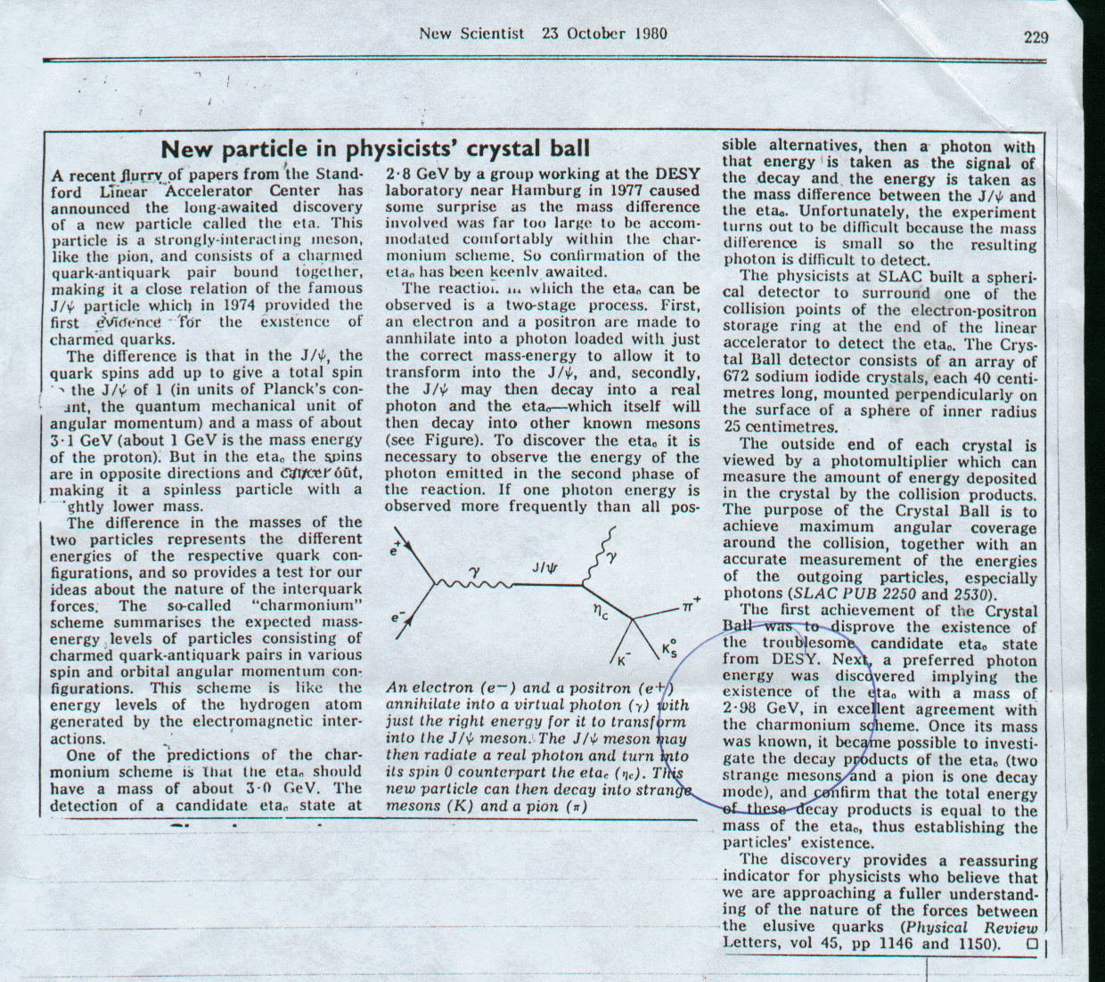

Picture Bmeson1.gif
New Scientist 14 April 1983
^{n=7 M=me.(n.π)}3
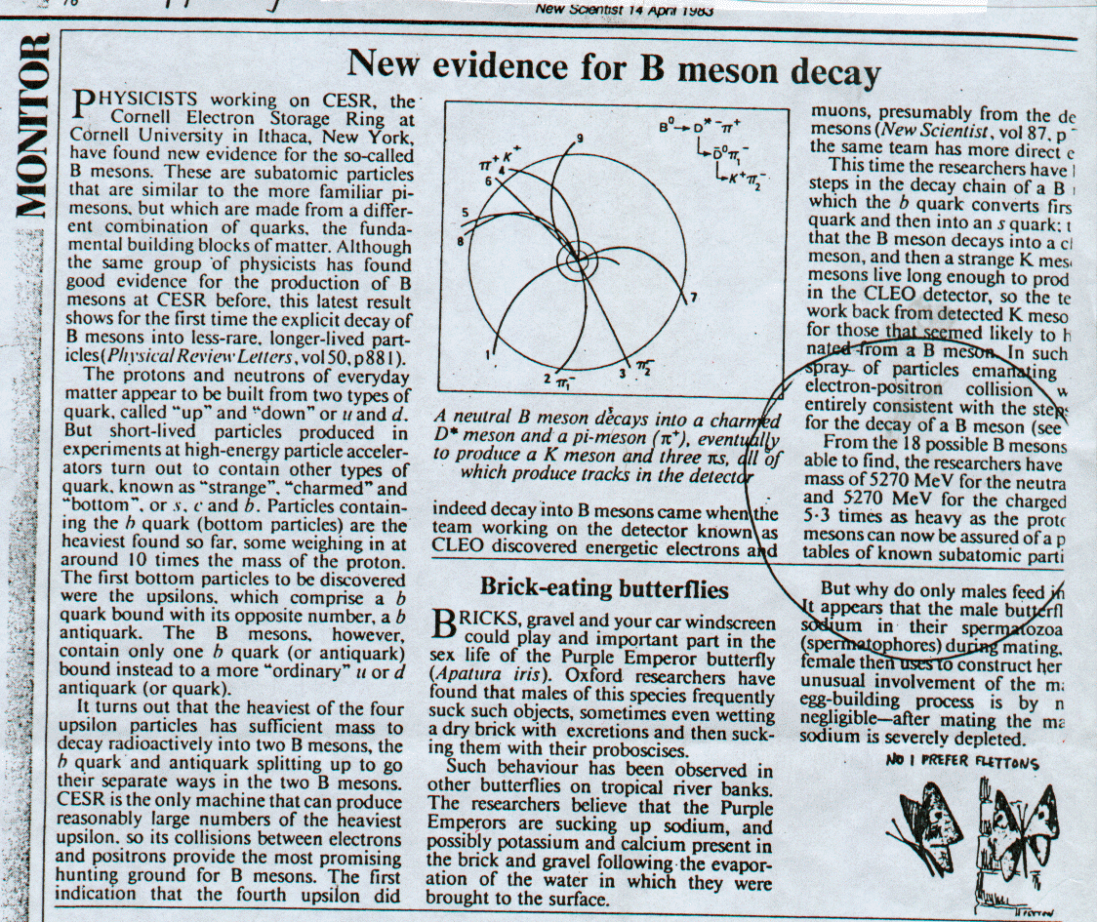

Picture Bneson2.gif
Cern Data
^{n=7 M=me.(n.π)}3
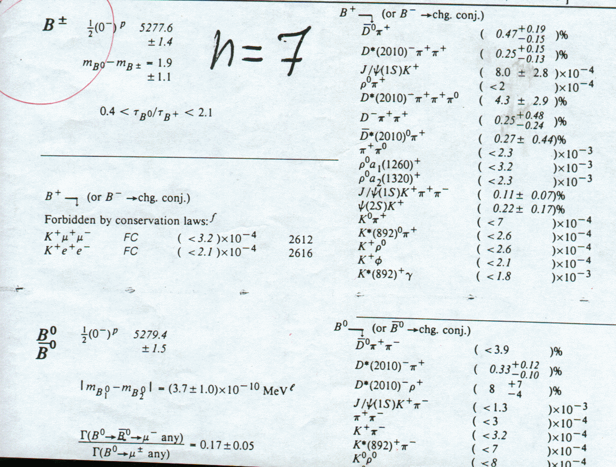

Picture zeta1.gif
Ref ??????????
^{n=8 M=me.(n.π)}3
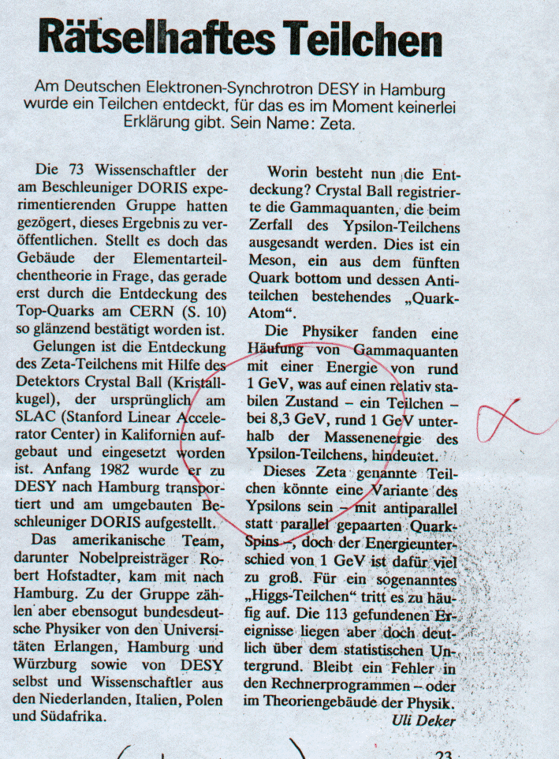

Picture zeta2.gif
New Scientist 16 August 1984
^{n=8 M=me.(n.π)}3
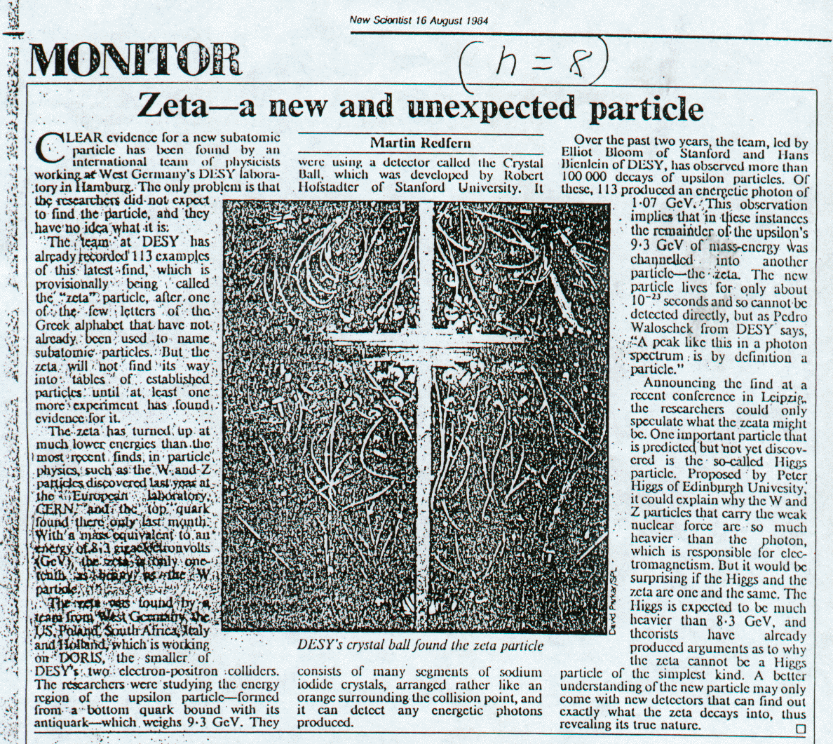

Picture Glue1.gif
New Scientist September 1980
^{n=9,10,11,12 M=me.(n.π)}3
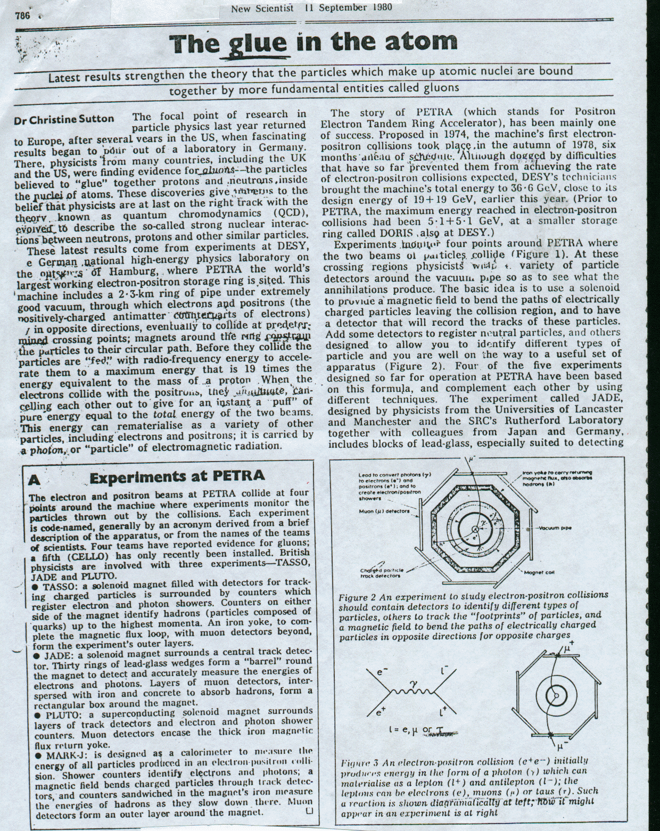

Picture Glue2.gif
New Scienstist 11 September 1980
^{n=6,9,10,11,12 M=me.(n.π)}3
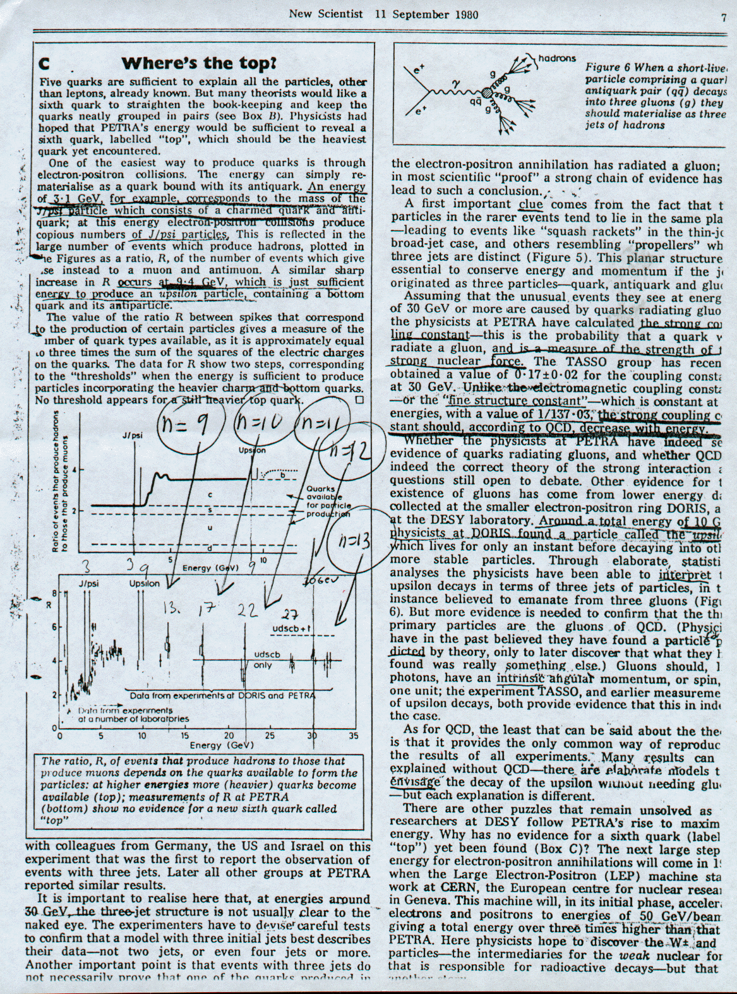

Picture Glue3.gif
New Scientist 11 September 1980
^{n=6.9,10,11,12 M=me.(n.π)}3
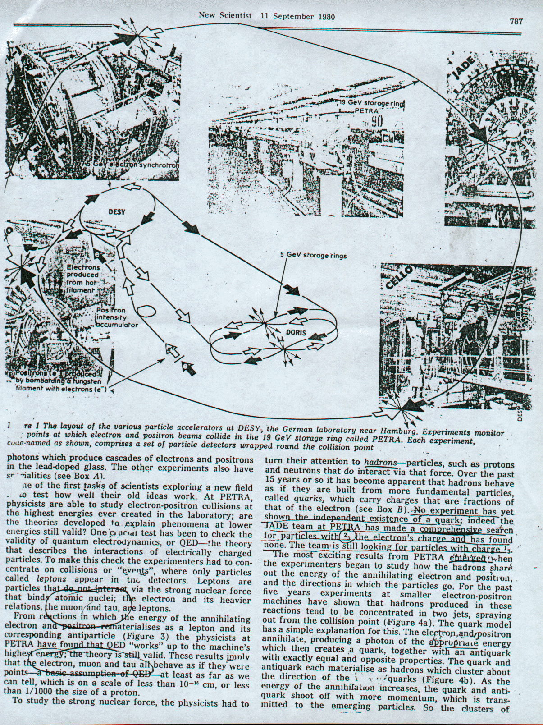

Picture Glue4.gif
New Scientist 11 September 1980
^{n=6,9,10,11,12 M=me.(n.π)}3
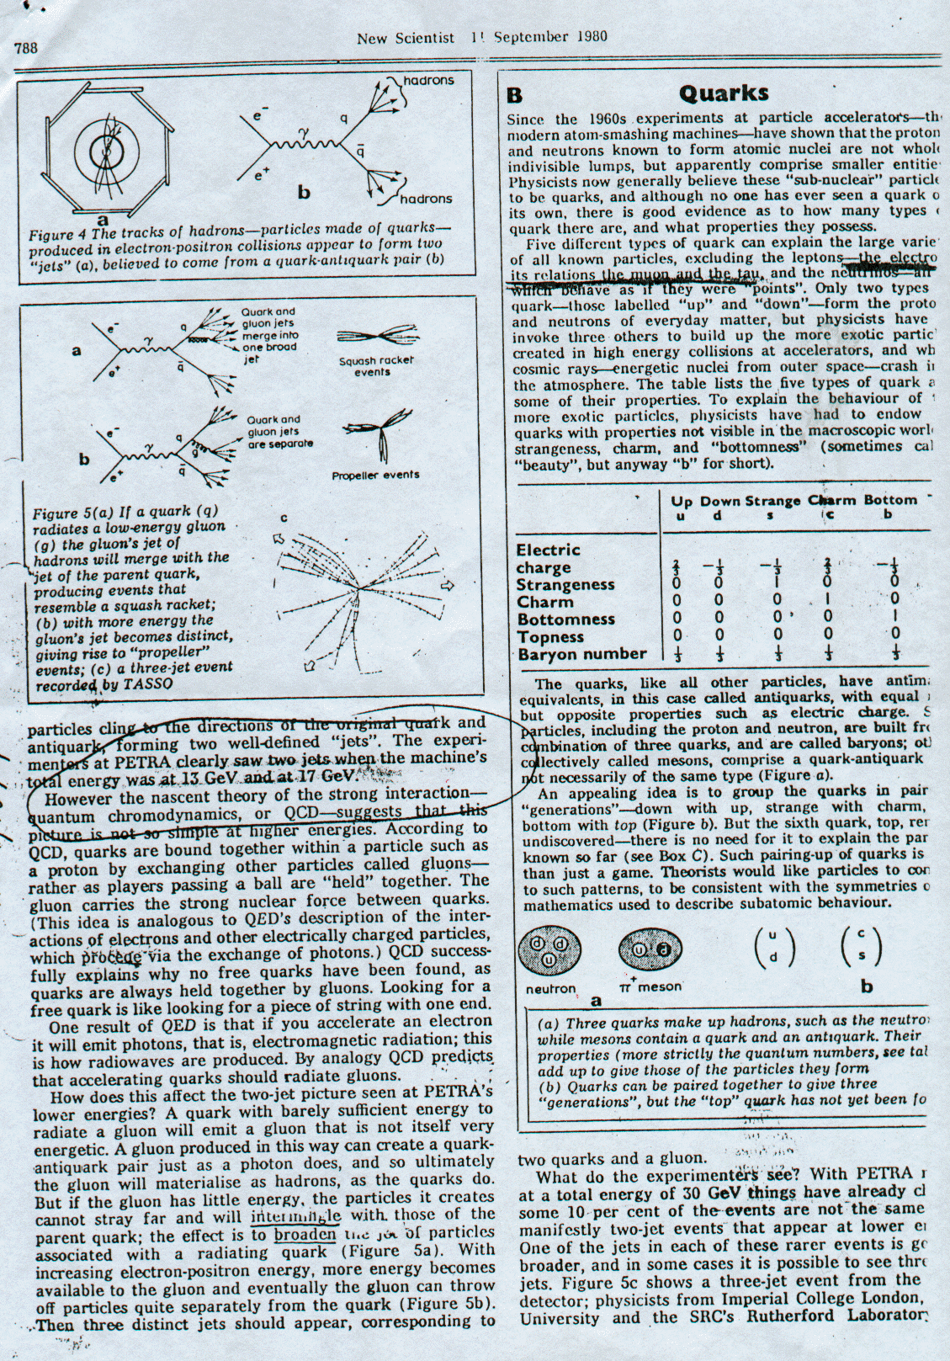

Picture Kosmos1.gif
^{n=6,9,10,11,12 M=me.(n.π)}3

Picture Mystery.gif
New Sceintist 25 May 1984
^{n=14 M=me.(n.π)}3
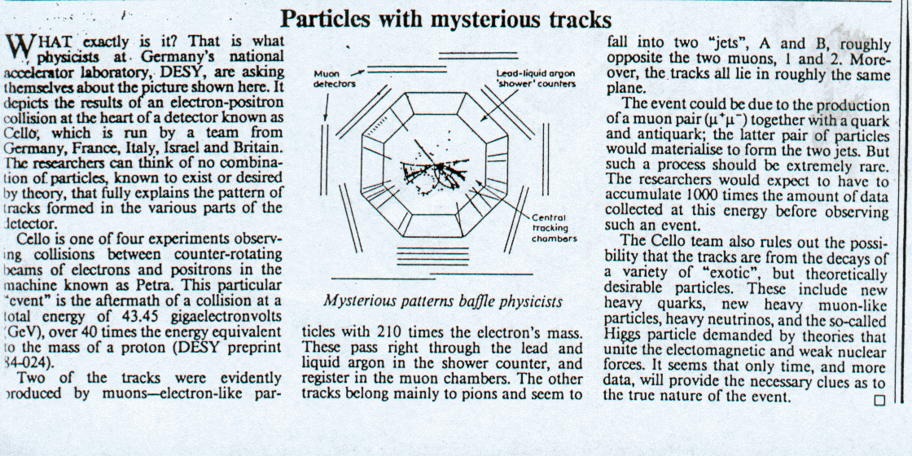

Picture Desy.gif
Uppsala Nya Tidning 2000
^{n=14,15 M=me.(n.π)}3
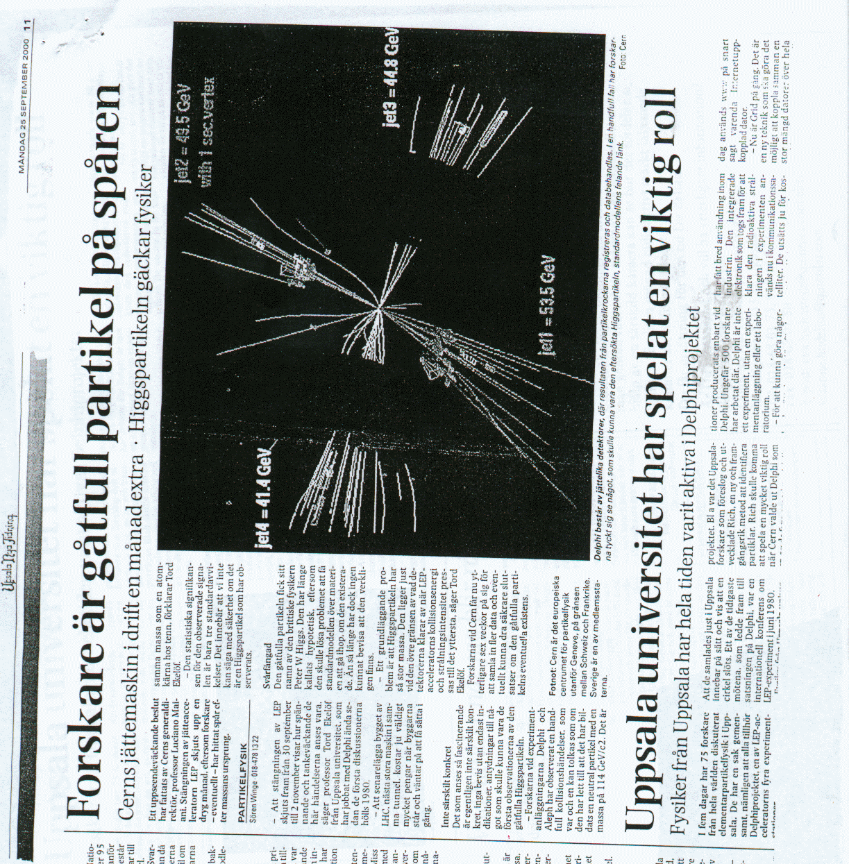

Picture Wz..gif
Cern Data
^{n=17,18 M=me.(n.π)}3
