BASIC PRINCIPLES BEHIND THE QUANTUM BEHAVIOUR OF THE ATOM
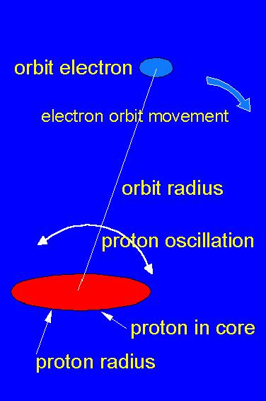 | In the simplest atomic system  (the hydrogen atom), the core is  a single proton particle and the  orbital particle is an electron.  Between these particles acts an  electrical force. Both particles  have mass, and of that reason  even mass inertial forces act  on them. The electrical force  is polarized and of that  reason the proton oscillates  in the common electrical  field.
This simple model leads to all quantum mechanical formulae known from quantum mechanics, explain Bohr's quantum mechanical relation m.v.D = h/(2.Pi) as well as deriving Planck's constant and the fine structure constant.
More about all that, see "Matter Unified" on the webb http://www.newphys.se/elektromagnum/physics/Tedenstigg/own
Email: ove.tedenstig@swipnet.se

