MATTER UNIFIED

ISBN 91-9738 18-1-0

“DO A PAPER BOOK”

- Written by Microsoft Word Editor
- Pictures edited and produced by
- Lotus FreeLance Graphics
- Pictures edited by Agfa PhotoShoop
- Data program by Borland Turbo Pascal and Borland C++ Builder
- PC operative system Windows 2000

The book contains the following chapters and sections:

Front cover pages 04

Content 16

Preface 08

Introduction 24

Chapter 1 basicc oncepts 74

Chapter 2 vacuum space 68

Chapter 3 the electric field 62

Chapter 4 the magnetic field 42

Chapter 5 Maxwell’s equations 38

Chapter 6 quantum theory 86

Chapter 7 the atomic core 66

Chapter 8 the nature of light 160

Chapter 9 gravitation 50

Chapter 10 singular particles 68

Chapter 11 complex particles 28

Chapter 12 properties of particles 36

Chapter 13 Einsteins theory 90

Chapter 14 fimensional analysis 16

Chapter 15 references 08

Epilogue text 02

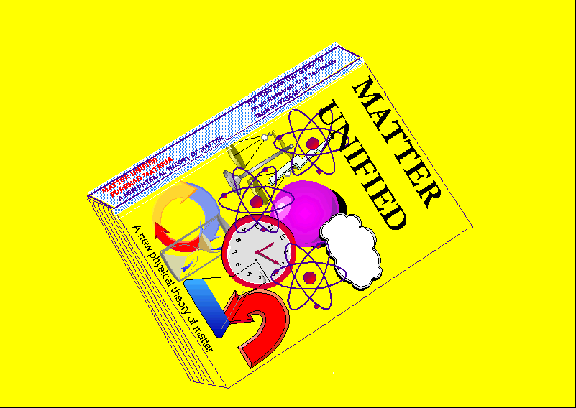

- Number of pages total 946
- Double side printing
- Odd numbering on front side
- Even numbering on back side
- HP “photosmart” 7200 series printer for single book printing
- HP Laser/Toner Jet printer for a larger amount of copies
- Use 80 gram/m² standard A4 size paper
- Cut papers in size 17 x 22,5 cm
- Collect all pages and press together
- Apply strong rubber-glue on the back , let it dry
- Apply a cotton textile dryed with rubber glue on the same side, let it dry
- Apply the front page and back page and “rygg” page.

- Apply a transparent plastic cover for preventing dust destroying the book when handling. The folio may be an “over-head” photo film plastic sheet.

- The book is complete

- If interested to in some form supporting or sponsoring me in my scientific work, you are welcome to do that. My intension is to some time printing my theory as a paper-book for access to the open market, but for time being that is impossible because of economical reasons.

- Ove Tedenstig
- Idungatan 37
- 19 551 Maersta
- Stockholn/Sweden

