2-3 Milestone: Project Proposal
By, Eric Sawyer

2D scene to replicate:
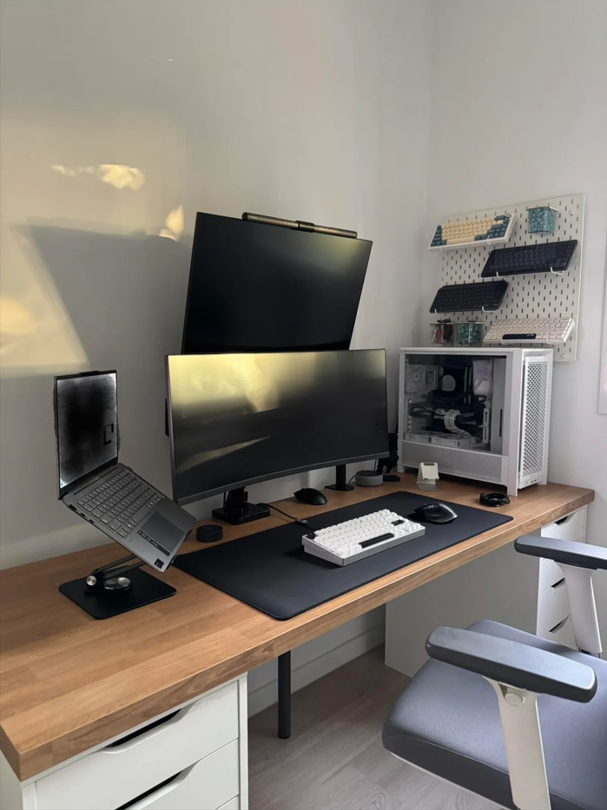
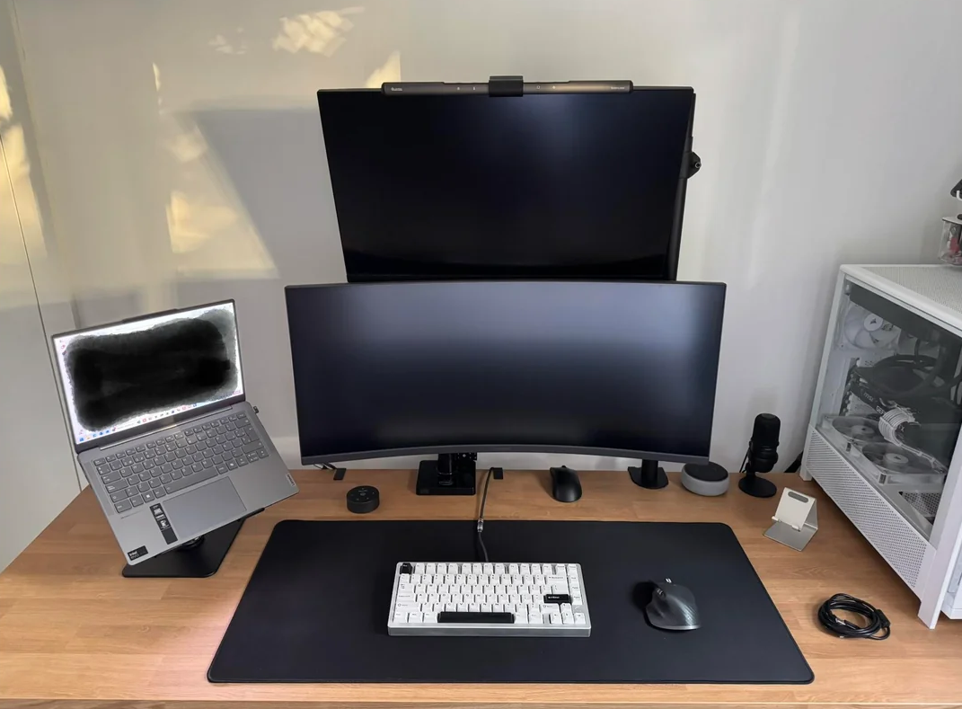
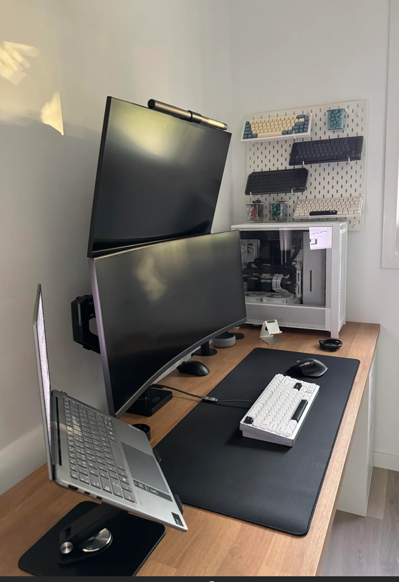

Selected 2D Scene: Computer Desk
The scene I chose to use for 3d replication is a computer desk setup designed for productivity and gaming. The desk setup includes multiple monitors, input devices, a laptop, and a desktop tower arranged on a wooden desk surface. As well as some extra equipment on the wall. Multiple reference photos were taken from three different angles to capture the spatial relationships and shapes of all objects.

Objects that will be replicated in 3D:
1. Wooden Desk
The desk serves as the foundation of the scene and acts as the ground plane. This wooden surface is approximately 4-5 feet wide and 2 feet deep. The desk is essential to the composition as it grounds all other objects and provides spatial context.
2. Desktop Monitors
The monitors are the most prominent object in the scene. They feature rectangular display screens with a curved design. This is an ideal object for 3D modeling because it clearly demonstrates the combination of multiple basic shapes, as boxes for the screen bodies and a cylinder for the stand.
3. Keyboard
The white mechanical keyboard is a well-defined rectangular object positioned on the desk. Its simple geometric form makes it ideal for 3D representation and helps establish the workspace scale.
4. Computer Tower
The PC case is an object that demonstrates composite shape creation. It features a main box body with cylindrical ventilation areas and rectangular panels, making it a good choice for practicing multi-shape assembly.
Supporting Objects: Laptop, mouse, mouse pad, and cable organizers complete the scene.

3D Shapes Used
The scene incorporates the following basic 3D shapes:
- Plane (desk surface)
- Box (monitors, keyboard, PC case)
- Cylinder (monitor stand)
- Cone (speakers)

Explain which basic 3D shapes will be used to replicate the 2D objects
Wooden Desk
Shape: Large rectangular horizontal plane. The plane acts as the ground and reference surface for all other objects. The plane fulfills the requirement to include at least one plane in every scene and serves as the foundation for spatial grounding.
Desktop Monitor
Screen Body: Box (rectangular prism). Monitor Stand Base: Cylinder (circular pedestal). Stand Pole: Cylinder. The monitor decomposes into a rectangular screen (box) and cylindrical support structures, demonstrating composite modeling and meeting the requirement of one object made from multiple basic shapes.
Object 3: Keyboard
Shape: Box (rectangular prism). The keyboard's simple geometry makes it straightforward to model while providing clean visual definition and another way of establishing workspace scale.
Object 4: PC Case
Main Chassis: Box. Front Ventilation Panel: Cylinders (arranged in grid to represent vent holes). Top Panel: Box. The PC case is the most complex object, demonstrating how multiple basic shapes combine to create realistic detail. This will require the most complex composition to replicate.

