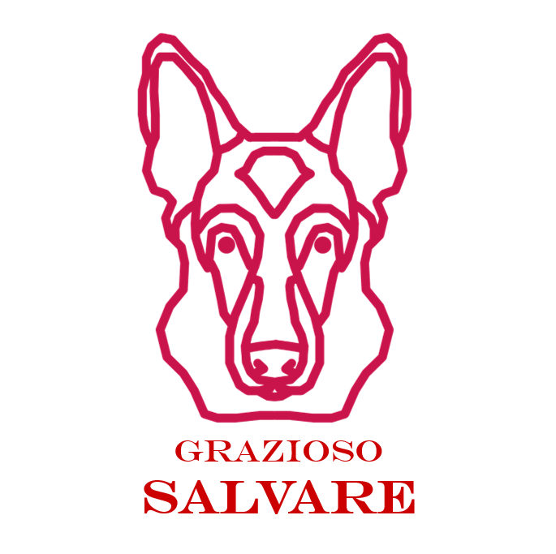

Grazioso Salvare Dashboard README
Eric Sawyer | 2026-10-18
Purpose and Functionality:
Global Rain's dashboard helps Grazioso Salvare screen Austin Animal Center outcome records for search-and-rescue training. Initial load retrieves all records through AnimalShelter.read({}). Water, Mountain or Wilderness, and Disaster or Individual Tracking selections issue fresh model queries. Reset restores the unfiltered records and clears table search, sorting, selection and page. The source and record count are always labeled. Historical outcomes do not establish current availability.
The read-only table offers native per-column filtering, multi-column sorting, ten-row pagination and single-row selection. Filter examples: type Dog in Animal Type, or >= 26 in Age Upon Outcome In Weeks. The geolocation chart reflects all matching table rows, or the selected row; Clear row selection returns the map to all visible records. The horizontal breed chart summarizes the top ten breeds and an Other breeds total across all filtered pages, not only the displayed page. The logo links to https://www.snhu.edu and the header identifies Eric Sawyer.

Screenshots:
- Initial dashboard state
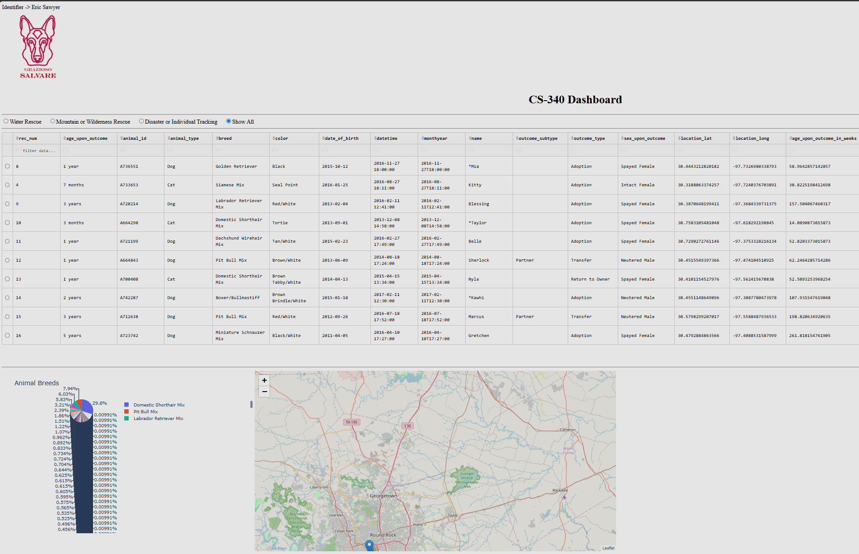
- Mountain or Wilderness filter applied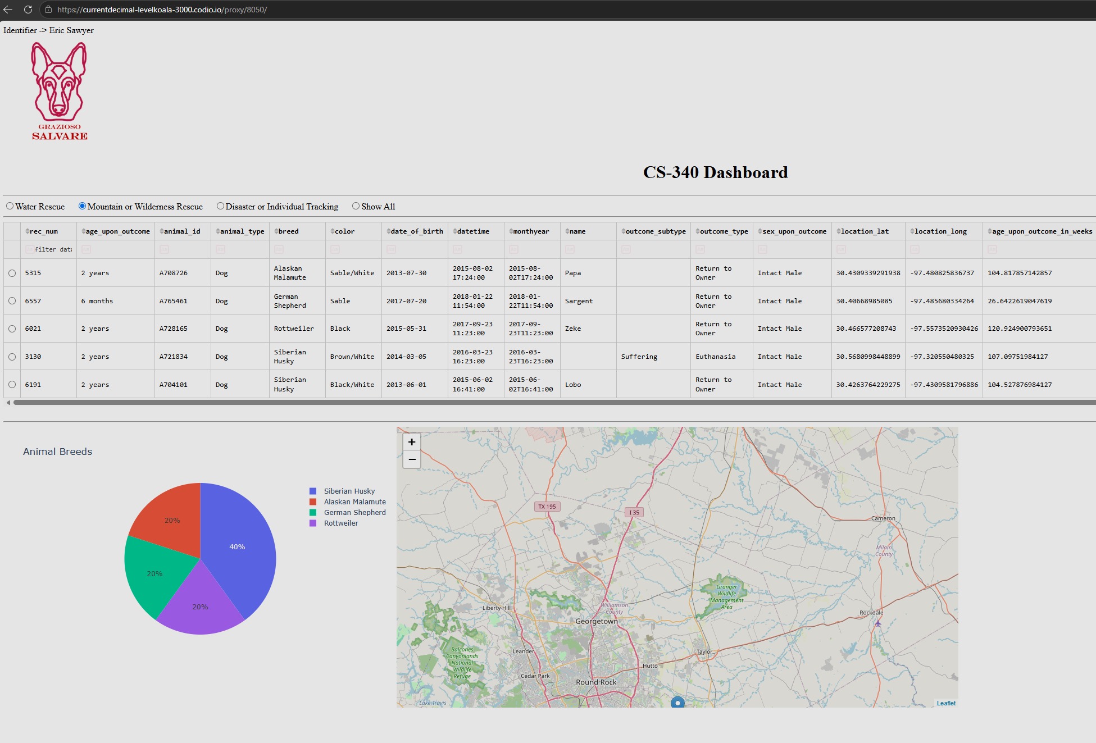

- Disaster or Individual tracking filter applied
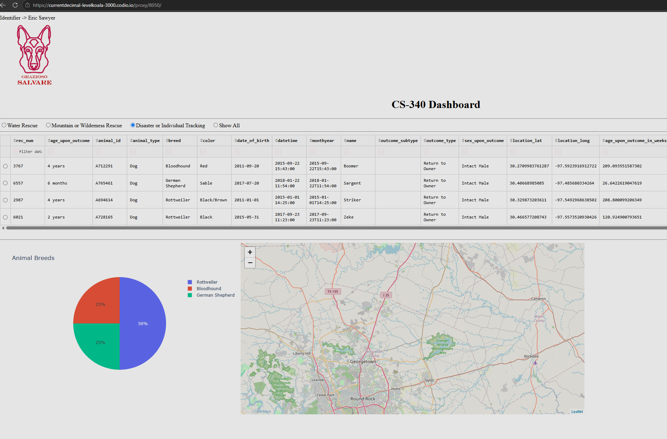
- Water Rescue filter applied
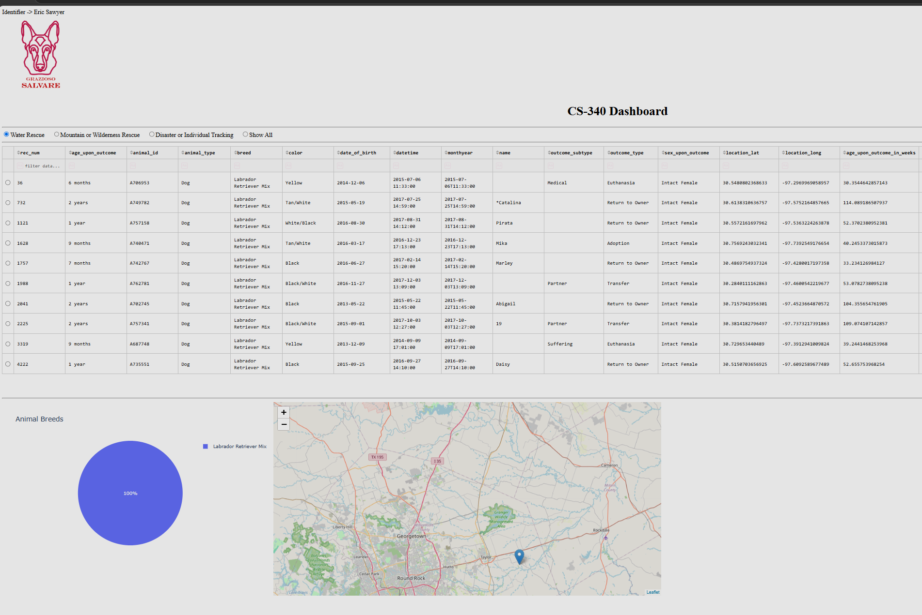

Tools Used:
MongoDB stores flexible BSON documents; PyMongo maps dictionaries to query documents and exposes CRUD operations in Python. Numeric range queries, regex breed matching and projections support the screening workflow. The AnimalShelter class is the only database access layer.
Dash HTML components, DataTable, and Plotly figures provide a browser UI without a separate JavaScript application. Dash callbacks turn rescue selections into MongoDB queries. Reset clears client table state as well as the database query. The map uses named fields and excludes invalid coordinates; empty results and missing coordinates produce messages instead of index errors.

Steps and challenges
- Reviewed All Materials: I kicked things off by thoroughly reviewing the project instructions, the reference notebooks, my original CRUD module, the CSV schema, the logo, and the new four-page Dashboard Specifications Document.
- Built Out the Target Queries: I successfully translated the specific rescue criteria and preferred dog breed combinations into functional database filters on the dashboard.
- Polished the User Experience: I made sure all the dashboard components stay perfectly in sync. I also added a smooth Reset button, handled edge cases like sorting data or empty states, and ensured that if a database error happens, the app displays a clear error message instead of confusing the user with an incorrect "no matches found" notice.

