A single cycle processing unit done for our finishing project on EC413.

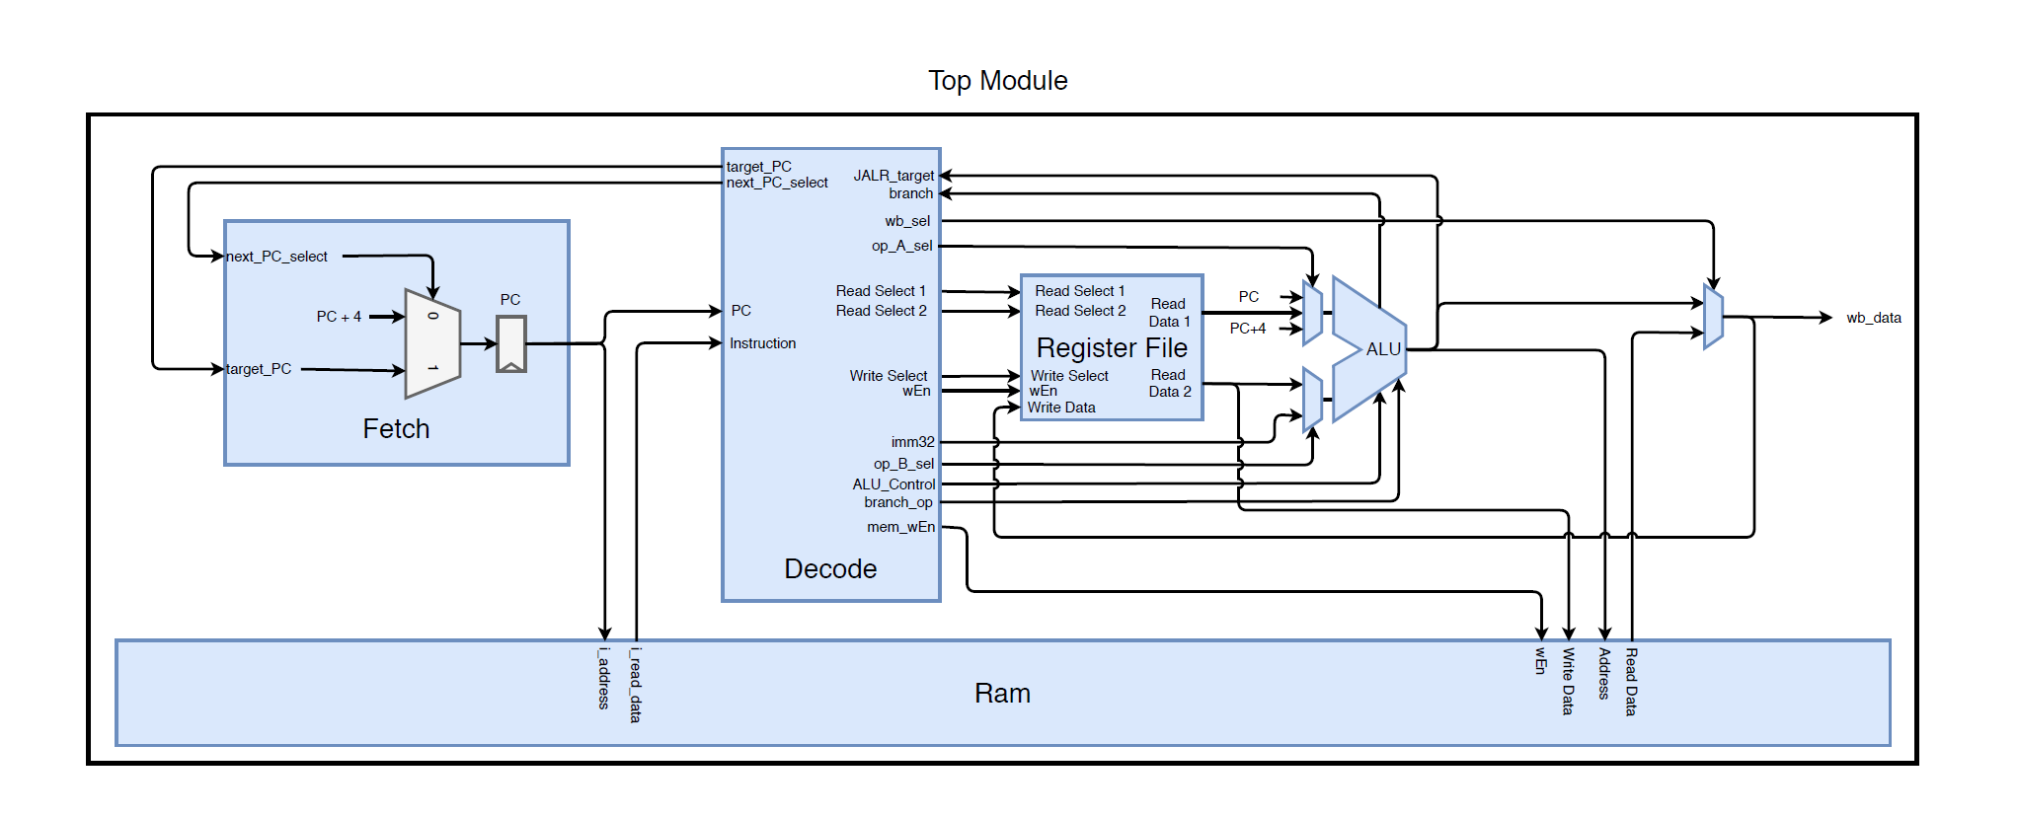The top module is based on this diagram: