Chapter 5 Evidence Pack
Outline, screenshots, test-case tables and results data for Chapter 5: System Implementation
Esborn Kihiu · evidence captured on the lab on 15 October 2026, 23:40 to 23:55
This pack is source material, not chapter text. The outline lists what each section should cover and which evidence supports it; the screenshots are real full-screen captures from the lab; the tables record what the lab actually did. Write the chapter paragraphs yourself, in your own words, and follow Strathmore's rules on acknowledging AI assistance.

1. Outline of Chapter 5 (guideline structure)
Headings follow the guideline report's Chapter 5. Under each heading: what to cover, and the evidence in this pack that supports it.

5.1 Introduction
- Purpose of the chapter: how the system was built and how it was tested against the requirements (Table 3.2).
- What the reader will find: modules, environment, test cases, detection results, discussion.

5.2 System Implementation

5.2.1 Key modules of the system
- Table of modules and their purpose: Table A in section 3 of this pack.

5.2.2 Development environment
- Hardware: one laptop, Kali Linux (kernel 7.1.5), 7.1 GiB usable memory.
- Software and versions: Docker; Containerlab 0.81.0; Arista cEOS-lab 4.36.2F; FreeRADIUS 3.2.1; Python 3.14 with scikit-learn 1.8.0, pandas 2.3.3, Netmiko; Zabbix 7.0 (server, web, PostgreSQL).
- How the lab is built: zt-dev.clab.yml lists devices and links; lab-up.sh checks memory, deploys one node at a time, waits for the switches, applies configs over SSH, logs users in with 802.1X, starts and registers Zabbix, runs six self-tests.
- Evidence 1 (lab containers).

5.2.3 Access control module (802.1X and RADIUS)
- 802.1X on acc1 ports Et2 to Et4 (and Et7 for a new desk); PEAP/MSCHAPv2 from wpa_supplicant; FreeRADIUS at 10.10.10.5 returns the VLAN (Tunnel-Private-Group-Id): bob 10, alice 20, guest1 30.
- Ports stay closed until a login succeeds; the VLAN follows the user's identity, not the port.
- Evidence 2 (logged-in users by VLAN).

5.2.4 Segmentation and policy module
- ZT_POLICY on core Ethernet1 inbound (Table 4.2); why on the trunk port (cEOS-lab has no ACLs on VLAN interfaces); lines 71 to 79 reserved for automatic blocks.
- Edge iptables: default DROP, NAT to the internet, inside to DMZ only TCP 80, DMZ never starts connections inward.
- Evidence 6 (rule counters), Evidence 7 (DMZ isolation).

5.2.5 Traffic collection and feature extraction module
- SPAN on acc1: Et2, Et3, Et4 copied to Et6 (SIEM); tcpdump streamed to the pipeline; failed logins read from the RADIUS log.
- Eight features per PC per 10-second window (Table 4.3).
- Evidence 3 (mirror session).

5.2.6 Anomaly detection module
- Isolation Forest (200 trees, StandardScaler) trained on unlabelled traffic with rare attacks; threshold = 99th percentile of a separate normal run (-0.019); plus the rule: 5 or more failed logins in a window.
- Evidence 21 (score distribution chart).

5.2.7 Automated response module
- Classification order and actions (Table 4.4): DoS = block IP (ZT_POLICY deny line); port scan and brute force = quarantine (RADIUS rule, VLAN 99, port bounce); insider = disable account; off-hours or unclassified = alert only. Infrastructure addresses protected; actions logged and reversible.
- Evidence 9 (block line 71), Evidence 11 (quarantine).

5.2.8 Monitoring and alerting module
- Every node pushes its traffic, CPU and memory every 30 s; the pipeline pushes scores, alerts and actions; two dashboard pages; email alert action configured (sending not yet working, see Table F).
- Evidence 18 (network health), Evidence 19 (threat detection).

5.3 System Testing and Results

5.3.1 Authentication and access control testing
- Table B (test cases TC1 to TC4); Evidence 2 and 4.

5.3.2 Segmentation and lateral movement testing
- Table C (TC5 to TC9); Evidence 5, 6, 7.

5.3.3 Unit testing of the software components
- Table D (offline test suites); Evidence 17.

5.3.4 Anomaly detection testing
- Datasets (Table G), method (5-fold leave-one-run-out), results of the three designs (Table H), per intensity, classification accuracy; Evidence 21 to 23.

5.3.5 Automated response testing
- Table E (TC10 to TC15) with Evidence 8 to 16; timings (Table I).

5.3.6 Monitoring and performance testing
- Table F; Evidence 18 to 20; memory limits (lowest free memory 1,272 MB in the rehearsal; the out-of-memory incident when a browser was also open).

5.4 Discussion of the results
- Points to discuss: normal-only training could not see features that never vary (0% brute force and off-hours); mixed training fixed it; slow brute force needed the rule; alert-only design kept false alarms harmless; comparison with the literature in Chapter 2; limitations (simulated traffic, simulated night-time, small lab, 8 GB RAM, same-VLAN traffic not filtered).
- Validation against FR1 to FR8 (Table 3.2).

2. Screenshots
Full-screen captures taken on the lab laptop with shot.sh, screens.sh and zabbix_shots.sh. Each terminal capture shows the command at the top and its real output.
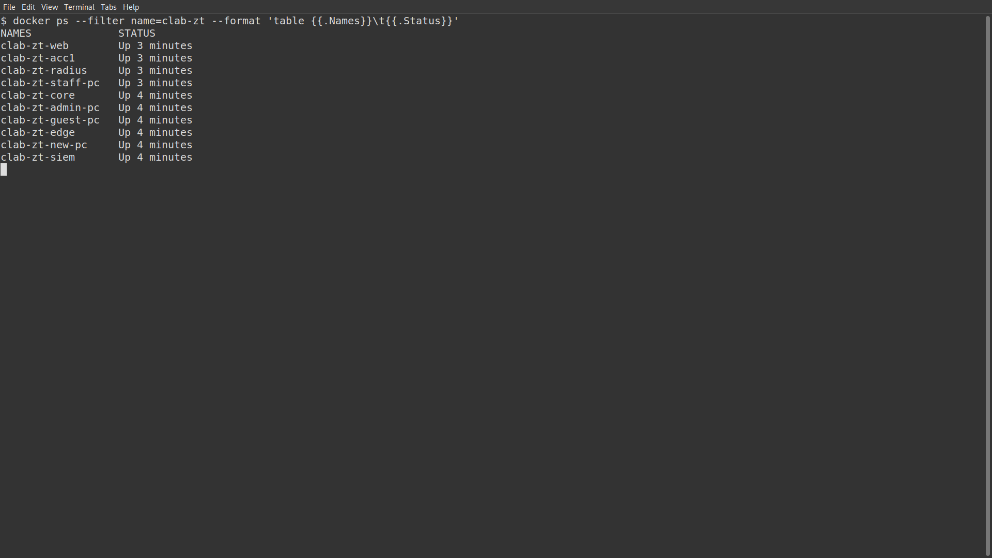
Evidence 1: Lab containers running
What it shows: All ten lab containers up after lab-up.sh (two switches, edge, web, RADIUS, SIEM and four PCs).
Use in: 5.2.2 (file: results/screens/01_lab_nodes.png)
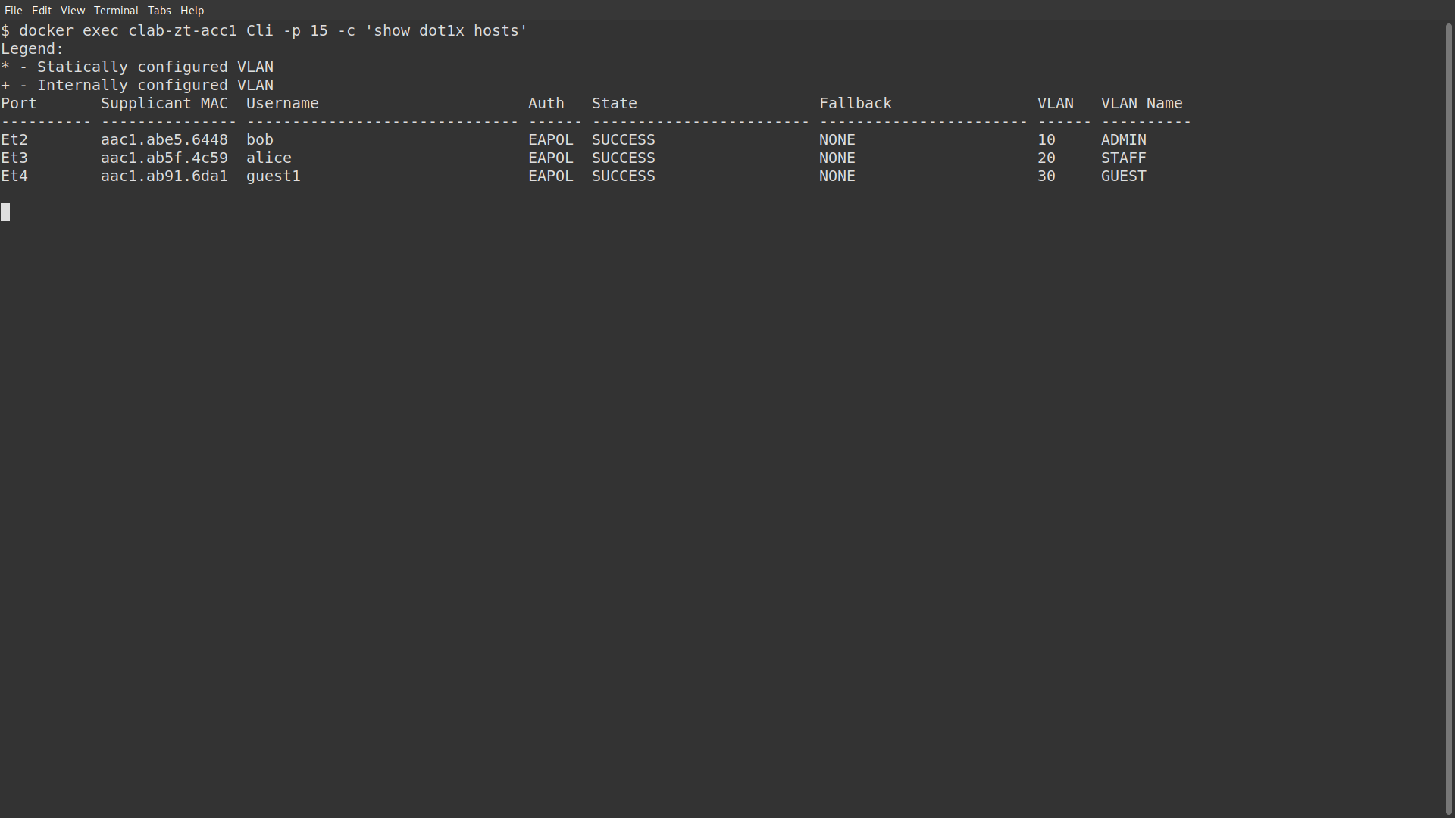
Evidence 2: 802.1X sessions on the access switch
What it shows: bob SUCCESS in VLAN 10 ADMIN, alice in 20 STAFF, guest1 in 30 GUEST.
Use in: 5.2.3, Table B TC1 (file: results/screens/02_dot1x_hosts.png)
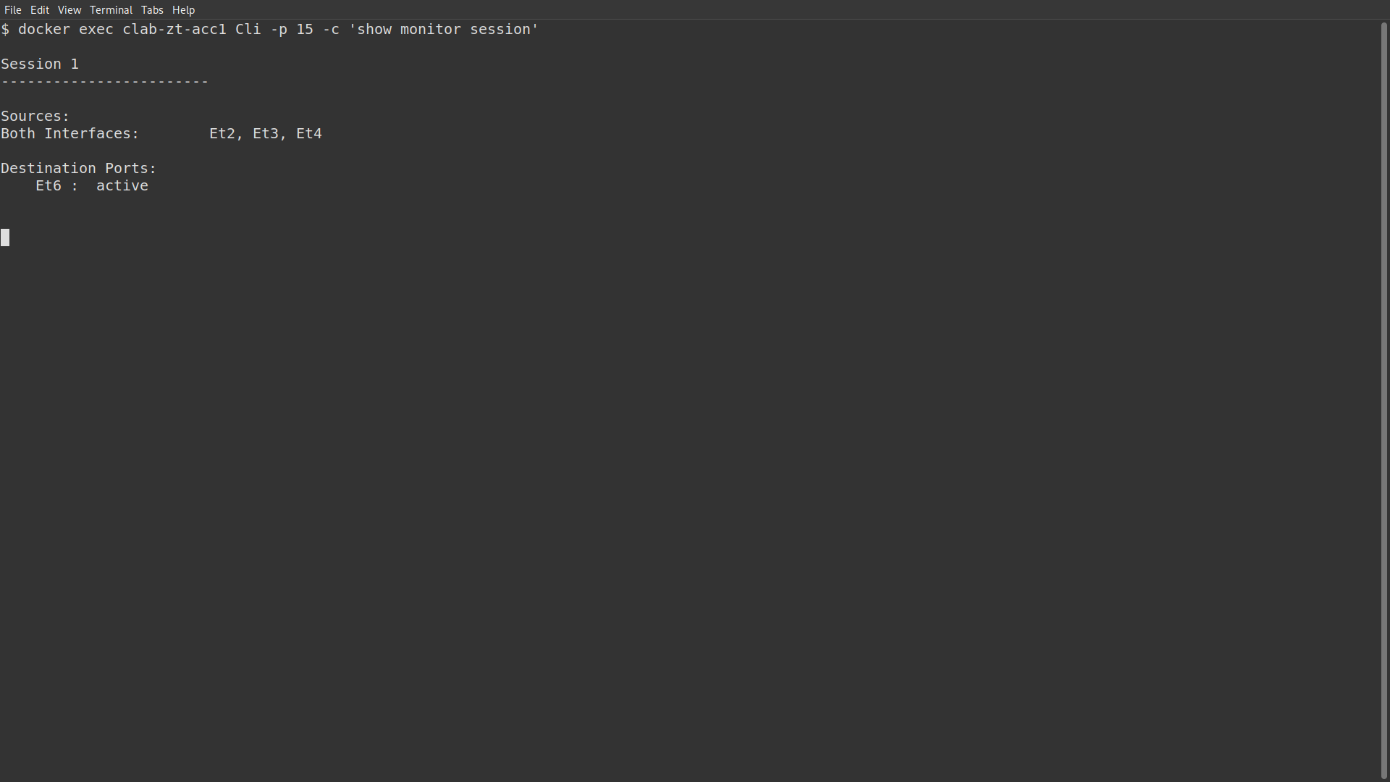
Evidence 3: Port mirroring to the SIEM
What it shows: Monitor session 1: sources Et2, Et3, Et4 (both directions), destination Et6.
Use in: 5.2.5 (file: results/screens/03_span_session.png)
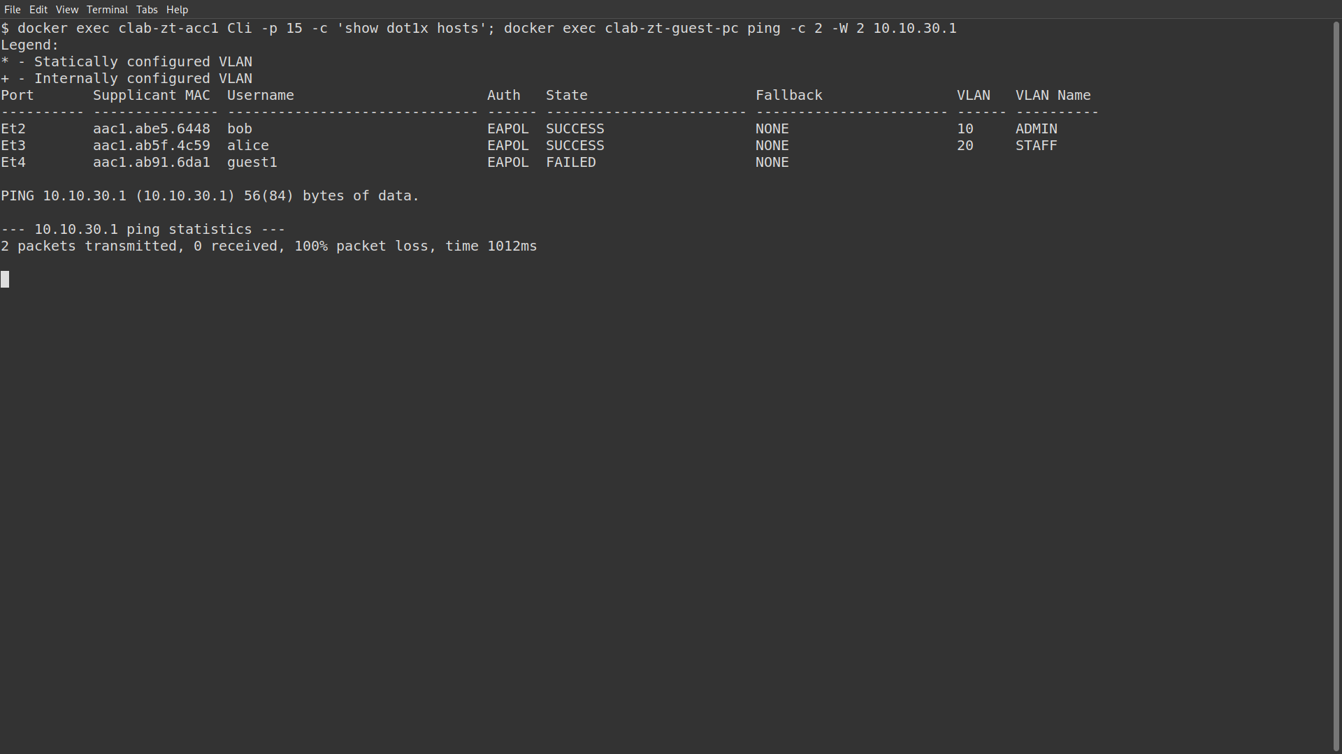
Evidence 4: Login with a wrong password
What it shows: guest1 FAILED on Et4 with no VLAN; ping to its own gateway 10.10.30.1: 100% packet loss.
Use in: 5.3.1, Table B TC2 (file: results/screens/04_wrong_password.png)
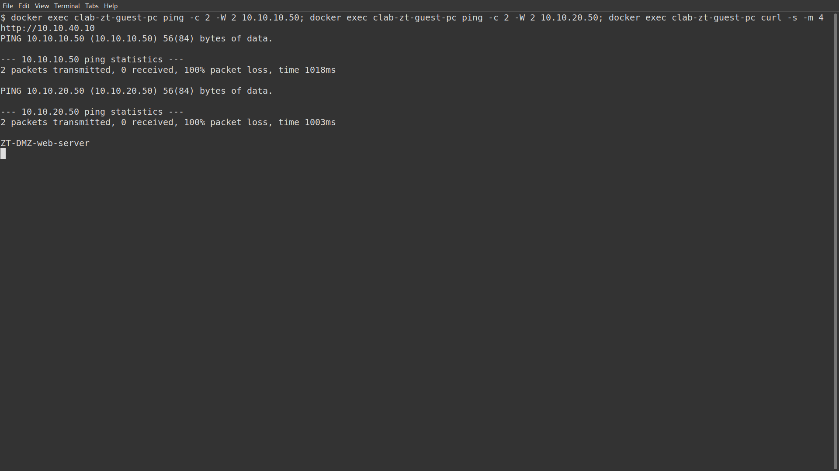
Evidence 5: Lateral movement attempt from the guest PC
What it shows: Pings from guest-pc to the admin PC (10.10.10.50) and the staff PC (10.10.20.50) fail; the DMZ web page is returned.
Use in: 5.3.2, Table C TC5 to TC7 (file: results/screens/05_lateral_movement.png)
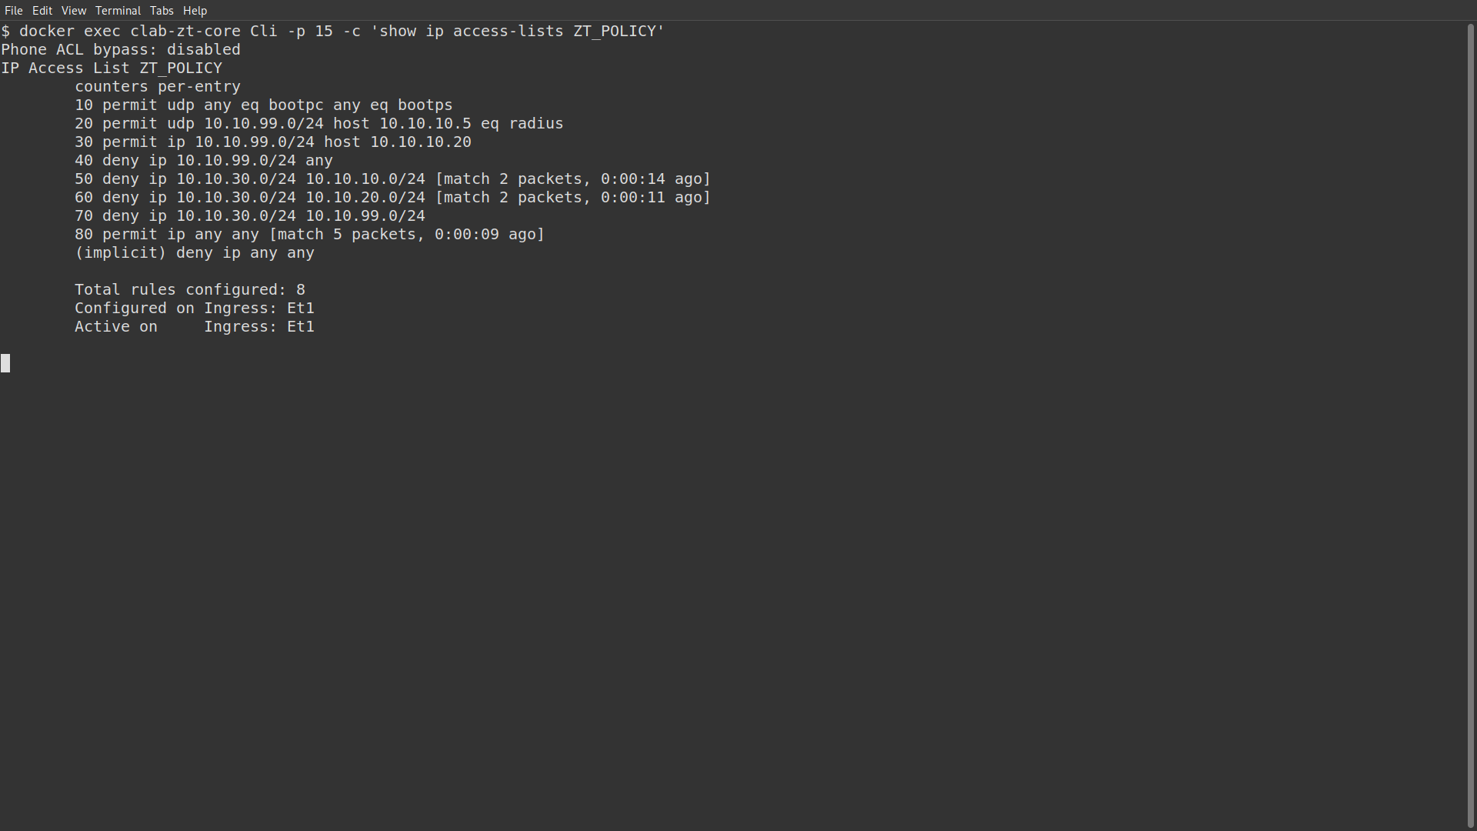
Evidence 6: ZT_POLICY counters after the attempt
What it shows: Line 50 (guest to admin) and line 60 (guest to staff) each matched 2 packets.
Use in: 5.2.4, 5.3.2 (file: results/screens/06_zt_policy_counters.png)
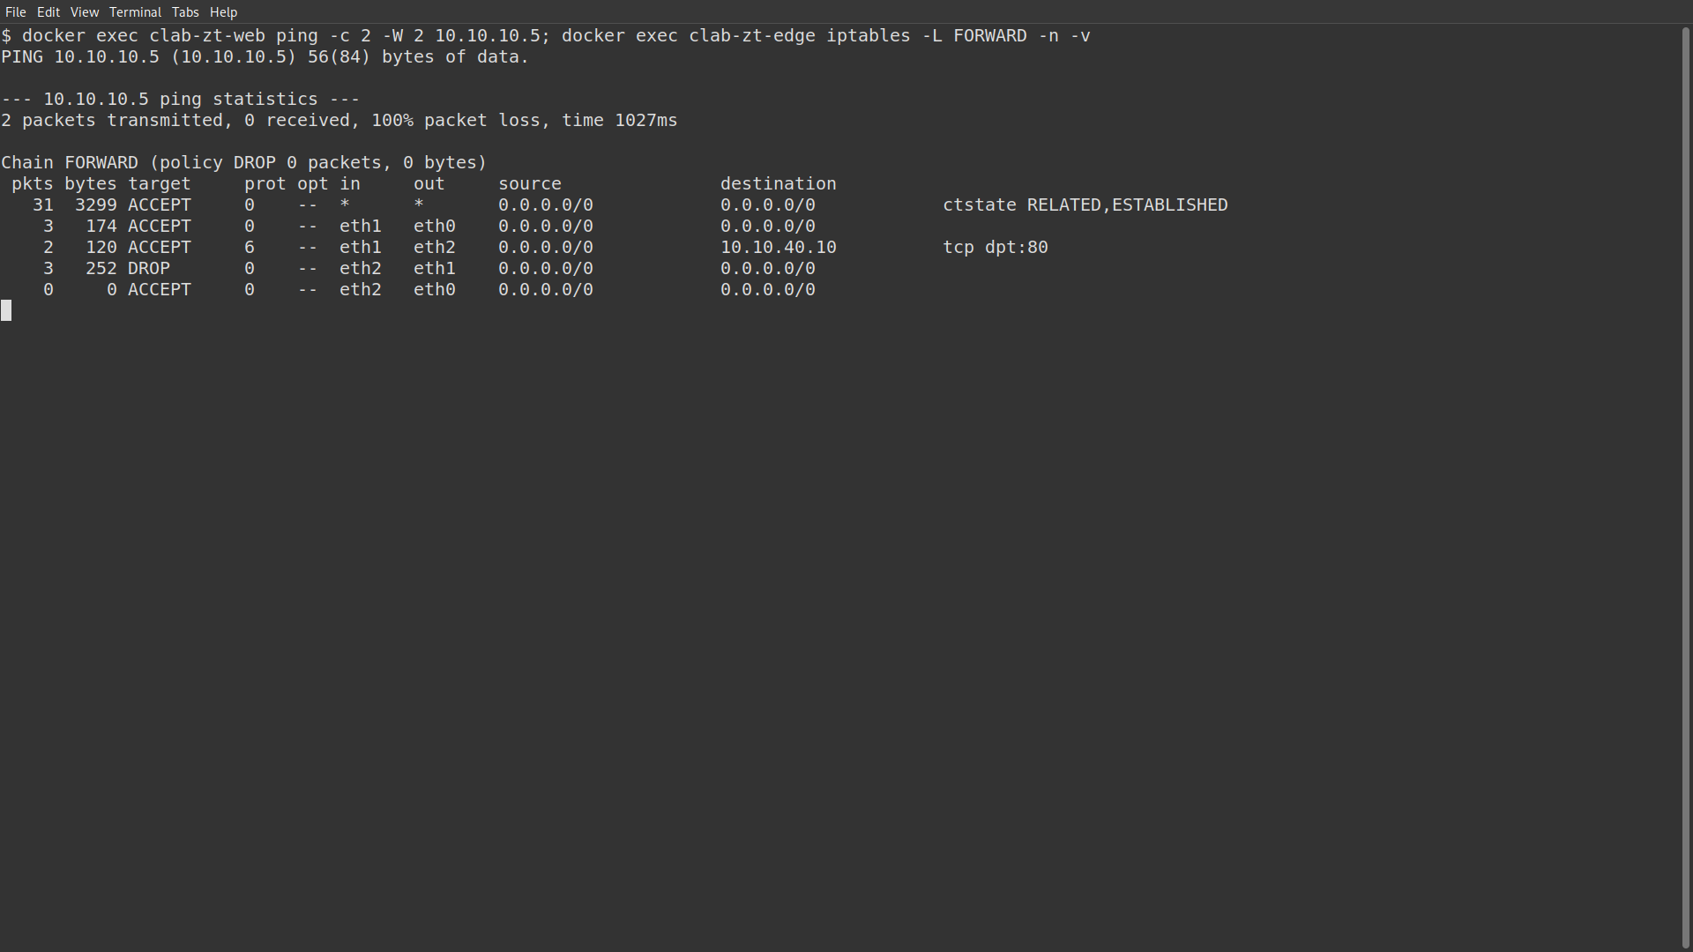
Evidence 7: DMZ cannot reach the inside
What it shows: Ping from the web server to RADIUS fails; the edge FORWARD chain shows the DROP rule for DMZ to inside counting packets.
Use in: 5.2.4, Table C TC8 (file: results/screens/07_dmz_isolation.png)
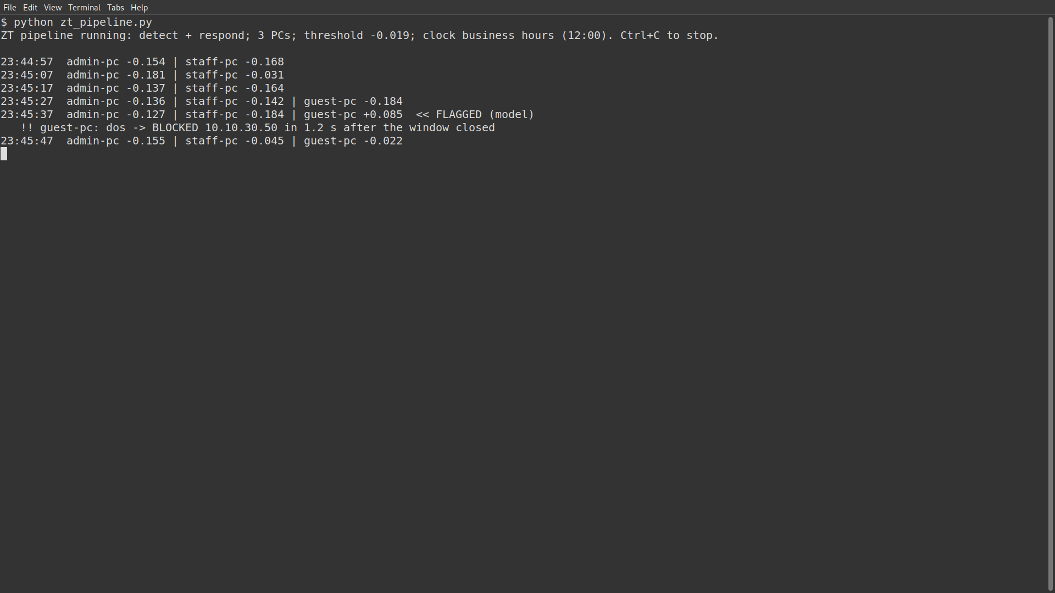
Evidence 8: Detector during the DoS attack
What it shows: guest-pc score above the threshold, flagged by the model; dos -> BLOCKED 10.10.30.50, 1.2 s after the window closed.
Use in: 5.3.5, Table E TC10 (file: results/screens/08_detector_dos.png)
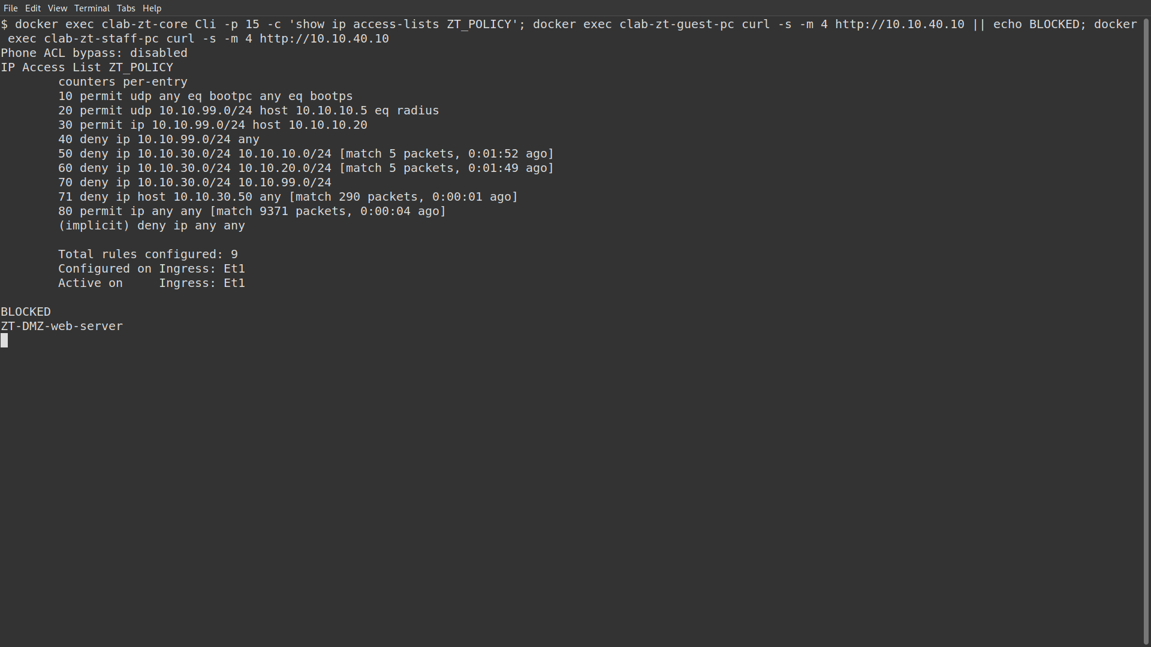
Evidence 9: Block applied on the core switch
What it shows: New line 71 deny ip host 10.10.30.50 any matched 290 packets; guest-pc BLOCKED, staff-pc still gets the web page. (The long command at the top wrapped and is partly cut; the full command is in screens.sh.)
Use in: 5.2.7, Table E TC10 (file: results/screens/09_dos_blocked.png)
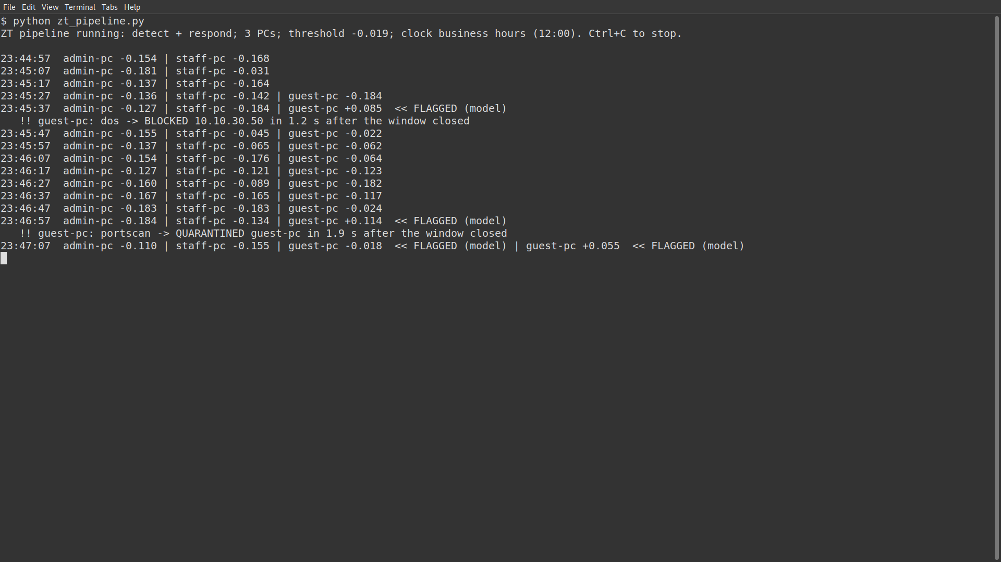
Evidence 10: Detector during the port scan
What it shows: portscan -> QUARANTINED guest-pc, 1.9 s after the window closed.
Use in: Table E TC11 (file: results/screens/10_detector_portscan.png)
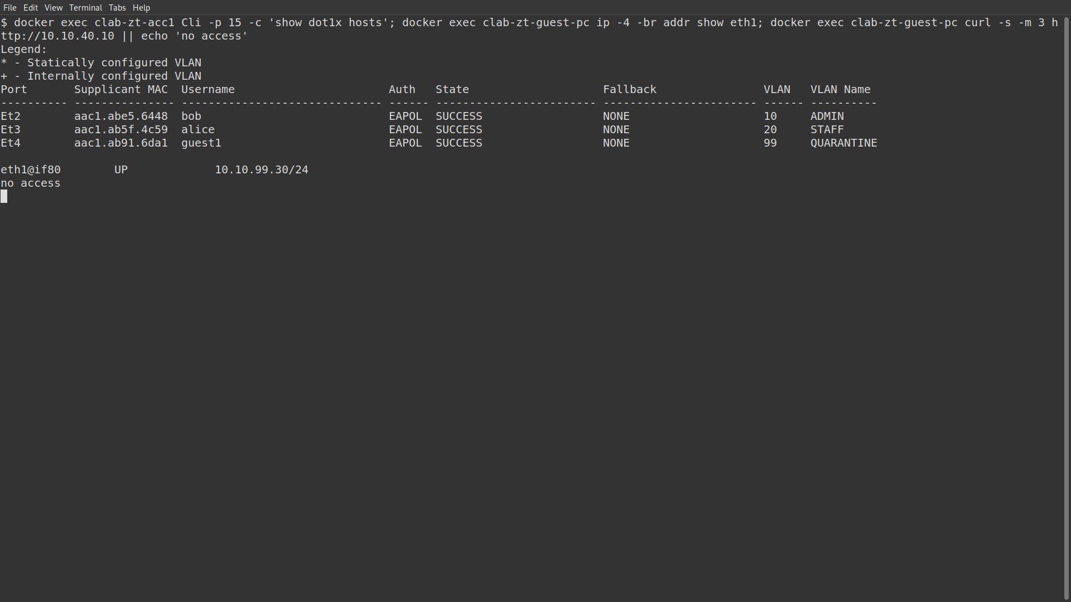
Evidence 11: Guest PC in quarantine
What it shows: guest1 SUCCESS in VLAN 99 QUARANTINE, address 10.10.99.30, no web access.
Use in: 5.2.7, Table E TC11 (file: results/screens/11_portscan_quarantined.png)
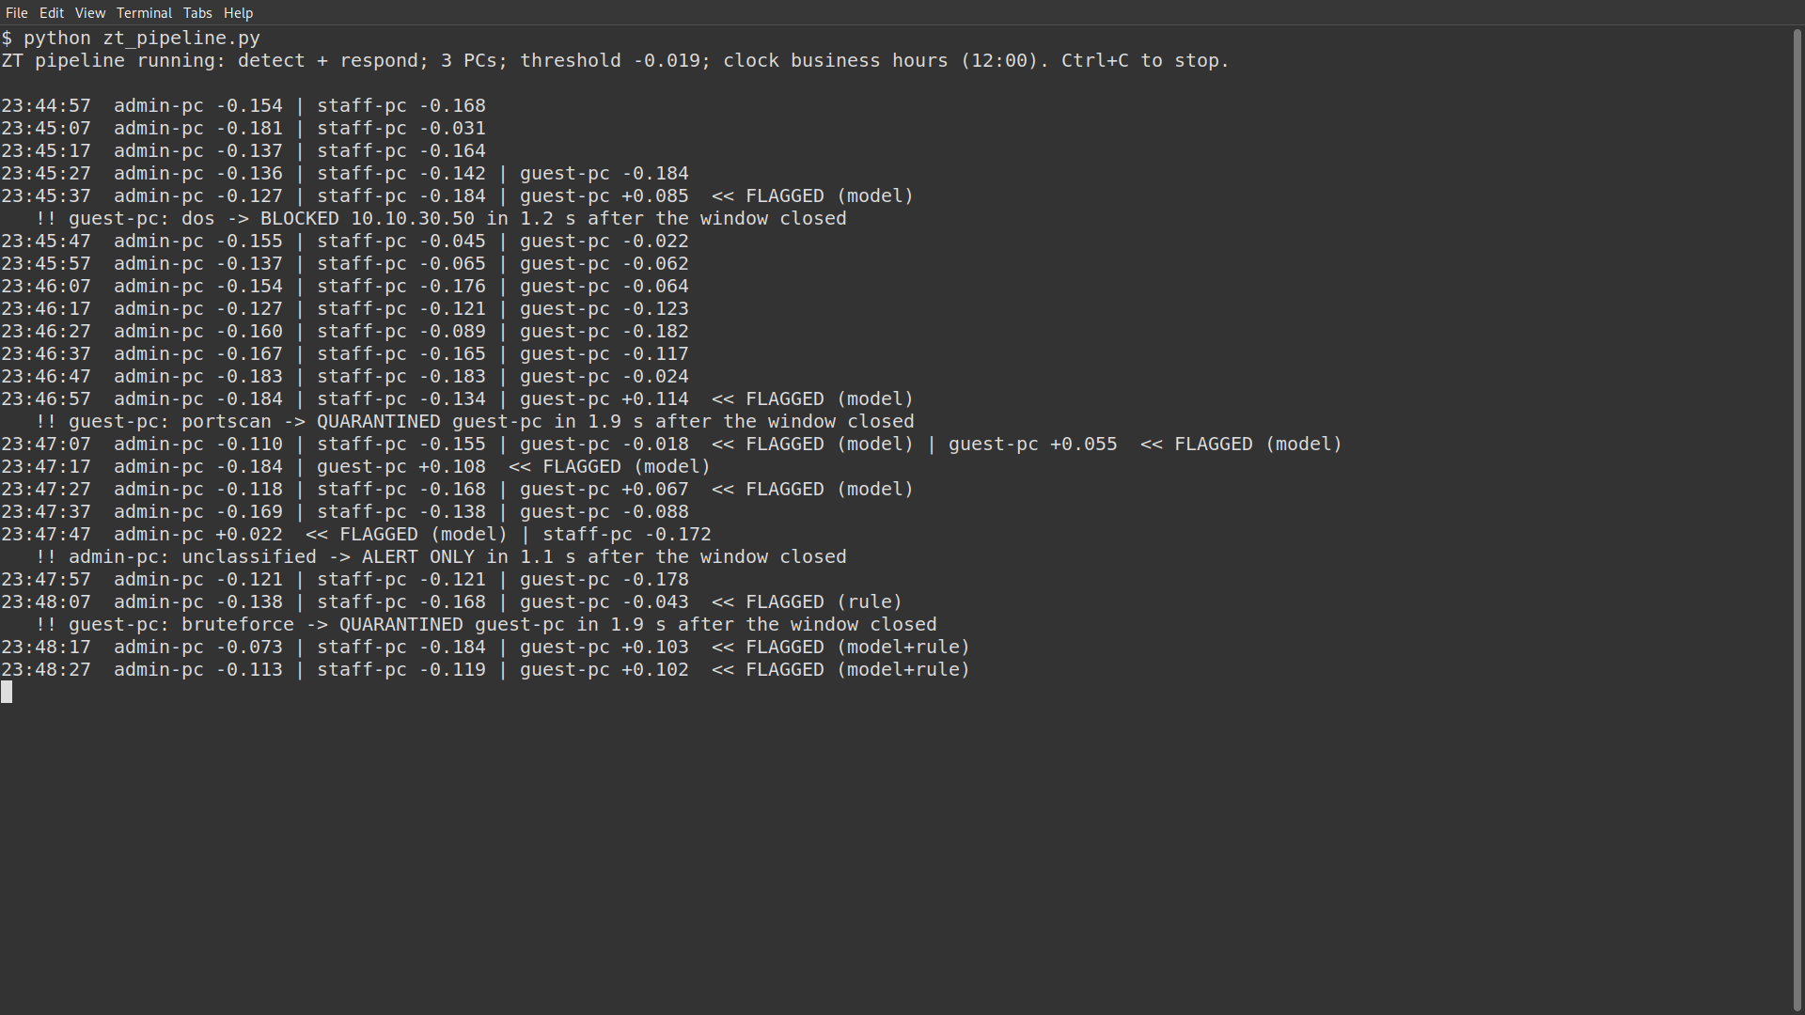
Evidence 12: Detector during the brute-force attack
What it shows: Flagged by the failed-login rule; bruteforce -> QUARANTINED guest-pc, 1.9 s.
Use in: Table E TC12 (file: results/screens/12_detector_bruteforce.png)
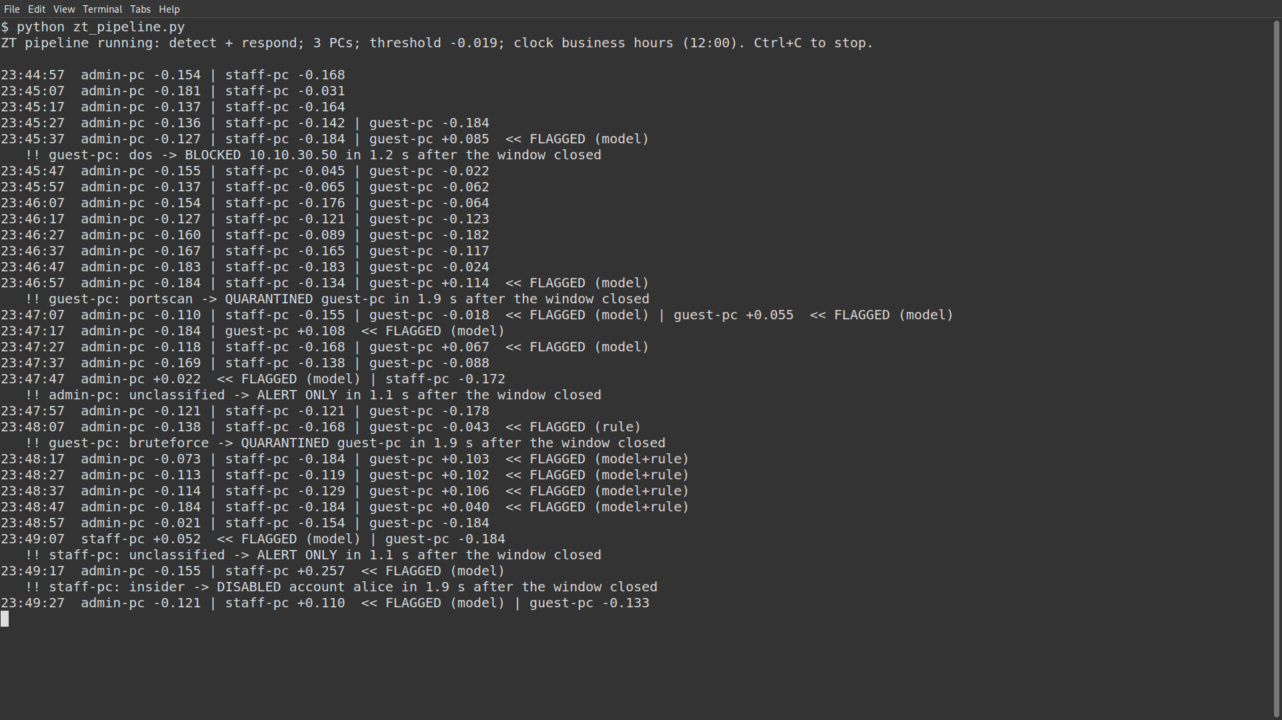
Evidence 13: Detector during the insider data theft
What it shows: insider -> DISABLED account alice, 1.9 s.
Use in: Table E TC13 (file: results/screens/13_detector_insider.png)
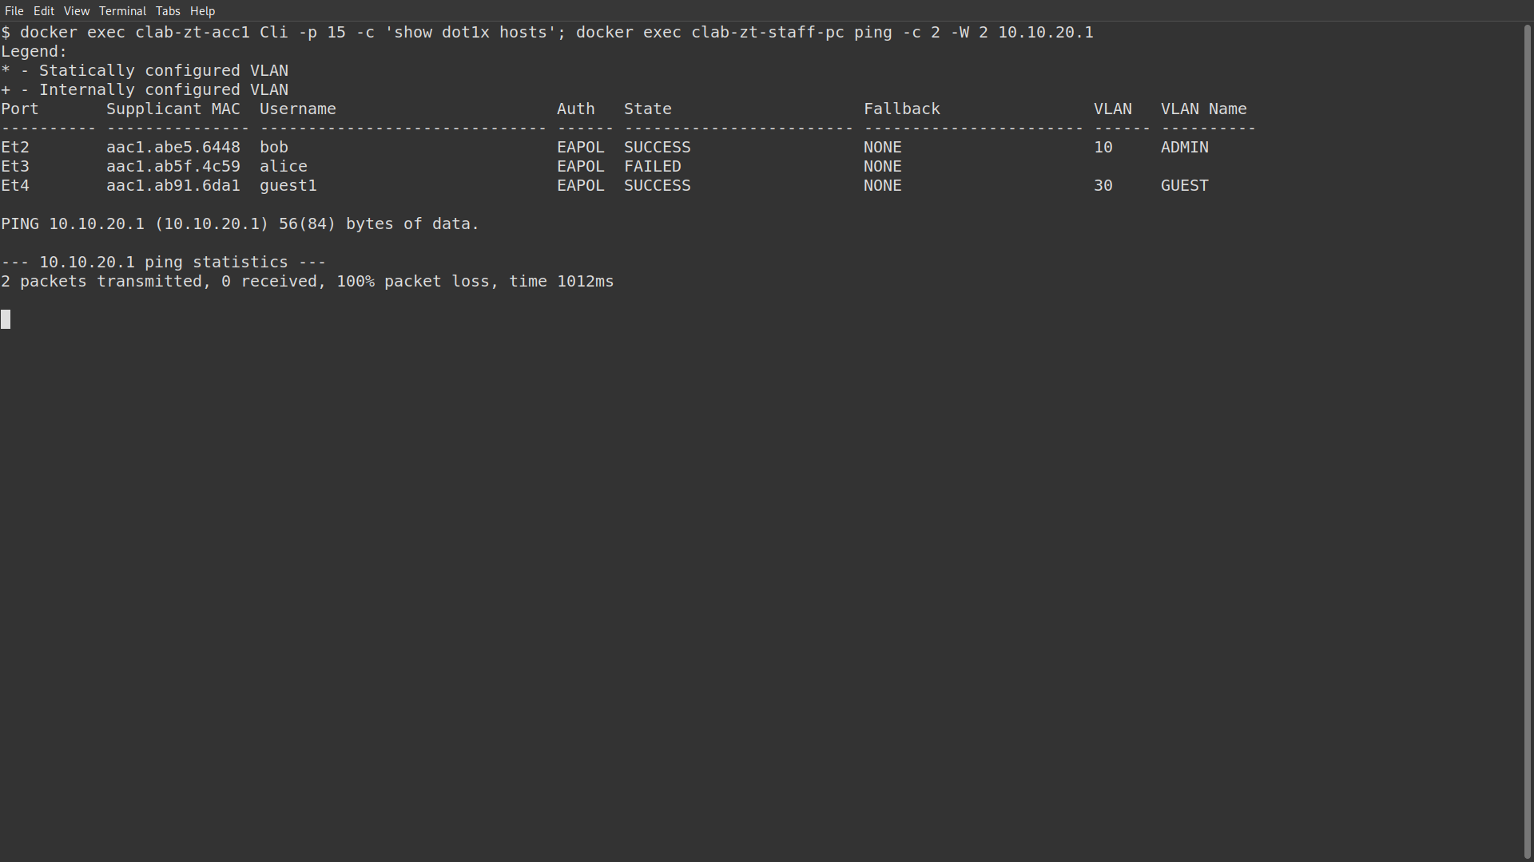
Evidence 14: Account disabled
What it shows: alice FAILED on Et3 with no VLAN; staff-pc ping to its gateway: 100% packet loss.
Use in: Table E TC13 (file: results/screens/14_insider_disabled.png)
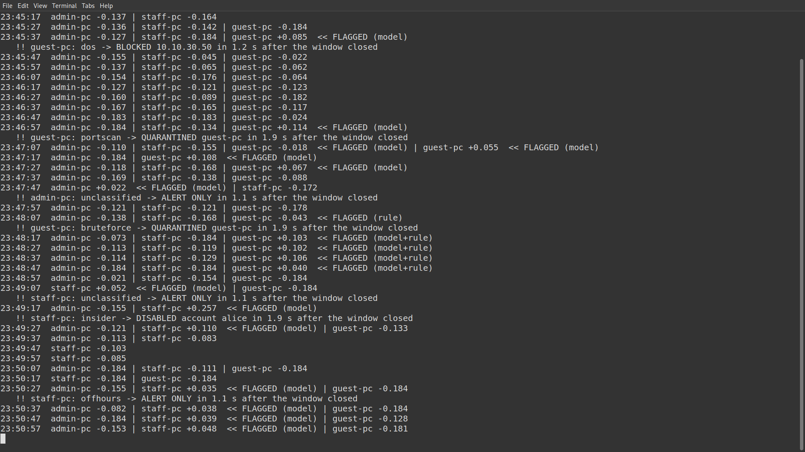
Evidence 15: Detector during the off-hours session
What it shows: offhours -> ALERT ONLY, 1.1 s; the full history of the run is visible in this window.
Use in: Table E TC14 (file: results/screens/15_detector_offhours.png)
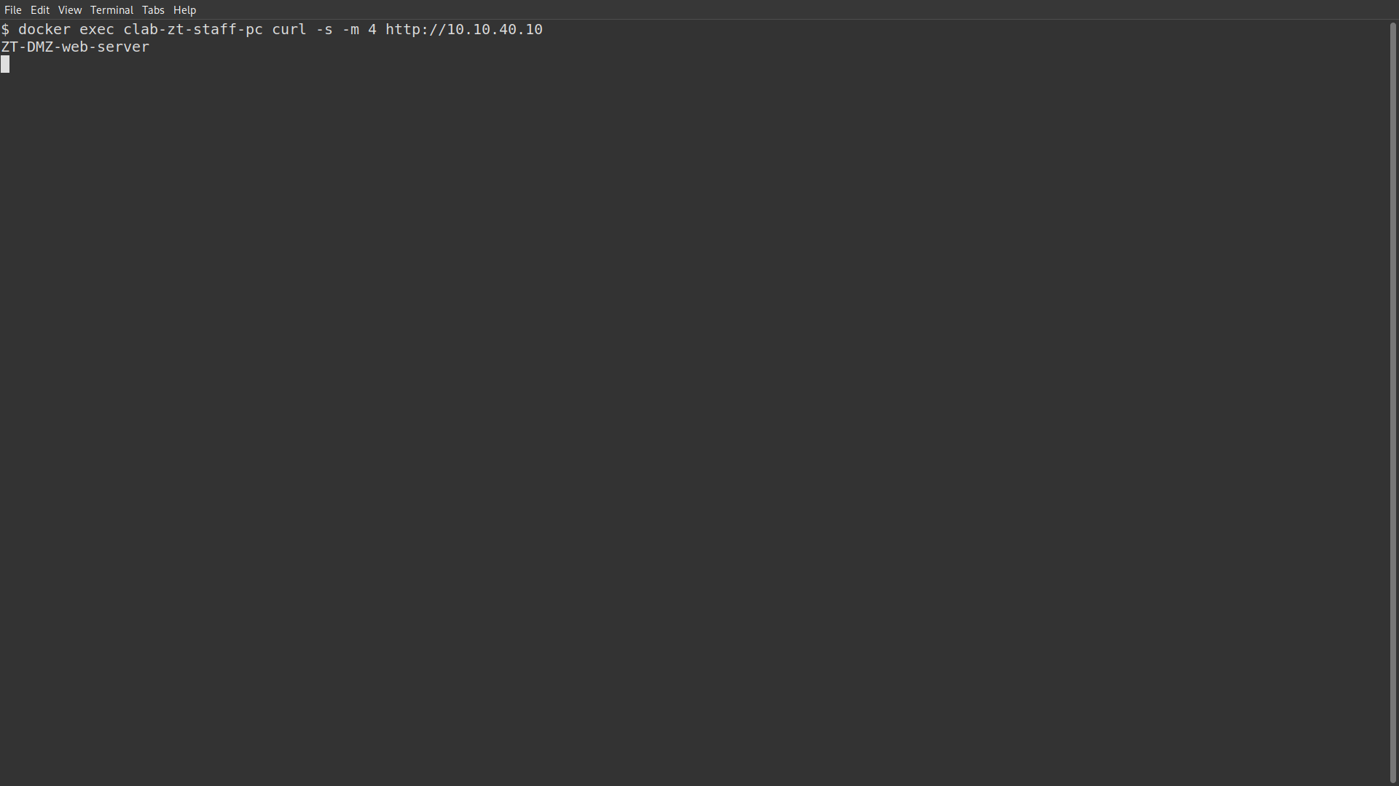
Evidence 16: Off-hours user not cut off
What it shows: staff-pc still reaches the DMZ web server after the alert.
Use in: Table E TC14 (file: results/screens/16_offhours_no_block.png)
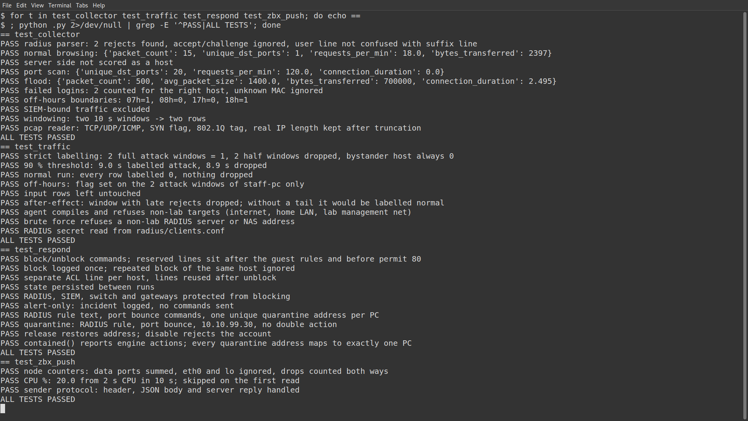
Evidence 17: Offline test suites
What it shows: All four suites end with ALL TESTS PASSED.
Use in: 5.3.3, Table D (file: results/screens/17_offline_tests.png)
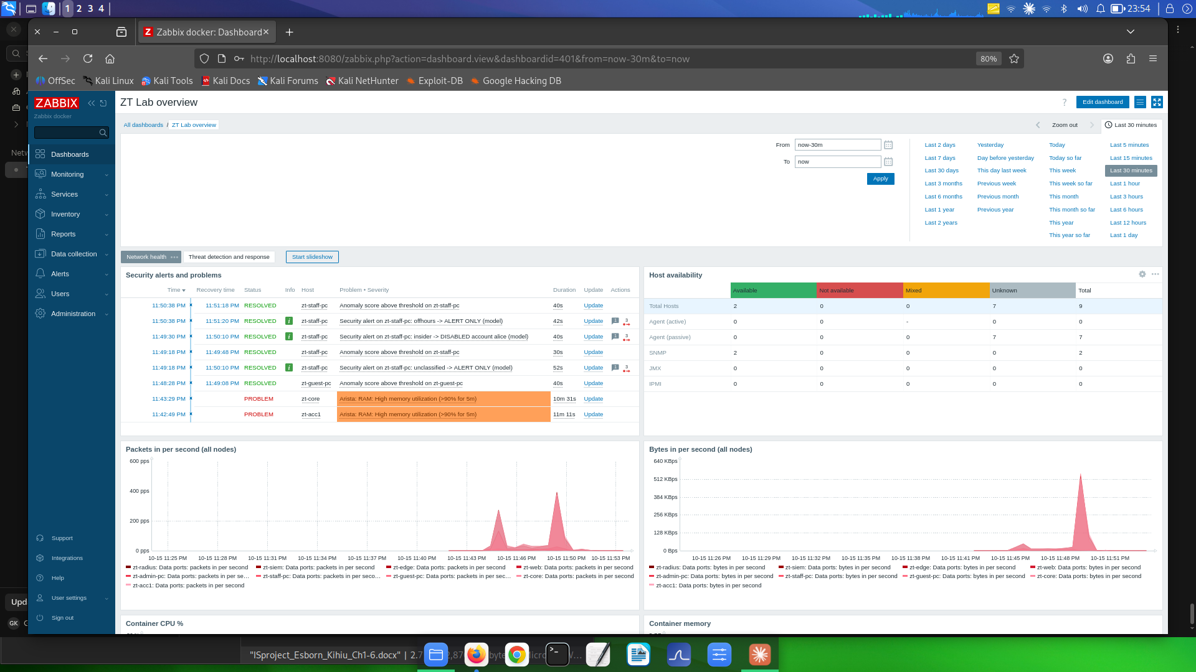
Evidence 18: Zabbix network health page (Firefox)
What it shows: Security alerts list, host availability, packets and bytes per second with the attack spikes.
Use in: 5.2.8, Table F (file: results/screens/18_zabbix_health.png)
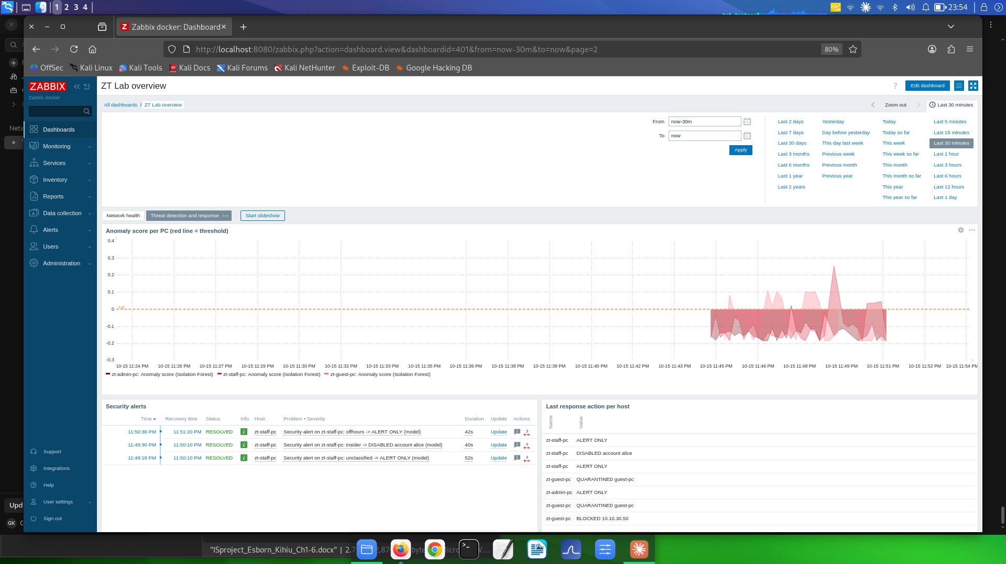
Evidence 19: Zabbix threat detection and response page (Firefox)
What it shows: Anomaly scores per PC crossing the threshold line during the attacks; security alerts; last response action per host (blocked, quarantined, disabled, alert only).
Use in: 5.2.8, Table F (file: results/screens/19_zabbix_detection.png)
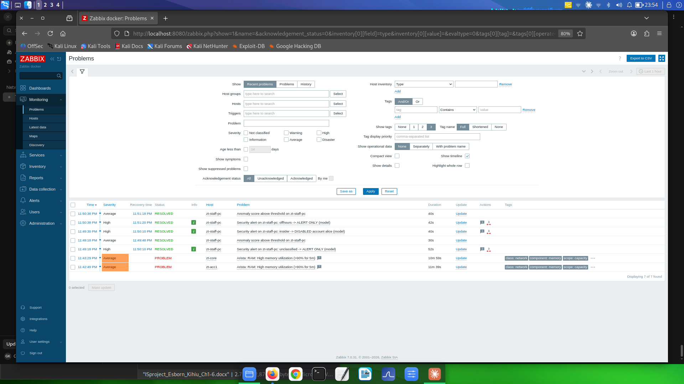
Evidence 20: Zabbix problems list (Firefox)
What it shows: The security alerts raised by the pipeline, with times and hosts.
Use in: 5.3.6, Table F (file: results/screens/20_zabbix_problems.png)
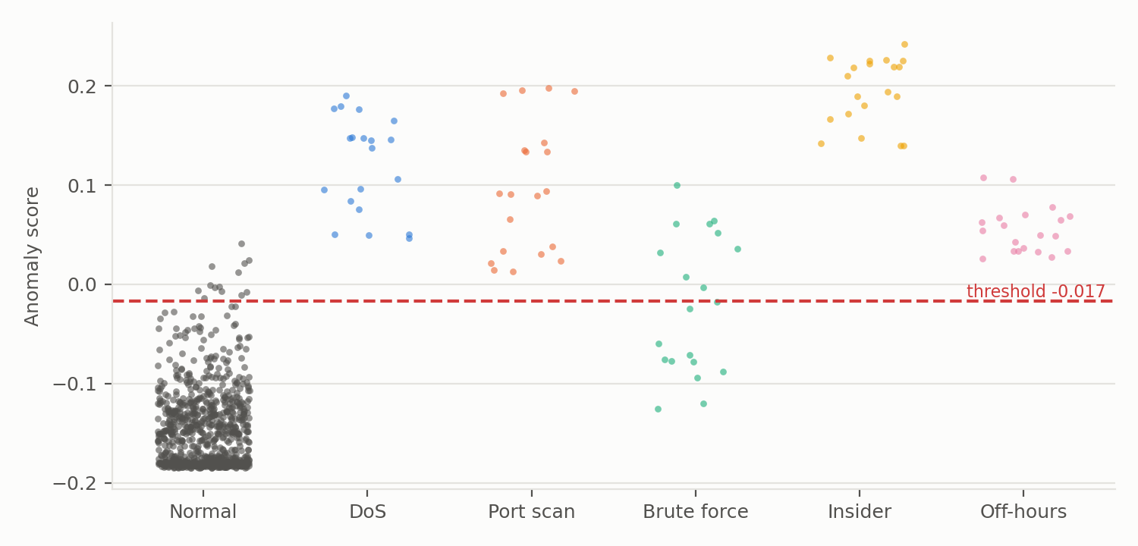
Evidence 21: Anomaly score of every test window (chart)
What it shows: Normal windows below the threshold; attack windows above it; brute force on both sides.
Use in: 5.2.6, 5.3.4 (file: results/score_distribution.png)
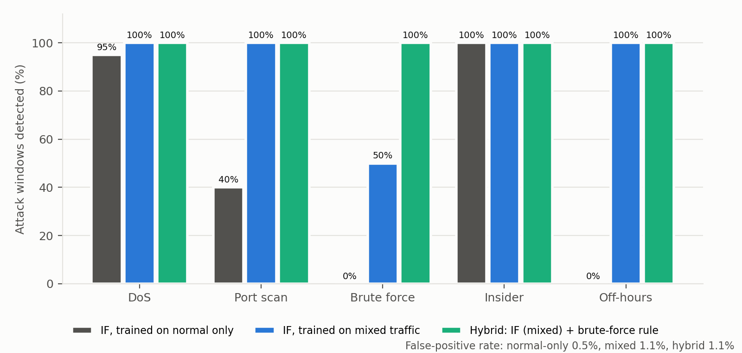
Evidence 22: Detection rate by attack type for three designs (chart)
What it shows: Normal-only, mixed and hybrid designs per attack type.
Use in: 5.3.4 (file: results/detection_by_type.png)
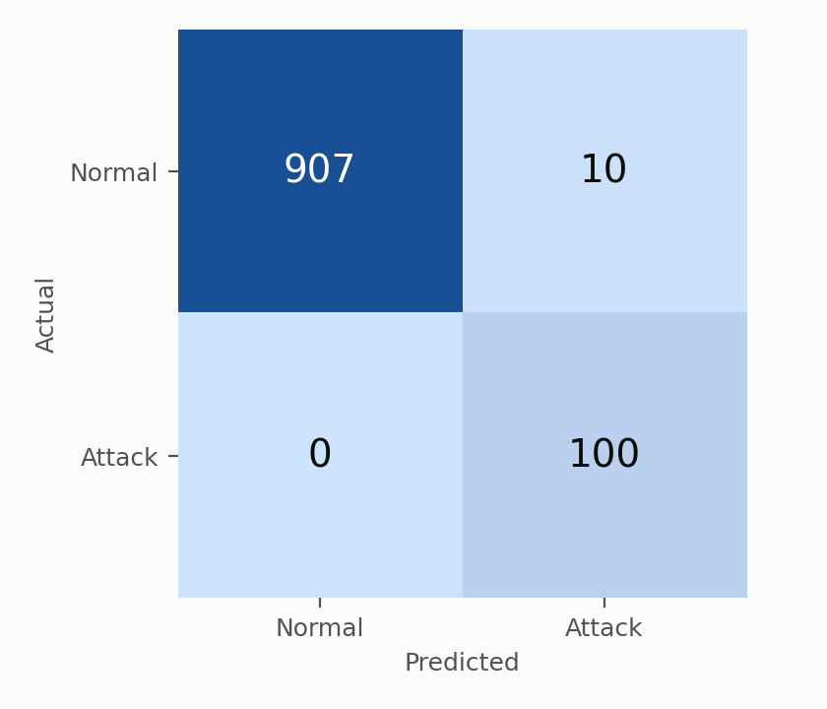
Evidence 23: Confusion matrix of the hybrid detector (chart)
What it shows: 907 TN, 10 FP, 0 FN, 100 TP over five folds.
Use in: 5.3.4 (file: results/confusion_matrix.png)

3. Tables (records of what the lab did)

Table A: Modules of the system
Module | Purpose | Implemented in
Lab environment | Builds and rebuilds the network | zt-dev.clab.yml, lab-up.sh, lab-down.sh
Access control | 802.1X login, VLAN by identity | acc1.cfg, FreeRADIUS
Segmentation and policy | Limits traffic between VLANs; isolates the DMZ | ZT_POLICY (core), edge-fw.sh
Traffic collection | Copies user traffic; 8 features per PC per 10 s | SPAN on acc1, zt_collector.py
Anomaly detection | Isolation Forest plus failed-login rule | zt_model.py
Automated response | Block, quarantine, disable or alert | zt_respond.py
Pipeline | Runs collection, scoring and response continuously | zt_pipeline.py
Monitoring and alerting | Node health, scores, alerts, actions; email action | Zabbix 7.0, zt_zbx_push.py, zbx_email_setup.py

Table B: Authentication and access control test cases
Test case | Test steps | Expected result | Actual result | Status
TC1 Valid 802.1X login | Lab built; PCs log in; show dot1x hosts | Each user authenticated in the VLAN of the role | bob VLAN 10, alice 20, guest1 30, all SUCCESS (Evidence 2) | Passed
TC2 Wrong password | guest-pc logs in with a wrong password | Port stays closed, no network | Et4 FAILED, no VLAN; 100% loss to gateway (Evidence 4) | Passed
TC3 Re-authentication after reconnect | Unplug staff-pc; plug back in | Session removed; new login required | alice removed on unplug; SUCCESS again on replug; RADIUS accept count 3 to 4 (guide Exercise 3, tested 15 Oct) | Passed
TC4 New user onboarding | Plug in new-pc as carol with no account; create account; reload RADIUS; reconnect | Rejected without account; staff VLAN after | FAILED with Access-Reject; then carol SUCCESS VLAN 20 STAFF (guide Exercise 6, tested 15 Oct) | Passed

Table C: Segmentation and lateral movement test cases
Test case | Test steps | Expected result | Actual result | Status
TC5 Guest to admin PC | Ping 10.10.10.50 from guest-pc | Blocked | 100% loss; ZT_POLICY line 50 matched 2 packets (Evidence 5, 6) | Passed
TC6 Guest to staff PC | Ping 10.10.20.50 from guest-pc | Blocked | 100% loss; line 60 matched 2 packets (Evidence 5, 6) | Passed
TC7 Guest to DMZ web | curl http://10.10.40.10 from guest-pc | Allowed | Page returned: ZT-DMZ-web-server (Evidence 5) | Passed
TC8 DMZ to inside | Ping RADIUS from the web server | Blocked by the edge | 100% loss; edge DROP rule counted the packets (Evidence 7) | Passed
TC9 Lab self-tests | Run lab-up.sh | Six connectivity checks pass | 6 of 6 PASS on every rebuild | Passed

Table D: Unit test suites
Suite | What it checks | Checks | Result
test_collector.py | RADIUS log parsing, features, windowing, pcap reader | 10 | All passed
test_traffic.py | Labelling rules, after-effect, lab-only targets, secret handling | 9 | All passed
test_respond.py | Switch commands, de-duplication, protection, quarantine and disable logic | 10 | All passed
test_zbx_push.py | Node counters, CPU calculation, Zabbix sender protocol | 3 | All passed

Table E: Automated response test cases (evidence run, 15 Oct 23:45 to 23:51)
Test case | Test steps | Expected result | Actual result | Status
TC10 DoS | attack --mode dos (40 s) from guest-pc, detector running | Flagged; source IP blocked | Flagged by the model; BLOCKED 10.10.30.50 in 1.2 s; line 71 matched 290 packets; staff unaffected (Evidence 8, 9) | Passed
TC11 Port scan | attack --mode portscan (40 s) | Flagged; host quarantined | QUARANTINED guest-pc in 1.9 s; VLAN 99, 10.10.99.30, no web access (Evidence 10, 11) | Passed
TC12 Brute force | attack --mode bruteforce (40 s) | Flagged; host quarantined | Flagged by the failed-login rule; QUARANTINED guest-pc in 1.9 s (Evidence 12) | Passed
TC13 Insider data theft | attack --mode insider (40 s) on staff-pc | Flagged; account disabled | DISABLED account alice in 1.9 s; Et3 FAILED (Evidence 13, 14) | Passed
TC14 Off-hours session | attack --mode offhours (40 s) on staff-pc | Alert only; no access change | ALERT ONLY in 1.1 s; staff-pc still reaches the web (Evidence 15, 16) | Passed
TC15 Normal users | Normal traffic on all PCs throughout | No block, quarantine or disable of a normal user | 2 alert-only false alarms (admin-pc 23:47:58, staff-pc 23:49:18); no access changed | Passed

Table F: Monitoring test cases
Test case | Test steps | Expected result | Actual result | Status
TC16 Node metrics | lab-up.sh; push loop every 30 s | All nodes report | 9 nodes, 63 values per cycle, 0 failed; all hosts available (Evidence 18) | Passed
TC17 Scores, alerts, actions | Run attacks with the pipeline | Scores, alerts and actions visible | Score spikes above threshold, alerts and last actions shown (Evidence 19, 20); rehearsal: 113 scores and 6 actions received | Passed
TC18 Email alerts | Security alert with email action configured | Email to the administrator | Not delivered: Gmail rejected the login (App Password not yet set up) | Pending

Table G: Datasets
Class | Runs | Attack windows | Notes
Normal | 4 x 10 min | 0 | 594 normal windows
DoS | 5 x 60 s | 20 | 40 to 120 requests/s
Port scan | 5 x 60 s | 20 | 10 to 50 ports/s
Brute force | 5 x 60 s | 20 | 1 to 8 attempts/s
Insider | 5 x 60 s | 20 | 0.5 to 2.5 MB/s
Off-hours | 5 x 60 s | 20 | normal traffic marked as night

Table H: Detection results (5-fold, 100 attack and 917 normal windows)
Design | TP | FN | FP | TN | Accuracy | Precision | Detection rate | F1 | FPR | ROC-AUC
IF, normal only | 47 | 53 | 5 | 912 | 94.3% | 0.904 | 47% | 0.618 | 0.5% | 0.807
IF, mixed | 90 | 10 | 10 | 907 | 98% | 0.900 | 90% | 0.900 | 1.1% | 0.990
Hybrid (chosen) | 100 | 0 | 10 | 907 | 99% | 0.909 | 100% | 0.952 | 1.1% | 0.990

Attack-type classification: 100% of 100 attack windows named correctly.

Table I: Response timings (end of window to action applied)
Attack | Evidence run (15 Oct) | Rehearsal with Zabbix (14 Oct)
DoS | 1.2 s | 1.2 s
Port scan | 1.9 s | 1.9 s
Brute force | 1.9 s | 1.9 s
Insider | 1.9 s | 1.9 s
Off-hours | 1.1 s | 1.1 s

4. Appendix candidates (guideline report has these)
- Appendix A: Turnitin similarity report (you add it).
- Appendix B: Gantt chart: needs your real project dates (proposal, literature review, design, implementation, testing, report).
- Appendix C: Incident log extract of the evidence run: results/screens/incidents_screens_run.jsonl.
- Appendix D: Extra screenshots not used in the chapter.

