A Zero Trust Network with Automated Threat Detection and Response using Isolation Forest
Esborn Kihiu
Adm No. 168863
A Project Submitted to the School of Computing and Engineering Sciences, Strathmore University, for the Award of Bachelor of Science in Computer Networks and Cyber Security
STRATHMORE UNIVERSITY
NAIROBI, KENYA
October 2026

Declaration and Approval
I declare that this work has not been submitted or previously submitted and approved, in whole or in part, for the award of a degree by this or any other University. To the best of my knowledge and belief, the report contains no material previously published or written by another person except where due reference is made in the report itself.
Student
Esborn Kihiu
Adm No. 168863
Signature  …………………… Date …………………………
Supervisor
Mr. James Gikera
Lecturer, Computer Networks and Telecommunications
School of Computing and Engineering Sciences
Signature ……………………………… Date …………………………

Acknowledgement
I thank God for the strength and good health to complete this project. I am grateful to my supervisor, Mr. James Gikera, for his guidance and for the detailed feedback he gave on every draft, which greatly improved this work.
I also thank Strathmore University and the School of Computing and Engineering Sciences for the knowledge and resources that made this project possible. Finally, I thank my family and friends for their support and patience throughout my studies.

Abstract
Most enterprise networks still trust a device once it is inside the perimeter. If an attacker gets in, or a staff account is misused, there is little to stop them moving between internal systems, and signature-based tools often do not notice. This project designed and built a Zero Trust enterprise network with an automated threat detection and response layer based on the Isolation Forest algorithm. The network was first planned in Cisco Packet Tracer and was then rebuilt in Container lab, where it runs real Arista cEOS switch software in containers on a single laptop. Users log in with IEEE 802.1X, and a Free RADIUS server places each user in the VLAN for their role (admin, staff or guest). An access list on the core switch limits traffic between the segments, a Linux edge firewall separates the internal network from a DMZ web server and the internet, and VLAN 99 is used to quarantine devices. Traffic from the user ports is mirrored to a SIEM host, where a Python collector summarizes each host’s activity every ten seconds into eight features, such as packet count, unique destination ports and failed logins. An Isolation Forest model, trained without labels, scores each window, and a simple policy rule flags windows with repeated failed logins. When a window is anomalous, a response engine classifies it and blocks the source IP for denial-of-service traffic, quarantines the host for port scans and brute-force attempts, disables the account for insider data theft, or raises an alert for off-hours activity. Scores, alerts and actions are shown on a Zabbix dashboard. The system is evaluated with simulated normal and attack traffic, using the detection rate, the false positive rate and the time from detection to action.
Keywords: Zero Trust, 802.1X, Network Segmentation, Anomaly Detection, Isolation Forest, Automated Response, Containerlab

Table of Contents
Declaration and Approval ii
Acknowledgement iii
Abstract iv
Table of Contents v
List of Figures ix
List of Tables x
List of Abbreviations and Acronyms xi
Definition of Terms xiii
Chapter 1: Introduction 1
1.1 Background Information 1
1.2 Problem Statement 2
1.3 Objectives of the Study 2
1.3.1 General Objective 2
1.3.2 Specific Objectives 2
1.4 Scope and Limitations 3
1.4.1 Scope 3
1.4.2 Limitations 3
1.5 Significance of the Study 4
Chapter 2: Literature Review 5
2.1 Introduction 5
2.2 Security Challenges in Enterprise Networks 5
2.2.1 Limits of Perimeter-Based Security 5
2.2.2 Insider Threats and Credential Misuse 5
2.2.3 Limits of Signature-Based Detection 5
2.2.4 Slow Incident Response 6
2.2.5 Visibility and Alert Overload 6
2.3 Technology Review 6
2.3.1 Zero Trust Architecture 6
2.3.2 Authentication, Authorization and Accounting with 802.1X 7
2.3.3 VLAN Segmentation and Access Control Lists 7
2.3.4 Demilitarized Zone (DMZ) 8
2.3.5 Network Threats Considered 8
2.3.6 Machine Learning in Intrusion Detection 9
2.3.7 Isolation Forest Algorithm 9
2.3.8 Network Simulation and Emulation Platforms 11
2.3.9 Python Tools for Collection, Automation and Monitoring 12
2.4 Existing Solutions for Enterprise Threat Detection 12
2.5 Research Gap 13
2.6 Conceptual Framework 14
Chapter 3: Methodology 15
3.1 Introduction 15
3.2 Project Methodology 15
3.2.1 Requirements Gathering and Analysis 16
3.2.2 Quick Design 16
3.2.3 Prototype Development 17
3.2.4 Testing and Refinement 17
3.2.5 Final Validation 17
3.3 Change of Simulation Platform and Topology 17
3.4 System Requirements 19
3.4.1 Functional Requirements 19
3.4.2 Non-Functional Requirements 20
3.5 Implementation Requirements 21
3.5.1 Hardware Requirements 21
3.5.2 Software Requirements 21
3.6 Testing and Validation 22
3.6.1 Functional Testing 23
3.6.2 Security Testing 23
3.6.3 Data Collection and Labeling 24
3.6.4 Performance Testing 24
3.6.5 Evaluation Metrics 25
3.6.6 Validation of Results 26
Chapter 4: System Design 27
4.1 Introduction 27
4.2 Black-Box 27
4.3 System Analysis 28
4.3.1 Use-Case Diagram 28
4.3.2 Sequence Diagram 29
4.3.3 Activity Diagram 32
4.3.4 Entity Relationship Diagram (ERD) 33
4.3.5 Class Diagram 35
4.4 System Design 36
4.4.1 System Architecture Diagram 36
4.4.2 Network Topology 38
4.4.3 Access Control Policy 39
4.4.4 Detection Features and Response Rules 40
Chapter 5: Results and Discussion 43
5.1 Introduction 43
5.2 Functional Testing of the Zero Trust Network 43
5.2.1 Authentication and Dynamic VLAN Assignment 43
5.2.2 Segmentation and the DMZ 44
5.2.3 Collection and Feature Extraction 45
5.3 Datasets 45
5.4 Detection Results 46
5.4.1 Overall Performance 46
5.4.2 Detection by Attack Intensity 48
5.4.3 Score Distribution and Confusion Matrix 49
5.4.4 Attack Classification 50
5.5 Automated Response Results 51
5.5.1 Individual Response Actions 51
5.5.2 End-to-End Test 52
5.6 Monitoring Results 54
5.7 Performance and Resource Use 54
5.8 Validation against the Requirements 55
5.9 Discussion 56
5.10 Summary 57
Chapter 6: Conclusions and Recommendations 58
6.1 Conclusion 58
6.2 Recommendations 59
6.3 Future Work 59
References 61
Appendix 65

List of Figures
Figure 2.1: Isolating a normal and an anomalous session with random splits 10
Figure 2.2: Conceptual framework 14
Figure 3.1: Prototyping methodology and the prototypes built 16
Figure 4.1: Black-box view of the system 28
Figure 4.2: Use-case diagram 29
Figure 4.3: Sequence diagram for one anomalous window 31
Figure 4.4: Activity diagram of the detection and response loop 33
Figure 4.5: Entity relationship diagram 34
Figure 4.6: Class diagram 36
Figure 4.7: System architecture 37
Figure 4.8: Network topology as built in Containerlab 38
Figure 5.1: Detection rate by attack type for the three designs 47
Figure 5.2: Anomaly score of every test window with the tuned threshold (mixed training) 49
Figure 5.3: Confusion matrix of the hybrid detector over the five folds 50
Appendix A: Turnitin similarity report 65
Appendix B: Gantt Chart 65

List of Tables
Table 2.1: Threats considered and the traffic features they affect 8
Table 2.2: Comparison of network simulation and emulation platforms 11
Table 2.3: Comparison of existing threat detection approaches 13
Table 3.1: Packet Tracer design compared with the Containerlab build 18
Table 3.2: Functional requirements and how each is verified 20
Table 3.3: Hardware used 21
Table 3.4: Software used 22
Table 3.5: Attack scenarios used for testing 23
Table 3.6: Confusion matrix used for evaluation 25
Table 4.1: VLAN and addressing plan 39
Table 4.2: Entries of the ZT_POLICY access list 40
Table 4.3: Features extracted for each host in each window 41
Table 4.4: Response taken for each attack type 42
Table 5.1: 802.1X authentication results on the access switch (acc1) 44
Table 5.2: Segmentation self-tests (lab-up.sh) and the rule that decides each one 45
Table 5.3: Datasets collected; the last five columns are medians per window (of the attack windows, or of all windows in the normal runs): packets, bytes, destination ports, failed logins and new connections per minute 46
Table 5.4: Detection results of the three designs (5 folds, 100 attack and 917 normal windows) 47
Table 5.5: Detection rate per run, from the weakest to the strongest intensity 48
Table 5.6: Response actions tested individually on the live lab 52
Table 5.7: End-to-end test of the live pipeline (14 October 2026) 53
Table 5.8: Functional requirements and the results that show they are met 55

List of Abbreviations and Acronyms
AAA – Authentication, Authorization and Accounting
ACL – Access Control List
cEOS – Containerized Extensible Operating System (Arista)
CPU – Central Processing Unit
CSV – Comma-Separated Values
DHCP – Dynamic Host Configuration Protocol
DDoS – Distributed Denial of Service
DMZ – Demilitarized Zone
DoS – Denial of Service
FN – False Negative
FP – False Positive
HTTP – Hypertext Transfer Protocol
IDS – Intrusion Detection System
IEEE – Institute of Electrical and Electronics Engineers
IP – Internet Protocol
IPS – Intrusion Prevention System
ISE – Identity Services Engine
JSON – JavaScript Object Notation
LTS – Long-Term Support
MAC – Media Access Control
MSCHAPv2 – Microsoft Challenge Handshake Authentication Protocol version 2
MTU – Maximum Transmission Unit
NAS – Network Access Server
NAT – Network Address Translation
PEAP – Protected Extensible Authentication Protocol
RADIUS – Remote Authentication Dial-In User Service
RAM – Random Access Memory
SIEM – Security Information and Event Management
SNMP – Simple Network Management Protocol
SOAR – Security Orchestration, Automation and Response
SPAN – Switched Port Analyzer
SSH – Secure Shell
SVI – Switched Virtual Interface
SVM – Support Vector Machine
TCP – Transmission Control Protocol
TN – True Negative
TP – True Positive
UDP – User Datagram Protocol
UEBA – User and Entity Behavior Analytics
UML – Unified Modeling Language
VLAN – Virtual Local Area Network
ZTA – Zero Trust Architecture

Definition of Terms
Zero Trust – A security approach in which no user or device is trusted by default, even inside the network, and every request is checked before access is given.
802.1X – An IEEE standard for port-based access control, in which a switch port stays closed until the connected device authenticates.
Supplicant – The software on a user’s device that sends the login details in 802.1X; wpa_supplicant in this project.
Authenticator – The switch that controls the port and passes the login request to the RADIUS server; acc1 in this project.
Dynamic VLAN assignment – Placing a user in a VLAN based on the reply from the RADIUS server instead of a fixed port setting.
Quarantine VLAN – A restricted VLAN (VLAN 99) for devices that have not logged in or have been flagged as suspicious.
Port mirroring (SPAN) – A switch feature that copies the traffic of chosen ports to another port for monitoring.
Session window – The activity of one host during one ten-second period; the unit that the model scores.
Anomaly score – A value from the Isolation Forest that shows how different a session window is from normal behavior.
Containerlab – An open-source tool that builds network labs from a topology file using containers.

Chapter 1: Introduction

1.1 Background Information
Enterprise networks today connect far more users, devices and services than they did a few years ago. Staff work remotely, applications have moved to the cloud, and new devices join the network every day. Most of these networks are still protected with a perimeter model, where a firewall at the edge keeps outsiders out and anything already inside is trusted. According to Mensah (2024), this assumption is the main weakness of the perimeter model, because an attacker who gets past the edge, or an insider who misuses a valid account, can move between internal systems with very little resistance.
Zero Trust was proposed as a response to this problem. It works on the principle of “never trust, always verify”. No user or device is trusted because of where it is connected; every request is authenticated, authorized and monitored, and users get only the access their role needs (Aramide, 2024; Mensah, 2024). In a campus or enterprise network these ideas are usually put in place with IEEE 802.1X authentication against a RADIUS server, Virtual Local Area Networks (VLANs) that separate groups of users, and Access Control Lists (ACLs) that control the traffic between those groups. Commercial products such as Cisco Identity Services Engine (ISE) combine these into one identity-based policy system (Islam & Dhanekula, 2023).
Access control alone does not show what an authenticated user does after logging in. Many organizations still depend on signature-based intrusion detection, which can only recognize attacks that have been seen and described before. Unusual behavior such as a burst of requests, a scan of many ports or a large download at night does not match a stored signature, so it is often missed or noticed late (Rautaray, 2025). Machine learning offers a different approach, in which a model learns what normal traffic looks like and flags whatever does not fit (Hidayat et al., 2023).
Isolation Forest is an unsupervised anomaly detection algorithm that suits this task well. It does not need labeled attack data. It builds random trees and measures how quickly each record can be separated from the rest, and unusual records are separated in fewer steps, so they get a higher anomaly score (Fuhnwi et al., 2023; Lakshmi et al., 2024).
This project brings the two ideas together. A Zero Trust network was designed and built with 802.1X authentication, role-based VLANs, ACLs, a demilitarized zone (DMZ) and a quarantine VLAN. Traffic from the user ports is copied to a monitoring host, where Python scripts extract features and an Isolation Forest model scores them. When the model flags a host, the system responds on its own by blocking the source IP address, moving the host to the quarantine VLAN, disabling the user’s account or alerting the administrator. The network was first planned in Cisco Packet Tracer, but it was rebuilt in Containerlab with Arista cEOS switches so that the Python scripts could connect to real switch software, capture real traffic and change the configuration. The reasons for this change are explained in Section 3.3.

1.2 Problem Statement
Most enterprise networks still assume that a user or device that has passed the perimeter can be trusted. Once inside, an attacker, or a careless or malicious insider, can move from one segment to another, scan for services, flood a server or copy large amounts of data, often without being stopped. Firewalls and signature-based intrusion detection systems mainly look for known attacks, so new or slow behavioral attacks do not raise an alert (Rautaray, 2025). Even when an alert is raised, a person has to read it, investigate it and then change the network by hand, and Falowo and Bou Abdo (2026) note that this manual step is a major source of delay. During that time the attacker keeps working. The result is service disruption, data loss and access to systems that the user was never meant to reach. There is therefore a need for a network that verifies every user before giving access, limits each user to their own segment, watches behavior after login, and responds automatically when that behavior becomes abnormal.

1.3 Objectives of the Study

1.3.1 General Objective
The main objective of this project was to design and simulate a Zero Trust enterprise network with automated threat detection and response using the Isolation Forest machine learning algorithm.

1.3.2 Specific Objectives
- To investigate Zero Trust architecture principles, identity-based access control and common threats to enterprise networks.
- To implement machine learning-based anomaly detection using the Isolation Forest algorithm and Python-based traffic and log collection.
- To design and develop a segmented Zero Trust network with VLANs, ACLs, a DMZ, a quarantine VLAN and automated threat response.
- To test and validate how well the system detects and responds to simulated attacks on the network.

1.4 Scope and Limitations

1.4.1 Scope
The project covered the design, build and testing of a Zero Trust enterprise network in a simulated environment, together with a detection and response layer. On the access control side it included 802.1X authentication of users against Free RADIUS, dynamic VLAN assignment for admin, staff and guest users, an ACL on the core switch between the segments, a Linux edge firewall, a DMZ web server and a quarantine VLAN. On the detection side it included mirroring user traffic to a SIEM host, extracting eight features per host every ten seconds and scoring them with an Isolation Forest model, supported by a simple rule for repeated failed logins. The response side covered blocking a source IP address, quarantining a host, disabling an account and raising alerts, with all results shown on a Zabbix dashboard.
The network was built in Container lab on a single laptop running Kali Linux, using Arista cEOS for the two switches and Debian-based Linux containers for the firewall, the servers and the user PCs. Python was used for traffic collection, feature extraction, the model and the automated response. The attacks studied were denial of service, port scanning, brute-force login attempts, insider data theft and off-hours activity.

1.4.2 Limitations
The project was carried out in a lab and not on a production network, so all user and attack traffic was generated by scripts. The model was therefore trained and tested on simulated traffic, which is simpler than real enterprise traffic. The laptop used has 16 GB of RAM, of which about 15 GB is usable, and each cEOS switch needs about 1.4 GB. Running three cEOS switches at once froze the machine, so the topology planned in Packet Tracer (two routers and four switches) was reduced to one core switch, one access switch and a Linux container acting as the edge router and firewall. As a result there is no redundancy and all users share one access switch.
The cEOS-lab software forwards traffic in software and does not accept ACLs on VLAN interfaces, so the segment policy was applied on the core switch’s trunk port instead. Off-hours activity was simulated by marking time windows as night-time, because collecting real traffic at night would also have taught the model that night-time use is normal. Free RADIUS was used instead of Cisco ISE; it applies the same AAA principles but does not have ISE’s posture checks or graphical policy tools. Forensic investigation and cloud native Zero Trust were outside the scope of the project.

1.5 Significance of the Study
The project shows, in a working lab, how Zero Trust access control and machine learning detection can support each other. Access control limits where a user can go, while the detection layer watches what the user does once allowed in. Because the model is unsupervised, it can flag behavior it was never trained on, which signature-based tools cannot do. Automating the response also shortens the time between detection and containment, which matters most for fast attacks such as denial of service (Jones, 2025).
The lab itself is a useful result. It runs on one laptop with free software, and the whole network can be rebuilt with one command. Students and small organizations that cannot afford Cisco ISE or a commercial SIEM can use the same approach to learn and test Zero Trust ideas. The design can also guide institutions such as universities, banks and SACCOs that want to add segmentation and behaviour monitoring to their existing networks.

Chapter 2: Literature Review

2.1 Introduction
This chapter reviews the literature and the technologies behind the project. It starts with the security problems that enterprise networks face, then looks at Zero Trust architecture and the technologies used to apply it: 802.1X with RADIUS, VLANs, ACLs and the DMZ. It then reviews machine learning for intrusion detection, with a focus on the Isolation Forest algorithm, and compares the platforms that can be used to simulate such a network. The chapter ends with a review of existing detection solutions, the gap that this project addresses and the conceptual framework.

2.2 Security Challenges in Enterprise Networks
Cloud services, remote work and the growing number of connected devices have made enterprise networks larger and harder to defend. Spending on security tools has gone up, but breaches still happen, and this has pushed organizations toward Zero Trust and toward better ways of detecting threats (Ahmadi, 2024). The main challenges are discussed below.

2.2.1 Limits of Perimeter-Based Security
Perimeter security trusts anything that is inside the network. Remote work and cloud services have made the line between inside and outside unclear, and an attacker who passes authentication can often reach internal systems with little resistance, because the model was not designed to keep checking users once they are in (Mensah, 2024).

2.2.2 Insider Threats and Credential Misuse
Insider threats are difficult to catch because the person uses valid credentials and normal access. A staff member copying large amounts of data, or an attacker using stolen credentials, does not trigger the usual alarms at login. Detecting this needs monitoring of what the access is used for, not only of whether it was granted (Aramide, 2024). Rauf et al. (2023), for example, detect insiders with a hybrid machine learning framework that learns from employee activity.

2.2.3 Limits of Signature-Based Detection
Signature-based tools compare traffic with patterns of known attacks. They work well against attacks that have been seen before, but new attacks, slow scans and changes in user behavior do not match any rule (Rautaray, 2025). In many organizations such incidents are only discovered later, during an investigation.

2.2.4 Slow Incident Response
The time between detection and containment is valuable to an attacker. When every alert has to be read, escalated and acted on by a person, an attack can continue for minutes or hours. Studies of incident response show growing interest in automating at least the first containment steps, although trust in fully automatic actions is still limited (Falowo & Bou Abdo, 2026; Jones, 2025). Kumar et al. (2025) combined a Security Orchestration, Automation and Response (SOAR) platform with endpoint detection and response so that detected threats are handled automatically.

2.2.5 Visibility and Alert Overload
Enterprise networks produce more logs than analysts can review by hand. Important events are lost among routine ones, and slow attacks stay below the threshold of any single alert. Tools that summarize traffic and point out only the unusual parts are needed to make monitoring practical (Vadisetty & Polamarasetti, 2024).

2.3 Technology Review
The proposed system combines several technologies, each of which addresses part of the problems described in Section 2.2. They are reviewed in this section.

2.3.1 Zero Trust Architecture
Zero Trust Architecture (ZTA) removes the idea of a trusted internal network. Every request for a resource is authenticated and authorized wherever it comes from, and access is checked continuously instead of only at login (Al-Tamimi et al., 2024). Mensah (2024) summarizes its main principles as continuous verification, least-privilege access, segmentation of the network into small zones, and monitoring of behaviour after access is granted. Least privilege means that a user or device gets only what its role needs, while segmentation means that a compromised device cannot move freely across the network. Chang and Xu (2026) show an access control model in which trust is checked again at each stage of a session instead of once at login, and Nam et al. (2026) review the methods used to turn observed behavior into a trust score.
In practice these principles are enforced by identity services, network segmentation and monitoring tools working together. Ahmadi (2025) describes identity-based segmentation that moves a device to a different segment automatically when its behavior becomes risky, which is close to the quarantine response used in this project. Zero Trust access control has also been applied outside office networks, for example in industrial networks (Abuhasel, 2023).

2.3.2 Authentication, Authorization and Accounting with 802.1X
Authentication, Authorization and Accounting (AAA) answers three questions about every connection: who the user is, what the user may do and what the user did (Aramide, 2024). In wired enterprise networks AAA is usually applied with IEEE 802.1X. The user’s device, called the supplicant, sends its credentials through the switch, called the authenticator, to a RADIUS server, and the switch port stays closed until the server accepts the login.
The RADIUS server can also return the VLAN that the user should be placed in. This is called dynamic VLAN assignment, and it means that the VLAN follows the user’s identity instead of the physical port. Cisco ISE is a widely used commercial implementation that adds device profiling and posture checks (Islam & Dhanekula, 2023). Bradatsch and Kargl (2024) describe how security service functions can be built into network-level access control, so that more than the login itself is considered when traffic is admitted. This project uses FreeRADIUS, an open-source RADIUS server that supports 802.1X with PEAP and MSCHAPv2 and can return a VLAN for each user (FreeRADIUS, n.d.). It applies the same AAA principles as ISE at no cost.

2.3.3 VLAN Segmentation and Access Control Lists
A VLAN divides one physical switched network into separate logical networks, each with its own broadcast domain. Devices in one VLAN can only reach another VLAN through a router or Layer 3 switch, where the traffic can be filtered (Baligodugula et al., 2024). ACLs are ordered lists of permit and deny rules applied to an interface. Used together, VLANs and ACLs make it possible to give each group of users only the access it needs (Bredesen & Mujeye, 2025). Bello et al. (2025) used dynamic micro segmentation together with role-based and attribute-based access control to apply Zero Trust to legacy systems.
Dube (2026) describes segmentation at several levels, from coarse network zones down to individual workloads. This project uses role-based VLANs for admin, staff and guest users, plus a quarantine VLAN for devices that have not logged in or have been isolated. One ACL on the core switch controls the traffic between these VLANs.

2.3.4 Demilitarized Zone (DMZ)
A DMZ is a separate network segment for services that must be reachable from less trusted networks, such as a public web server. A firewall between the DMZ and the internal network makes sure that, even if a DMZ server is compromised, it still cannot open connections to internal systems. In this project the DMZ holds a web server that guests and staff can reach on port 80, while the edge firewall blocks any connection that the DMZ tries to open toward the internal VLANs.

2.3.5 Network Threats Considered
The project focuses on five threats that are common on enterprise networks and that change measurable features of the traffic. They are summarized in Table 2.1. Machine learning has already been used to detect several of these attacks from traffic features, for example port scans and DDoS attacks (Altidor & Talhi, 2024). Insider data theft and off-hours use are the hardest of these to catch, because the user has valid access and nothing looks wrong when they log in.
Threat | What happens | Feature most affected
Denial of service (DoS) | A host floods a server with requests to use up its resources | Packet count and request rate
Port scan | A host probes many ports on a target to find running services | Number of unique destination ports
Brute-force login | Repeated password guesses against the authentication service | Failed logins (RADIUS Access-Reject)
Insider data theft | A valid user downloads an unusually large amount of data | Bytes transferred
Off-hours use | A valid account is used at an unusual time, which may mean stolen credentials | Off-hours flag
Table 2.1: Threats considered and the traffic features they affect

2.3.6 Machine Learning in Intrusion Detection
Rule-based systems detect only what their rules describe, while machine learning learns patterns from data (Rautaray, 2025). Supervised methods such as random forests and neural networks learn from labeled examples of normal and attack traffic and usually reach high accuracy on known attack types (Ali et al., 2025; Hidayat et al., 2023). Their weakness is that they need labeled attack data, which is hard to get, and they may miss attacks that were not in the training set.
Unsupervised methods learn only what normal traffic looks like and flag anything that differs from it. They can detect new attacks, at the cost of more false alarms if the normal baseline is poor (Vadisetty & Polamarasetti, 2024). Kukartsev et al. (2024) show that simulated network traffic can be used to train and compare such models when real enterprise data is not available, which is the approach followed in this project. Syzranova et al. (2026) compared Isolation Forest, One-Class Support Vector Machine (SVM) and autoencoder detectors trained only on benign traffic. Both this setting and training on unlabeled mixed traffic were tested in this project, and the results are compared in Chapter 5.

2.3.7 Isolation Forest Algorithm
Isolation Forest is an unsupervised algorithm that finds anomalies by isolating them instead of by describing normal data. It builds many random trees. At each node it picks a random feature and a random split value between that feature’s minimum and maximum, and it keeps splitting until each record is on its own. Records that are very different from the rest end up alone after only a few splits, while normal records, which sit among many similar ones, need many splits (Fuhnwi et al., 2023). Figure 2.1 shows this with two features: the normal session in part (a) needed ten splits to be isolated, while the anomalous session in part (b) was isolated after two.
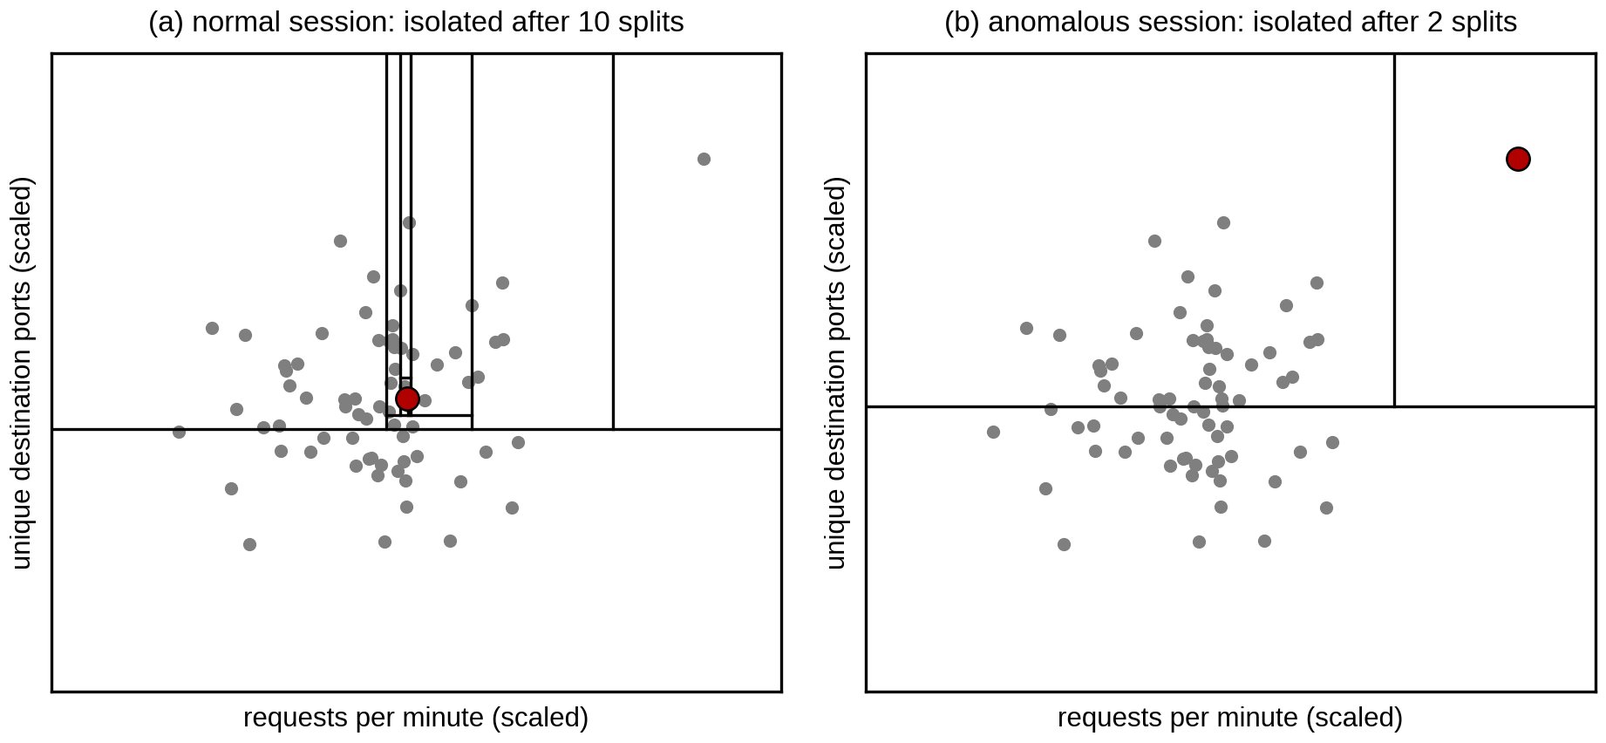
Figure 2.1: Isolating a normal and an anomalous session with random splits
The average number of splits needed across all the trees, called the path length h(x), is turned into an anomaly score using Equation 2.1:
$s(x, n) = 2^{-E(h(x)) / c(n)}$ (2.1)
where E(h(x)) is the average path length of record x over all the trees and c(n) is the average path length for a sample of n records, which is used to normalize the score. Scores close to 1 point to anomalies, while scores well below 0.5 point to normal records (Lakshmi et al., 2024). The scikit-learn implementation used in this project reports a related decision score and allows the threshold to be tuned (scikit-learn developers, n.d.).
Isolation Forest has been applied to network intrusion detection in several recent studies. Fuhnwi et al. (2023) used it together with a One-Class SVM to detect intrusions in IP network traffic, Moomtaheen et al. (2024) tuned the Extended Isolation Forest to find malicious activity in Zeek connection logs, and Lakshmi et al. (2024) evaluated it on synthetic network traffic at different contamination rates, which is close to the simulated-traffic approach used in this project.
Isolation Forest suits this project for three reasons. It never needs labeled data: it can be trained on normal traffic alone, or on unlabeled traffic in which attacks are rare, so no labeled attack examples have to be prepared. It is fast to train and to score, which matters because every host is scored every ten seconds on a laptop with limited memory. It also works well with a small number of numeric features, such as the eight traffic features used here.

2.3.8 Network Simulation and Emulation Platforms
A network like this one can be studied with a simulator or with an emulator. Cisco Packet Tracer is a simulator that is widely used for teaching. It is easy to use and supports VLANs, ACLs and routing, but its devices are models of Cisco IOS rather than the real software, and scripts running on the host cannot log in to them the way they can with real devices (Cisco Networking Academy, n.d.). GNS3 runs real network operating system images inside virtual machines, which gives realistic behavior but uses a lot of memory for each device. Containerlab builds a lab from a short topology file and runs each network operating system as a container (Containerlab, n.d.). Arista’s cEOS-lab is the EOS switch software packaged for this purpose; it supports 802.1X, VLANs, ACLs, port mirroring and SSH, and it is free to download (Arista Networks, n.d.). Table 2.2 compares the three options against the needs of this project.
Container-based emulation runs unmodified software in lightweight containers, but its timing can become less accurate when the containers ask for more CPU or input/output than the machine can give (Chen et al., 2025). This was a real concern on an 8 GB laptop, and it is one reason why the lab is deployed one node at a time and Zabbix is stopped during data collection.
Criterion | Cisco Packet Tracer | GNS3 | Containerlab with cEOS
Device software | Simulated models of Cisco IOS | Real images in virtual machines | Real Arista EOS in containers
Scripts on the host can log in (SSH) | No | Yes | Yes
Real packets available to Python | No | Yes | Yes (tcpdump in the containers)
Memory per switch | Very low | High (one virtual machine each) | About 1.4 GB per cEOS node
Rebuilding the lab | Open a saved .pkt file | Saved project | One topology file and one script
Cost | Free | Free; some images need licences | Free
Table 2.2: Comparison of network simulation and emulation platforms
Containerlab with cEOS was chosen because it was the only option that met all the needs of the project: real switch software, 802.1X with dynamic VLANs, SSH access for the automated response and real packets for the detection pipeline, while still fitting on an 8 GB laptop.

2.3.9 Python Tools for Collection, Automation and Monitoring
Python was used for every software part of the project. Packets mirrored to the SIEM host are captured with tcpdump and read by a small Python reader built on the struct module, which takes only the header fields needed for the features. Scapy was tried first but used too much memory on large captures. Netmiko, a Python library for connecting to network devices over SSH, is used to push configuration to the switches and is also used by the response engine (Byers, n.d.; Choi, 2024). Scikit-learn provides the Isolation Forest and the feature scaler (scikit-learn developers, n.d.), while pandas and NumPy are used to prepare the data.
Zabbix is an open-source monitoring platform. In this project it polls the two switches over SNMP, receives the values that the Python scripts push to it, shows them on dashboards and opens a problem whenever a trigger fires (Zabbix, n.d.).

2.4 Existing Solutions for Enterprise Threat Detection
Enterprise security usually relies on several tools used together. Firewalls enforce access rules at network boundaries. Intrusion detection systems (IDS) such as Snort and Suricata compare traffic with signatures and raise alerts, and intrusion prevention systems (IPS) also block the matching traffic. Security Information and Event Management (SIEM) platforms collect logs from many devices in one place, and User and Entity Behavior Analytics (UEBA) tools add machine learning to spot unusual user behavior. Identity-based access control platforms such as Cisco ISE apply policy at the point where users connect (Islam & Dhanekula, 2023). Table 2.3 compares these approaches with the proposed system.
Approach | Detection basis | New attacks | Response | Main limitation
Firewall | Fixed rules on addresses and ports | No | Blocks by rule | Does not look at behavior
Signature IDS / IPS | Known attack signatures | No | Alert (IDS) or block (IPS) | Misses unknown attacks
SIEM | Log correlation rules | Partly | Alert to an analyst | Response is manual
UEBA | Behavior baselines (machine learning) | Yes | Alert to an analyst | Costly; not linked to network control
Cisco ISE | Identity and device posture at login | No | Assigns VLAN or policy | Little view of behavior after login
This project | Isolation Forest on traffic features | Yes | Automatic block, quarantine or alert | Tested on simulated traffic only
Table 2.3: Comparison of existing threat detection approaches
Each of these tools covers part of the problem. Most depend on known signatures or on a person to decide what to do. Those that use behavior analytics are often expensive and are not linked to the access control layer, so a suspicious host is reported but not contained.

2.5 Research Gap
The literature shows that Zero Trust access control and machine learning detection are both well studied, but they are usually treated separately. Zero Trust work focuses on identity, policy and segmentation (Ahmadi, 2024; Mensah, 2024), while studies of machine learning intrusion detection focus on accuracy on public datasets (Ali et al., 2025; Hidayat et al., 2023) and rarely act on the network. Studies of automated response show that organizations are interested in automation, but few working examples link detection directly to network controls (Falowo & Bou Abdo, 2026). There is also little work that students or small organizations can reproduce without expensive licences. This project addresses these gaps by building a reproducible lab in which an unsupervised detector watches the traffic of a segmented Zero Trust network, and its output changes the network directly through ACL entries and VLAN quarantine.

2.6 Conceptual Framework
Figure 2.2 shows the conceptual framework of the study. The independent variables are the three parts of the system: Zero Trust access control, anomaly detection and automated response. Access control decides who gets onto the network and which segment they can reach. Anomaly detection watches what each host does after login and gives every ten-second window an anomaly score. Automated response turns a high score into an action suited to the type of attack.
The dependent variable is the security of the network. It is measured by how many attacks are detected, how many normal windows are wrongly flagged, how long it takes from detection to action, and whether a compromised host is stopped from reaching other segments. The moderating variables affect how well the independent variables work: the quality of the traffic used to train the model, the threshold chosen for the anomaly score and the limited memory of the lab machine.
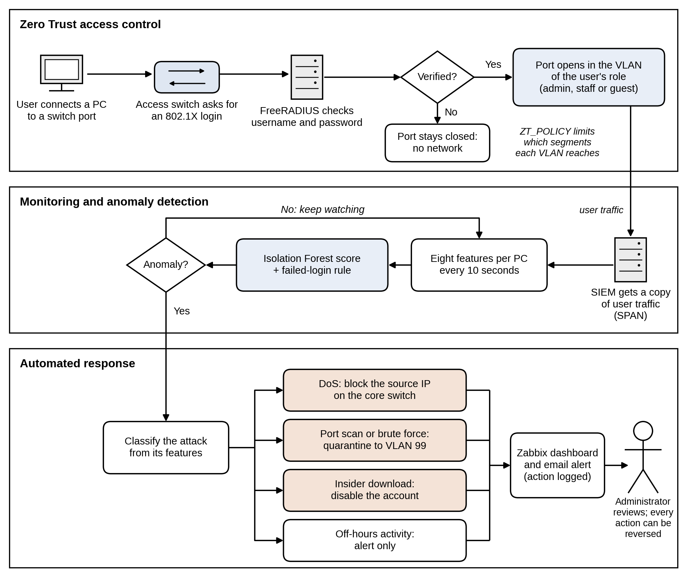
Figure 2.2: Conceptual framework

Chapter 3: Methodology

3.1 Introduction
This chapter describes how the project was carried out. It explains the development methodology, the move from Cisco Packet Tracer to Containerlab and the changes this made to the topology, the functional and non-functional requirements, the hardware and software used, and the way the system is tested and validated.

3.2 Project Methodology
The project used a quantitative approach, because the success of the system is measured with numbers taken from simulated attack runs: the detection rate, the false positive rate and the response time. Prototyping was chosen as the development methodology. In prototyping, a working version is built early, tested, and improved in repeated cycles until it meets the requirements.
This fitted the project for two reasons. First, several parts carried technical risk, such as whether 802.1X with dynamic VLANs would work on cEOS at all, and building a small prototype first was the quickest way to find out. Second, many problems only showed up once the lab was running, so each round of testing changed the design. Figure 3.1 shows the cycle and the three prototypes built in this project.
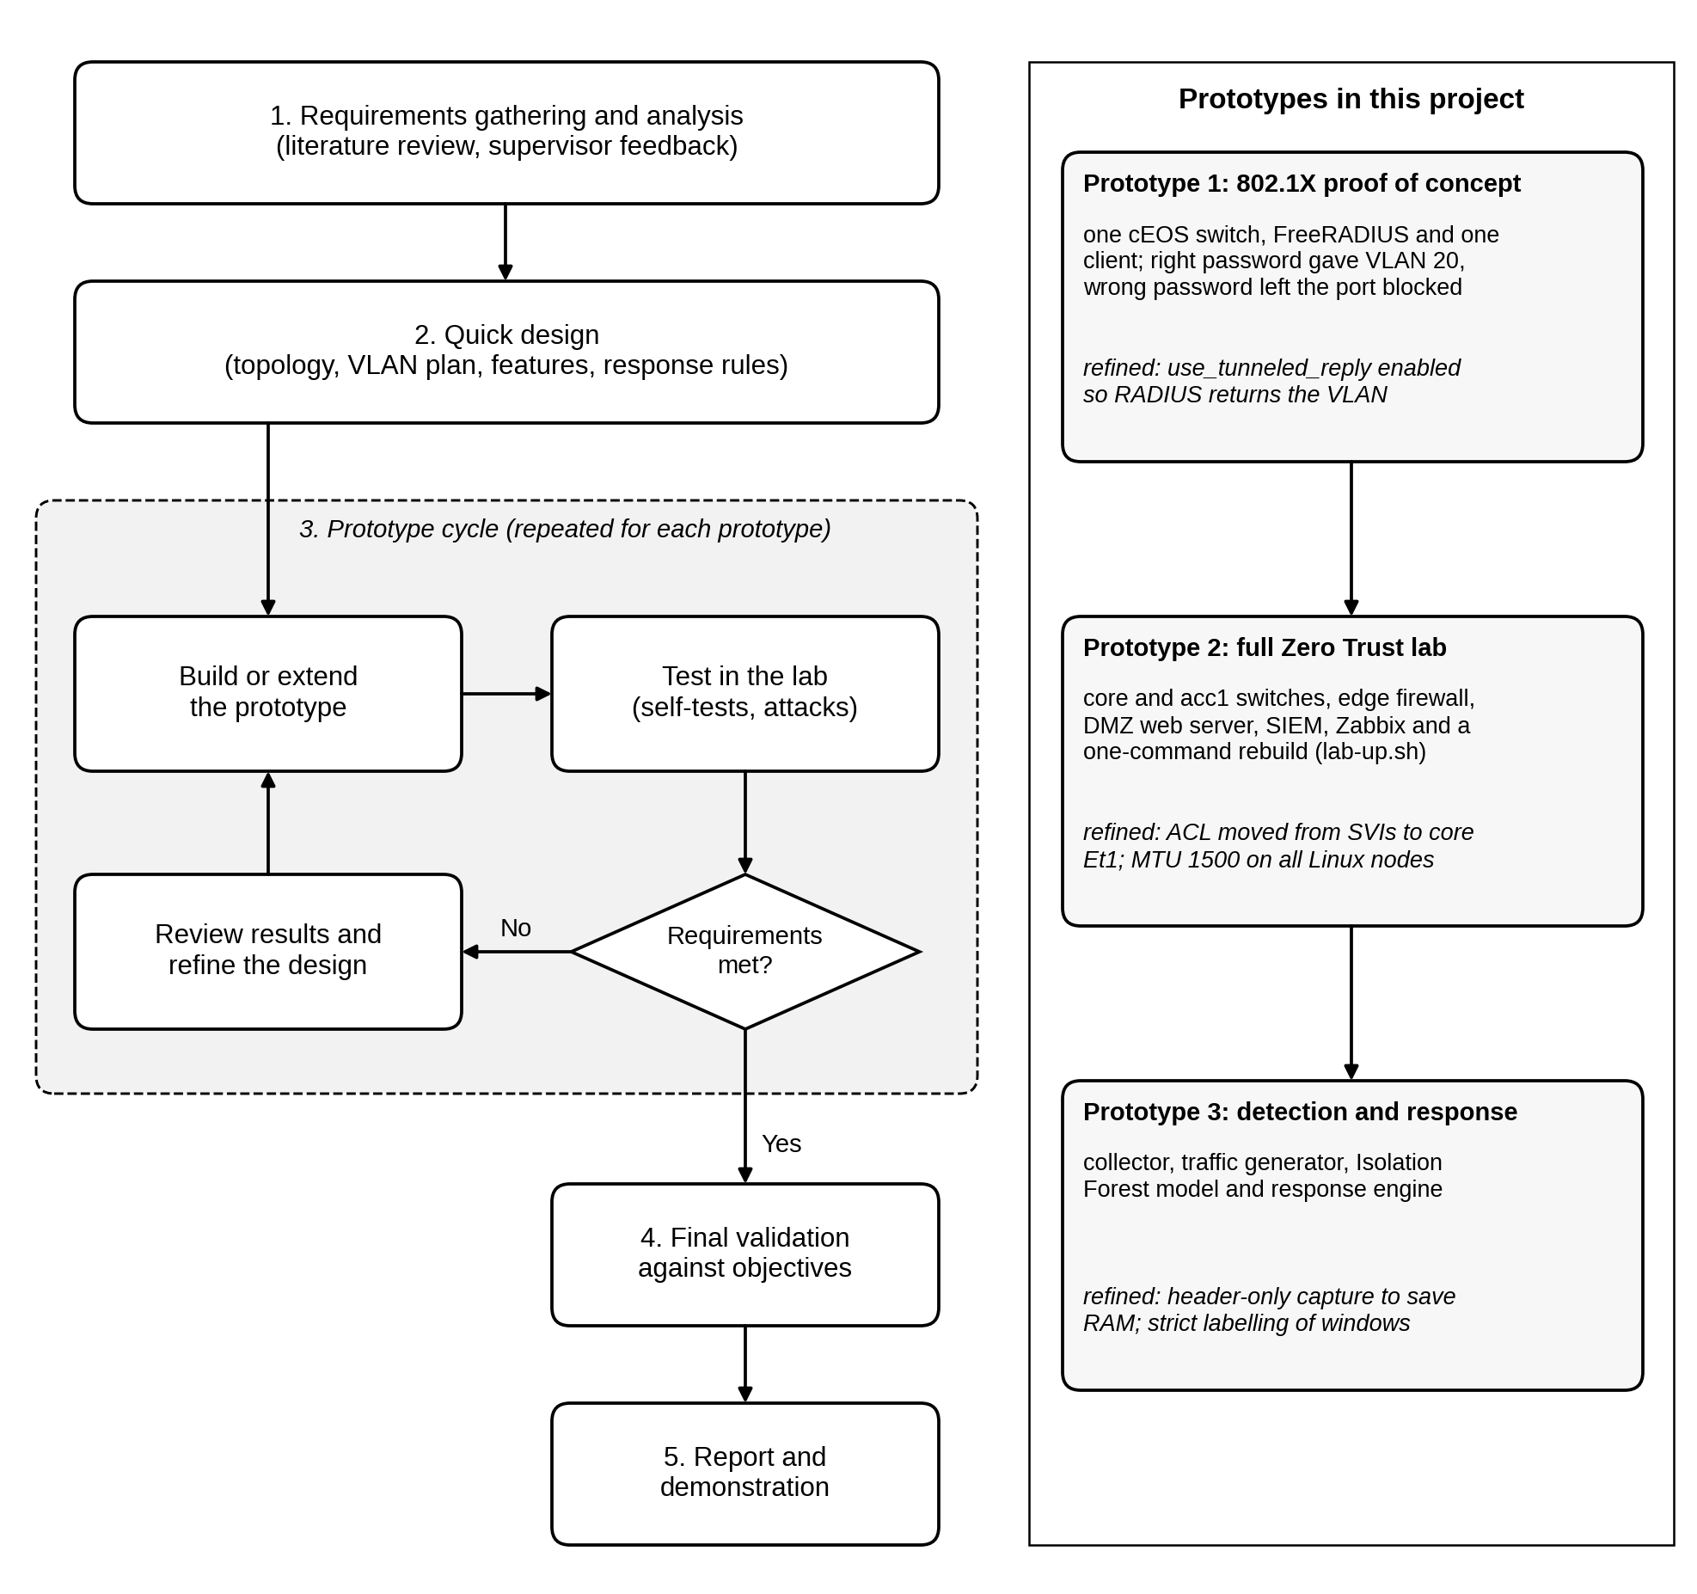
Figure 3.1: Prototyping methodology and the prototypes built

3.2.1 Requirements Gathering and Analysis
Requirements were taken from the literature review in Chapter 2, from the objectives in Section 1.3 and from the supervisor’s feedback on earlier drafts. They were grouped into functional and non-functional requirements, which are described in Section 3.4.

3.2.2 Quick Design
A first design was drawn in Cisco Packet Tracer with VLANs, ACLs, a DMZ and a quarantine VLAN. It was then turned into a Containerlab topology file, an addressing plan, a list of the features the model would use and the rules the response engine would follow.

3.2.3 Prototype Development
Three prototypes were built, each one adding to the one before. Prototype 1 was a proof of concept with one cEOS switch, a FreeRADIUS server and one client, built to test the riskiest assumption first. With the correct password the client was placed in VLAN 20, and with a wrong password the port stayed blocked. Prototype 2 was the full Zero Trust network: the core and access switches, the edge firewall, the DMZ web server, the SIEM host and Zabbix monitoring, all rebuilt by one script (lab-up.sh). Prototype 3 adds the detection and response layer, made up of the collector, a traffic generator for normal and attack traffic, the Isolation Forest model and the response engine.

3.2.4 Testing and Refinement
Each prototype was tested before the next one was started, and the problems found during testing changed the design. For example, FreeRADIUS did not return the VLAN until the use_tunneled_reply option was enabled. cEOS rejected ACLs on VLAN interfaces, so the policy was moved to the core switch’s trunk port. The first full dataset was also discarded after large downloads kept failing; the cause was that the Linux containers used a 9,500-byte MTU while the switches routed at 1,500 bytes, and all lab interfaces were then set to 1,500.

3.2.5 Final Validation
The finished system is validated against the objectives using the tests and metrics described in Section 3.6, and the results will be reported in Chapter 5.

3.3 Change of Simulation Platform and Topology
The proposal planned to build the network in Cisco Packet Tracer and GNS3, with Cisco ISE for authentication. During the first phase of the project this plan was changed, for three reasons. First, the detection and response layer needs Python scripts on the host that can log in to the switches, capture packets and change the configuration. Packet Tracer devices cannot be reached by scripts on the host in this way, so the automated response could not have been shown working on the network. Second, Cisco ISE needs a licence and far more memory than the lab machine has. Third, GNS3 runs each device as a virtual machine, which would not fit in 16 GB of RAM together with the servers and the monitoring tools.
The network was therefore rebuilt in Containerlab, with Arista cEOS-lab 4.36.2F for the switches and FreeRADIUS for AAA. The security design stayed the same: users still authenticate with 802.1X, get a VLAN based on their identity, are limited by ACLs and are separated from the DMZ by a firewall. The topology, however, had to be reduced. The first deployment with three cEOS switches froze the laptop, so the two routers and four switches of the Packet Tracer design became one core switch, one access switch and a Linux container that does the work of the edge router. Table 3.1 compares the two designs.
Element | Packet Tracer design (proposal) | Containerlab build (current)
Platform | Cisco Packet Tracer and GNS3 | Containerlab 0.81.0 on Kali Linux
Internet / ISP | ISP-SIM-RTR (Cisco 2911 router) | The host’s Docker network with NAT
Edge router and firewall | ZeroTrust-Edge-RTR with WAN_INBOUND_ACL | edge: Linux container with iptables
Core switch | ZeroTrust-Core-SW (Cisco 3560) | core: Arista cEOS
Access switches | Three Cisco 2960 switches | One switch, acc1: Arista cEOS
AAA server | Cisco ISE | FreeRADIUS 3.2.1
Segment policy | GUEST_ACL and QUARANTINE_ACL on the SVIs | One ACL, ZT_POLICY, inbound on core Ethernet1
Traffic collection | Simulated log collector | SPAN copy of Et2 to Et4 sent to the SIEM host
Monitoring | Zabbix 7.0 | Zabbix 7.0
Network devices | 2 routers and 4 switches | 2 switches and 1 Linux firewall
Table 3.1: Packet Tracer design compared with the Containerlab build
The reduced topology keeps every security function of the original design. The three access switches in the Packet Tracer design mainly separated the users physically. In a Zero Trust design the separation comes from the VLAN given at login and not from the switch a user is plugged into, so one access switch is enough. The edge container provides routing, NAT and the perimeter firewall while using less than 1 MB of memory, compared with about 1.4 GB for each cEOS switch.

3.4 System Requirements

3.4.1 Functional Requirements
The functional requirements describe what the system must do;
- Access control. Every user port on the access switch must stay closed until the user logs in with 802.1X. FreeRADIUS must check the username and password and return the user’s VLAN, so that the admin user (bob) is placed in VLAN 10, the staff user (alice) in VLAN 20 and the guest user (guest1) in VLAN 30. A wrong password must leave the port blocked, and ports that have not authenticated stay in the quarantine VLAN 99.
- Segmentation. Guests must not reach the admin, staff or quarantine subnets. A quarantined device may reach only the RADIUS server on UDP port 1812, so that it can log in again, and the SIEM host, so that it can be investigated. The internal VLANs may reach the DMZ web server only on TCP port 80, and the DMZ must not be able to open connections into the internal network.
- Collection and detection. The SIEM host must receive a copy of all traffic on the user ports and turn it into one record per host every ten seconds, with eight features. Failed logins must be read from the FreeRADIUS log and counted against the host that caused them. The Isolation Forest model must be trained without labels, must give each record an anomaly score and must flag records above a threshold tuned on normal traffic. A window with five or more failed logins must also be flagged, because a slow password attack changes no other feature.
- Response and monitoring. For a flagged record the system must work out the likely attack type and act without waiting for a person: block the source IP address for denial of service, move the host to VLAN 99 for a port scan or a brute-force attempt, disable the user’s account for insider data theft, and raise an alert only for off-hours activity or anomalies it cannot classify. Every action must be logged with its time, and the administrator must be able to release a blocked or quarantined host. Anomaly scores, alerts and actions must appear on a Zabbix dashboard together with the health of every node. Table 3.2 lists these requirements with the part of the lab that meets each one and how each one is checked.

No. | Requirement | Met by | How it is verified
FR1 | Users log in with 802.1X before getting network access | acc1 Et2 to Et4 and FreeRADIUS | show dot1x hosts; wrong-password test
FR2 | The VLAN is assigned from the user’s identity | FreeRADIUS users file | bob in VLAN 10, alice in 20, guest1 in 30
FR3 | Guests cannot reach admin, staff or quarantine subnets | ZT_POLICY on core Et1 | Ping tests and ACL hit counters
FR4 | The DMZ cannot start connections to the internal network | edge iptables rules | Ping from web to RADIUS fails; DROP counters
FR5 | Traffic is summarized per host every 10 seconds | SPAN to siem; zt_collector.py | Offline tests; dataset files
FR6 | Each window is scored by the Isolation Forest and the failed-login rule | zt_model.py | 5-fold leave-one-run-out evaluation
FR7 | Anomalies are answered automatically by attack type | zt_respond.py | Deny entry, VLAN 99 or failed login seen after each attack
FR8 | Scores, alerts and actions reach the administrator | Zabbix and zt_zbx_push.py | Dashboard pages and Problems list
Table 3.2: Functional requirements and how each is verified

3.4.2 Non-Functional Requirements
- Performance. Each ten-second window must be captured, scored and, if needed, acted on before the next window ends, so the time from detection to action should be well under ten seconds. Normal users must not notice the monitoring, because it works on a mirrored copy of the traffic and not in the traffic path.
- Accuracy. The detector should flag most attack windows while keeping false alarms on normal users low. A wrong quarantine cuts off a legitimate user, so the threshold is tuned on a separate normal run, and off-hours anomalies only raise an alert.
- Reliability and reproducibility. The whole lab must be rebuilt from scripts with one command (lab-up.sh), and it must check itself after every build. Six self-tests confirm that the guest can reach the DMZ web server and the internet but not the RADIUS server or the staff PC, that the staff PC can reach the RADIUS server, and that the DMZ cannot reach the RADIUS server.
- Resource use. The lab must run on a laptop with 8 GB of RAM. lab-up.sh refuses to start if less than 4.5 GB is free and deploys one node at a time, and Zabbix is stopped while datasets are collected. The collector keeps only the first 128 bytes of each packet to save memory.
- Safety and maintainability. The traffic generator must never send traffic outside the lab, so its agent refuses any target outside 10.10.0.0/16. The system must use free and widely available tools, and every configuration file and script is kept in Git so that the lab can be changed and rebuilt easily. Lab passwords exist only in the configuration files and must be removed before the code is shared.

3.5 Implementation Requirements

3.5.1 Hardware Requirements
The project was built and tested on one laptop, described in Table 3.3. Memory was the main constraint. The full lab with Zabbix uses about 5.5 GB of the 14.1 GB available, which is why the topology was reduced and why lab-up.sh checks the free memory before it starts.
Component | Specification
Processor | AMD Ryzen 5 5600U, 6 cores and 12 threads
Memory | 16 GB DDR4 (about 14.1 GB usable)
Storage | NVMe SSD with a 221 GB system partition
Operating system | Kali Linux Rolling, 64-bit, installed directly on the laptop
Network | Internet connection for downloads and for the guest internet test
Table 3.3: Hardware used

3.5.2 Software Requirements
All the software used is free. Table 3.4 lists each package with the version used and its purpose in the project.
Software | Version | Purpose
Kali Linux | Rolling | Host operating system
Docker | 28.5.2 | Runs all the lab containers
Containerlab | 0.81.0 | Builds the lab from zt-dev.clab.yml
Arista cEOS-lab | 4.36.2F | Software for the core and access switches
Debian (zt-node image) | 12 (bookworm) | Base image for the edge, servers and PCs
FreeRADIUS | 3.2.1 | AAA server for 802.1X
wpa_supplicant | 2.10 | 802.1X client on the three PCs
iptables | Debian 12 package | Edge firewall and NAT
tcpdump | 4.99.3 | Packet capture on the SIEM host
Python | 3.14 (host), 3.11 (containers) | Collector, traffic generator, model and response
Netmiko | 4.8.0 | SSH to the switches for configuration and response
scikit-learn, pandas, NumPy | Current stable releases | Isolation Forest, scaling and data handling
Zabbix | 7.0 LTS | Monitoring dashboards and alerts
Git | Current | Version control and automatic backups
Visual Studio Code | Current | Writing and editing scripts
Cisco Packet Tracer | 8.3 | Initial design only (Section 3.3)
Table 3.4: Software used

3.6 Testing and Validation
Testing checks each part of the system on its own first, and then the whole system against the objectives.

3.6.1 Functional Testing
The access control layer is tested with the self-tests in lab-up.sh and with manual checks. The command show dot1x hosts on acc1 must show all three users authenticated and in the right VLANs, and a login with a wrong password must be rejected with the port left blocked. Ping and web tests between the segments are compared with the expected results in Table 3.2, and the hit counters on ZT_POLICY and on the edge firewall confirm which rule handled each packet.
The collector and the traffic generator have offline tests (test_collector.py with ten checks and test_traffic.py with six) that run on saved data without the lab, so they can be repeated after every change. The model is tested with the leave-one-run-out method described in Section 3.6.3, so it is always scored on runs it has never seen.

3.6.2 Security Testing
Attack traffic is generated by zt_traffic.py, which copies a small agent into each PC container and controls it from the host. Normal background traffic, made up of web page loads, file downloads and pings, runs on all three PCs throughout every test, so the detector must find the attacker among normal users. Table 3.5 lists the attack scenarios and the response expected for each one.
Attack | Source | How it is generated | Intensities | Expected response
Denial of service | guest-pc | HTTP flood on the DMZ web server | 40 to 120 requests/s | Block source IP
Port scan | guest-pc | TCP connect scan of the web server | 10 to 50 ports/s | Quarantine host
Brute force | guest-pc (injected at RADIUS) | Wrong passwords for bob, alice and admin | 1 to 8 attempts/s | Quarantine host
Insider data theft | staff-pc | Repeated download of a 20 MB file | 0.5 to 2.5 MB/s | Disable account
Off-hours use | staff-pc | Normal traffic in windows marked as night | Not applicable | Alert only
Table 3.5: Attack scenarios used for testing
802.1X login frames never reach the IP network, so a password attack is only visible as the RADIUS requests that the switch relays and the rejects that follow. A real 802.1X client also retries only about every 20 seconds, which is too slow to look like an attack. The generator therefore sends the relayed requests straight to FreeRADIUS, using the switch’s NAS address (10.10.10.11) and guest-pc’s MAC address. It cannot run on the SIEM host, because the SIEM’s switch port is the SPAN destination, which only receives traffic.

3.6.3 Data Collection and Labeling
The datasets were collected with collect_datasets.sh. Four normal runs of ten minutes each were captured: normal_01 and normal_02 are used for training, normal_03 to tune the threshold and normal_04 as unseen normal test data. The threshold is the 99th percentile of the scores on normal_03, which aims at about 1% false alarms. Each attack was then run five times for 60 seconds, once at each of the intensities in Table 3.5, with the attack active from the 10th to the 50th second.
The model is evaluated with 5-fold leave-one-run-out cross-validation. In fold k, run k of every attack type is held out for testing and the model is trained on two other runs of each type, so every run, including the weakest attacks, is tested by a model that never saw it. Two training modes are compared: normal-only, where the model sees only normal traffic, and mixed, where it sees unlabeled traffic in which attacks make up about 9% of the windows.
Every ten-second window is labeled as normal or attack only so that the results can be scored; the model never sees the labels. A window is labeled as an attack only if the attack covered at least 90% of it. Windows that the attack only partly covered are left out, so that they are not counted as false alarms or missed attacks. Because FreeRADIUS delays each reject by one second, the window just after a brute-force run is also left out.

3.6.4 Performance Testing
Performance testing measures the time from the end of a window to the completed response (Equation 3.6), using timestamps written by the pipeline at each step. It also checks that CPU and memory use on each node stay within limits during attacks. Every node pushes its CPU, memory and packet rates to Zabbix every 30 seconds, so the load on the lab can be compared between normal and attack runs.

3.6.5 Evaluation Metrics
The detector’s output is compared with the labels using the four counts of a confusion matrix, shown in Table 3.6. A true positive (TP) is an attack window that was flagged, a false negative (FN) is an attack window that was missed, a false positive (FP) is a normal window that was flagged and a true negative (TN) is a normal window that was not flagged.
Actual class | Predicted attack | Predicted normal
Attack window | True positive (TP) | False negative (FN)
Normal window | False positive (FP) | True negative (TN)
Table 3.6: Confusion matrix used for evaluation
From these counts the detection rate (DR, also called recall), the false positive rate (FPR), the precision (P), the accuracy (Acc) and the F1-score are calculated for each attack type and each intensity using Equations 3.1 to 3.5. The F1-score balances precision against the detection rate, which matters here because the test runs contain many more normal windows than attack windows.
$DR = \frac{TP}{TP + FN}$ (3.1)
$FPR = \frac{FP}{FP + TN}$ (3.2)
$P = \frac{TP}{TP + FP}$ (3.3)
$Acc = \frac{TP + TN}{TP + TN + FP + FN}$ (3.4)
$F1 = \frac{2 × P × DR}{P + DR}$ (3.5)
The response time of each incident is measured from the moment the ten-second window closes to the moment the response action is confirmed on the network, as in Equation 3.6.
$T_{r} = t_{action} - t_{window}$ (3.6)

3.6.6 Validation of Results
The system will be considered valid if legitimate users in all three VLANs keep working without being flagged, each attack type is detected at its stronger intensities, DoS sources are blocked, scanning and brute-force hosts end up in VLAN 99, the account is disabled after insider data theft, off-hours activity raises an alert without cutting access, guests never reach internal resources, and every action appears in Zabbix with its timing. Each of these checks maps back to one of the specific objectives in Section 1.3.2.

Chapter 4: System Design

4.1 Introduction
This chapter presents the design of the system. It starts with a black-box view of the inputs and outputs, then uses UML diagrams (use-case, sequence, activity and class diagrams) and an entity relationship diagram to describe how the system behaves and what data it keeps. It ends with the system architecture, the network topology as built in Containerlab, and the addressing, policy, feature and response tables that the implementation follows.

4.2 Black-Box
Figure 4.1 shows the system as a black box with three external actors. Network users (admin, staff and guest) send their 802.1X credentials and their normal traffic into the system. In return they get access to the VLAN for their role, or they are refused if the login fails. The simulated attacker sends attack traffic: a DoS flood, a port scan, brute-force logins, a large insider download or off-hours activity. What comes back to the attacker is a blocked source address, a move to the quarantine VLAN or a disabled account.
The network administrator provides the user accounts, the VLAN policy and the normal traffic run used to train the model and can release a host that was blocked or quarantined. In return the administrator receives the anomaly scores, the alerts and the actions taken, together with the time each response took, through the Zabbix dashboard and the incident log.
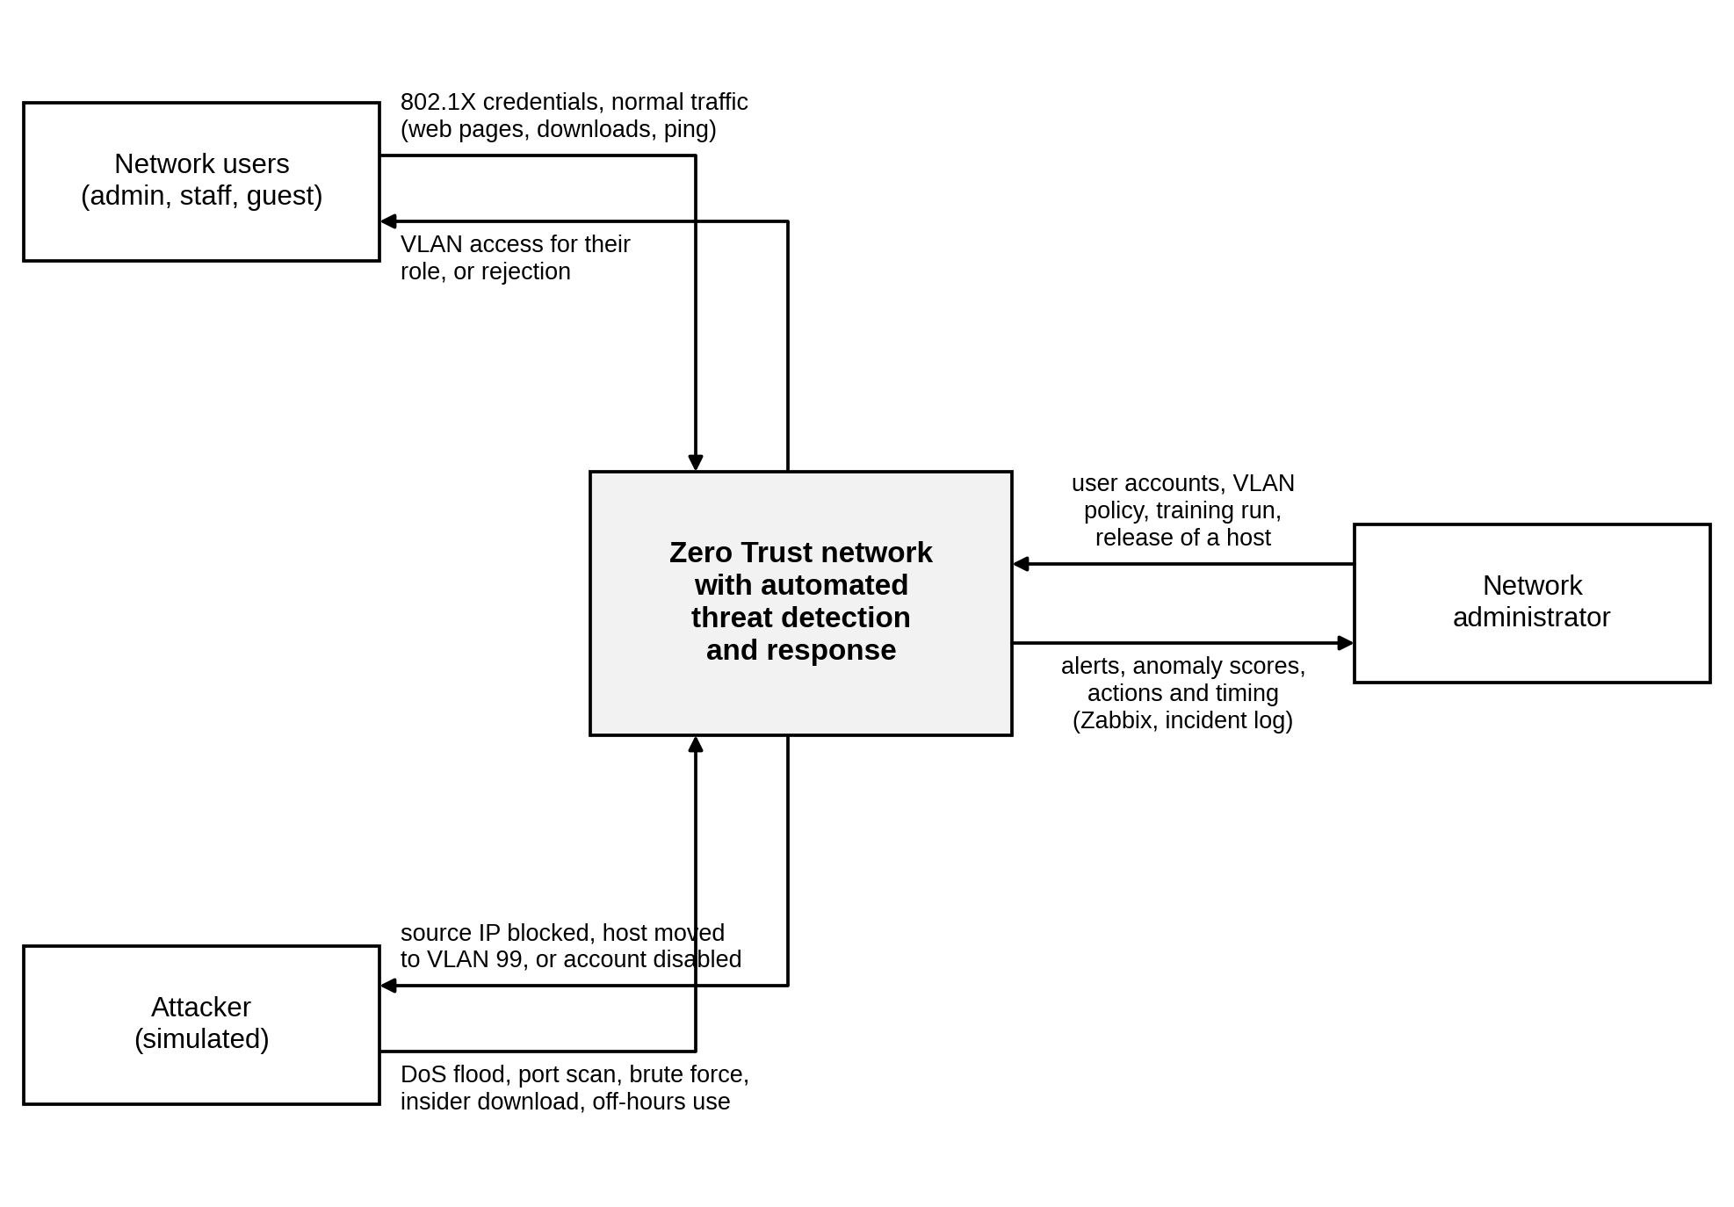
Figure 4.1: Black-box view of the system

4.3 System Analysis

4.3.1 Use-Case Diagram
Figure 4.2 shows the use cases of the system and its three actors. The network user logs in with 802.1X and then accesses the resources allowed for their role; accessing resources always includes logging in. The attacker generates attack traffic, which passes through the same network as normal traffic. The network administrator manages users and VLAN policy, trains the Isolation Forest model, monitors network traffic, views alerts and scores, and releases or re-enables hosts that the system has acted on.
Monitoring network traffic includes scoring each session with the Isolation Forest, and scoring includes extracting the session features. When the score is above the threshold, the Respond to anomaly use case extends scoring. Responding takes four specific forms: blocking the source IP, quarantining the host in VLAN 99, disabling the account and raising an alert. FreeRADIUS, the switches and Zabbix are treated as parts of the system rather than as actors, because they were built and configured as part of this project.
The diagram uses standard UML notation, which is also explained in the key under the figure. A dashed arrow marked «include» points to a use case that always runs as part of another one, a dashed arrow marked «extend» shows a use case that runs only when a condition is met, and a solid arrow with a hollow head shows that one use case is a specific kind of another.
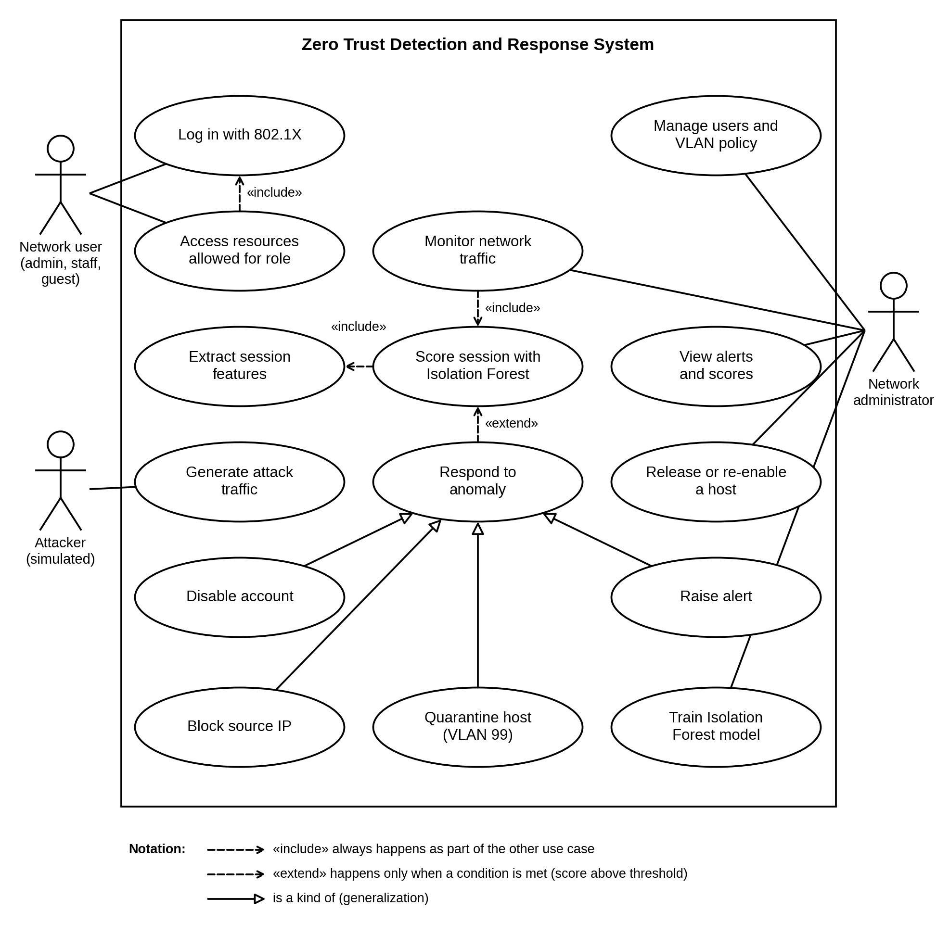
Figure 4.2: Use-case diagram

4.3.2 Sequence Diagram
Figure 4.3 shows the messages exchanged when one attack window is detected. The attacker on guest-pc sends packets through acc1, which copies them to the SIEM host on Ethernet6 (messages 1 and 2). When the ten-second window closes, the collector extracts the eight features, asks the Isolation Forest for a score and pushes the score to Zabbix (messages 3 to 6). Scores are pushed for every window, normal or not, so the dashboard always shows the current state of each host.
If the score is above the threshold, or the window has five or more failed logins, the collector passes the record to the response engine, which classifies the attack (messages 7 and 8). The inner alt fragment shows the three possible paths. For a DoS attack the response engine adds a deny line for the source address to ZT_POLICY on the core switch, using one of the sequence numbers 71 to 79 that are reserved for this (messages 9 and 10). For a port scan, a brute force or insider data theft, it writes a rule for the user into FreeRADIUS and bounces the user’s port on acc1 (messages 11 to 14). The rule sends the user to VLAN 99 for a quarantine, or rejects the login for a disabled account. This method was chosen because 802.1X assigns the VLAN at login, so changing the VLAN of the port on the switch would be overwritten at the next login. The lab has no DHCP server, so after a quarantine the engine also gives the PC its quarantine address, for example 10.10.99.30 for guest-pc (message 15). For off-hours or unclassified anomalies the network is not changed (message 16). In every case the alert, the action and the response time are sent to Zabbix and written to the incident log (messages 17 and 18).
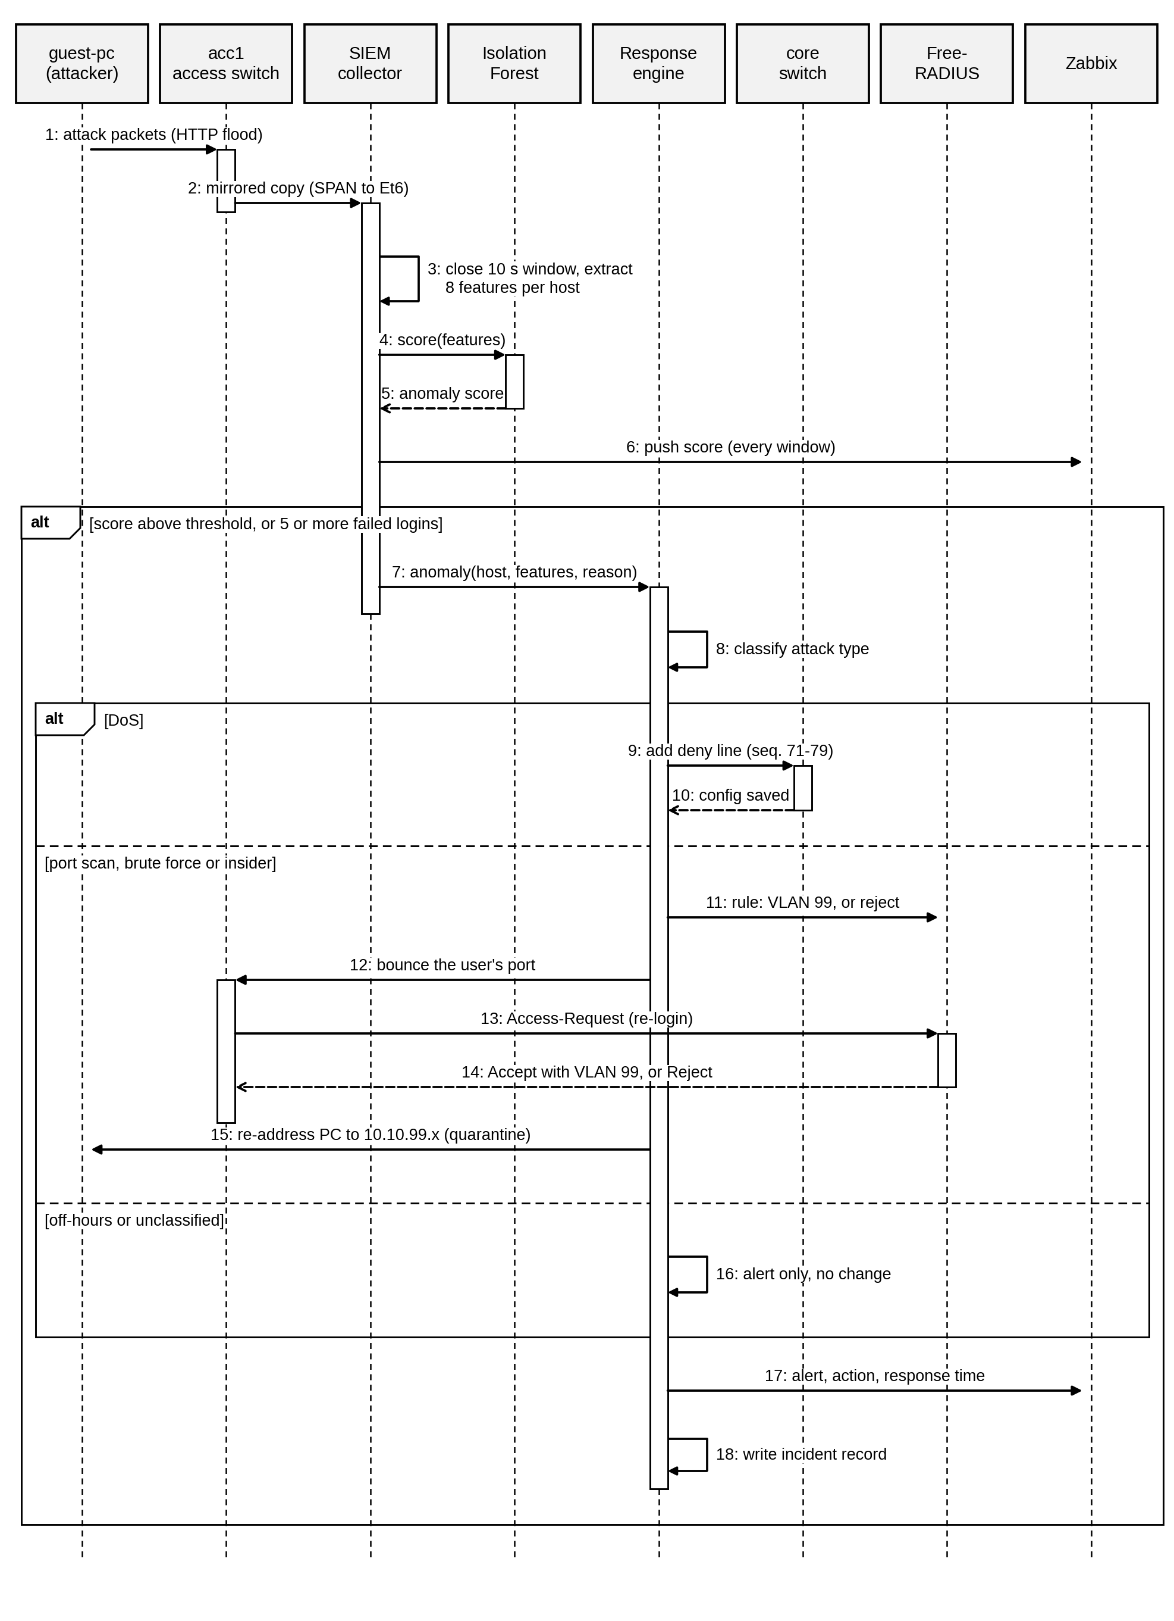
Figure 4.3: Sequence diagram for one anomalous window

4.3.3 Activity Diagram
The activity diagram in Figure 4.4 shows the loop that runs on the SIEM host. Each pass starts with two activities in parallel: capturing the mirrored packets for ten seconds and reading new Access-Reject lines from the Free RADIUS log. When both have finished, the packets are grouped by host, the eight features are computed, the features are scaled and the Isolation Forest returns a score, which is pushed to Zabbix.
A window is flagged when its score is above the threshold or when it contains five or more failed logins. If neither is true, the loop moves on to the next window, so normal traffic is never interrupted. Otherwise, the attack type is classified, and one of four branches runs. A DoS adds a deny line for the source IP on the core switch; a port scan or brute force moves the user to VLAN 99 and bounces the port; insider data theft disables the account by rejecting the user’s login and bouncing the port; and off-hours or unclassified anomalies raise an alert without changing access. The branches then merge, the incident is recorded and sent to Zabbix with its response time, and the loop continues until it is stopped.
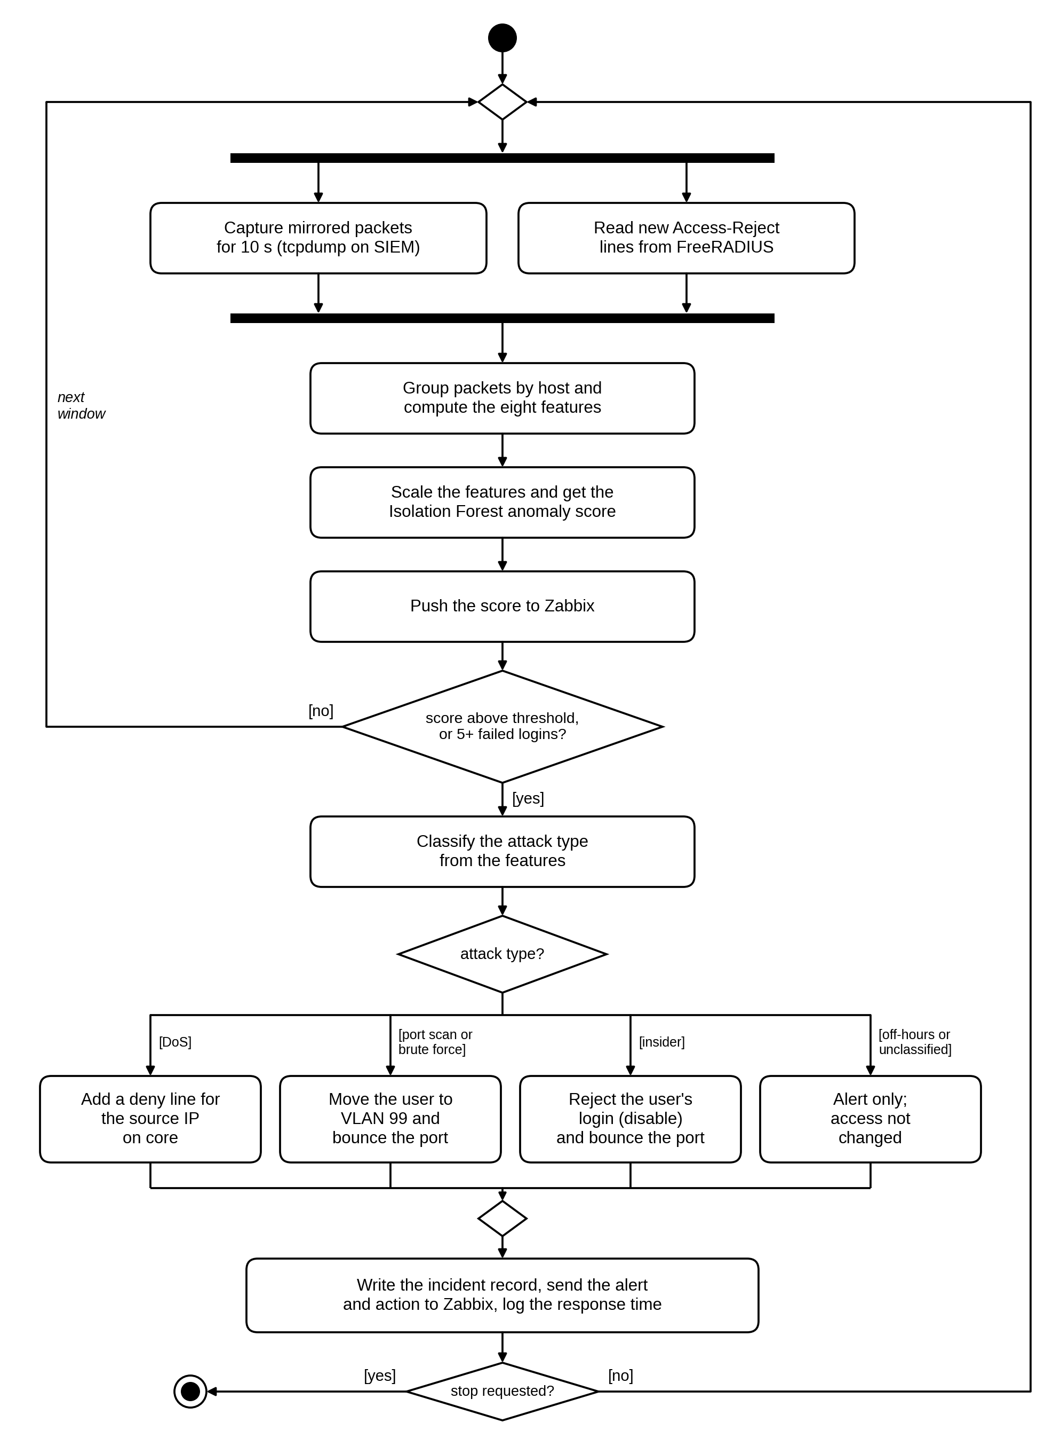
Figure 4.4: Activity diagram of the detection and response loop

4.3.4 Entity Relationship Diagram (ERD)
Figure 4.5 shows the data that the system stores and how it is related, using crow’s foot notation. A VLAN is assigned to many user accounts and contains many hosts. A user account makes many authentication events, one for each RADIUS accept or reject, and logs in on hosts. Each host generates one session window every ten seconds. SESSION_WINDOW holds the eight features, the anomaly score and, for evaluation only, the label. A session window raises at most one alert, and each alert triggers one or more response actions. RESPONSE_ACTION records what was done (block, quarantine, disable or alert only), its target, the time it took and when the host was released.
Through its target, a quarantine action changes the user’s VLAN to 99 in FreeRADIUS, which changes the VLAN of the user’s host at the next login. This is where the detection layer feeds back into access control. In the implementation the session windows are stored in CSV files, the alerts and actions in a JSON incident log, and the users and VLANs in the FreeRADIUS users file and the switch configuration.
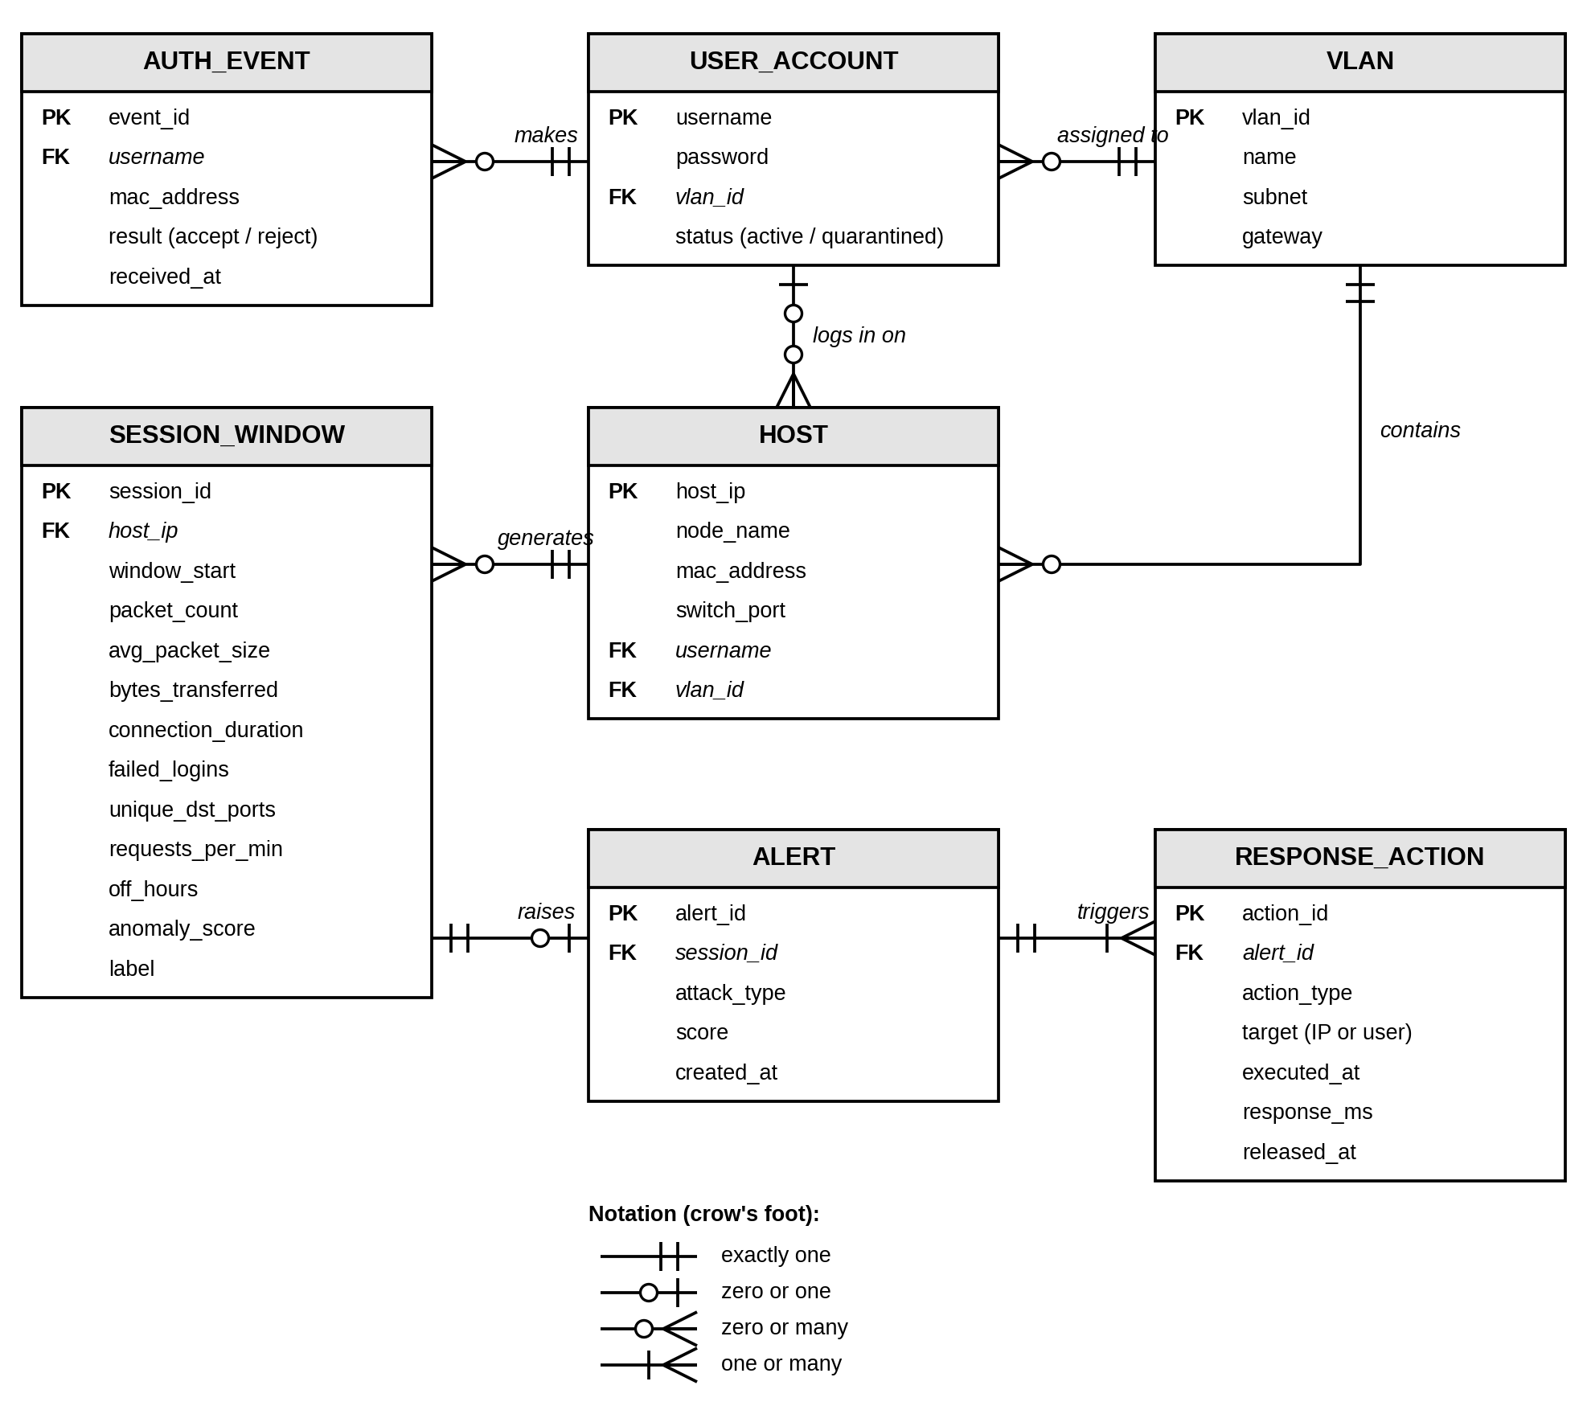
Figure 4.5: Entity relationship diagram

4.3.5 Class Diagram
Figure 4.6 shows the main Python classes and modules and the files that hold them. The zt_collector module captures the mirrored packets, reads them and builds one row of features per host per window, and it uses a RadiusRejectParser object to turn FreeRADIUS log lines into failed-login events. AnomalyDetector in zt_model.py wraps the scikit-learn StandardScaler and an IsolationForest of 200 trees, with methods to fit on rows, score them, tune the threshold on a normal run and save or load the trained model. The detect() function makes the final decision for each window: it flags the window if the model flags it or if the failed-login rule fires, and records which of the two did.
Three classes in zt_respond.py handle the response. AlertBuilder classifies a flagged window by checking its features from the most to the least specific and builds the alert record. NetworkActions produces the exact switch and RADIUS commands for each action; it changes nothing itself, so it can be tested offline. ResponseEngine applies those commands over SSH with Netmiko, keeps the SSH sessions open so that an action takes about a tenth of a second, remembers what it has already done so that a host is never acted on twice, and records every incident. The zt_zbx_push module sends scores, alerts and timings to Zabbix on TCP port 10051. PipelineOrchestrator in zt_pipeline.py owns the detector and the response engine and runs the loop shown in Figure 4.4.
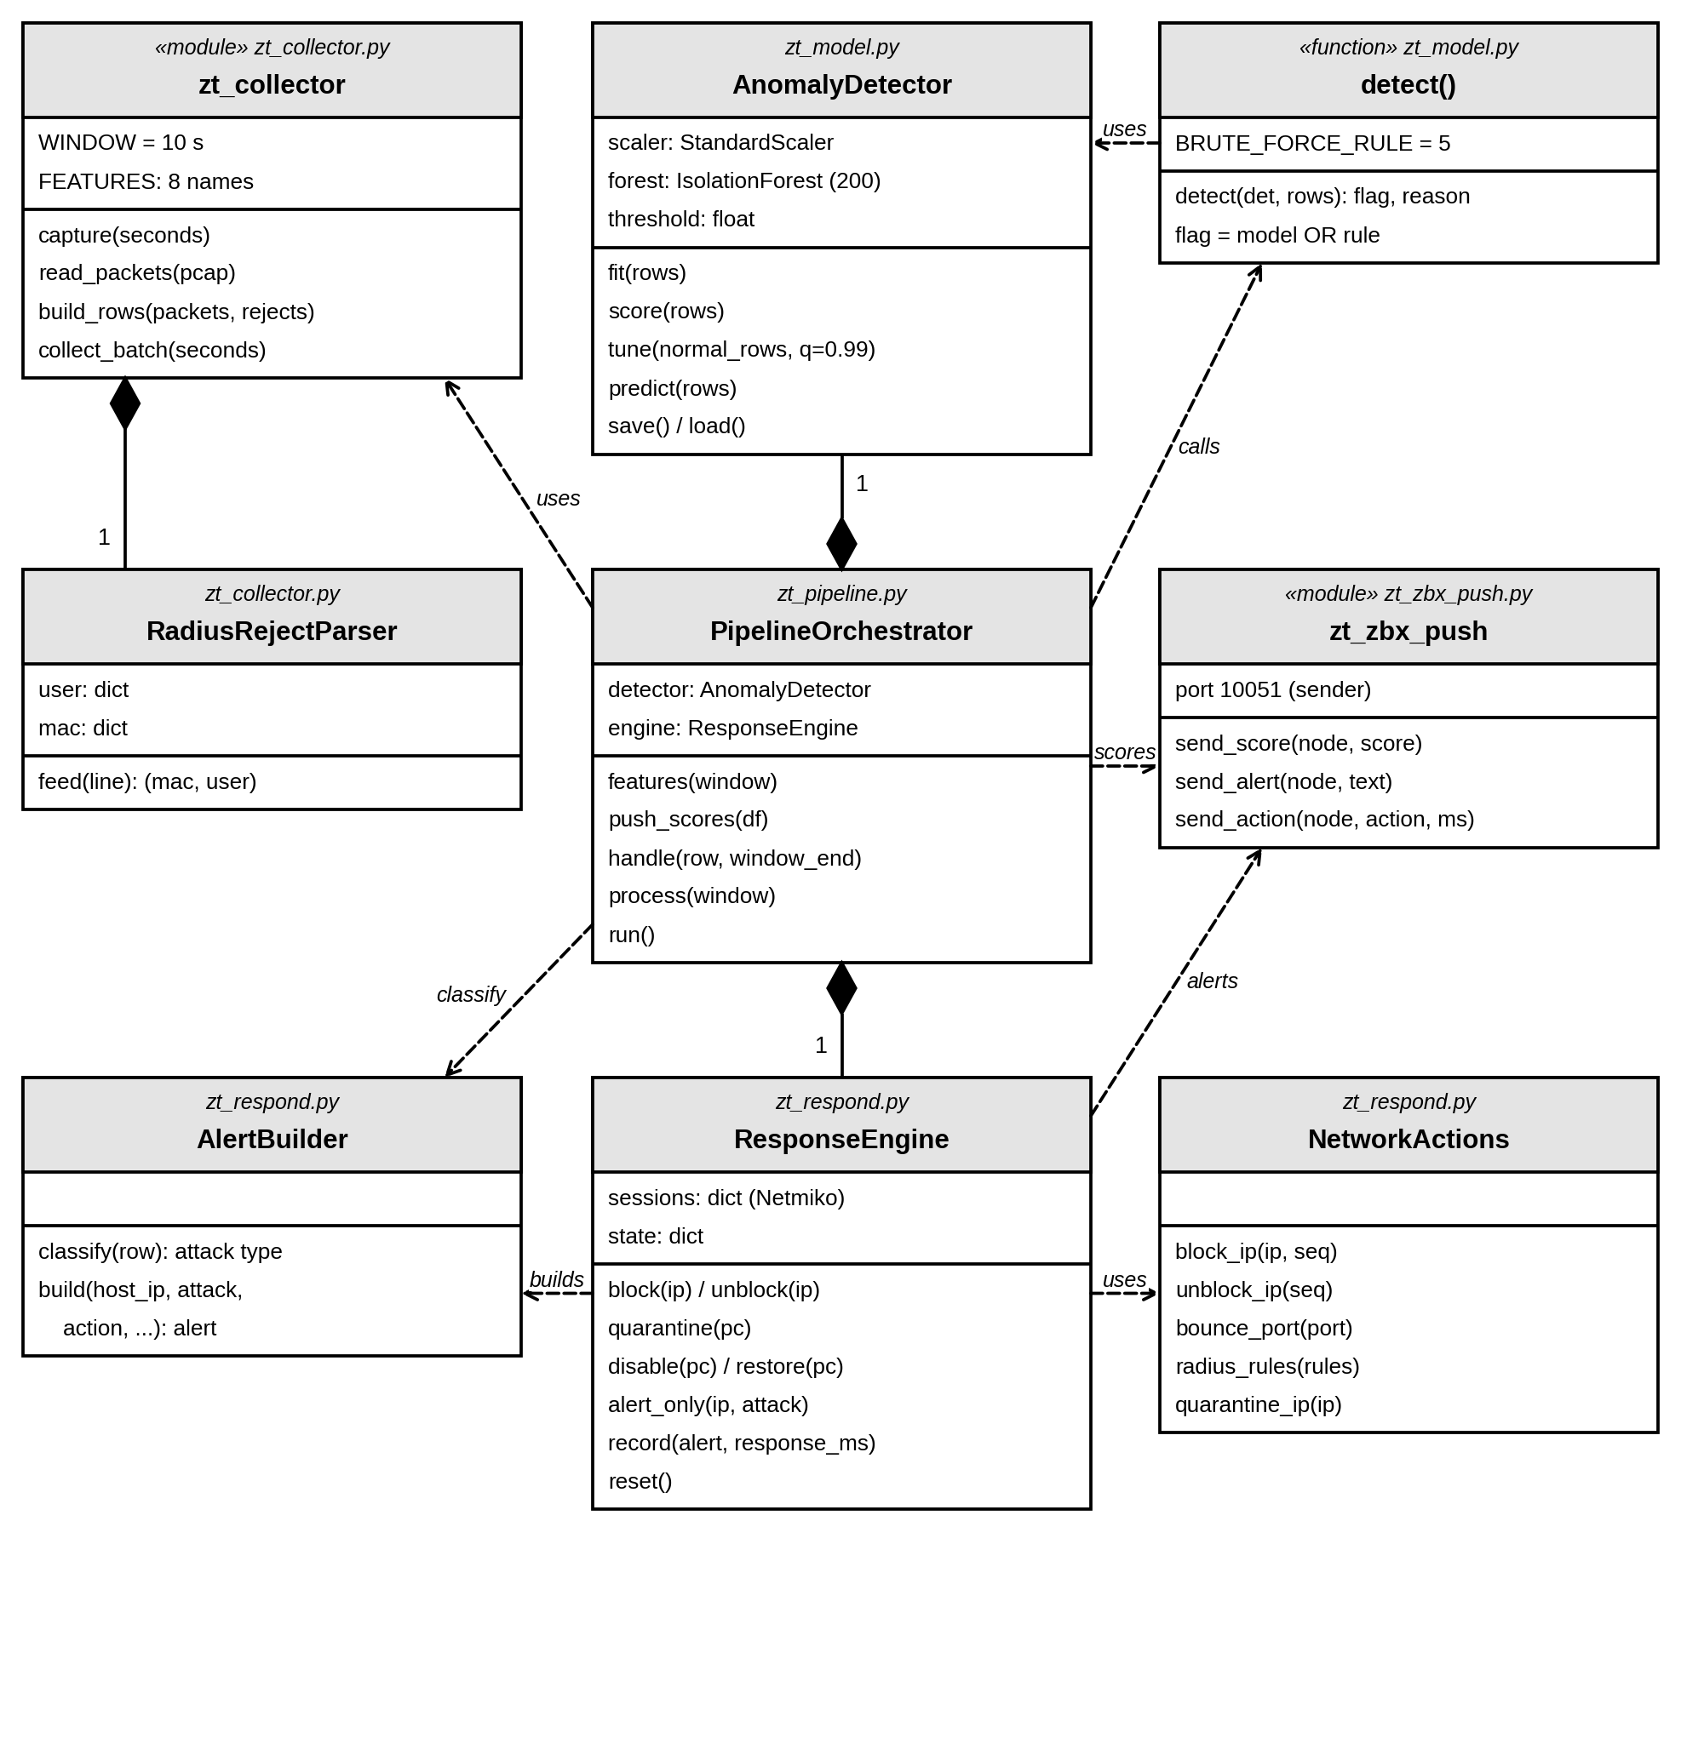
Figure 4.6: Class diagram

4.4 System Design

4.4.1 System Architecture Diagram
Figure 4.7 shows the system architecture. The network side has four layers. At the top, the edge firewall connects the lab to the internet through NAT and separates it from the DMZ web server; its default forwarding policy is DROP and only the traffic described in Section 4.4.3 is allowed. The core switch is the default gateway for VLANs 10, 20, 30 and 99, routes between them and applies the ZT_POLICY ACL. The access switch acc1 authenticates the three users with 802.1X and copies their traffic to the SIEM host, and FreeRADIUS places each user in their VLAN after login.
The security services are in VLAN 10. FreeRADIUS answers the 802.1X requests from acc1, and the SIEM host runs the pipeline made up of the collector, the Isolation Forest, the classifier and the response engine. The response engine changes the network in two places: the ACL on the core switch for a block, and the user’s rule in FreeRADIUS together with a port bounce on acc1 for a quarantine or a disabled account. Zabbix runs on the host machine and receives the scores, the alerts and the health data of every node.
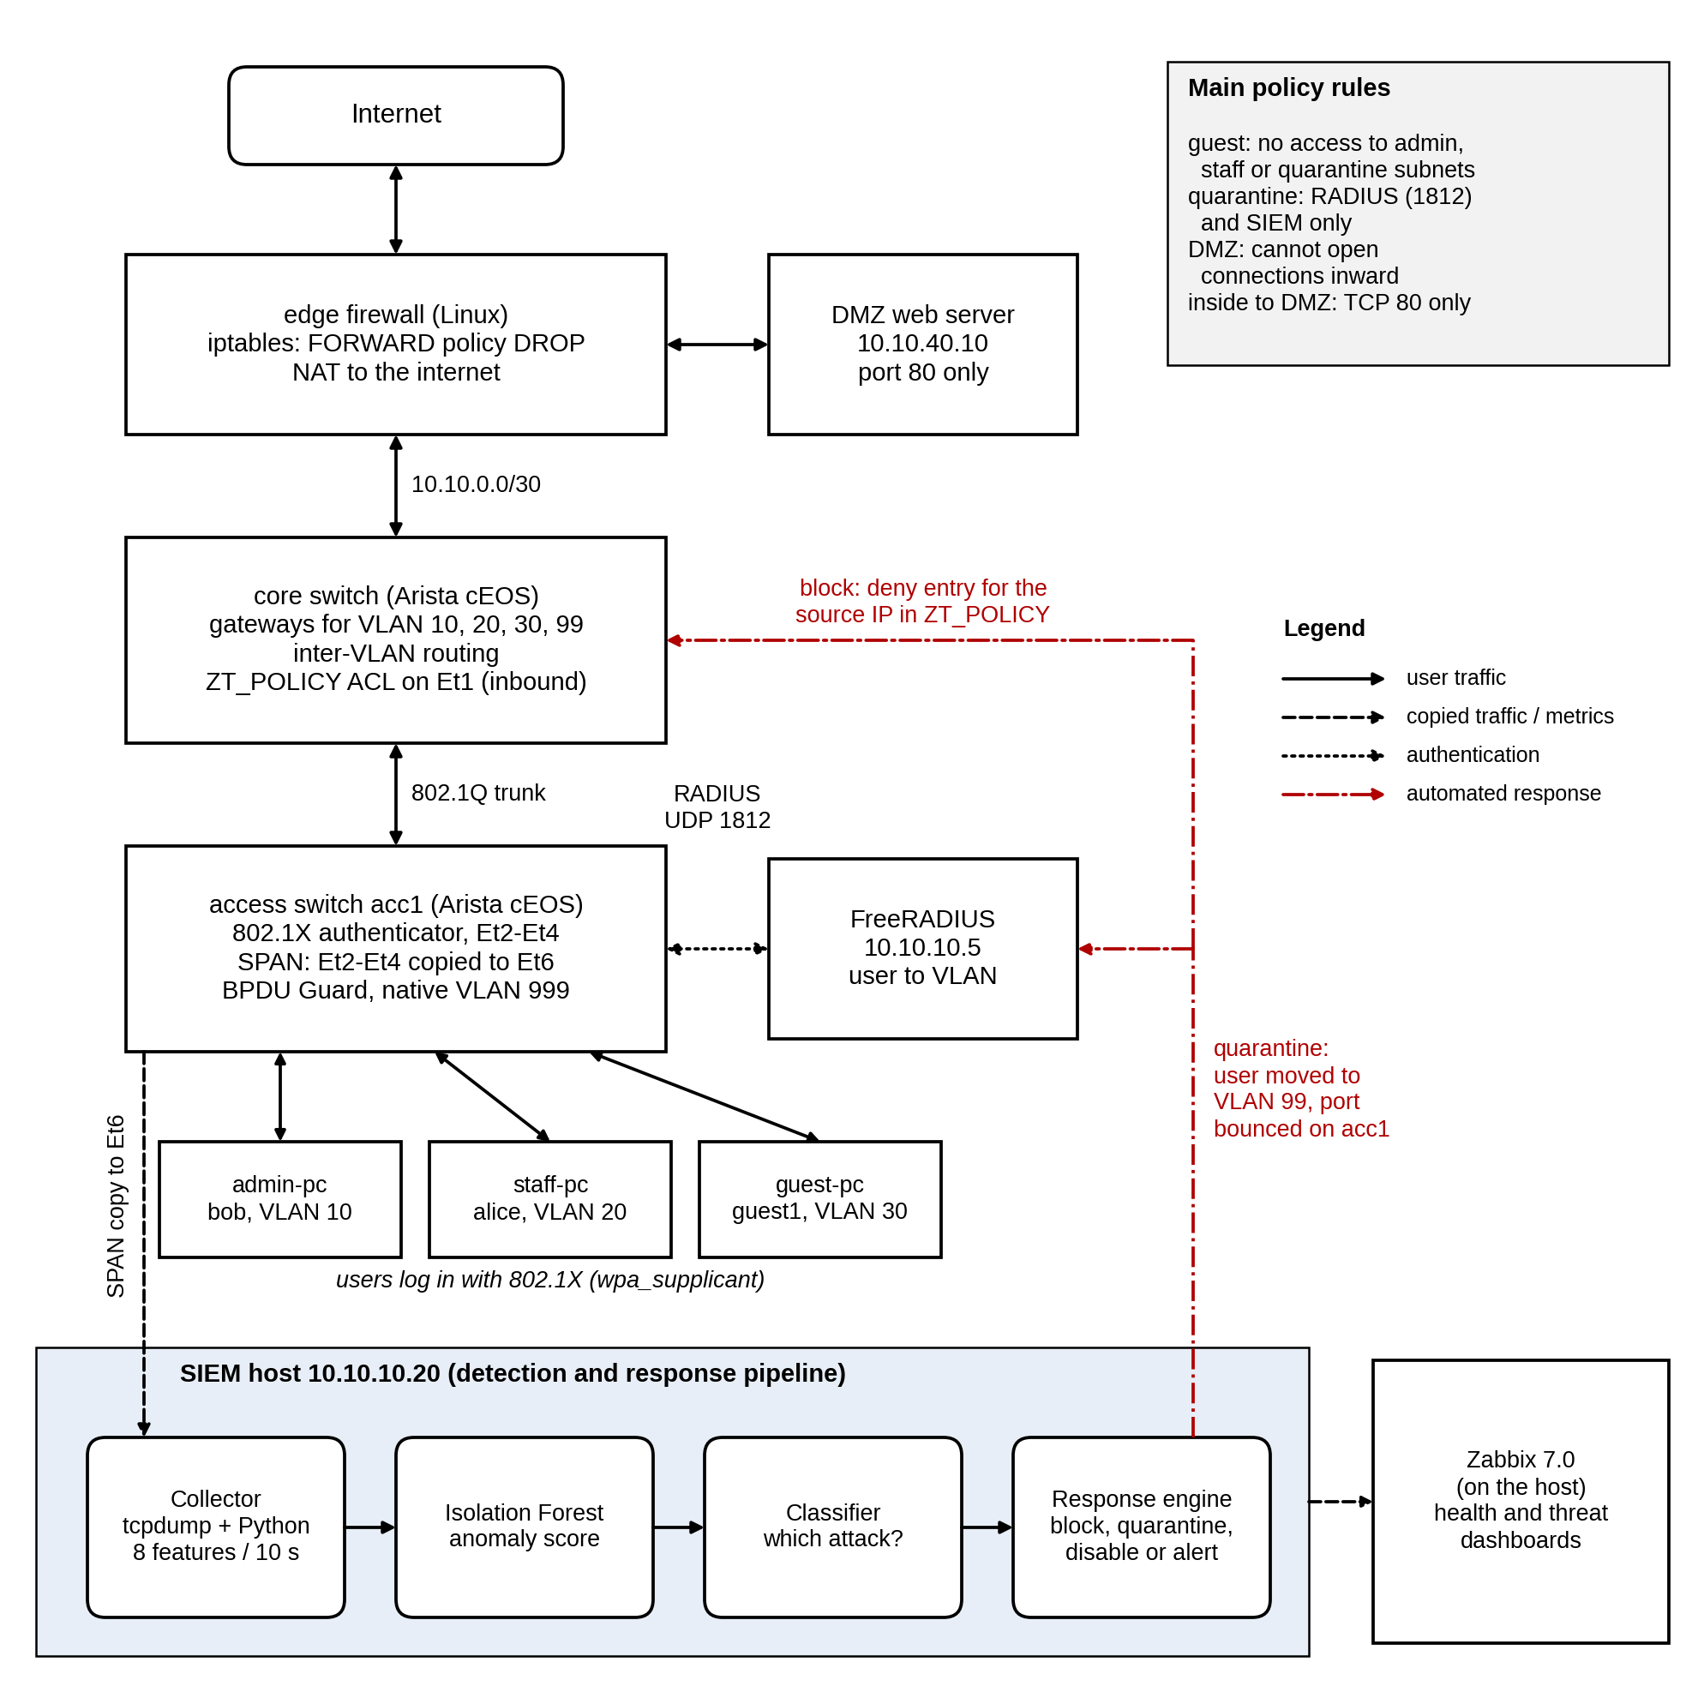
Figure 4.7: System architecture

4.4.2 Network Topology
Figure 4.8 shows the topology as built in Containerlab, with the interface names and addresses used in the configuration files. The core switch connects to the edge firewall over a routed /30 link on Ethernet3, and to acc1 over an 802.1Q trunk on Ethernet1. The trunk carries only VLANs 10, 20, 30 and 99 and uses an unused native VLAN (999) to prevent VLAN hopping. On acc1, Ethernet2 to Ethernet4 are 802.1X ports for the three PCs, with PortFast and BPDU Guard enabled. Ethernet5 and Ethernet6 are fixed VLAN 10 ports for FreeRADIUS and the SIEM host, and Ethernet6 is also the SPAN destination. Table 4.1 gives the addressing plan.
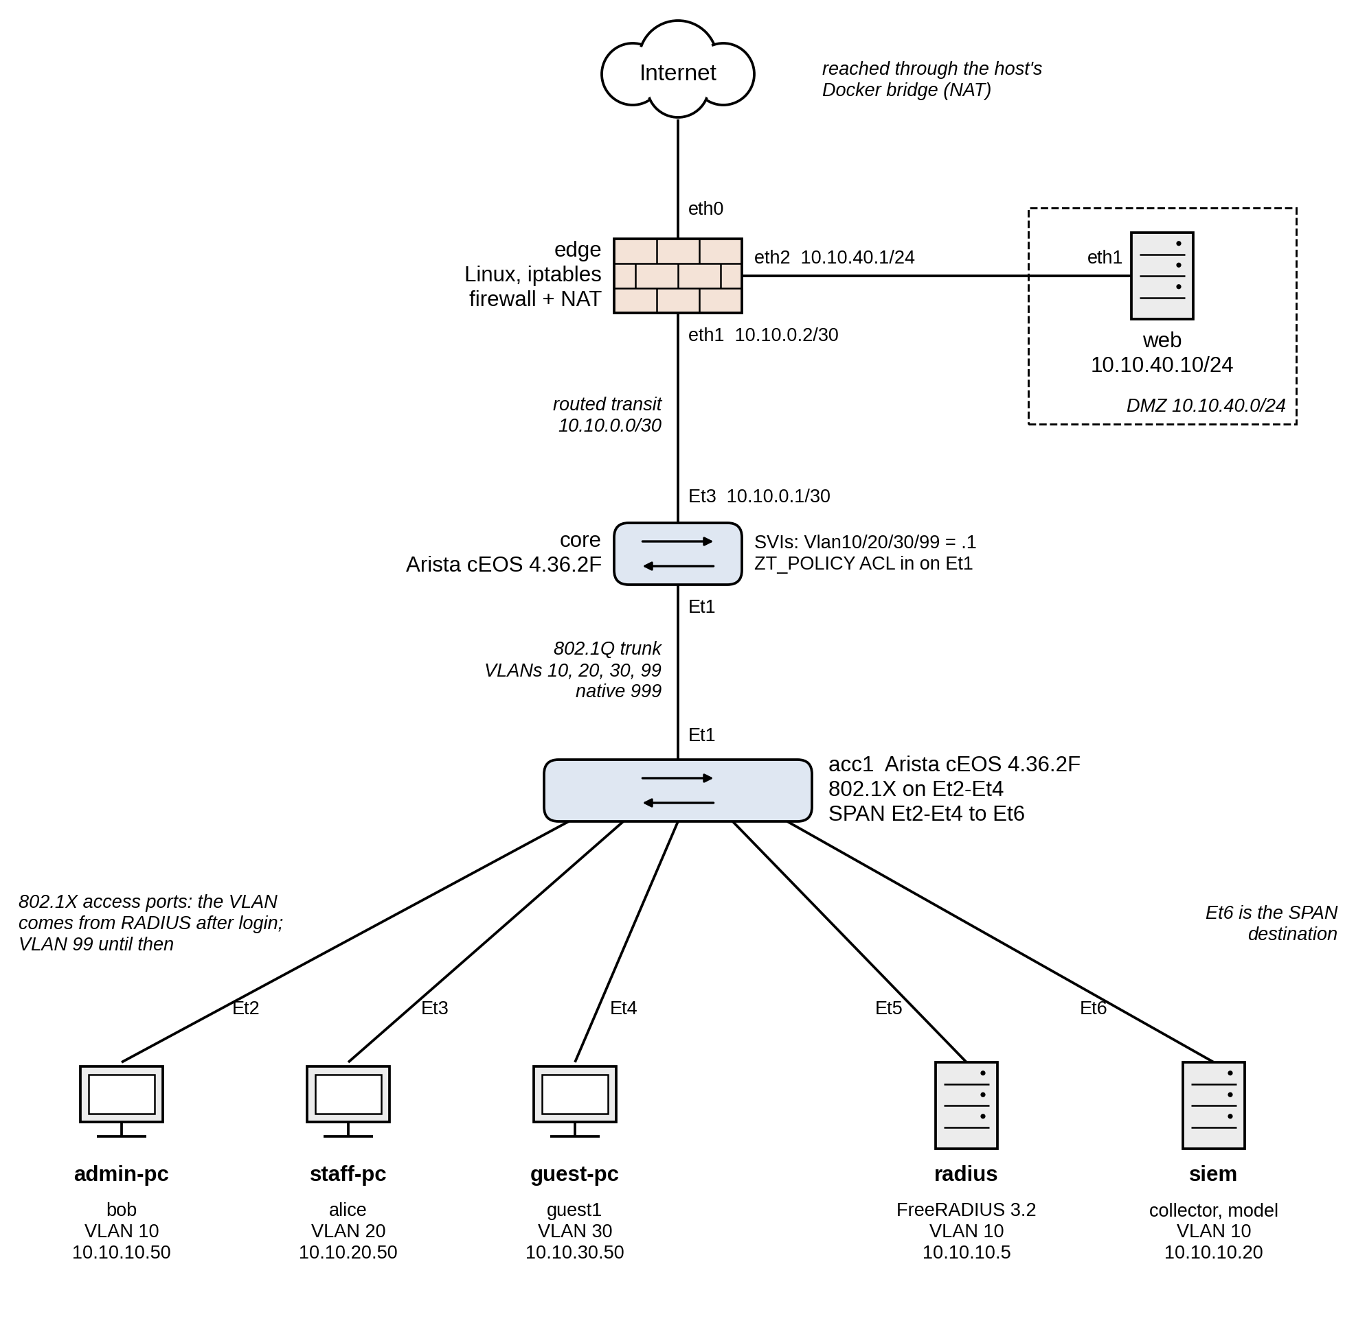
Figure 4.8: Network topology as built in Containerlab
VLAN | Name | Subnet | Gateway | Hosts
10 | ADMIN | 10.10.10.0/24 | 10.10.10.1 | admin-pc .50, radius .5, siem .20, acc1 .11
20 | STAFF | 10.10.20.0/24 | 10.10.20.1 | staff-pc .50
30 | GUEST | 10.10.30.0/24 | 10.10.30.1 | guest-pc .50
99 | QUARANTINE | 10.10.99.0/24 | 10.10.99.1 | Quarantined PCs: admin .10, staff .20, guest .30
999 | NATIVE_UNUSED | None | None | Native VLAN of the trunk only
DMZ | None | 10.10.40.0/24 | 10.10.40.1 (edge) | web .10
Transit | None | 10.10.0.0/30 | None | core .1, edge .2
Table 4.1: VLAN and addressing plan

4.4.3 Access Control Policy
The segment policy is enforced in two places. On the core switch, the ZT_POLICY ACL is applied inbound on Ethernet1, the trunk from acc1, so it sees all traffic from the user VLANs before it is routed. It was first planned as separate ACLs on the VLAN interfaces, but cEOS-lab does not support ACLs on VLAN interfaces, so the rules were merged into one ACL on the trunk port. Table 4.2 lists its entries. When the response engine blocks an address, it inserts a deny line for that address in the range 71 to 79, which is reserved for this between the guest rules and the final permit.
Seq. | Action | Traffic matched | Purpose
10 | permit | UDP from port 68 (bootpc) to port 67 | DHCP
20 | permit | 10.10.99.0/24 to 10.10.10.5, UDP 1812 | A quarantined host may log in again
30 | permit | 10.10.99.0/24 to 10.10.10.20 | A quarantined host may be investigated
40 | deny | 10.10.99.0/24 to any | Quarantine reaches nothing else
50 | deny | 10.10.30.0/24 to 10.10.10.0/24 | Guest to admin blocked
60 | deny | 10.10.30.0/24 to 10.10.20.0/24 | Guest to staff blocked
70 | deny | 10.10.30.0/24 to 10.10.99.0/24 | Guest to quarantine blocked
80 | permit | any to any | All other traffic
Table 4.2: Entries of the ZT_POLICY access list
Staff traffic to the admin VLAN is currently allowed by entry 80. Limiting staff to only the admin services they need would be a further improvement in line with least privilege.
The edge firewall adds the perimeter rules with iptables. Forwarded traffic is dropped by default, and replies to existing connections are allowed. The internal VLANs may go out to the internet and may reach the DMZ web server only on TCP port 80. The DMZ may reach the internet, but any connection it starts toward the internal network is dropped. Outgoing traffic is translated (NAT) to the edge’s external address.

4.4.4 Detection Features and Response Rules
The collector turns the traffic of each host in each ten-second window into the eight features listed in Table 4.3. Each feature was chosen because at least one of the threats in Table 2.1 changes it.
Feature | Meaning | Attack it reveals
packet_count | Packets sent or received by the host | DoS, data theft
avg_packet_size | Mean IP packet length | Data theft (large), floods (small)
bytes_transferred | Total IP bytes in the window | Insider data theft
connection_duration | Mean flow duration | Port scan (very short flows)
failed_logins | RADIUS Access-Rejects for the host’s MAC address | Brute force
unique_dst_ports | Distinct destination ports the host opened | Port scan
requests_per_min | New connections started by the host, per minute | DoS, port scan
off_hours | 1 if the window is outside 08:00 to 17:59 | Off-hours use
Table 4.3: Features extracted for each host in each window
The response depends on the attack type, as shown in Table 4.4. The classifier checks the signs in the order of the table, from the most to the least specific, and each limit is far above normal traffic: the 99th percentile of normal windows is 540 packets, 430 kB, one destination port and 48 new connections per minute. Large downloads can also come from legitimate work, so insider data theft disables the account instead of isolating the host, and the administrator can re-enable it after checking. Work at night is only reported.
Attack type | Main signs | Action | Where it is applied
DoS | requests_per_min of 300 or more | Block source IP | Deny line (71 to 79) in ZT_POLICY on core
Port scan | unique_dst_ports of 10 or more | Quarantine host | VLAN 99 rule in FreeRADIUS and port bounce on acc1
Brute force | failed_logins of 5 or more | Quarantine host | VLAN 99 rule in FreeRADIUS and port bounce on acc1
Insider data theft | bytes_transferred of 5 MB or more | Disable account | Reject rule in FreeRADIUS and port bounce on acc1
Off-hours or unclassified | off_hours = 1, or none of the above | Alert only | Zabbix and incident log
Table 4.4: Response taken for each attack type

Chapter 5: Results and Discussion

5.1 Introduction
This chapter presents the results of testing the Zero Trust network and its detection and response layer, following the test plan in Section 3.6. It first reports the functional tests of access control and segmentation, then the datasets collected for the model, the detection results of the Isolation Forest, the automated response tests, the end-to-end test of the complete pipeline and the monitoring results from Zabbix. The results are then checked against the functional requirements in Table 3.2 and discussed in relation to the literature reviewed in Chapter 2. All the numbers in this chapter come from the result files kept with the project (the results folder, the data folder and the incident log), so every table can be traced back to the run that produced it.

5.2 Functional Testing of the Zero Trust Network

5.2.1 Authentication and Dynamic VLAN Assignment
Each of the three users logged in with 802.1X (PEAP with MSCHAPv2), and FreeRADIUS returned the VLAN for the user’s role. The access switch showed all three sessions as authorized, each in its own VLAN. A login with a wrong password was then attempted from guest-pc: FreeRADIUS answered with an Access-Reject, the port changed to the FAILED state with no VLAN, and guest-pc could not even reach its own gateway. After the port was bounced and the correct password used, guest-pc was authorized again in VLAN 30 and reached the DMZ web server. The results are summarized in Table 5.1.
Port | User | Test | Switch state | Result
Et2 | bob (admin) | Correct password | SUCCESS, VLAN 10 ADMIN | Access as admin
Et3 | alice (staff) | Correct password | SUCCESS, VLAN 20 STAFF | Access as staff
Et4 | guest1 (guest) | Correct password | SUCCESS, VLAN 30 GUEST | Access as guest
Et4 | guest1 (guest) | Wrong password | FAILED, no VLAN | No network; 100% ping loss to gateway
Et4 | guest1 (guest) | Port bounced, correct password | SUCCESS, VLAN 30 GUEST | Access restored
Table 5.1: 802.1X authentication results on the access switch (acc1)

5.2.2 Segmentation and the DMZ
The six self-tests run by lab-up.sh after every rebuild check the segment policy from the user side, and all six passed on every rebuild. Guests reached the DMZ web server and the internet but not the RADIUS server or the staff PC; staff reached the RADIUS server; and the DMZ web server could not start a connection to the internal network. The hit counters on the ZT_POLICY entries rose with each blocked attempt, which shows that the core switch, and not a missing route, did the blocking. On the edge firewall the DROP counter for DMZ-to-internal traffic rose in the same way. Table 5.2 lists the checks.
Test | Expected | Result | Enforced by
guest-pc to DMZ web server (HTTP) | Reach | PASS | edge: internal to DMZ on TCP 80 only
guest-pc to internet (HTTP) | Reach | PASS | edge: internal to internet, NAT
guest-pc to RADIUS (10.10.10.5) | Block | PASS | ZT_POLICY line 50
guest-pc to staff PC (10.10.20.50) | Block | PASS | ZT_POLICY line 60
staff-pc to RADIUS | Reach | PASS | ZT_POLICY line 80 (permit)
DMZ web server to RADIUS | Block | PASS | edge: DMZ to internal DROP
Table 5.2: Segmentation self-tests (lab-up.sh) and the rule that decides each one

5.2.3 Collection and Feature Extraction
The offline tests of the Python components passed in full: 10 checks for the collector (test_collector.py), 9 for the traffic generator (test_traffic.py), 10 for the response engine (test_respond.py) and 3 for the Zabbix sender (test_zbx_push.py). They include a check that the fast packet reader built on the struct module returns exactly the same fields as Scapy on a sample capture, and checks that the traffic generator refuses any target outside the lab network.
Testing also exposed a fault that the functional tests had missed. In the first dataset collection the insider attack produced only about 30 packets per window instead of megabytes. The cause was an MTU mismatch: the Linux containers used 9,500-byte frames, while the cEOS switches route with an MTU of 1,500, so large replies were dropped at the core. Pings and small web pages fitted inside 1,500 bytes, which is why nothing had looked wrong before. After all lab interfaces were set to an MTU of 1,500, a 20 MB download ran at about 6 MB/s, and every dataset was collected again. The first datasets were kept as evidence of the fault but were not used.

5.3 Datasets
Four normal runs of ten minutes and five runs of each attack, at five intensities, were collected after the MTU fix. Table 5.3 summarizes them. The windows of attack runs that are not attack windows belong to the other two PCs, or to the attacker before and after its attack, and are labeled normal. For comparison, 99% of normal windows have at most 536 packets, 430 kB, 1 destination port and 48 new connections per minute, and no normal window has a single failed login.
Class | Runs | Windows | Attack | Packets | Bytes | Ports | Fails | Conn./min
Normal | 4 | 594 | 0 | 22 | 1,876 | 1 | 0 | 12
DoS | 5 | 83 | 20 | 8,340 | 836,670 | 1 | 0 | 4,632
Port scan | 5 | 72 | 20 | 376 | 25,829 | 296 | 0 | 1,779
Brute force | 5 | 68 | 20 | 21 | 1,792 | 1 | 30 | 12
Insider | 5 | 75 | 20 | 12,215 | 15,528,831 | 1 | 0 | 24
Off-hours | 5 | 69 | 20 | 14 | 1,190 | 1 | 0 | 12
Table 5.3: Datasets collected; the last five columns are medians per window (of the attack windows, or of all windows in the normal runs): packets, bytes, destination ports, failed logins and new connections per minute
Every attack type differs clearly from normal traffic in at least one feature: DoS in its packets and connection rate, port scan in its destination ports, brute force in its failed logins and insider data theft in its bytes. The off-hours class is normal traffic in every feature except the off-hours flag, which is what defines it.

5.4 Detection Results

5.4.1 Overall Performance
The detector was evaluated with 5-fold leave-one-run-out cross-validation (Section 3.6.3). Over the five folds, 100 attack windows and 917 normal windows were scored. Three designs were compared: the Isolation Forest trained on normal traffic only, the Isolation Forest trained on unlabeled mixed traffic in which about 9% of the windows were attacks, and the hybrid design chosen for the system, which adds one policy rule (five or more failed logins in a window) to the mixed model. Table 5.4 gives the results, calculated with Equations 3.1 to 3.5 and using their symbols: accuracy (Acc), precision (P), detection rate (DR), F1-score (F1) and false positive rate (FPR), with the area under the ROC curve (AUC).
Design | TP | FN | FP | TN | Acc | P | DR | F1 | FPR | AUC
IF, normal only | 47 | 53 | 5 | 912 | 94.3% | 0.904 | 47% | 0.618 | 0.5% | 0.807
IF, mixed | 90 | 10 | 10 | 907 | 98% | 0.900 | 90% | 0.900 | 1.1% | 0.990
Hybrid (chosen) | 100 | 0 | 10 | 907 | 99% | 0.909 | 100% | 0.952 | 1.1% | 0.990
Table 5.4: Detection results of the three designs (5 folds, 100 attack and 917 normal windows)
Trained on normal traffic only, the Isolation Forest raised few false alarms (0.5%) but found fewer than half of the attack windows (47%). Trained on mixed traffic it found 90% of them with a false positive rate of 1.1%, and its ROC-AUC rose from 0.807 to 0.990. The hybrid design found every attack window (100%) without any extra false alarm, giving an accuracy of 99% and an F1-score of 0.952. The ROC-AUC of the hybrid design is that of its Isolation Forest score, because the rule gives a yes or no answer and has no score.
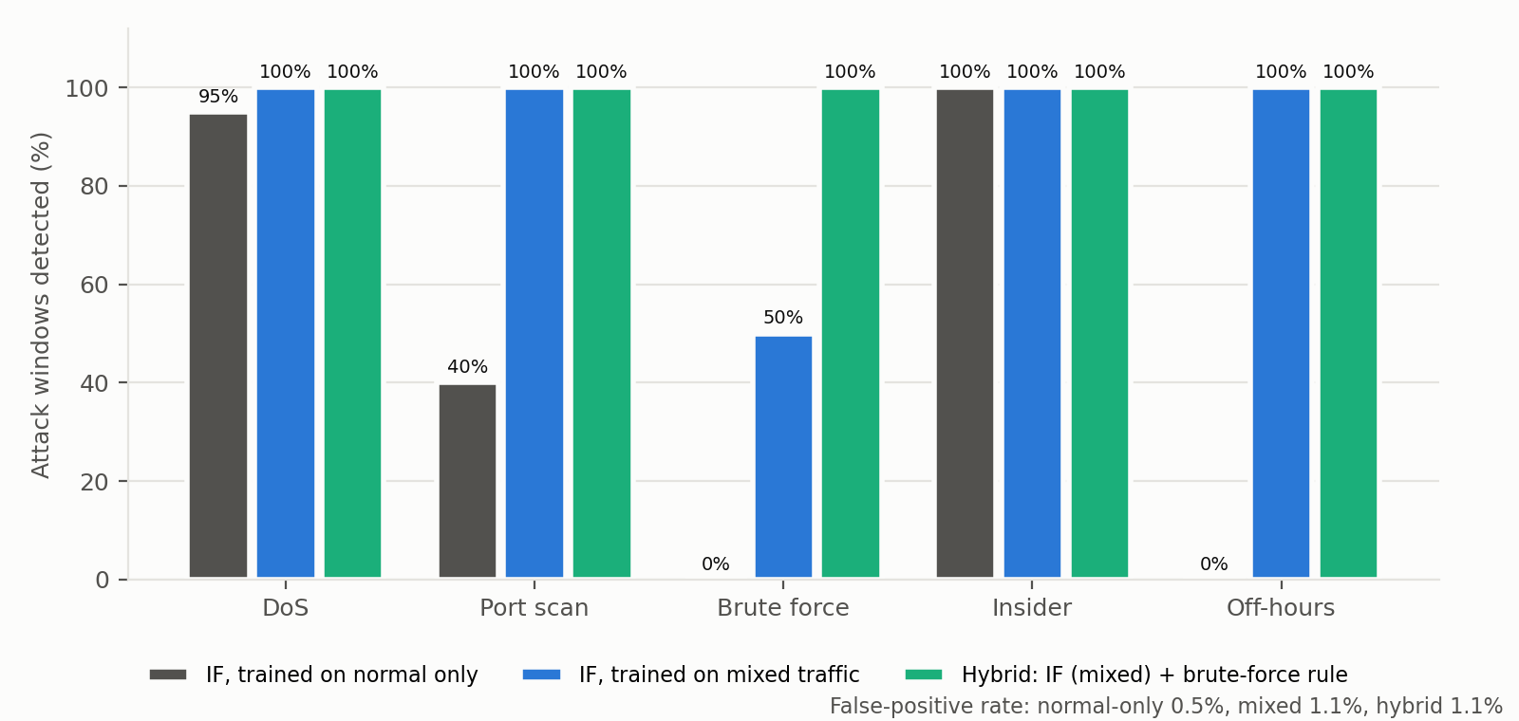
Figure 5.1: Detection rate by attack type for the three designs
Figure 5.1 breaks the detection rate down by attack type. DoS and insider data theft were detected by every design, because they change several features strongly at once. The normal-only model missed every brute-force and off-hours window and most port-scan windows.

5.4.2 Detection by Attack Intensity
Attack | Intensity | IF, normal only | IF, mixed | Hybrid
DoS | 40 requests/s | 75% | 100% | 100%
DoS | 60 requests/s | 100% | 100% | 100%
DoS | 80 requests/s | 100% | 100% | 100%
DoS | 100 requests/s | 100% | 100% | 100%
DoS | 120 requests/s | 100% | 100% | 100%
Port scan | 10 ports/s | 25% | 100% | 100%
Port scan | 20 ports/s | 50% | 100% | 100%
Port scan | 30 ports/s | 0% | 100% | 100%
Port scan | 40 ports/s | 50% | 100% | 100%
Port scan | 50 ports/s | 75% | 100% | 100%
Brute force | 1 attempts/s | 0% | 0% | 100%
Brute force | 2 attempts/s | 0% | 0% | 100%
Brute force | 3 attempts/s | 0% | 50% | 100%
Brute force | 5 attempts/s | 0% | 100% | 100%
Brute force | 8 attempts/s | 0% | 100% | 100%
Insider | 0.5 MB/s | 100% | 100% | 100%
Insider | 1 MB/s | 100% | 100% | 100%
Insider | 1.5 MB/s | 100% | 100% | 100%
Insider | 2 MB/s | 100% | 100% | 100%
Insider | 2.5 MB/s | 100% | 100% | 100%
Table 5.5: Detection rate per run, from the weakest to the strongest intensity
Table 5.5 shows the detection rate of every run. The off-hours runs have no intensity and are left out; all five were missed by the normal-only model and fully detected by the other two designs. The mixed model detected the weakest DoS and port-scan runs that the normal-only model partly missed. The one weakness of the mixed model was slow password guessing: at one or two attempts per second, about 10 to 20 failed logins per window, none of the windows were flagged, at three attempts per second half of them were, and from five attempts per second all of them were. In those windows every feature except failed_logins looks normal, so the anomaly score only reaches the level of a busy normal window. Lowering the threshold enough to catch them would have raised the false positive rate to about 5 to 10%. The brute-force rule closes this gap: it fired on every brute-force window at every speed and on no normal window.

5.4.3 Score Distribution and Confusion Matrix
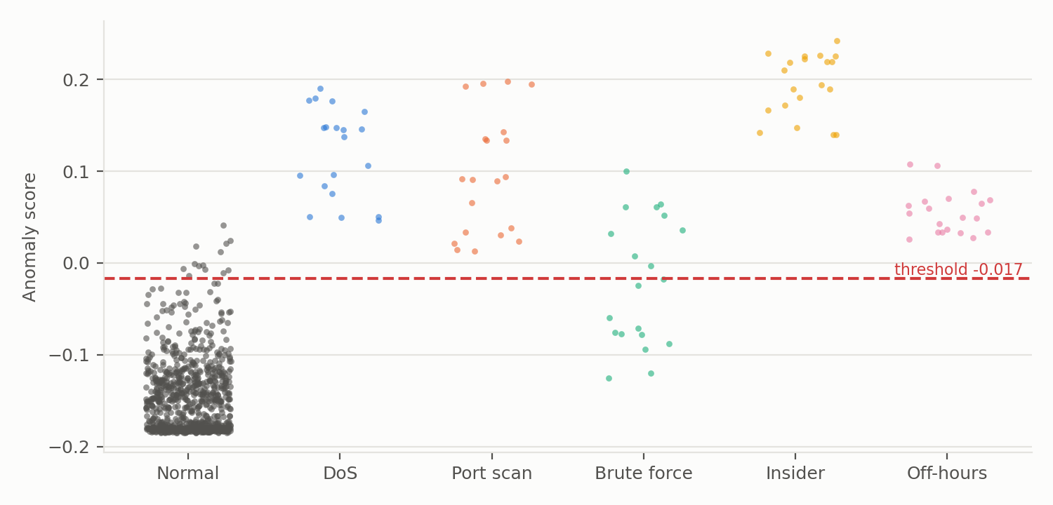
Figure 5.2: Anomaly score of every test window with the tuned threshold (mixed training)
Figure 5.2 plots the anomaly score of every test window. Normal windows form a dense band below the threshold of -0.017 (the average over the five folds), with a thin tail of busy windows near it; these produce the false alarms. DoS, port-scan, insider and off-hours windows lie well above the threshold. The brute-force windows spread on both sides of it, which matches the intensity results in Table 5.5.
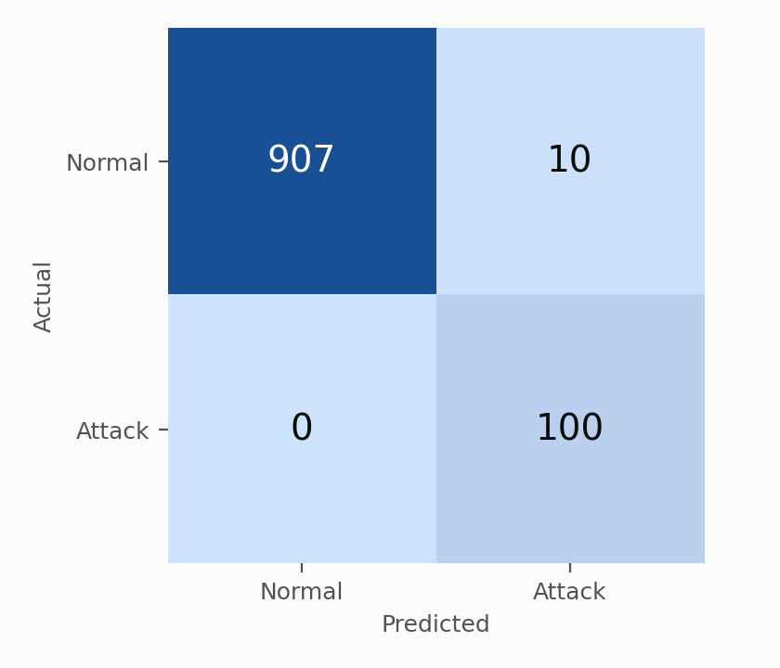
Figure 5.3: Confusion matrix of the hybrid detector over the five folds
Figure 5.3 shows the confusion matrix of the hybrid detector. All 100 attack windows were detected and 907 of the 917 normal windows were left alone. All 10 false positives were windows of admin-pc or staff-pc that contained one or more downloads of the 200 kB test file, about 213 kB and 250 packets compared with a median of 1.9 kB and 22 packets for normal windows. Such downloads are part of normal behavior but rare, so the model treats them as unusual. Because their features match no attack type, they are classified as unclassified and lead only to an alert, as discussed in Section 5.5.2. (The held-out normal run normal_04 is scored by the model of every fold, so a window in it can appear in more than one fold.)

5.4.4 Attack Classification
Once a window is flagged, the response engine decides the attack type from its features, in the order of Table 4.4. Applied to all 100 labeled attack windows, the classifier named the correct type for 100% of them: 20 out of 20 for each of DoS, port scan, brute force, insider and off-hours. Each limit in the classifier is far above normal traffic, so a normal window that is flagged by mistake almost always ends up as unclassified, and an unclassified window only raises an alert.

5.5 Automated Response Results

5.5.1 Individual Response Actions
Each response action was first tested on its own from the command line (zt_respond.py) on the live lab. Table 5.6 gives the results. The block took effect at once: guest-pc lost all access while staff-pc was not affected, and the new deny entry counted the dropped packets. For quarantine, FreeRADIUS was told to place the user in VLAN 99 and the access port was bounced; the PC logged in again on its own and was in the quarantine VLAN 1.1 seconds after the bounce. The ZT_POLICY counters then showed exactly the access Table 4.2 allows a quarantined host: one packet permitted to the RADIUS server on UDP 1812, two permitted to the SIEM, and 11 denied, covering the web server, the staff PC, the internet, the gateway and a ping to the RADIUS server. Disabling an account left the port in the FAILED state, and every action could be undone.
Action | Command | Observed result | Time
Block IP | block 10.10.30.50 | ZT_POLICY line 71 deny ip host 10.10.30.50 any, 5 packets matched in the first second; guest-pc HTTP 000, staff-pc HTTP 200 | 0.1 s on the switch (0.8 s including SSH login)
Repeat block | block 10.10.30.50 | Ignored: host already blocked | -
Protected address | block 10.10.10.5 | Refused: infrastructure address | -
Quarantine | quarantine guest-pc | guest1 SUCCESS in VLAN 99, address 10.10.99.30; no web access; staff-pc unaffected | 1.4 s (in VLAN 99 1.1 s after bounce)
Quarantine policy | - | ZT_POLICY line 20: 1 permitted, line 30: 2 permitted, line 40: 11 denied | -
Release | release guest-pc | Back in VLAN 30 with its own address; web access restored | 1.1 s
Disable account | disable staff-pc | alice rejected by FreeRADIUS; Et3 FAILED; staff-pc has no network | 1.4 s
Enable account | enable staff-pc | Back in VLAN 20; web access restored | 2.2 s
Table 5.6: Response actions tested individually on the live lab

5.5.2 End-to-End Test
In the end-to-end test the live pipeline (zt_pipeline.py) ran while all three PCs generated normal traffic, and each attack was launched for 40 seconds, with the network reset between attacks. Nobody triggered any response by hand. Table 5.7 shows, for each attack, the window in which it was flagged, what fired (the model, the rule or both), how it was classified, the action taken and the response time from Equation 3.6, measured from the moment the window closed to the moment the action was applied on the network.
Attack | Window flagged | Fired | Classified as | Automatic action | Response time
DoS from guest-pc | 14:56:26 | model | dos | BLOCKED 10.10.30.50 | 1.1 s
Port scan from guest-pc | 14:57:46 | model | portscan | QUARANTINED guest-pc | 1.8 s
Brute force on guest-pc’s port | 14:59:16 | model+rule | bruteforce | QUARANTINED guest-pc | 1.8 s
Insider download on staff-pc | 15:00:46 | model | insider | DISABLED account alice | 1.8 s
Off-hours session on staff-pc | 15:02:06 | model | offhours | ALERT ONLY | 1.0 s
Table 5.7: End-to-end test of the live pipeline (14 October 2026)
Every attack was detected in the first or second window after it started, classified correctly and answered with the action set out in the Chapter 4 activity diagram. Response times ranged from 1.0 to 1.8 seconds after the window closed. About one second of this is a deliberate wait for late packets; a block then takes about 0.1 seconds, while quarantine and disabling an account take longer because FreeRADIUS has to reload its rules and the port has to be bounced. Counting from the start of an attack, the response came within one ten-second window plus these one to two seconds, so a DoS source was cut off about eight seconds after its flood began.
Two other alerts were raised during the test, both of the alert-only kind, so no user was cut off. The first was the window in which the insider download had just begun, which did not yet hold enough data to be classified as insider. The second was a genuine false alarm on guest-pc during normal traffic, which agrees with the false positive rate of about 1% measured in Section 5.4.
Earlier runs of the same test found three faults that the offline tests had not. All PCs had addresses ending in .50, so a quarantined PC (then 10.10.99.50) was matched to the wrong PC and admin-pc was quarantined by mistake; each PC now has its own quarantine address. FreeRADIUS compares file times to the second, so two rule changes within one second could leave a rule in force; reloads are now spaced and confirmed in its log. Finally, the reload check failed while the RADIUS log was growing fast during a brute force, and the error stopped the pipeline; a failed response is now logged and detection continues. These faults show the value of testing the whole system end to end and not only its parts.

5.6 Monitoring Results
All nine lab nodes pushed their own data to Zabbix every 30 seconds: packets and bytes per second on their lab interfaces, dropped packets, CPU and memory use. Each push cycle was accepted in full (54 values, 0 failed). The two dashboard pages worked as designed: the network health page showed host availability and the traffic, CPU and memory of every node, and the threat detection page showed the anomaly score of each PC against the threshold line, the security alerts, the last action per PC and the detection-to-action time. A test alert sent through the alert channel appeared as a problem on the right host. Zabbix also raised a real problem of its own: both cEOS switches used over 90% of their memory allowance, which matches the memory pressure discussed next.
A final rehearsal of the full demonstration repeated the end-to-end test with Zabbix and the push loop running. 5 of the 5 attacks were answered automatically with the expected action, 1.1 to 1.9 seconds after the window closed, and Zabbix received 113 anomaly scores and 6 response actions during the run; the security alerts opened 2 problems in Zabbix, one for each PC that was acted on, each staying open until an administrator closes it. No false alarms occurred and no user was blocked, quarantined or disabled by mistake. The lowest free memory during the run was 1272 MB.

5.7 Performance and Resource Use
The whole lab ran on one laptop with 7.1 GiB of usable memory. The two cEOS switches used about 1.5 GB each, and with all nine nodes running, about 1.5 GB remained free, or about 0.5 to 0.75 GB with Zabbix also running. This limit shaped several decisions: the switches were reduced from seven to two, the lab is deployed one node at a time, packets are captured with only their first 128 bytes and read with a light parser instead of Scapy, and Zabbix was stopped during dataset collection.
The limit was also reached once. During a rehearsal with Zabbix running, another memory-heavy program (a document renderer) started at the same time, free memory fell to about 75 MB, and the kernel stopped the core switch, the access switch and staff-pc. The detection pipeline itself used about 130 MB. The incident shows that the design is sound but that the hardware leaves little margin: on a single 8 GB laptop the demonstration must run with other heavy programs closed, and a second memory module would remove the risk.

5.8 Validation against the Requirements
Table 5.8 compares the results with the functional requirements of Table 3.2. Every requirement was met.
No. | Requirement | Evidence | Met
FR1 | 802.1X login before network access | Table 5.1: three users authorized; wrong password gives FAILED and no access | Yes
FR2 | VLAN assigned from identity | Table 5.1: bob VLAN 10, alice 20, guest1 30, set by FreeRADIUS | Yes
FR3 | Guests cannot reach internal subnets | Table 5.2: guest to RADIUS and staff blocked; ZT_POLICY counters | Yes
FR4 | DMZ cannot start internal connections | Table 5.2: web to RADIUS blocked; edge DROP counters | Yes
FR5 | Traffic summarized per host every 10 s | Table 5.3 datasets; collector tests; live pipeline windows | Yes
FR6 | Windows scored by Isolation Forest and rule | Table 5.4: detection rate 100%, FPR 1.1% | Yes
FR7 | Automatic response by attack type | Table 5.7: block, quarantine, disable and alert without any manual step | Yes
FR8 | Scores, alerts and actions reach the administrator | Section 5.6: dashboard pages, problems list, 54 values per cycle | Yes
Table 5.8: Functional requirements and the results that show they are met
The validation criteria of Section 3.6.6 were also met. Legitimate users kept working: no normal window led to a block, quarantine or disabled account, only to alerts. Every attack type was detected at every tested intensity. DoS sources were blocked, scanning and brute-force hosts ended up in VLAN 99, the account was disabled after insider data theft, off-hours activity raised an alert without changing access, and guests never reached internal resources.

5.9 Discussion
The results support the idea that Zero Trust access control and machine learning detection work best together. Access control alone stopped the guest from reaching internal systems, but it could not see a DoS flood towards an allowed server, a port scan, or an insider copying data with valid credentials. The detection layer saw all of these, and its answers reused the Zero Trust controls themselves: the ACL for a block, and the identity-based VLAN for quarantine. This is close to the identity-based segmentation described by Ahmadi (2025), where a device is moved to another segment when its behavior becomes risky.
The most important finding about the model is that an Isolation Forest trained only on normal traffic cannot see features that never vary in that traffic. Failed logins and the off-hours flag were always zero in normal windows, so the trees never split on them and the model missed every brute-force and off-hours window. Benign-only training is the setting compared by Syzranova et al. (2026) for Isolation Forest, the One-Class SVM and autoencoders, and the results here show one of its weak points for Isolation Forest in particular: a feature that never varies in the benign data cannot be used by the trees at all. Trained instead on unlabeled traffic in which attacks are rare, the Isolation Forest isolated the unusual windows by the few splits that its design relies on (Fuhnwi et al., 2023; Lakshmi et al., 2024), detected every DoS, port-scan, insider and off-hours window, and reached a ROC-AUC of 0.990. It still never needed a labeled example, which keeps the main advantage of an unsupervised method.
Slow password guessing remained hard for the model, because it changes only one of the eight features. Adding one explicit rule solved this without extra false alarms. Hybrid detection designs have also been proposed in the literature, for example for insider threats (Rauf et al., 2023), and a policy rule fits the Zero Trust principle that every login attempt is checked. The results are reported with and without the rule, so the contribution of the model alone stays visible.
The response layer met its aim of acting without a person. With one to two seconds from the end of a window to the action, containment followed detection almost at once, which is the benefit of automated response for fast attacks such as denial of service (Jones, 2025). Studies of incident response note that trust in fully automatic actions is still limited (Falowo & Bou Abdo, 2026). The choice to answer unclassified anomalies and off-hours activity with an alert only addresses this: the false alarms seen in testing never cut off a user, and only attacks matching a clear signature led to an automatic change in access.
The results have limits. All traffic was generated by scripts, so normal behavior is more regular than in a real enterprise, and the false positive rate on real traffic would likely be higher. The off-hours flag was simulated rather than observed at night. The lab has one access switch and three users, and it runs on a software data plane with little spare memory. The model was tested on attack types and intensities that were also present, unlabeled, in its training traffic; new kinds of attacks were not tested. These limits are taken up in the recommendations in Chapter 6.

5.10 Summary
The Zero Trust network met all its functional requirements: users were authenticated and placed in VLANs by identity, guests were confined, and the DMZ was isolated. The hybrid detector found all 100 attack windows across five attack types and five intensities, with a false positive rate of 1.1% and an F1-score of 0.952, and named the attack type correctly every time. In the end-to-end test every attack was answered automatically, 1.0 to 1.8 seconds after its window closed, and every alert and action reached Zabbix.

Chapter 6: Conclusions and Recommendations

6.1 Conclusion
This project set out to design and simulate a Zero Trust enterprise network with automated threat detection and response using the Isolation Forest algorithm. All four specific objectives in Section 1.3.2 were met.
The first objective was to investigate Zero Trust principles, identity-based access control and common threats. The review in Chapter 2 shaped the design directly: users are verified with 802.1X before any port opens, their VLAN comes from their identity rather than from the port, traffic between segments is limited by an ACL and a firewall, and five threats were chosen because each one changes a measurable feature of the traffic.
The second objective was to implement machine learning detection. The collector turns the mirrored traffic into eight features per host every ten seconds, and an Isolation Forest trained without labels scores each window, supported by a rule for five or more failed logins. Tested over five folds on runs it had never seen, the hybrid detector found all 100 attack windows with a false positive rate of 1.1%, an accuracy of 99.0%, a precision of 0.909 and an F1-score of 0.952, and the classifier named the correct attack type for every one of them. An important finding was that a model trained on normal traffic alone detected only 47% of the attack windows, because features that never change in normal traffic, such as failed logins, are never used by its trees. Training on unlabeled mixed traffic, together with the failed-login rule, closed this gap.
The third objective was to design and develop the segmented network with automated response. The network was built in Containerlab with two Arista cEOS switches, FreeRADIUS, a Linux edge firewall, a DMZ web server, a quarantine VLAN and Zabbix monitoring, and the whole lab is rebuilt and self-tested with one command. The response engine can block a source address on the core switch, move a user to the quarantine VLAN, disable an account and raise alerts, and the administrator can undo every action.
The fourth objective was to test and validate the system. In the end-to-end test each of the five attacks was detected and answered automatically between 1.0 and 1.8 seconds after its ten-second window closed, while the other users kept working. Two windows raised alerts without a clear attack type; because unclassified anomalies only raise an alert, no legitimate user lost access.
Overall, the project shows that Zero Trust access control and unsupervised anomaly detection work well together. Access control limits where a user can go, while detection watches what the user does once inside and can change that access within seconds. It also shows that such a system can be built and tested on a single 8 GB laptop with free software.

6.2 Recommendations
Based on the results, the following recommendations are made to organizations that want to apply these ideas:
- Base network access on identity. 802.1X with a RADIUS server that assigns the VLAN makes segmentation follow the user, and it also makes quarantine and account disabling possible without changing the switch port configuration.
- Use anomaly detection together with a small number of clear policy rules, not instead of them. In this project the failed-login rule caught slow password attacks that the model alone could not see, without adding false alarms.
- Train the model on traffic that represents the real network, tune the threshold on separate normal data, and retrain the model when the network or its users change.
- Start in alert-only mode, review the alerts for some time, and then enable automatic actions one attack type at a time. Keep actions that can cut off a legitimate user reversible, and leave unclear cases such as night-time work to an analyst.
- Protect infrastructure addresses such as the RADIUS server, the SIEM and the gateways from automatic blocking, and keep a tested procedure for releasing hosts.
- Universities and training centres can use container-based labs like this one to teach Zero Trust and network automation, because they need no special hardware or licences.

6.3 Future Work
- Test the system on real enterprise traffic over a longer period, so that the baseline includes the normal changes between days, weeks and busy seasons.
- Add redundancy, more access switches and more users once more memory is available, and test the design on physical switches.
- Use DHCP in the quarantine VLAN instead of having the response engine assign the quarantine address, and add device posture checks before access is granted.
- Show which feature caused each alert, so that analysts can check and trust the model’s decisions more easily.
- Add more attack types, such as lateral movement over SSH, data exfiltration through DNS and ARP spoofing.
- Compare Isolation Forest with other unsupervised models such as autoencoders and the One-Class SVM on the same datasets (Syzranova et al., 2026).
- Connect the response engine to a ticketing or SOAR platform, and send alerts by email or SMS as well as to Zabbix (Kumar et al., 2025).

References
Abuhasel, K. A. (2023). A zero-trust network-based access control scheme for sustainable and resilient Industry 5.0. IEEE Access, 11, 116398–116409. https://doi.org/10.1109/ACCESS.2023.3325879
Ahmadi, S. (2024). Zero trust architecture in cloud networks: Application, challenges and future opportunities. Journal of Engineering Research and Reports, 26(2), 215–228.
Ahmadi, S. (2025). Autonomous identity-based threat segmentation for zero trust architecture. Cyber Security and Applications, 3, 100106.
Ali, M. L., Thakur, K., Schmeelk, S., Debello, J., & Dragos, D. (2025). Deep learning vs. machine learning for intrusion detection in computer networks: A comparative study. Applied Sciences, 15(4), 1903.
Al-Tamimi, S., Al-Haija, Q. A., & Alrawashdeh, K. (2024). Zero-trust architecture for securing Internet of Things (IoT) networks: A review. In 2024 5th International Conference on Communications, Information, Electronic and Energy Systems (CIEES) (pp. 1–6). IEEE. https://doi.org/10.1109/CIEES62939.2024.10811176
Altidor, J.-B., & Talhi, C. (2024). Enhancing port scan and DDoS attack detection using genetic and machine learning algorithms. In 2024 7th Conference on Cloud and Internet of Things (CIoT) (pp. 1–7). IEEE. https://doi.org/10.1109/CIoT63799.2024.10757005
Aramide, O. (2024). Zero-trust identity principles in next-gen networks: AI-driven continuous verification for secure digital ecosystems. World Journal of Advanced Research and Reviews, 23(3), 3304–3316.
Arista Networks. (n.d.). EOS user manual. Retrieved October 14, 2026, from https://www.arista.com/en/um-eos
Baligodugula, V. V., Ghimire, A., & Amsaad, F. (2024). An overview of secure network segmentation in connected IIoT environments. Computing & AI Connect, 1, Article 0004.
Bello, A. J., Diyan, M., & Asghar, I. (2025). Zero trust implementation for legacy systems using dynamic microsegmentation, role-based access control (RBAC), and attribute-based access control (ABAC). In 2025 4th International Conference on Computing and Information Technology (ICCIT) (pp. 181–189). IEEE. https://doi.org/10.1109/ICCIT63348.2025.10989392
Bradatsch, L., & Kargl, F. (2024). Integration of security service functions into network-level access control. IEEE Access, 12, 197783–197815. https://doi.org/10.1109/ACCESS.2024.3522575
Bredesen, R., & Mujeye, S. (2025). Network segmentation security with the implementation of threats. In Proceedings of the 2025 8th International Conference on Software Engineering and Information Management (ICSIM ’25) (pp. 137–141). Association for Computing Machinery.
Byers, K. (n.d.). Netmiko [Computer software]. GitHub. Retrieved October 14, 2026, from https://github.com/ktbyers/netmiko
Chang, P., & Xu, G. (2026). Design and implementation of a zero trust access control model driven by session lifecycle. IEEE Access, 14, 33819–33827. https://doi.org/10.1109/ACCESS.2026.3669103
Chen, G., Hu, Z., Qu, Y., & Jin, D. (2025). VT-IO: A virtual time system enabling high-fidelity container-based network emulation for I/O intensive applications. ACM Transactions on Modeling and Computer Simulation, 35(1), 1–25. https://doi.org/10.1145/3635307
Choi, B. (2024). Python network automation labs: SSH in action, paramiko and netmiko labs. In Introduction to Python network automation volume II (pp. 121–227). Apress. https://doi.org/10.1007/979-8-8688-0391-8_3
Cisco Networking Academy. (n.d.). Cisco Packet Tracer. Retrieved October 14, 2026, from https://www.netacad.com/cisco-packet-tracer
Containerlab. (n.d.). Arista cEOS. Retrieved October 14, 2026, from https://containerlab.dev/manual/kinds/ceos/
Dube, R. (2026). A taxonomy of segmentation in network security. IEEE Access, 14, 16921–16935. https://doi.org/10.1109/ACCESS.2026.3658250
Falowo, O. I., & Bou Abdo, J. (2026). Empirical study on automation, AI trust, and framework readiness in cybersecurity incident response. Algorithms, 19(1), 62.
FreeRADIUS. (n.d.). FreeRADIUS documentation. Retrieved October 14, 2026, from https://www.freeradius.org/documentation/
Fuhnwi, G. S., Adedoyin, V., & Agbaje, J. O. (2023). An empirical Internet Protocol network intrusion detection using Isolation Forest and One-Class Support Vector Machines. International Journal of Advanced Computer Science and Applications, 14(8). https://doi.org/10.14569/IJACSA.2023.0140801
Hidayat, I., Ali, M. Z., & Arshad, A. (2023). Machine learning-based intrusion detection system: An experimental comparison. Journal of Computational and Cognitive Engineering, 2(2), 88–97.
Islam, M. D. Z., & Dhanekula, A. (2023). Measuring the security impact of zero trust access controls: A mixed-methods study of identity-based policies (Cisco ISE + AD) and incident reduction. American Journal of Data Science and Analytics, 4(6), 1–42.
Jones, R. K. (2025). AI automated incident response and threat mitigation using AI. In Revolutionizing cybersecurity with deep learning and large language models (pp. 201–236). IGI Global Scientific Publishing.
Kukartsev, V., Kravtsov, K., Stefanenko, O., Podanyov, N., & Bezvorotnykh, A. (2024). Using machine learning techniques to simulate network intrusion detection. In 2024 International Conference on Intelligent Systems for Cybersecurity (ISCS) (pp. 1–4). IEEE.
Kumar, P. V., Pittala, R. B., Jashwanth, P., Vedamsh, R., Chandrika, D. S., Reddy, Y. V., Kiran, M. A., & Reddy, G. S. (2025). Automated threat detection and response using security orchestration, automation, and response (SOAR) and endpoint detection and response. In 2025 OITS International Conference on Information Technology (OCIT) (pp. 498–502). IEEE. https://doi.org/10.1109/OCIT66168.2025.11400041
Lakshmi, M., Rajavikram, G., Dattatreya, V., Jyothi, B. S., Patil, S., & Bhavsingh, M. (2024). Evaluating the isolation forest method for anomaly detection in software-defined networking security. Journal of Electrical Systems, 19(4), 279–297. https://doi.org/10.52783/jes.639
Mensah, F. (2024). Zero trust architecture: A comprehensive review of principles, implementation strategies, and future directions in enterprise cybersecurity. International Journal of Academic and Industrial Research Innovations, 10, 339–346.
Moomtaheen, F., Bagui, S. S., Bagui, S. C., & Mink, D. (2024). Extended isolation forest for intrusion detection in Zeek data. Information, 15(7), 404. https://doi.org/10.3390/info15070404
Nam, S.-W., Yu, G.-M., Jang, Y.-S., Kim, J.-S., Kim, J.-M., & Kim, M.-S. (2026). Trust quantification on zero trust architecture: A survey. IEEE Access, 14, 105289–105313. https://doi.org/10.1109/ACCESS.2026.3712376
Rauf, U., Wei, Z., & Mohsen, F. (2023). Employee Watcher: A machine learning-based hybrid insider threat detection framework. In 2023 7th Cyber Security in Networking Conference (CSNet) (pp. 39–45). IEEE. https://doi.org/10.1109/CSNet59123.2023.10339777
Rautaray, A. (2025). Machine learning techniques applied to intrusion detection systems. Power System Protection and Control, 53(1), 17–29.
scikit-learn developers. (n.d.). IsolationForest. Retrieved October 14, 2026, from https://scikit-learn.org/stable/modules/generated/sklearn.ensemble.IsolationForest.html
Syzranova, S., Pleva, M., & Harahus, M. (2026). Benign-only training for network intrusion detection: A comparative study of Isolation Forest, One-Class SVM, and autoencoders. In 2026 36th International Conference Radioelektronika (RADIOELEKTRONIKA) (pp. 1–6). IEEE. https://doi.org/10.1109/RADIOELEKTRONIKA71189.2026.11726544
Vadisetty, R., & Polamarasetti, A. (2024). Enhancing intrusion detection systems with deep learning and machine learning algorithms for real-time threat classification. In 2024 Asian Conference on Intelligent Technologies (ACOIT) (pp. 1–6). IEEE.
Zabbix. (n.d.). Zabbix 7.0 manual. Retrieved October 14, 2026, from https://www.zabbix.com/documentation/7.0/en/manual

Appendix
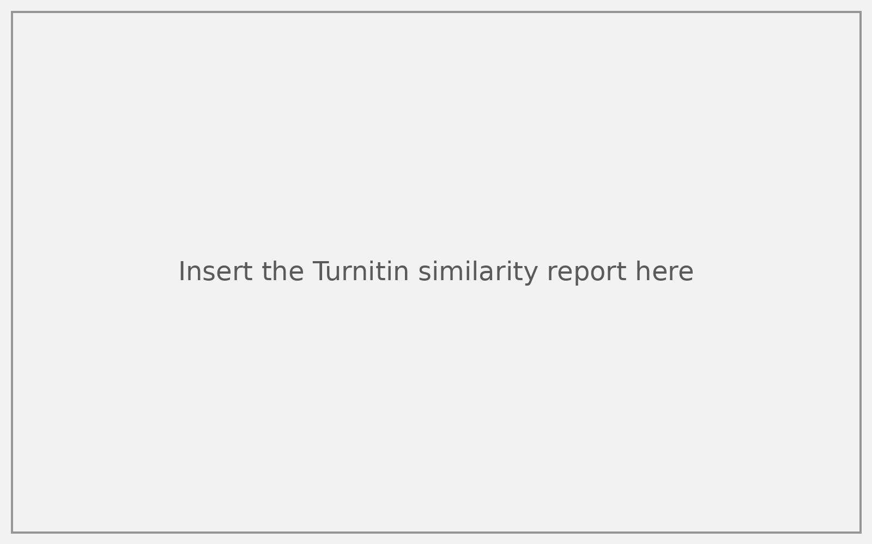
Appendix A: Turnitin similarity report
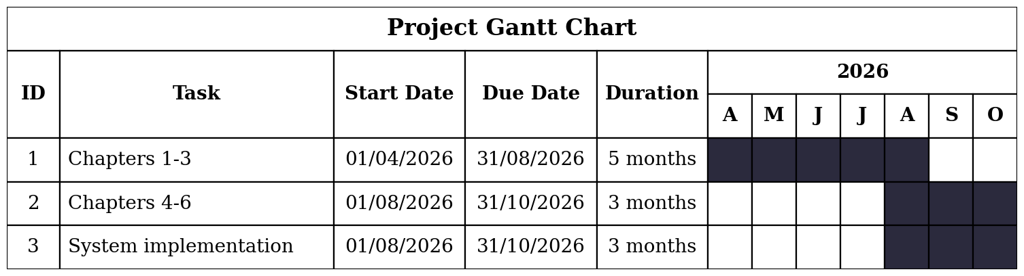
Appendix B: Gantt Chart

