CopyDog.Bat

Introduction
CopyDog.bat is a dos batch script to automate Echelons Self boot Method. The script has been tested under Microsoft Windows 2000 [Version 5.00.2195] & Windows 98 [Version 4.10.2222].

How To Make Your DC Games Self boot.

- Create a directory on your hard drive called selfboot.
- Unzip copydog.zip into this directory.
- Edit copydog.bat in a text editor e.g. Notepad or WordPad, as follows:
- Start your text editor and open copydog.bat
- Find the following section
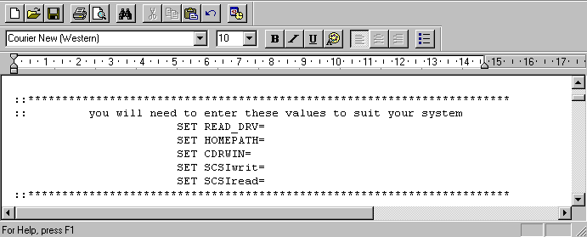
- You will now need to fill in the spaces after the = sign for the above values: -
  - SET READ_DRV= enter the drive letter of your cd reader.
  - SET HOMEPATH= enter the drive & path where you have created your selfboot dir.
  - SET CDRWIN= enter the drive & path & name for cdrwin.exe
  - SET SCSIwrit= this value can be obtained as shown below.
  - SET SCSIread= this value can be obtained as shown below.
    - To obtain the last two values:
    - Open a dos window i.e. Start_Programs_MS-DOS Prompt.
    - In the dos window change directory to your selfboot directory.
    - Type: cdrecord – scanbus
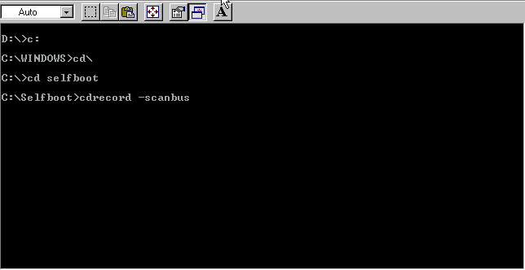
    - This will give you a result similar to the following:
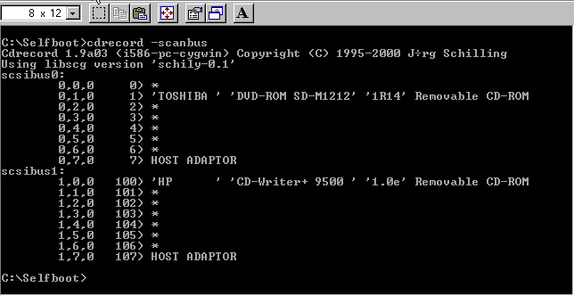
- From the above screen we find the cdrom or scsi device (as Bus,Id,Lun) for cd writer i.e.1,0,0

- From the above screen we find the cdrom or scsi device (as Bus,Id,Lun) for cd reader i.e.0,1,0
- Note: If you only have a cdwriter then use the same value for SCSIwrit & SCSIread.
- The resulting information that needs to be entered into copydog.bat should look similar to the following: 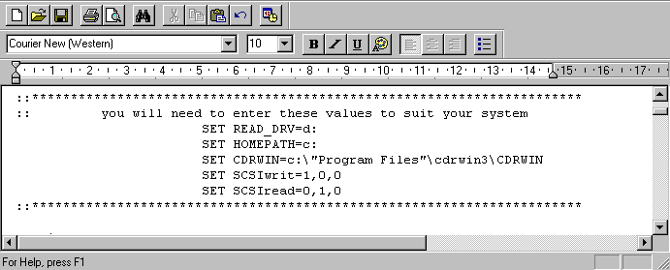

- After entering the information, save copydog.bat as type Text Document: 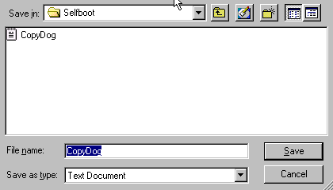

- Now we are ready to run CopyDog.bat:
- Open a dos window i.e. Start_Programs_MS-DOS Prompt.
- In the dos window change directory to your selfboot directory.
- Type copydog 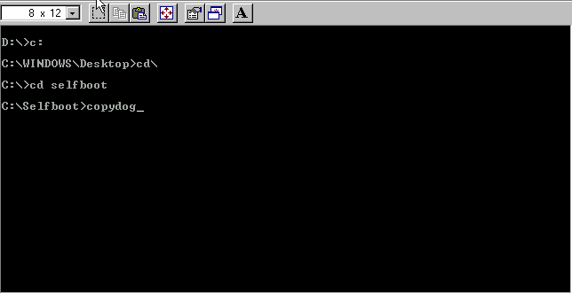
- For more advanced features please read copydog.txt.

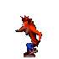CopyDog

