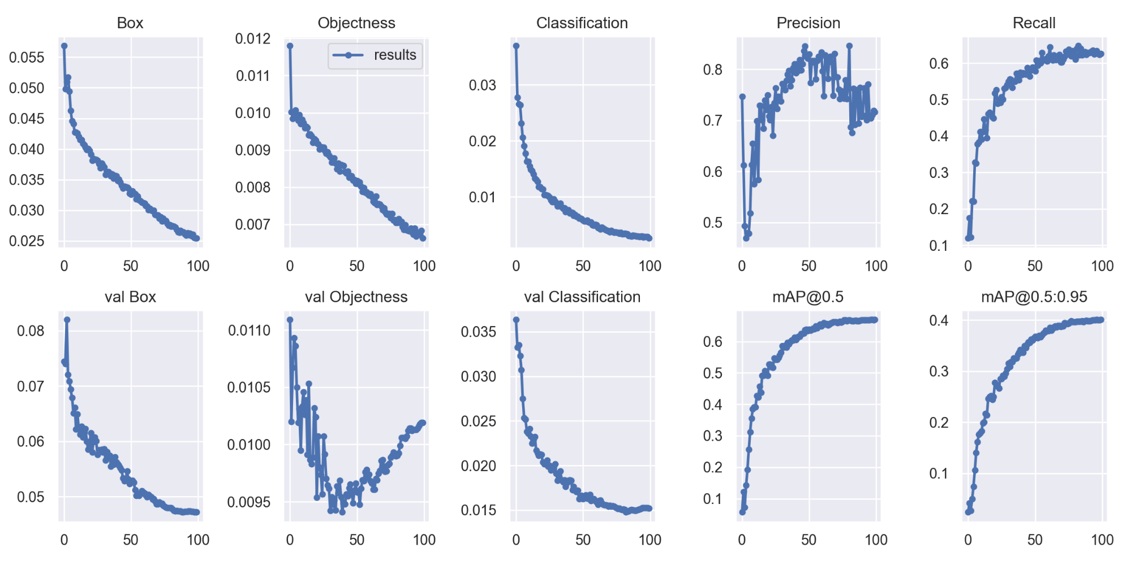

Box

Objectness

0.012

0.055

results

0.011

0.050

0.03

0.045

0.010

0.02

0.040

0.009

0.035

0.008

0.01

0.030

0.007

0.025

0

50

100

0

Classification

Precision

Recall

0.6

0.8

0.5

0.7

0.4

0.6

0.3

0.2

0.5

0.1

50

100

0

50

100

0

50

100

0

50

100

val Box

val Objectness

val Classification

mAP@0.5

mAP@0.5:0.95

0.4

0.08

0.0110

0.035

0.6

0.030

0.5

0.3

0.07

0.0105

0.4

0.025

0.2

0.3

0.06

0.0100

0.020

0.2

0.1

0.05

0.0095

0.1

0.015

0

50

100

0

50

100

0

50

100

0

50

100

0

50

100