SCHOOLS DIVISION OFFICE — CLICK TIME USER’S MANUAL

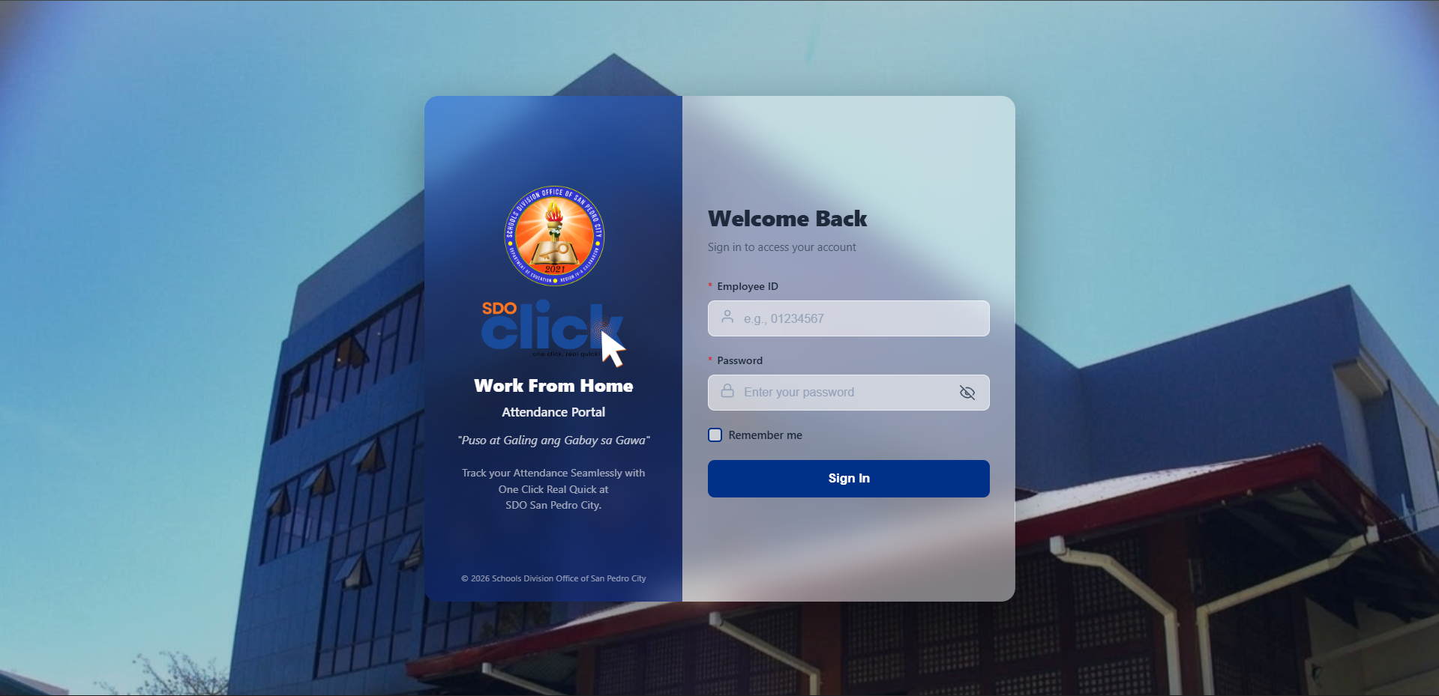
LOGIN PAGE
The Login Page allows users to securely access the system using their assigned Employee ID and password. For first-time users, the default password is the same as their Employee ID.

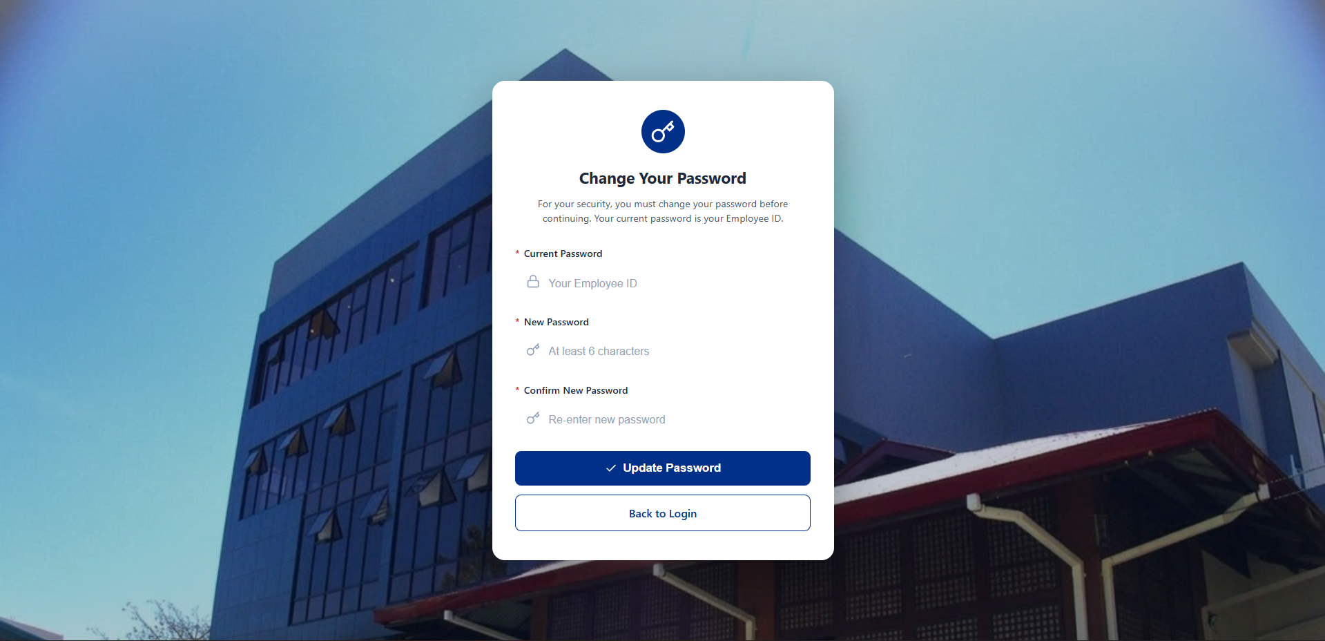
CHANGE PASSWORD
When a user logs in for the first time, the Change Password page will automatically appear. Users are required to change their default password to ensure the security of their account.
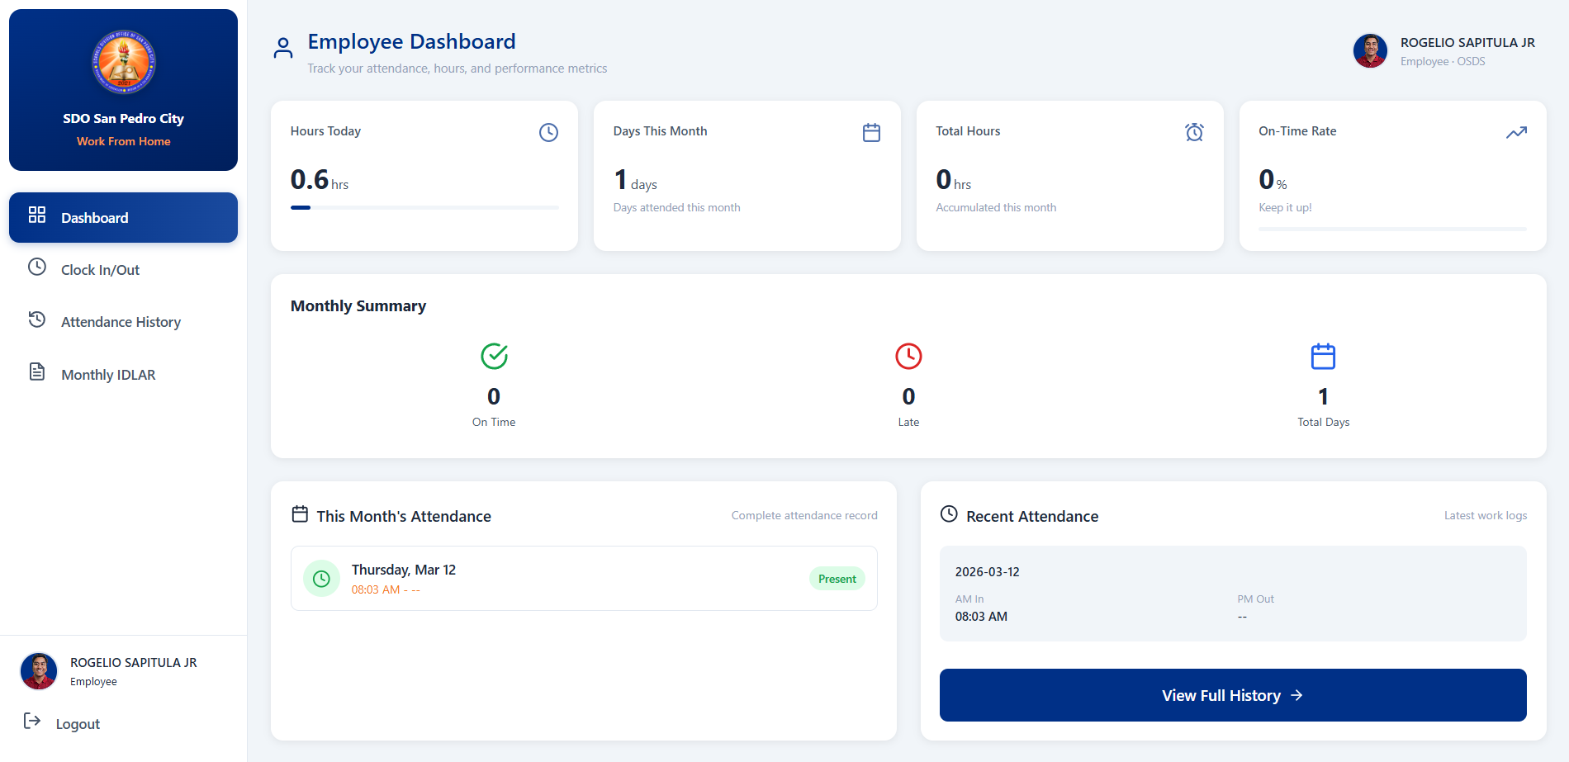
DASHBOARD
The Dashboard provides an overview of the user’s attendance and performance information.

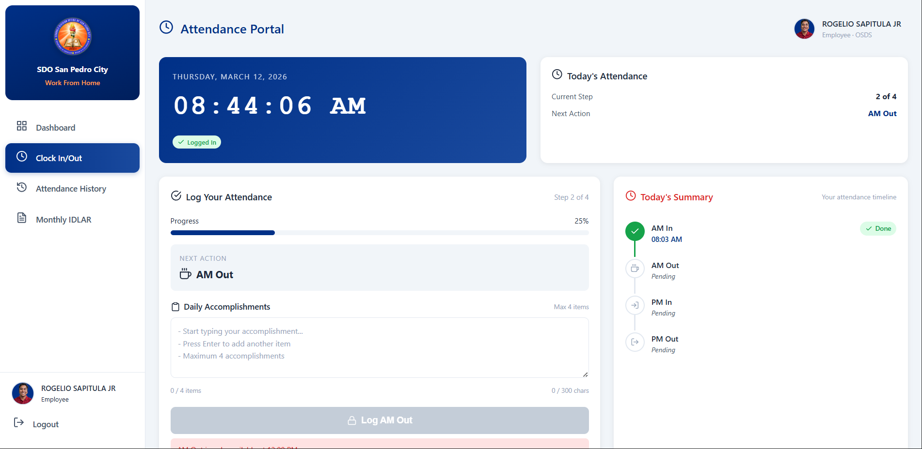
CLOCK IN/CLOCK OUT (ATTENDANCE PORTAL)
The Attendance Portal allows users to log their daily attendance. Users can view their “Today’s Attendance” and can record their “Time In and Time Out”.

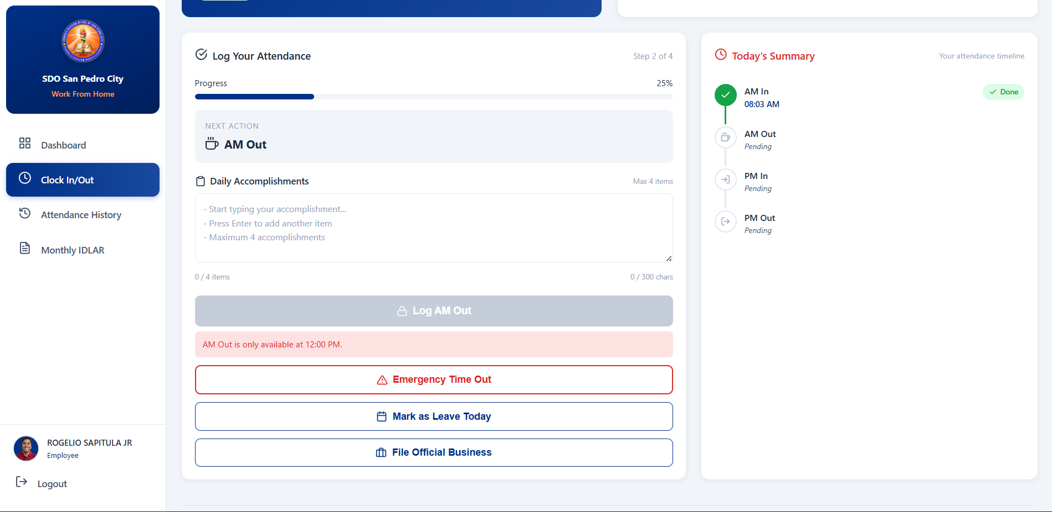
CLOCK IN/CLOCK OUT (ATTENDANCE PORTAL)
When the user successfully records their AM Time In, the remark will display: “AM Out is only available at 12:00 PM”.

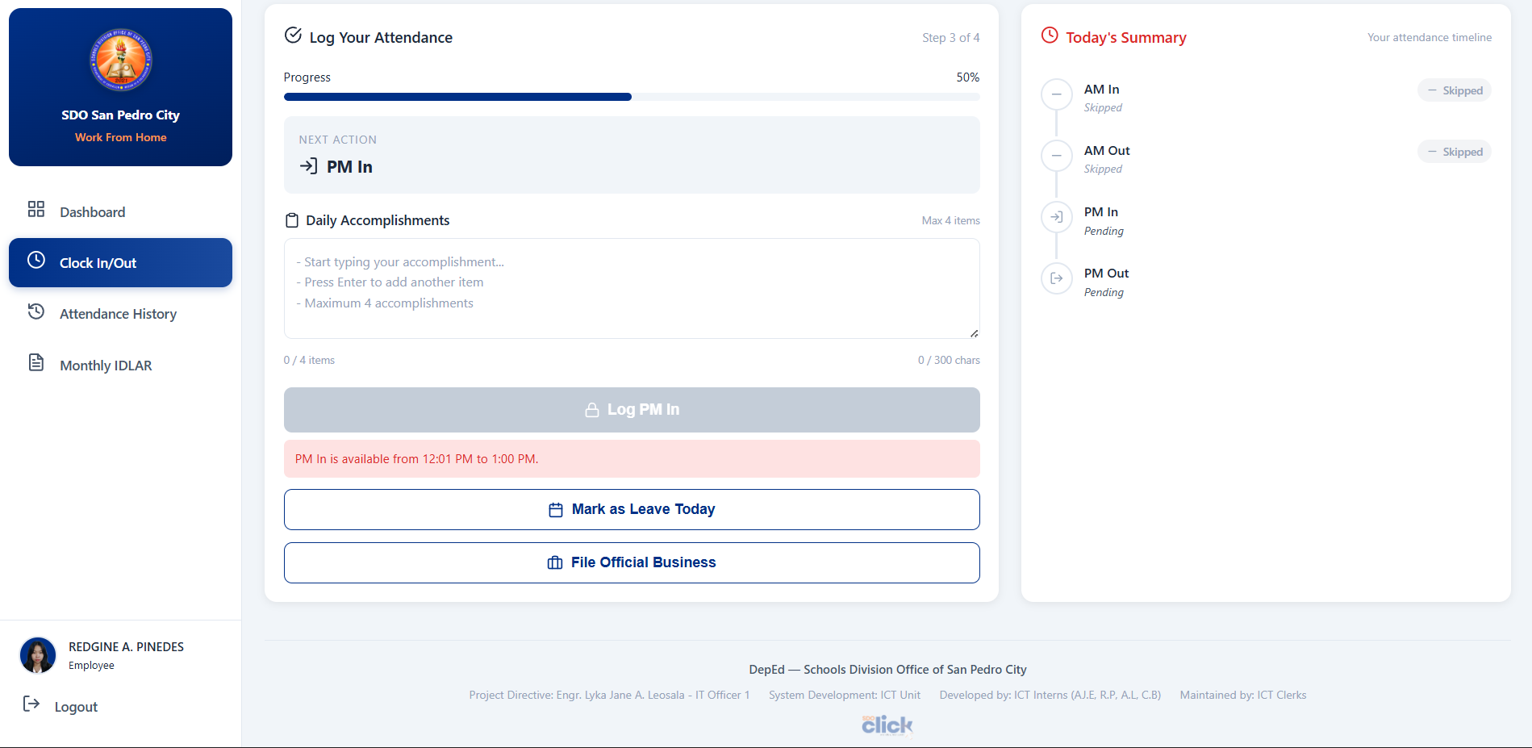
CLOCK IN/CLOCK OUT (ATTENDANCE PORTAL)
If the user skips the AM Time In, the system will display the remark: “PM In is available from 12:01 PM to 1:00 PM”.
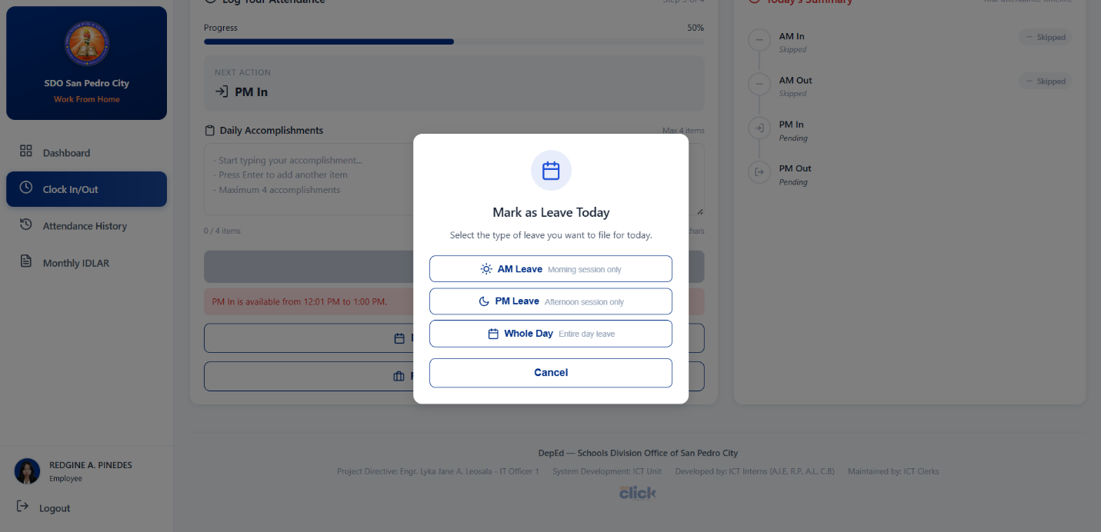
MARK AS LEAVE TODAY
This feature allows users to file leave for the current day. Users can select the type of leave: AM Leave, PM Leave, Whole Day.

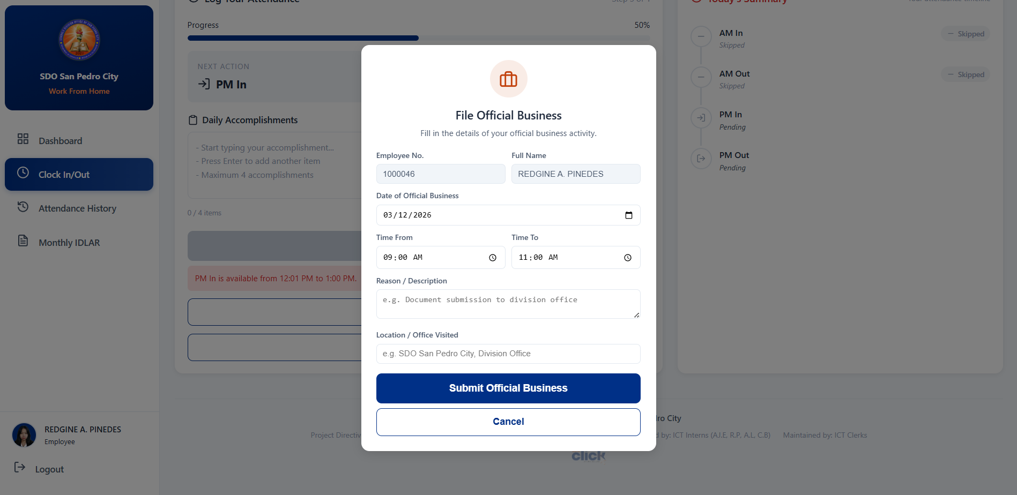
FILE OFFICIAL BUSINESS
The Official Business feature allows users to file requests when they need to perform official work outside their regular duties.

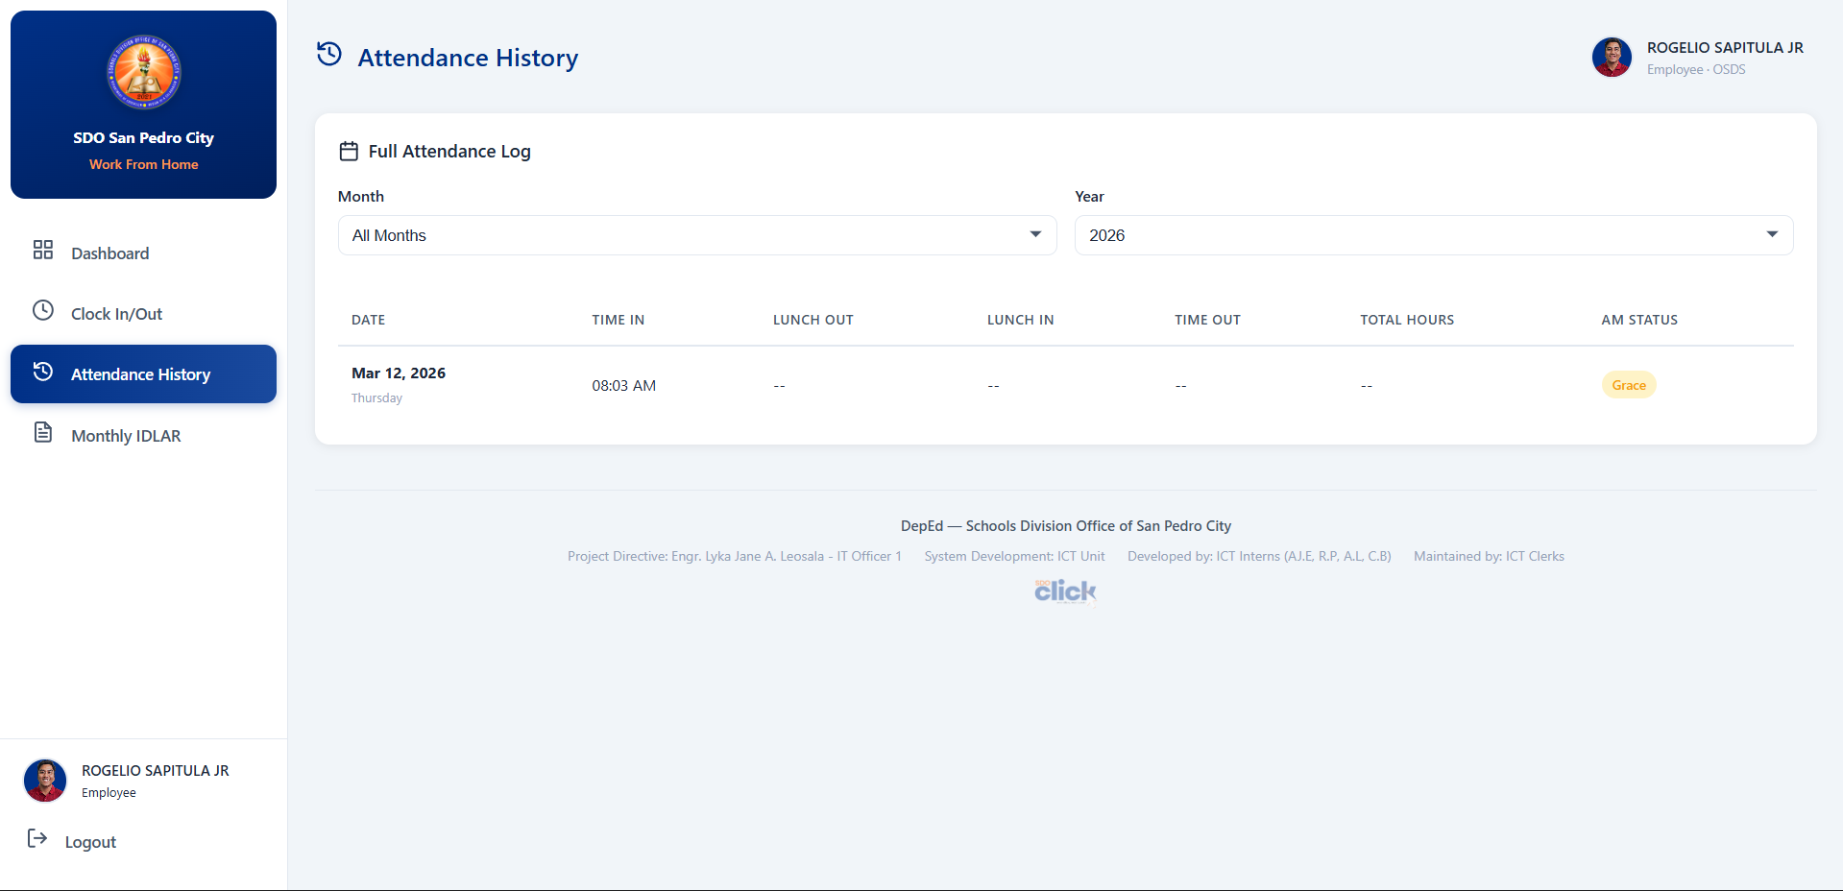
ATTENDANCE HISTORY
The Attendance History section allows users to view their complete attendance records. Users can view their Past time-in and time-out logs, Attendance status, and Daily records.

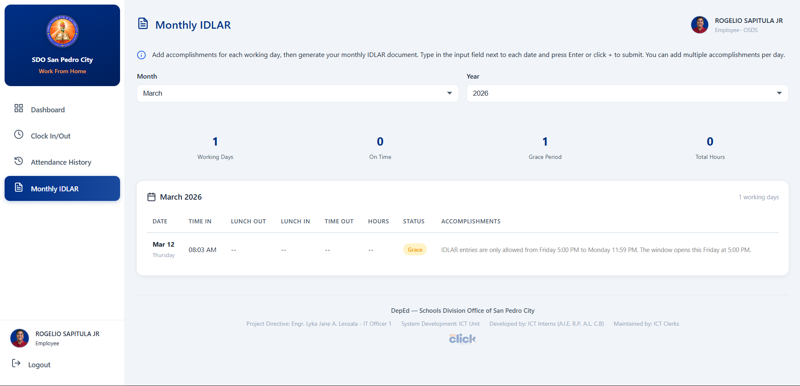
MONTHLY IDLAR
This feature allows users to record their daily accomplishments. Users can add accomplishments for each working day, can track their work progress, and also generate their Monthly IDLAR Document.

