
Republic of the Philippines

Department of Education
REGION IVA - CALABARZON
SCHOOLS DIVISION OFFICE OF SAN PEDRO CITY

LOCAL SCHOOL BOARD
NAME: ELAINE JULIA FRANCISCO DATE: JULY 1, 2026
PERIOD COVERED: JUNE 16-30, 2026

ACCOMPLISHMENT REPORT
As the assigned Clerk of the Division Office of San Pedro. I have served, performed, and accomplished the following duties, functions, and responsibilities:
- Attend Flag Ceremony.
- Assisting incoming and outgoing documents in the Personnel Unit.
- Responsible for monitoring and movement in DTR.
- Responsible for monitoring work-from-home (WFH) SDO personnel and responding to queries related to WFH arrangements.
- Monitored and updated employee attendance records, including approved leaves and participation in flag ceremonies.
- Completed the encoding of the initial Evaluation Results for School Principal 1
- Assisting in the Distribution of Advice of Assignment for Newly Hired Teachers| SY 2026-2027
JUNE 26, 2026 Friday (WFH)
- Successfully uploaded, verified, and edited service records of promoted elementary teachers to ensure accurate and updated personnel documentation.
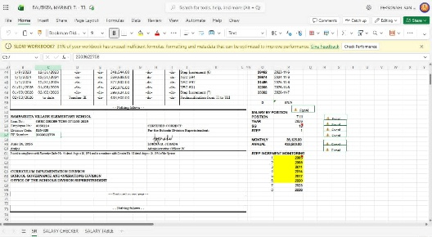

Prepared by: Noted by:

ELAINE JULIA FRANCISCO LORINA B. JURADA
Clerk Administrative Officer IV

Approved by:

PAUL JEREMY I. AGUJA
Administrative Officer V

