BIRTHDATE | AUGUST 30, 1989
ADDRESS | 80 Brgy. Sto. Niño, San Pedro City, Laguna



BARANGAY GOVERNMENT OF STO.NIÑO


SAN PEDRO CITY, PROVINCE OF LAGUNA

INCASE OF EMERGENCY, PLEASE NOTIFY:
JOY L. RIVA
09602724571
This is to certify that the person whose name
and signature appears herein is a bonified employee of
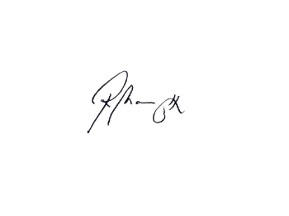
Barangay Government of Sto. Niño

HON. RAMON T. MAMAWAG
PUNONG BARANGAY
BARANGAY KAGAWAD
JASPHER
ID NUMBER
2026-005
VALID UNTIL: NOVEMBER 30, 2027





HOMO
JASPHER N.
Contact No.: (02) 8556.9685
brgystoninospl@gmail.com barangay.stonino.56
53 Sto. Niño St., Santo Niño, San Pedro City, Laguna
PHILIPPINE NATIONAL POLICE
(02) 8567-3381/8864-1548

CITY OF SAN PEDRO LAGUNA BUREAU OF FIRE PROTECTION
(02) 8808-0617/0936 470 2158

CITY DISASTER RISK REDUCTION AND MANAGEMENT OFFICE
(02) 8403-2648/0998 594-1743








