contentScanner
Content Scanner Service - Technical Documentation with Flowcharts

1. Overview
contentScanner is the background service (daemon) that ties the whole content-inspection solution together. It listens on a local Unix socket for files that a monitoring client wants to transmit or upload, receives each file, asks libcontentextraction.so to extract the text, and relies on libcontentcontrol to decide whether that text contains sensitive data (PAN, Aadhaar, card numbers, IBAN, e-mail, custom words and so on). Depending on the configured operating mode it then tells the client to ALLOW or BLOCK the file, raises an event for the management console, and can show a pop-up to the user.

Main responsibilities
- Run as a daemon with a PID file and clean shutdown on SIGTERM / SIGINT.
- Serve one client at a time over the Unix socket /opt/MicroWorld/var/run/contentScanner using a small text/binary handshake.
- Open archives (ZIP, 7z, RAR, TAR and many more, including nested ones) and scan every member.
- Apply one of three operating modes: monitoring, blocking or ask-user.
- Send BLOCKED (1502) and ALLOWED (1507) events through eventsender(), with de-duplication.
- Show pop-ups and notifications (GUI dialog, desktop notification, or an allow/deny question).
- Supervise the separate clipboardWatcher binary so clipboard monitoring stays alive.
This document is based on the 3 uploaded source files (main.cpp, askUser.cpp, popupInfo.cpp). Headers such as eventsender.h, readConfiguration.h and scanning_file.h were not included, so those parts are described by how they are called. Flowcharts for this binary and for the two libraries it calls are included in the relevant sections.

2. Position in the Solution
Three software components work as a chain. contentScanner is the only one with a process of its own; the other two are shared libraries loaded into it. Figure 1 shows the end-to-end path of one file.

3. Source File Map
File | Responsibility
main.cpp | Entire service: configuration and start-up, daemonising, signal handling, Unix-socket server (FileScan thread), archive scanning, mode policy (allow / block / ask), event de-duplication, clipboard-watcher supervisor, pop-up helper.
askUser.cpp | Helper askUser1(path): starts escanWebUser.sh and reads the user's answer from /opt/MicroWorld/var/run/escanWebUser.result. Older variants (socket based, polling with timeout) are kept as comments. The current main.cpp calls the script directly instead.
popupInfo.cpp | Helper popupInfo(message): sends the message to the GUI pop-up process over /opt/MicroWorld/var/run/escanwebsocket; if that socket is not available it starts escanWeb.sh with the message.

Globals defined in main.cpp and used by the libraries
Symbol | Used by | Meaning
readableFiletypeVec | libcontentextraction | List of text-like MIME types read directly as plain text (filled by initializeReadableFiletypes()).
isBlockPattern | libcontentcontrol, scanLog | Set to true at start-up when the configuration is readable; makes patternMatch() return at the first hit.
isBlockMode / isAskUser | main.cpp | Mode switches derived from ContentScanner:Status.
TermSignal | main.cpp | Set by the signal handler to stop the loops.

4. External Dependencies
Library / tool | Use
libarchive | Reading archives and compressed files (all formats and filters).
libmagic | MIME detection of archive members using /opt/MicroWorld/var/contentControl/magic.mgc.
pthread | FileScan thread, clipboard-supervisor thread, global mutex.
POSIX sockets | AF_UNIX stream server and client for pop-ups.
X11 headers | Included; display availability is checked with shell commands.
libcontentextraction.so | scanning_file(), initializeRegexes(), extractPatterns(), ClearRegexCache().
libcontentcontrol | patternMatch() (reached through scanning_file) and isBlockPattern.
eventsender, readConfiguration, scanLog | Product libraries: event reporting, configuration file reader, logger.
Helper programs | escanWebUser.sh, escanWeb.sh, notify.sh, escanWebDlp, clipboardWatcher (all under /opt/MicroWorld).

5. Operating Modes
The mode is chosen once at start-up from ContentScanner:Status in /opt/MicroWorld/etc/contentScanner.conf. A change needs a service restart.
Status | Mode | What happens when sensitive data is found
1 | Monitoring | Client is told ALLOW. An ALLOWED event is still raised for each detected item so administrators can see what left the machine.
2 | Blocking | Client is told BLOCK. A BLOCKED event is raised per detected item and a pop-up / notification is shown according to GuiPopup.
3 | Ask user | A pop-up asks Do you want allow transmission? for each detected item. The answer decides ALLOW (with ALLOWED event) or BLOCK (with BLOCKED event).
0 / other / missing | Stopped | Service logs the reason, removes its PID file and exits with code 1.

In every mode a white-list word hit (event text starting with [WLSstr |) is always allowed and only an ALLOWED event is sent. A file that cannot be opened (for example an encrypted file whose password failed, which produces an empty event text) is reported as Password : Invalid and blocked in blocking mode.

Other configuration values read by main()
Key | Effect
ContentScanner:GuiPopup | 2 = GUI pop-up through popupInfo(); 1 = desktop notification through notify.sh; otherwise none. Default 0.
ContentScanner:caseInSensitive | Passed to initializeRegexes() as allowLowercase.
ContentScanner:clipBoardMonitor | 1 or 2 starts the clipboard-watcher supervisor thread.
patterns section | Per-data-type enable flags read by extractPatterns().
customRegex section | Custom regexes and white/black word lists read by initializeRegexes().

6. Start-up and Shutdown
Figure 2 shows main(). The service refuses to run when the mode is 0, when the configuration file cannot be read, or when pattern/regex initialisation fails, so a half-configured scanner never accepts files.
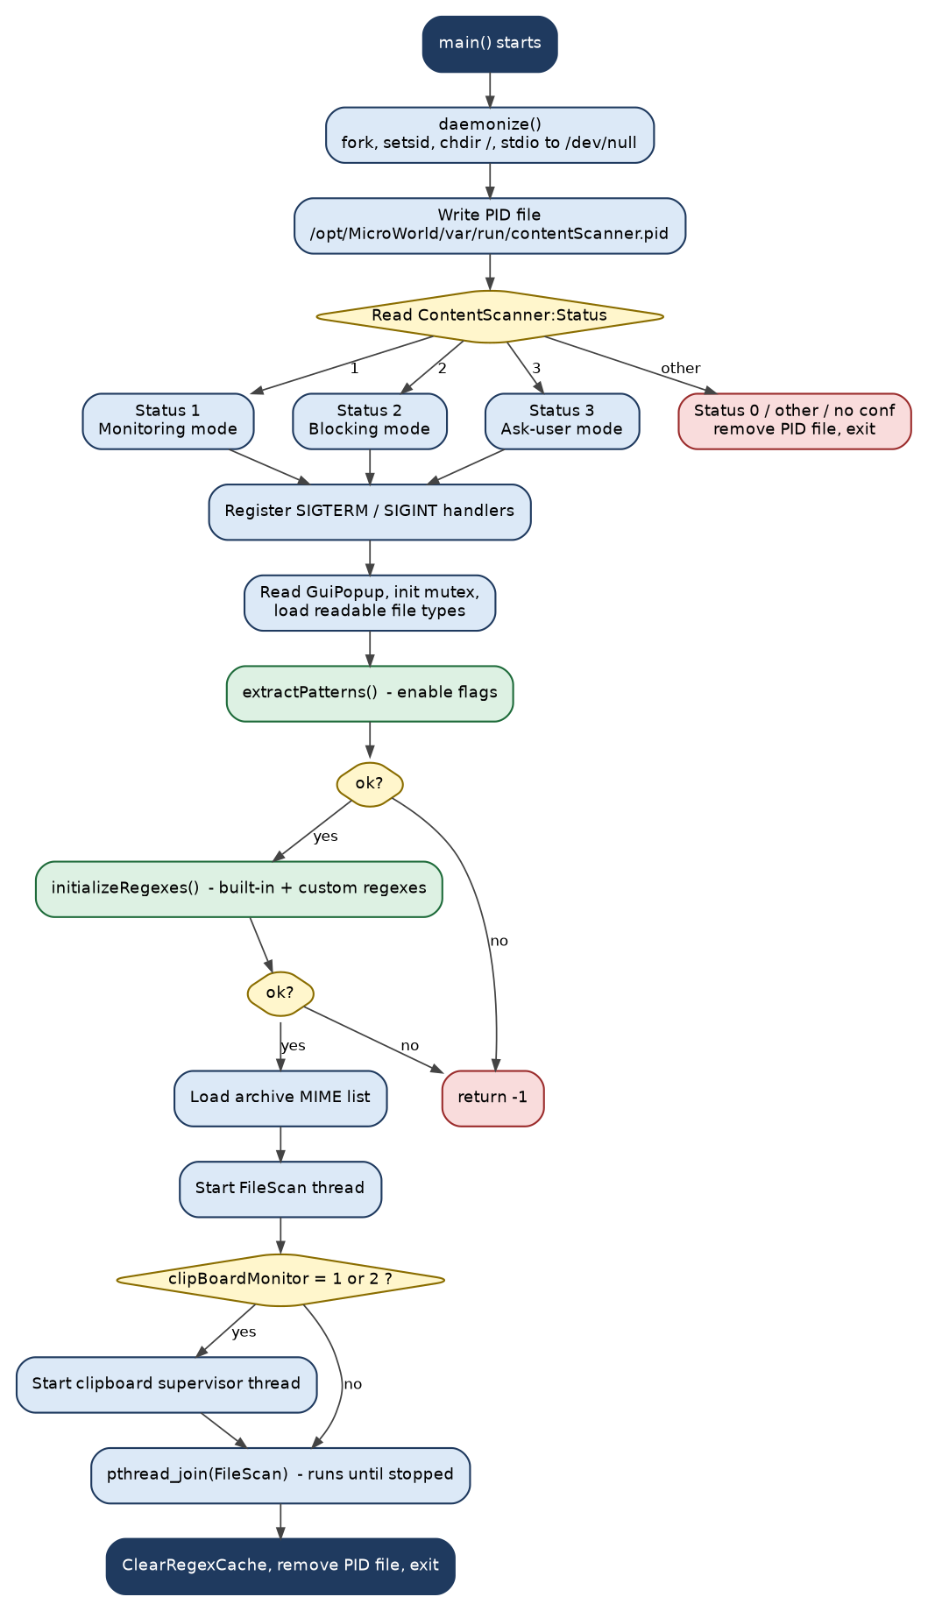
Figure 2 - main(): start-up sequence

Shutdown
On SIGTERM or SIGINT the handler logs the event, sets TermSignal, clears the regex cache, removes the PID file, kills any running clipboardWatcher with killall -9, and exits. The FileScan thread normally ends after its loop sees the flag; it then closes the server socket.

7. Socket Protocol
The client and the server talk over the Unix stream socket in a fixed order. Every step is acknowledged by a short keyword, so both sides stay in step. The first message carries the secret word OMKAROK followed by the original file path; anything else is rejected as an invalid client.
Step | Client sends | Server replies | Notes
1 | OMKAROK + original path | - | First 7 bytes must be OMKAROK, rest is the path.
2 | - | ACK | File name part is used to build the temp path under /opt/MicroWorld/var/run/.
3 | File size (8-byte long) | -
4 | - | DATAOK | Server allocates a buffer of that size.
5 | File bytes | - | Received until the size is reached or the connection fails.
6 | - | FILETYPEOK | File is saved to the temp path.
7 | MIME type string | - | Used by scanning_file() to pick the extractor.
8 | - | PROCESSOK
9 | Process name (application that sends the file) | - | Shown in the event text as APP:[name].
10 | - | ALLOW or BLOCK | Final verdict. Temp file is deleted and the socket closed.

A global mutex is taken for the whole exchange, so requests are handled strictly one after another.

8. Handling One Request
Figure 3 follows a connection from accept() to the final verdict. After the three handshake rounds the scanner decides between archive handling and normal scanning. If nothing sensitive is found the answer is simply ALLOW.
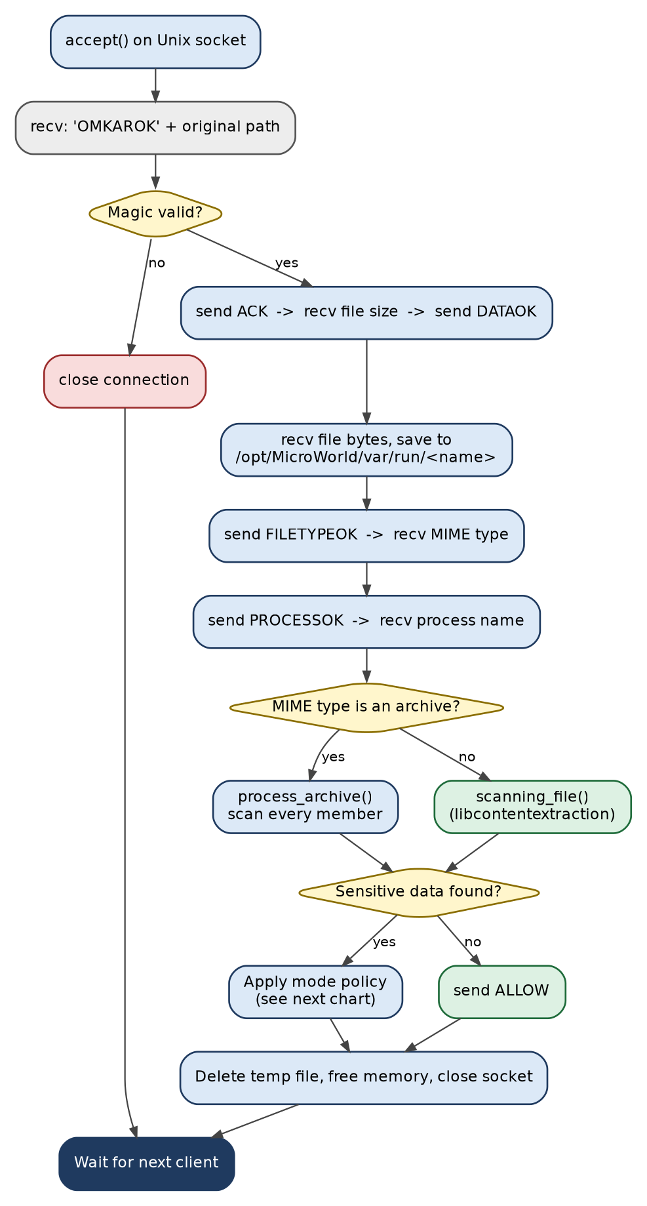
Figure 3 - FileScan thread: life of one request

Mode policy after a hit
When a scan reports sensitive data the policy in Figure 4 applies. The same logic exists for archive hits and for normal files.
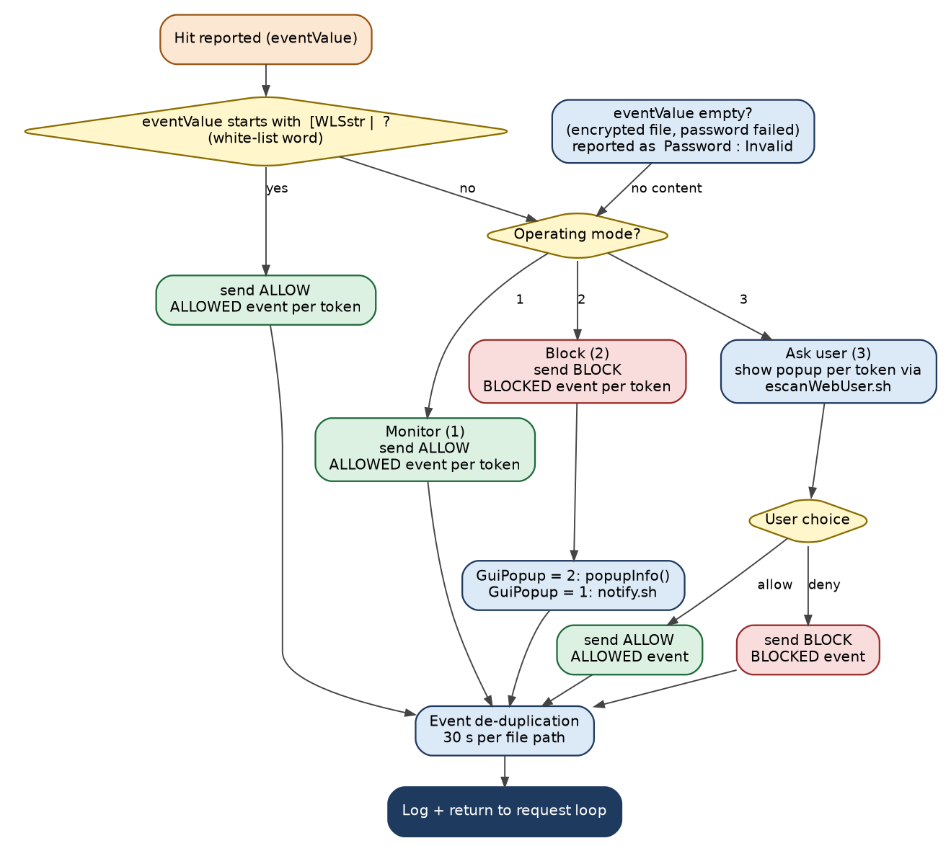
Figure 4 - Result handling by operating mode

Event text and tokens
The scanner library returns the hits as one string such as [PANCard | ABCDE1234F][EMailID | a@b.com]. main.cpp splits it into tokens with the regular expression \[[^\[\]]+\]. For each token it builds the strings URL:[NA] APP:[process] CONTENT:[token] and ""path":size", which are passed to eventsender(). The part before the pipe is also used as the readable content name in pop-ups.

9. Archive Scanning
When the MIME type sent by the client is in the archive list, process_archive() opens the file with libarchive and scans every member that is not a directory and not empty. Each member is read into memory, its type is detected with libmagic, and it is written to a temporary file so that the normal scanning_file() path can be used. Nested archives are handled by calling the function again.
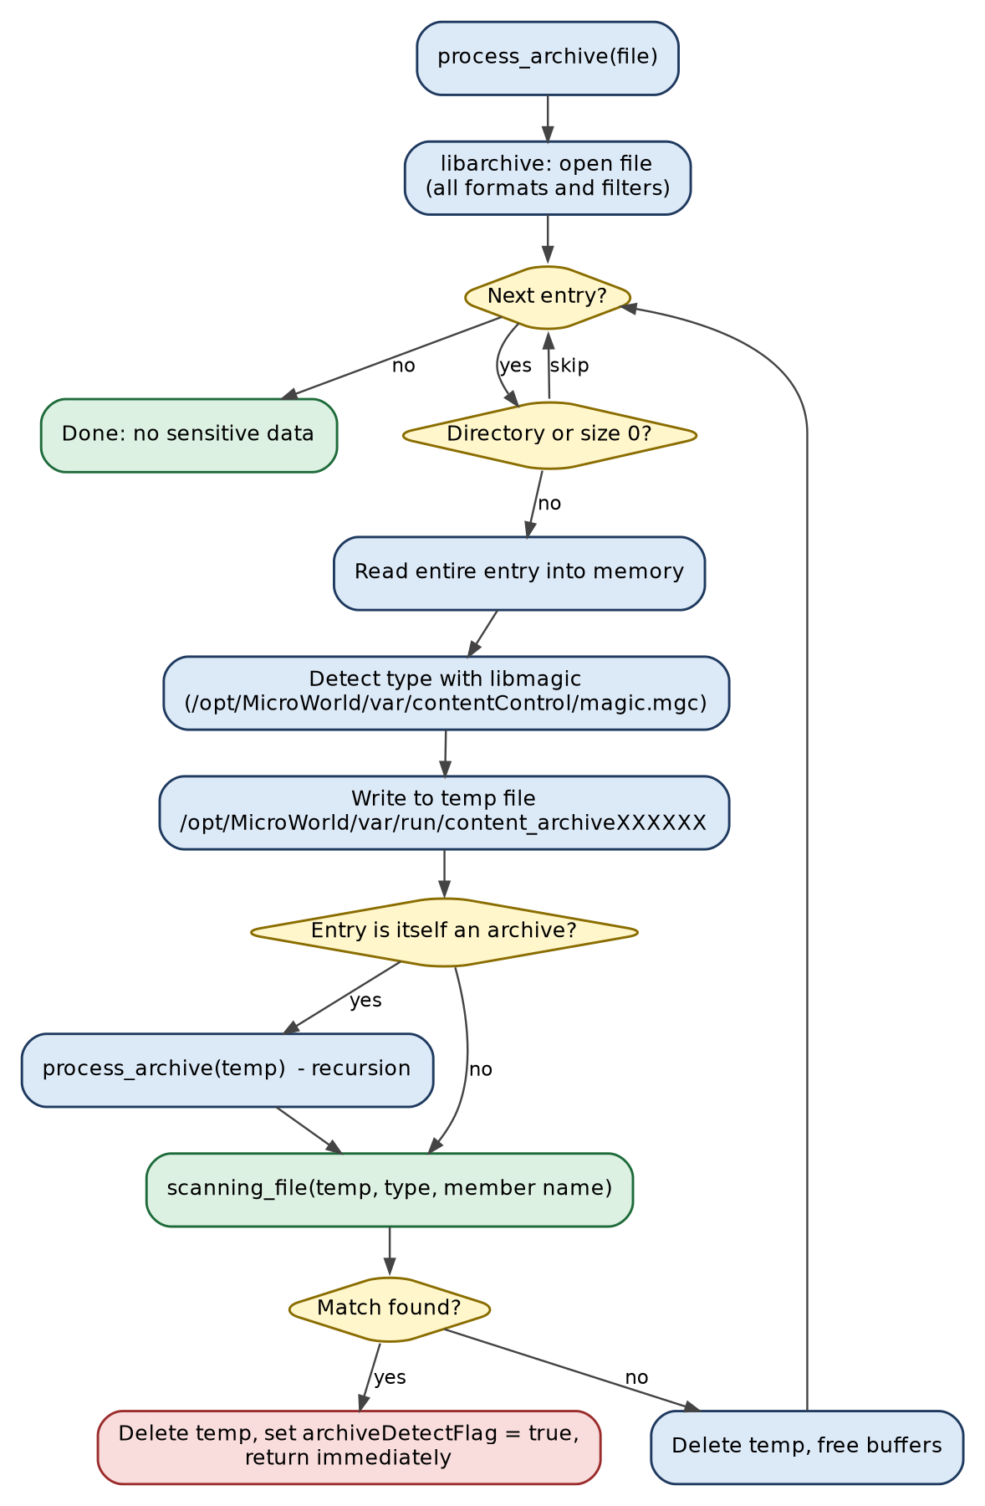
Figure 5 - process_archive(): scanning archive members
The list of archive MIME types is held in one comma-separated string (7z, ace, alz, arj, arc and others). A comment records that some package types (vnd and rpm) were removed from the list to avoid a crash in another daemon.

10. User Interaction
Mechanism | Where | Purpose
popupInfo(msg) | popupInfo.cpp | Informational pop-up (blocking mode with GuiPopup = 2). Tries the socket escanwebsocket; otherwise runs escanWeb.sh in the background.
notify.sh | main.cpp (system()) | Desktop notification (GuiPopup = 1): ATTENTION - This File has been blocked! with file and content.
escanWebUser.sh '<message>' 1 | main.cpp (system()) | Ask-user question. The exit status decides the answer: a non-zero status is treated as ALLOW, zero as BLOCK.
askUser1(path) | askUser.cpp | Same script, but reads the answer from escanWebUser.result. Present but not called in the current main.cpp.
popupThread() | main.cpp | Forks escanWebDlp with DISPLAY=:1 and a fixed XAUTHORITY; only referenced from commented code.

11. Event Reporting and De-duplication
Two separate de-duplicators, one for BLOCKED and one for ALLOWED events, keep the console from being flooded when the same file is retried. Each stores the last time an event was sent for a given file path.
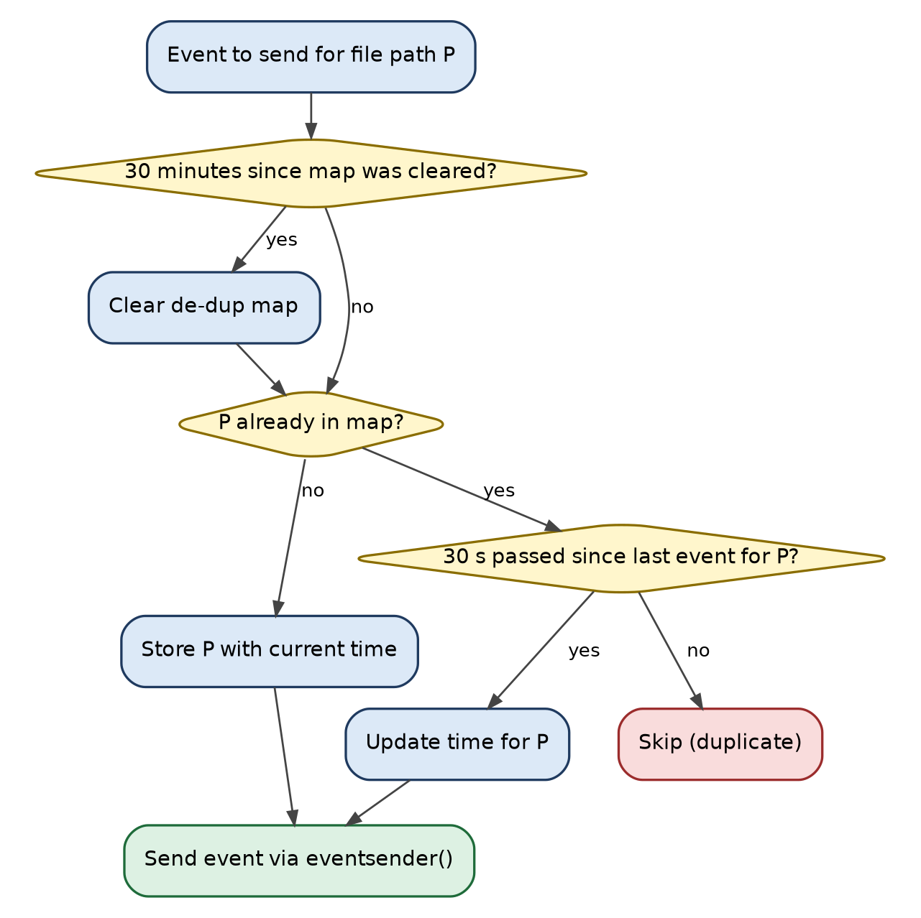
Figure 6 - Event de-duplication (30-second window, map cleared every 30 minutes)
Constant | Value
Event codes | BLOCKED = 1502, ALLOWED = 1507 (severity INFO = 0)
Event titles | File Upload Blocked, File Upload Allowed
Event source | contentScanner
De-dup window | 30 seconds per file path
Map reset | every 1,800 seconds (30 minutes)

12. Clipboard Watcher Supervisor
When clipBoardMonitor is 1 or 2, a supervisor thread keeps the external /opt/MicroWorld/sbin/clipboardWatcher running. Every 15 seconds it re-reads the setting, checks that a graphical session exists (X11 socket / Xorg process, or a Wayland socket under /run/user) and starts the watcher if it is not already running.
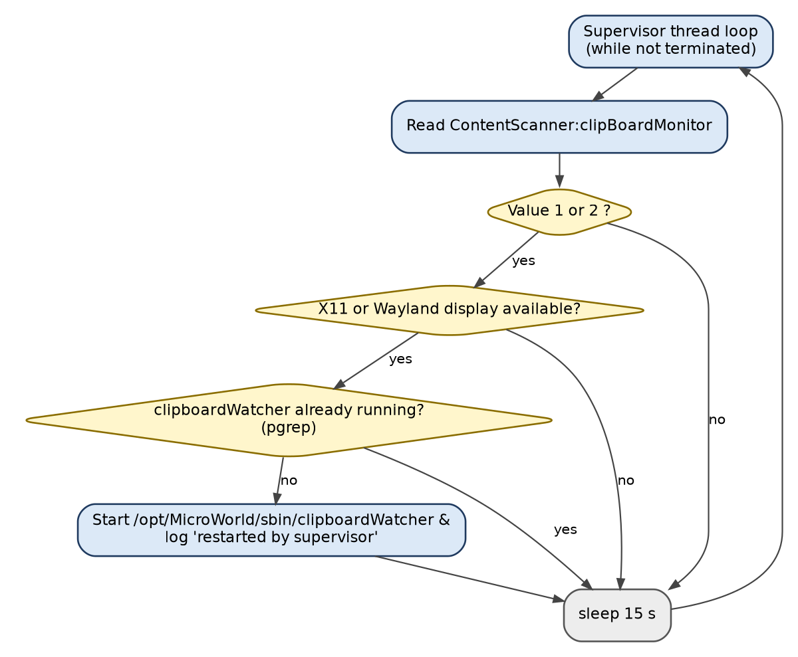
Figure 7 - Clipboard-watcher supervisor loop

13. What contentScanner Calls in the Libraries
The two libraries are documented separately. The charts below show the parts of them that are reached from contentScanner so that the full path can be read in one place.

13.1 libcontentextraction.so
Entry point scanning_file(filename, mime, originalPath, eventValue) empties the work directory, optionally finds the real type of an encrypted file, then chooses an extractor.
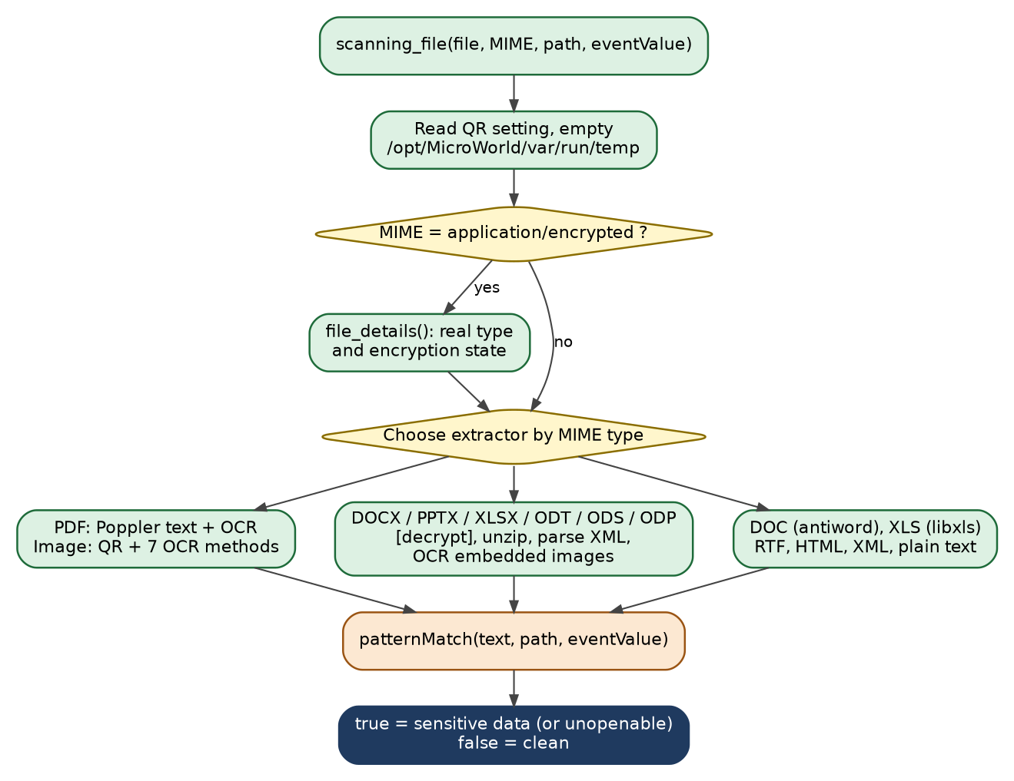
Figure 8 - scanning_file(): choosing the extractor
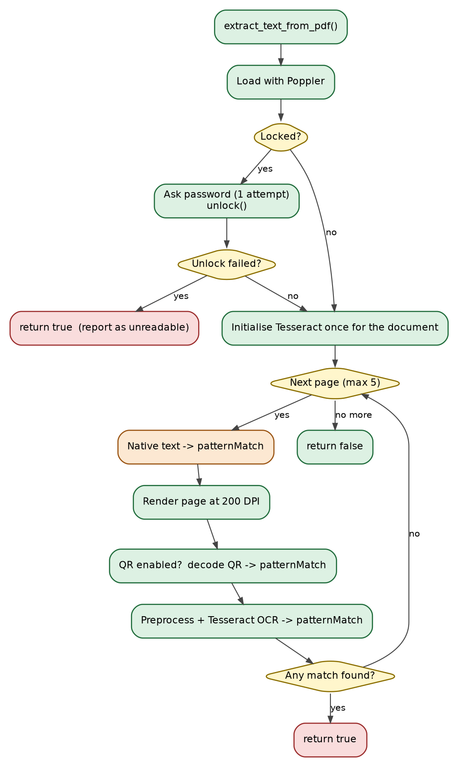
Figure 9 - PDF pipeline: Poppler text, QR and OCR (max 5 pages)
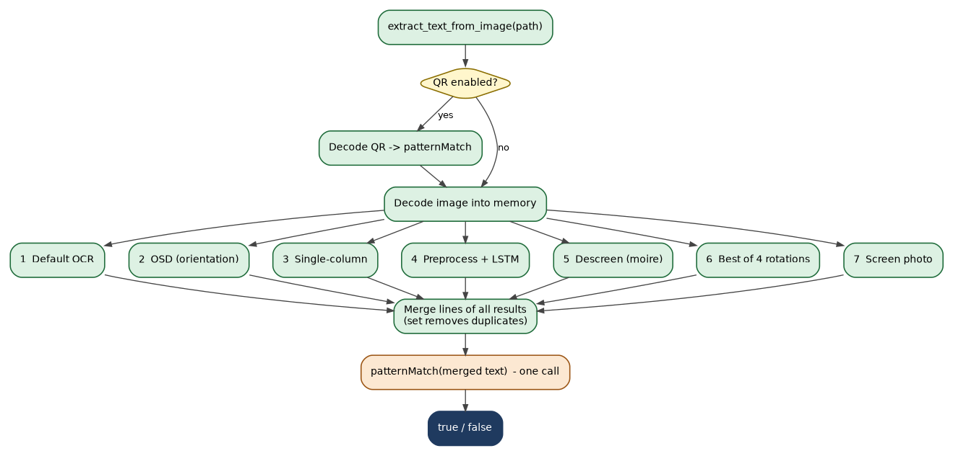
Figure 10 - Image pipeline: seven OCR methods merged
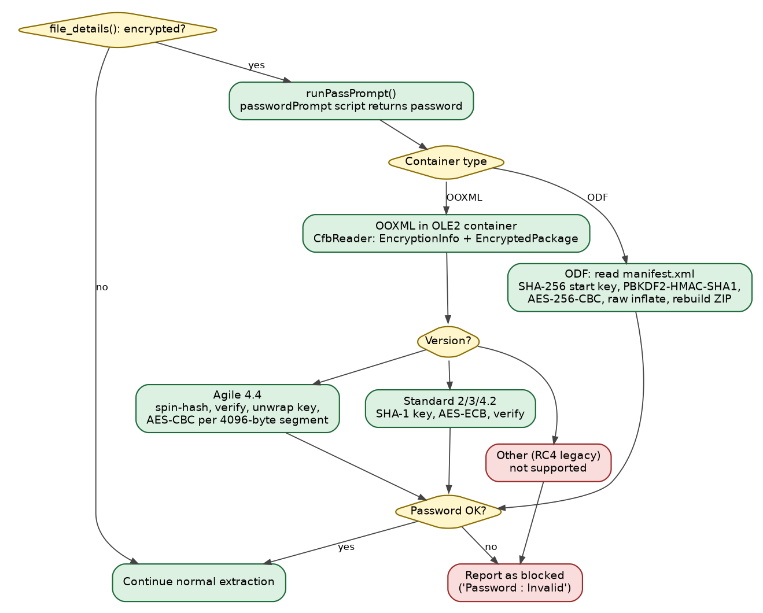
Figure 11 - Password-protected Office and OpenDocument files

13.2 libcontentcontrol
Every extractor ends with patternMatch(). It tests the 26 built-in data types in a fixed order, then custom regexes and custom words. Because main() sets isBlockPattern = true, the function returns at the first confirmed hit in this service.
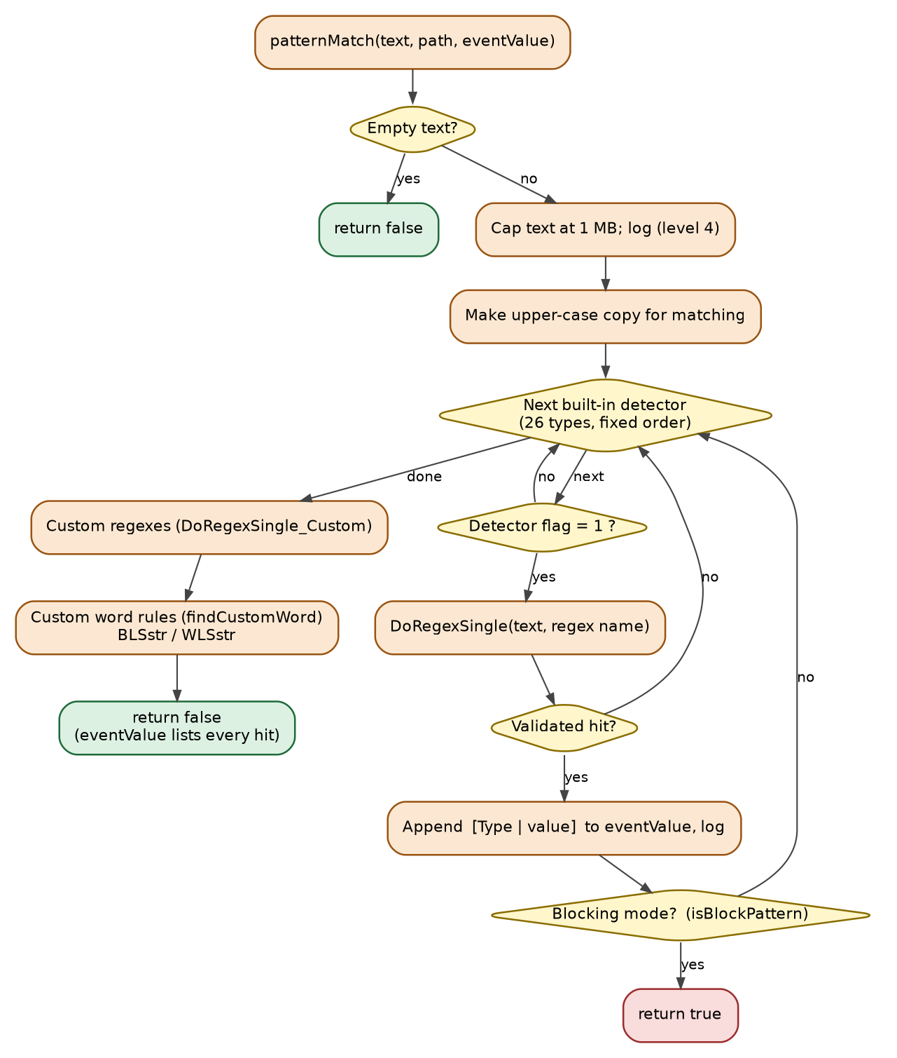
Figure 12 - patternMatch(): detector loop
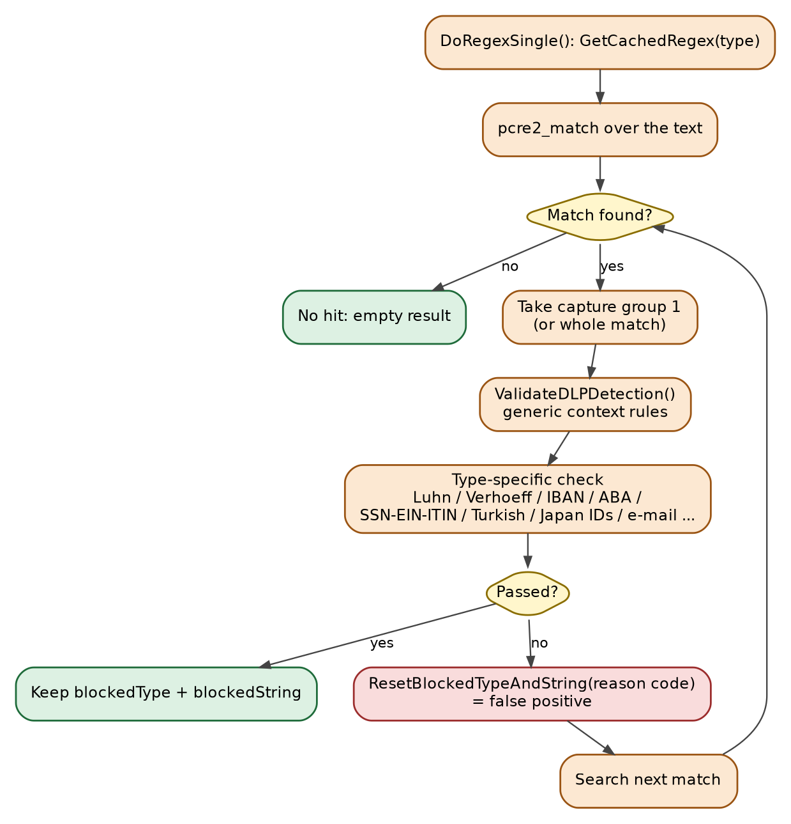
Figure 13 - Regex match and validation (false-positive filtering)

14. File and Path Reference
Path | Purpose
/opt/MicroWorld/etc/contentScanner.conf | Configuration (mode, GUI pop-up, patterns, custom regexes, clipboard monitor).
/opt/MicroWorld/var/run/contentScanner | Unix socket the service listens on.
/opt/MicroWorld/var/run/contentScanner.pid | PID file.
/opt/MicroWorld/var/run/<file name> | Temporary copy of the received file (deleted after the verdict).
/opt/MicroWorld/var/run/content_archiveXXXXXX | Temporary copies of archive members.
/opt/MicroWorld/var/run/temp | Work directory of libcontentextraction (emptied each scan).
/opt/MicroWorld/var/run/escanwebsocket | Socket of the GUI pop-up process.
/opt/MicroWorld/var/run/escanWebUser.result | Answer file used by askUser1().
/opt/MicroWorld/var/contentControl/magic.mgc | libmagic database.
/opt/MicroWorld/bin/escanWebUser.sh, escanWeb.sh, notify.sh, escanWebDlp | Pop-up and notification helpers.
/opt/MicroWorld/sbin/clipboardWatcher | Clipboard monitoring binary.
/var/MicroWorld/var/log/contentScanner.log | Log file (shared with both libraries).

15. Function Reference
Function | Purpose
int main() | Daemonise, read mode and configuration, initialise patterns/regexes, start threads, wait.
void daemonize() | Classic double-detach: fork, setsid, chdir /, redirect stdio to /dev/null.
int saveRTSPID(path) | Write the process ID to the PID file.
void term_signal_handle(sig) | Clean shutdown on SIGTERM / SIGINT.
void* FileScan(void*) | Socket server loop and complete request handling.
void process_archive(file, event, flag) | Recursive archive scanning.
const char* get_file_type(data, size) | libmagic MIME detection from memory.
bool isArchive(type) | Check the MIME type against the archive list.
void initializeReadableFiletypes() | Split the readable-types string into the vector used by the library.
void extract_filename(path, name) | Base name of a path.
int sendDeduplicatedEvent(path) / sendAllowedDeduplicatedEvent(path) | 1 = send, 0 = duplicate within 30 s.
void* clipboardWatcherSupervisor(void*) | Keep clipboardWatcher alive.
void popupInfo(msg) | Information pop-up (popupInfo.cpp).
int askUser1(msg) | Ask-user helper (askUser.cpp).

16. Build and Run
Build with the product headers on the include path and link against the two libraries and the system libraries named in section 4, for example:
g++ -std=c++17 -O2 main.cpp askUser.cpp popupInfo.cpp -o contentScanner \
-lcontentextraction -lcontentcontrol -larchive -lmagic -lpthread -lX11
Run as a privileged service (it writes under /opt/MicroWorld and /var/MicroWorld). The process daemonises itself, so no shell backgrounding is needed.

