mwencr
USB Device Encryption for Linux
Technical Documentation
Module | mwencr - USB Device Encryption feature for Linux
Organisation | MicroWorld Software Service Pvt. Ltd.
Source file | deviceEncryption.cpp
Source author | Omkar Gulambe (as stated in the source header; development started 23 June 2026)
Language and platform | C++ on Linux (libudev, pthreads, inotify, /proc)
Runs as | Root daemon; PID file /opt/MicroWorld/var/run/mwencr.pid
Configuration file | /opt/MicroWorld/etc/epsdaemon.conf
Document date | 15 October 2026

Overview
mwencr is a background service (daemon) for Linux that ties USB storage devices to a corporate ID (Corp ID). It does not encrypt the whole disk. Instead, it encrypts only sector 0 (the MBR) of the device, which holds the partition table and the two-byte boot signature 55 AA. The encryption uses the RC4 algorithm with a key built from the Corp ID and custom logic. Once sector 0 is encrypted, the disk cannot be recognised on a machine that does not hold the same Corp ID: it looks unformatted or unreadable.
On a machine that runs mwencr with the same Corp ID, the service temporarily restores sector 0 when the USB is plugged in, lets the operating system read and mount the disk, and then encrypts sector 0 again immediately. The machine therefore sees a normal, working disk, while the disk itself stays encrypted at rest and shows as encrypted on every other machine.

What the service does
- Detects USB disks through udev, both at start-up (disks already connected) and while running (plug-in and plug-out events).
- Decrypts and re-encrypts on plug-in. If the disk was encrypted with this machine's Corp ID, sector 0 is decrypted, the service waits briefly so the OS can read it, and sector 0 is encrypted again.
- Encrypts after a format. When a format or partitioning tool (mkfs, fdisk, parted, dd and others) finishes working on a USB disk, sector 0 is encrypted.
- Encrypts after a write (status 2 only). When a file is written or a folder is created on a mounted USB disk, sector 0 is encrypted.
- Protects against foreign keys. A disk encrypted by another company is left untouched, and a "USB not decrypted - invalid key" message is shown to the user if popups are enabled.
- Stays compatible with Windows. The RC4 routines and keys are the same as in the Windows version of the product, so the same disk can be handled on both platforms.

Why it is built in user space
The kernel version of this feature hooks the block layer (submit_bio_entry_handler()) and the write path (vfs_write_handler()) to see every disk operation. A user-space daemon has no such hooks, so mwencr replaces them with equivalent techniques: it reads and writes sector 0 directly with pread / pwrite, finds format tools by scanning /proc, and detects writes with inotify.

Scope of protection
It is important to be clear about what the feature protects:
Item | Treatment
Sector 0 (MBR) of the USB disk | Encrypted with RC4; the last two bytes are replaced by the company marker.
Rest of the disk (partitions, file system, file data) | Not modified by mwencr.
Disk seen by a machine with the same Corp ID | Works normally (decrypt on plug-in, then immediate re-encrypt).
Disk seen by any other machine | Partition table cannot be read, so the disk appears encrypted / unformatted.

Key Concepts and Terms
Term | Meaning in mwencr
Corp ID | Corporate identifier read from the configuration as a hexadecimal value (rc4:corpId). All machines of one company share it.
Sector 0 / MBR | First 512-byte sector of the disk. It contains the partition table and ends with the boot signature 55 AA when the disk is valid.
Boot signature `55 AA` | Bytes at offset 510 and 511 of sector 0. When present, the disk is treated as plain (not encrypted).
Encryption marker | Two bytes derived from the Corp ID. They are written at offset 510 and 511 of sector 0 in place of 55 AA when the sector is encrypted, which identifies "encrypted by us".
Storage key | Fixed key shared with the Windows product. The two marker bytes are patched into it (positions 10 and 20) so the final key depends on the Corp ID.
S-block | The RC4 internal state initialised from a key. Every transformation works on a fresh copy of the stored S-block, so encrypt and decrypt always give repeatable results.
Signature status | Result of looking at bytes 510-511: plain, encrypted by us, or encrypted by someone else.
status (rc4:status) | Operating mode of the daemon. Value 1 encrypts after a format only. Value 2 additionally encrypts after a write on a mounted disk.
encryptValue / decryptValue | Switches that turn the encrypt-on-event features and the decrypt-on-plug-in feature on or off.

How It Works at a Glance
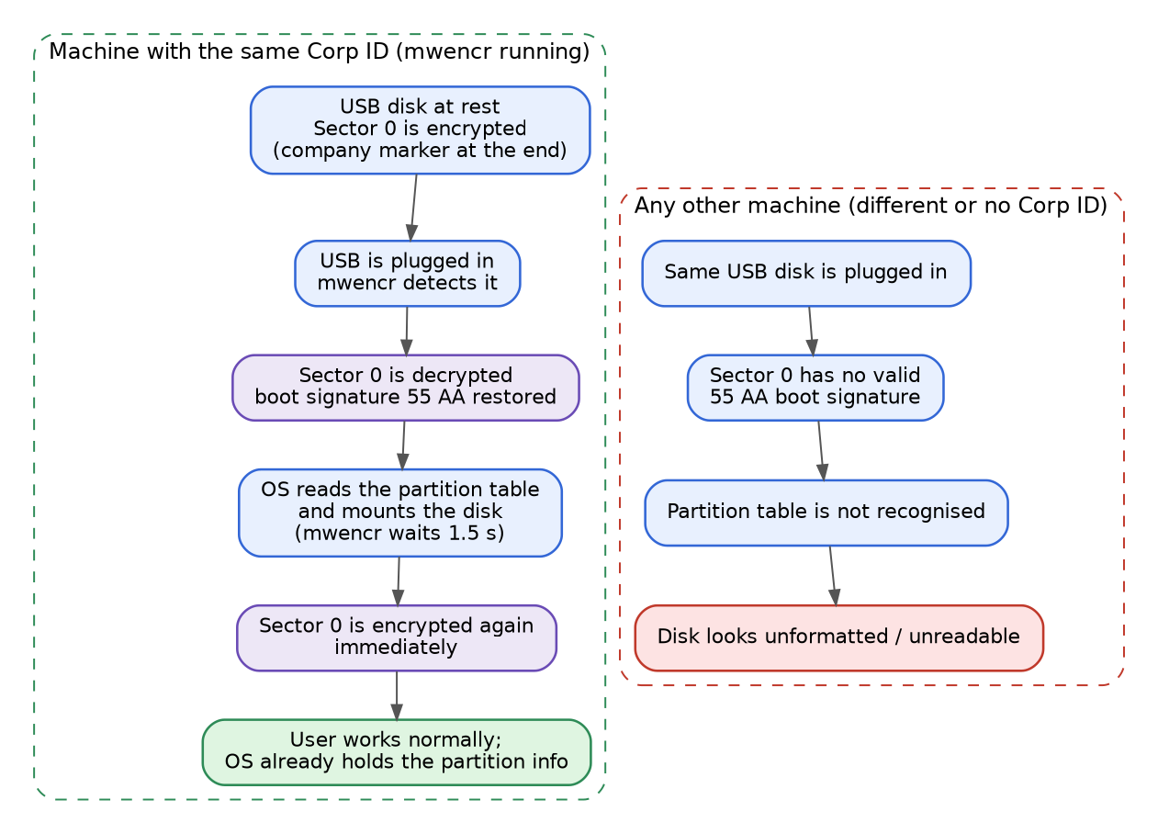
Figure: The same USB disk on a Corp ID machine and on any other machine
The decrypt-then-re-encrypt idea. The disk is stored encrypted. When it is plugged into a machine that runs mwencr with the matching Corp ID, the service restores sector 0 so the operating system can read the partition table and mount the file systems. After a short wait (1.5 seconds in the current code) the service encrypts sector 0 again. The operating system has already read the information it needs, so the user keeps working normally on that machine.
Why other machines see it as encrypted. Because sector 0 is encrypted again on disk, any other machine reads an invalid sector 0 with no 55 AA signature. It cannot find a partition table and shows the disk as unreadable or unformatted. A machine with a different Corp ID has a different marker, so it cannot decrypt the sector either.

System Architecture
mwencr is a multi-threaded daemon. The main thread listens for USB events, and helper threads watch mounts, format tools and file writes. All threads share one table of USB disks, protected by a mutex, and all disk changes go through a single routine that transforms sector 0.
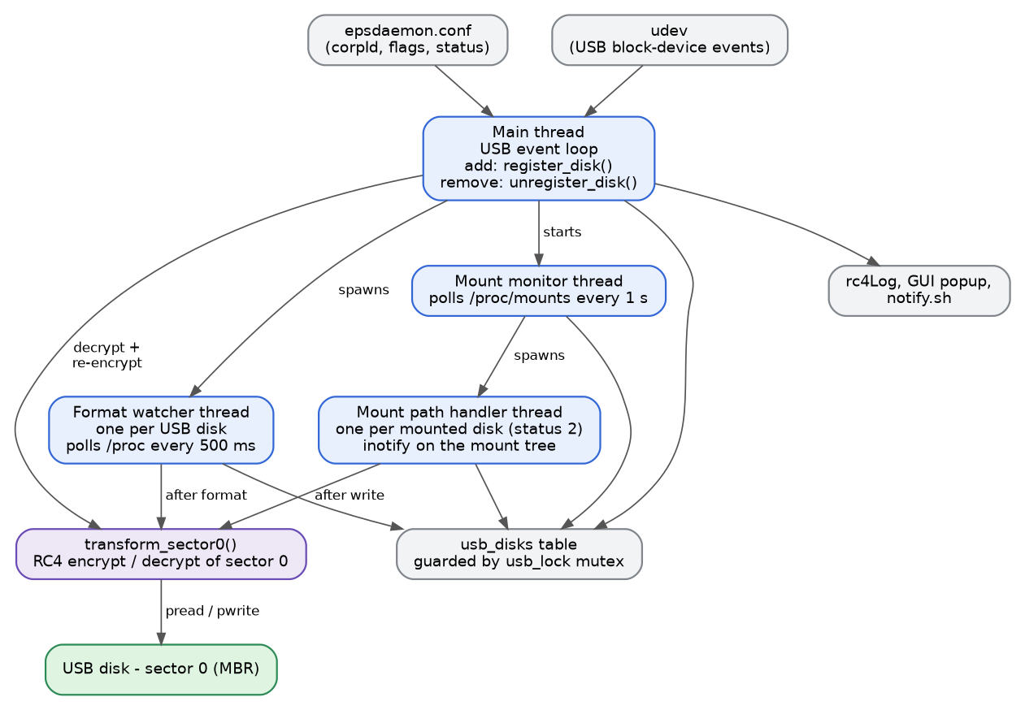
Figure: Threads, shared table and the sector 0 routine

Main components
Component | Responsibility
Start-up (main) | Checks for root, daemonizes, reads configuration, builds keys, enumerates existing USB disks and starts monitoring.
USB event monitor | Uses udev to enumerate disks and to receive add / remove events. Only whole USB disks (bus usb, device type disk) are handled.
Disk registry | register_disk() and unregister_disk() maintain the usb_disks table and drive the decrypt-and-re-encrypt step.
Crypto engine | RC4 routines, marker and S-block generation, signature status check and transform_sector0().
Format watcher | One thread per disk. Finds running format tools through /proc and encrypts sector 0 when the tool exits.
Mount monitor | One thread that compares /proc/mounts every second to find new and removed mounts.
Mount path handler | One thread per mounted disk (status 2). Uses inotify to detect writes and encrypts sector 0.
Support modules | External helpers: readConfiguration, isBinaryRunning, savePidFile, popupInfo, daemonize, rc4Log and the shared header main.h.

Configuration
All settings are read at start-up from /opt/MicroWorld/etc/epsdaemon.conf. The service must be restarted to apply a change.
Key | Required | Description and behaviour
rc4:corpId | Yes | Corp ID as a hex string, with or without a 0x prefix. The service exits if it cannot be read or is not valid hex.
rc4:status | Yes | Operating mode. Must be 1 or 2; any other value makes the service exit.
rc4:encryptValue | No | Non-zero enables encrypt-on-event (format watcher, and mount watchers in status 2). If it cannot be read, an error is logged and the feature stays off.
rc4:decryptValue | No | Non-zero enables decrypt-on-plug-in followed by immediate re-encrypt. If it cannot be read, the feature stays off.
rc4:loglevel | No | Logging verbosity. Default is 1.
rc4:GuiPopup | No | How the "invalid key" message is shown. 0 none (default), 1 runs /opt/MicroWorld/bin/notify.sh, 2 shows a popup through popupInfo.

Operating modes (status)
status | Format detection | Write detection on mounted disk | Typical use
1 | Yes | No | Light-weight mode: protect disks after formatting.
2 | Yes | Yes (mount path handler threads) | Full mode: also encrypt after any file or folder is written.
Both encrypt features additionally require encryptValue to be non-zero.

Effect of the encrypt and decrypt switches
encryptValue | decryptValue | Resulting behaviour
Off | Off | Disks are detected, registered and logged. Sector 0 is never changed.
On | Off | No action on plug-in. Format watcher (and mount watchers in status 2) encrypt sector 0 on events.
Off | On | Plug-in decrypt and immediate re-encrypt only. No watcher threads are started.
On | On | Full behaviour: plug-in decrypt and re-encrypt, plus encryption after format (and after write in status 2).

Detailed Workflow

Start-up sequence
The start-up has two parts: pre-checks and configuration, then initialisation and monitoring. Failures in the mandatory settings (Corp ID and status) stop the service. Failures to read the optional settings are only logged.
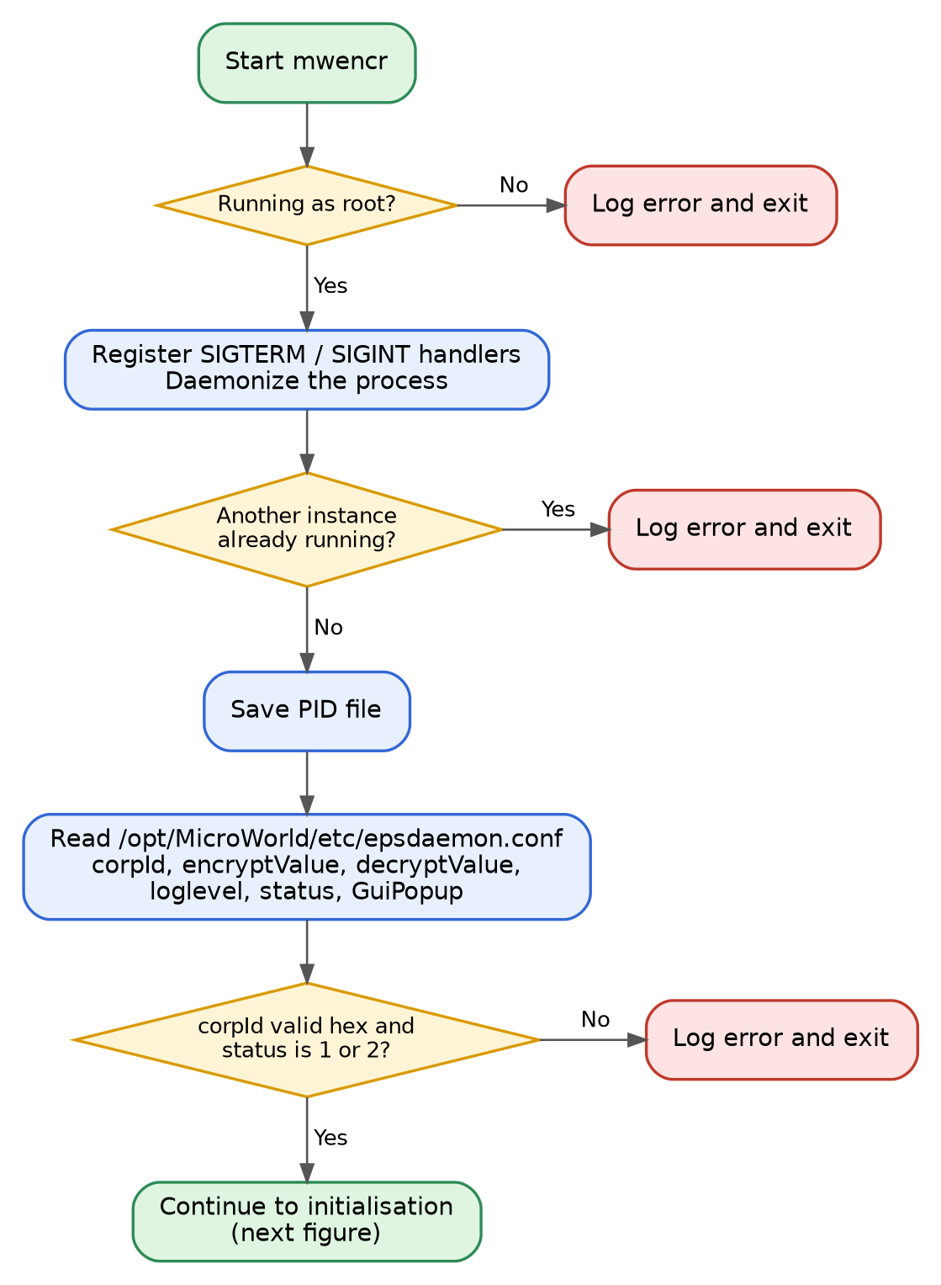
Figure: Start-up: pre-checks and configuration
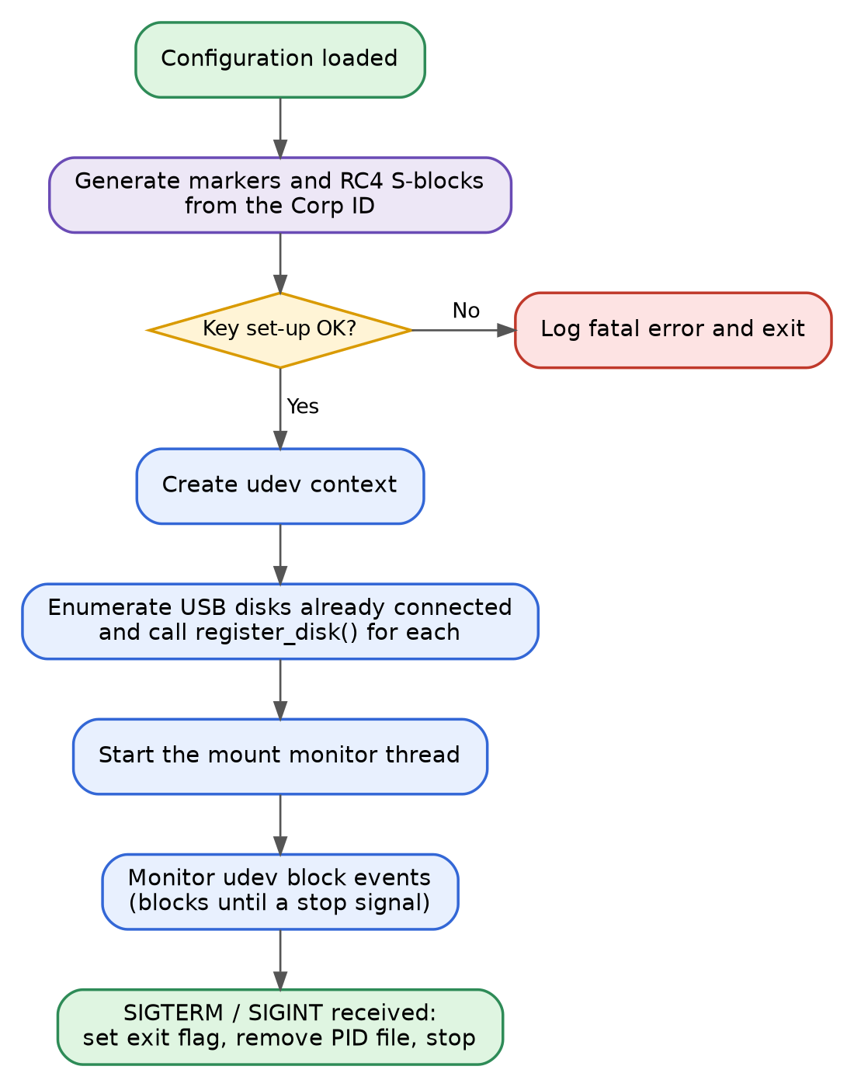
Figure: Start-up: initialisation and monitoring
- The service must run as root, because it opens raw block devices for reading and writing.
- It daemonizes first, then verifies through the PID file that no other copy is running.
- SIGTERM and SIGINT set an exit flag that all loops check; the handler also removes the PID file.
- After loading the settings, the service prints and logs a configuration summary (Corp ID, decrypt and encrypt state, log level, popup mode).

Marker and key generation
The Corp ID is turned into the two-byte marker that identifies a disk as "encrypted by us", and the same value is used to finish the storage key. The process is the same on Windows, which is what keeps disks portable.
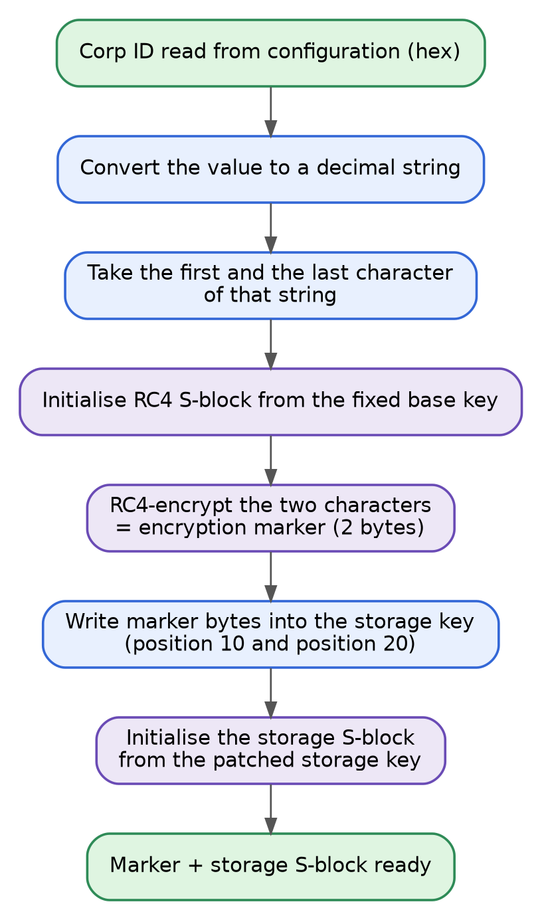
Figure: How the encryption marker and storage S-block are produced
- The Corp ID value is converted to a decimal string. Its first and last characters are used as the two input bytes.
- Those two bytes are encrypted with RC4 using the fixed base key; the result is the encryption marker.
- The marker bytes are written into the storage key at position 10 and position 20, and the storage S-block is built from that key.
- Both the marker and the storage S-block are created once and reused for every disk.
Note The Corp ID is entered in hexadecimal, but the marker is computed from the decimal text of the same value.

Reading the encryption status of a disk
The two bytes at offset 510 and 511 of sector 0 decide how a disk is classified. Two helper routines read them: mbr_encryption_status() works on a sector already in memory, and check_company_encrypted() reads the bytes straight from the device. They use different return codes, shown below.
Bytes 510-511 | Meaning | mbr_encryption_status | check_company_encrypted | Enc type in table
55 AA | Plain, valid disk | 0 | 0 | NONE
Equals company marker | Encrypted with our Corp ID | 1 | 1 | COMPANY
Anything else | Encrypted by another company (or unknown) | -1 | 2 | ANOTHER COMPANY

Core routine: transform sector 0
transform_sector0(device, mode) is the only place where the disk is changed. RC4 is symmetric, so the same keystream operation encrypts and decrypts; the mode decides which checks run and which two bytes are written at the end.
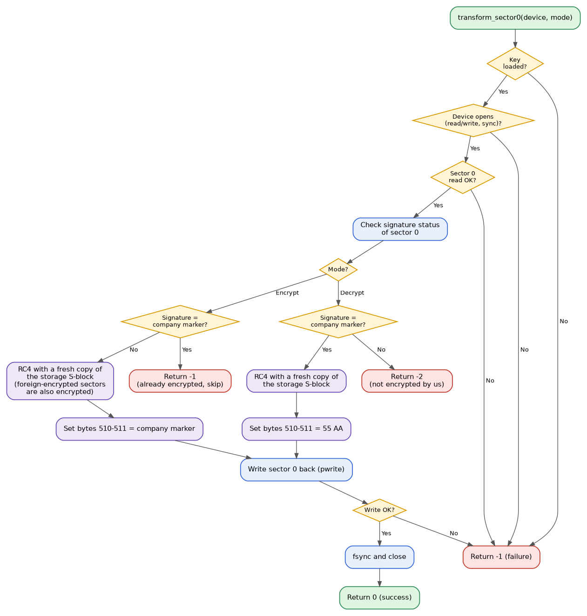
Figure: Flow of transform_sector0() for decrypt and encrypt
Return value | Meaning
0 | Sector 0 was transformed and written successfully.
-1 | Failure (key not loaded, open / read / write error) or, in encrypt mode, sector 0 is already encrypted with our marker and is skipped.
-2 | Decrypt requested but the disk is not encrypted with our marker (wrong key or not encrypted).

- The device is opened with read/write and synchronous access; the sector is read with pread and written back with pwrite, followed by fsync.
- Only the data part of the sector is transformed; the last two bytes are then set to 55 AA (decrypt) or to the company marker (encrypt).
- A disk encrypted by another company is still encrypted again if an encrypt is requested; decrypt is refused for it.

USB plug-in handling
register_disk() runs for each USB disk found at start-up and for each udev add event. It first records and classifies the disk, then performs the decrypt-and-re-encrypt step.
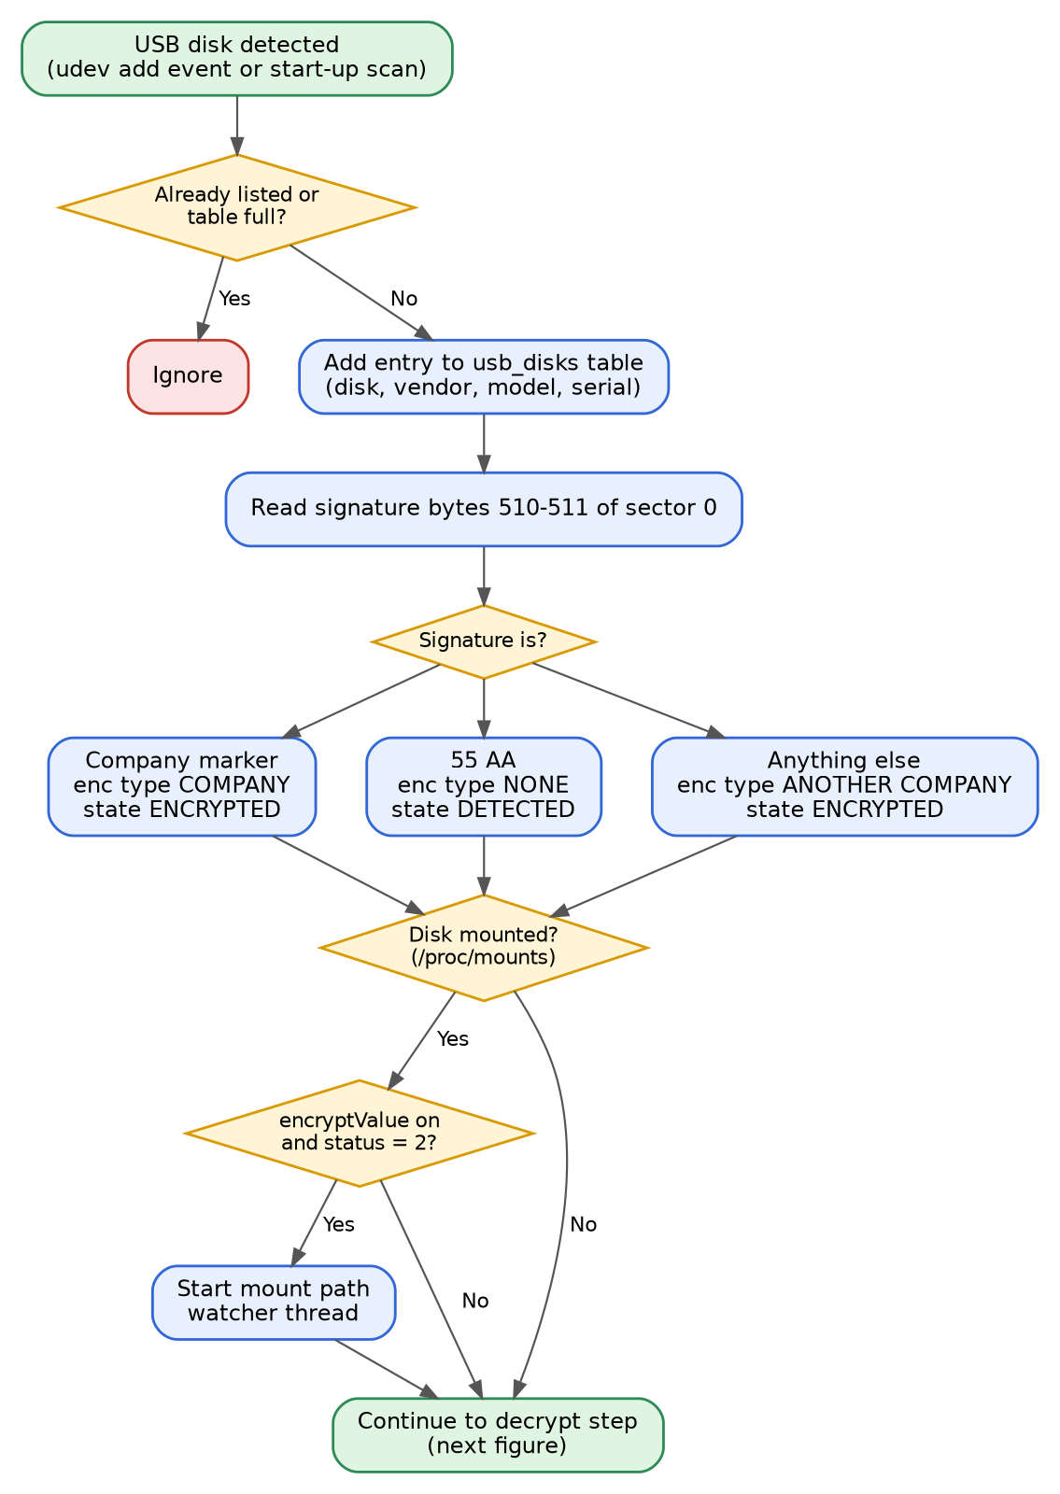
Figure: Plug-in: detection and classification
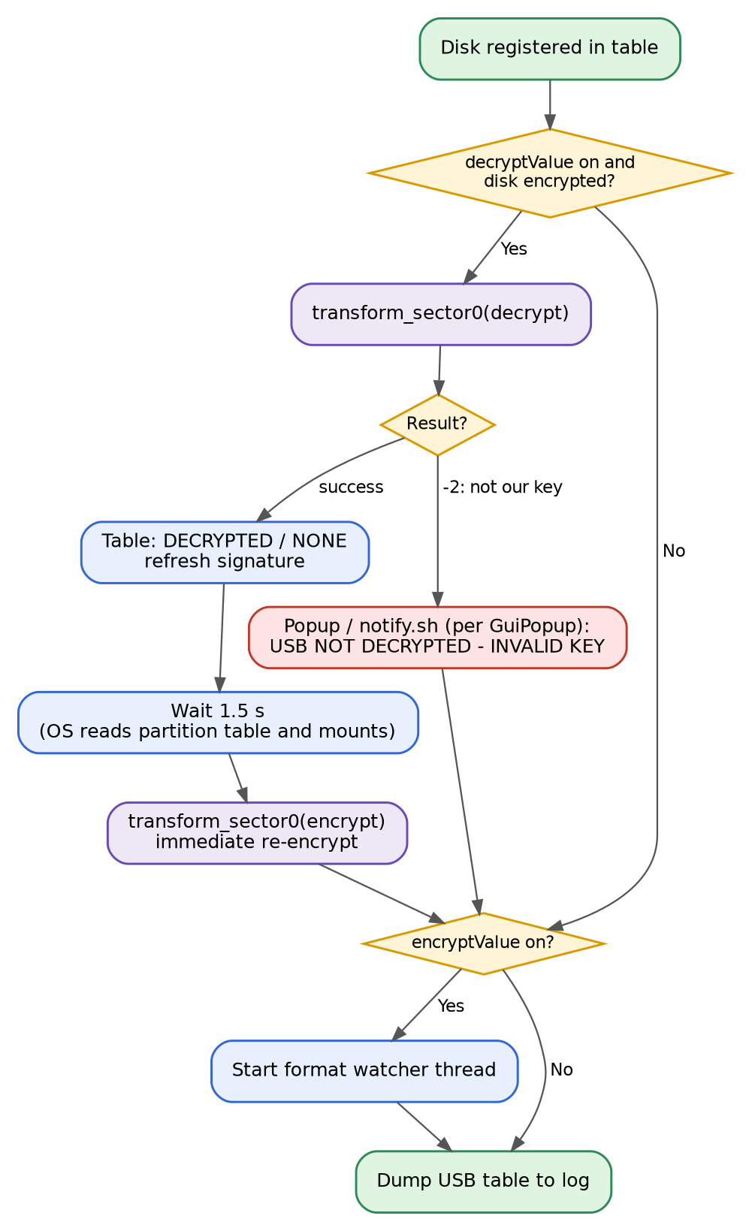
Figure: Plug-in: decrypt, wait and immediate re-encrypt

The decrypt and re-encrypt step
- It runs only when decryptValue is on and the disk is encrypted (by us or by another company).
- If the disk carries our marker, sector 0 is decrypted and the table shows DECRYPTED. The service then waits 1.5 seconds so the OS can read the partition table and mount the disk, and encrypts sector 0 again.
- If the disk belongs to another company, the decrypt attempt returns -2, the disk is left unchanged and a message "ATTENTION - USB NOT DECRYPTED - INVALID KEY!" is shown according to rc4:GuiPopup.
- The wait time is a tuning value. The source keeps shorter values (0.5 s and 0.7 s) as commented-out alternatives.
Note A plain disk (55 AA) is not encrypted at plug-in. It becomes encrypted later, either after a format or, in status 2, after the first detected write.

Format detection
A format watcher thread is started for every registered disk when encryptValue is on. It polls every 500 ms. When a known format tool has the disk (or one of its partitions) open, the watcher waits for the tool to exit and then encrypts sector 0, because formatting writes a fresh plain 55 AA signature.
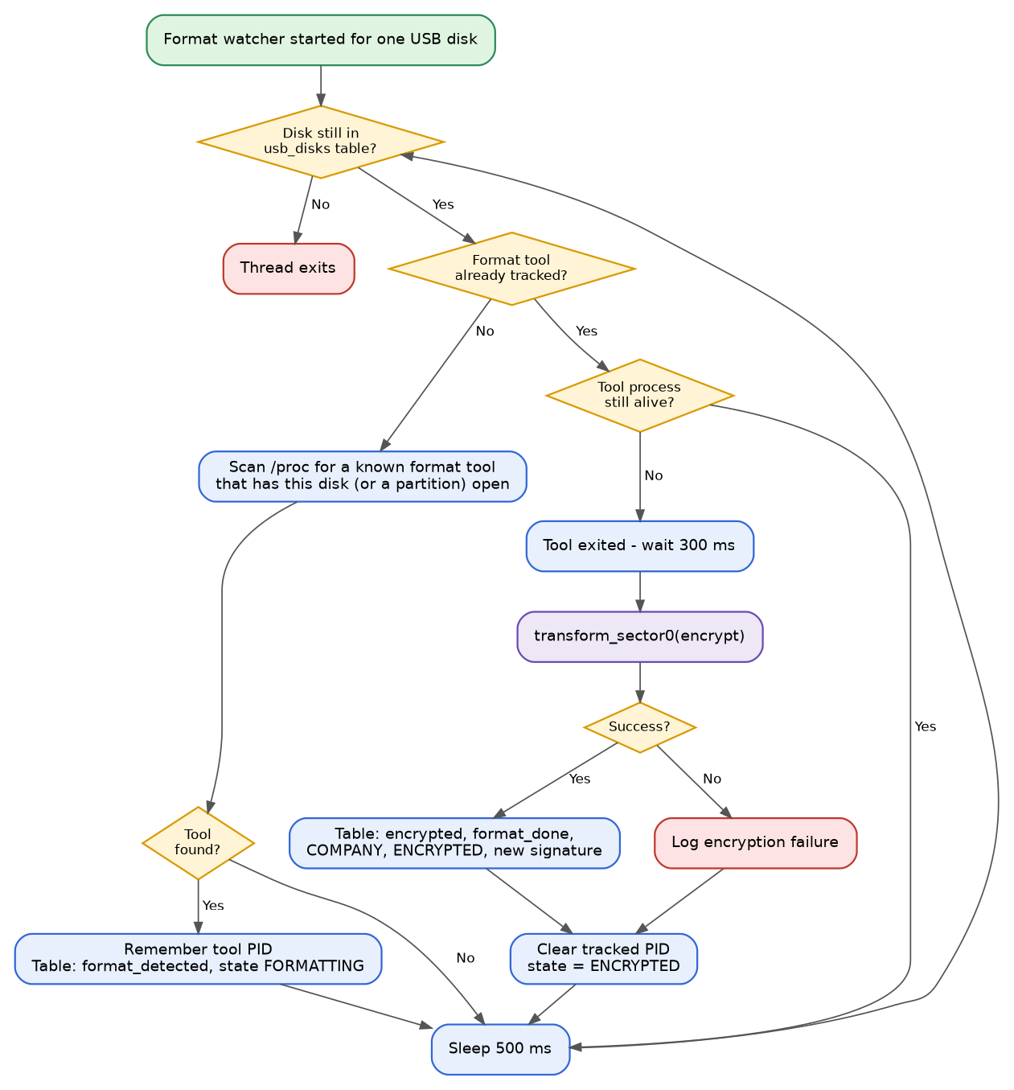
Figure: Format watcher thread

How a format tool is recognised
- Every process in /proc is checked: its name (/proc/<pid>/comm) must start with one of the tool names below.
- Then the open files of that process (/proc/<pid>/fd) are inspected. If any link starts with the disk path, the tool is working on this disk. Because the match is by prefix, a format of a partition such as /dev/sdb1 also counts for /dev/sdb.
- When the tool's process disappears, the watcher waits 300 ms and then encrypts sector 0.
Tracked tool names
fdisk cfdisk sfdisk gdisk sgdisk | parted gparted
mkfs mkfs.fat mkfs.vfat mkfs.ext3 mkfs.ext4 | mkfs.ntfs mkfs.exfat dd

Write detection on mounted disks (status 2)
In status 2, every mounted USB disk gets its own mount path handler thread. It places inotify watches on the mount point and all of its sub-directories and reacts to three kinds of events: a file closed after writing, a new directory, and a directory moved in.
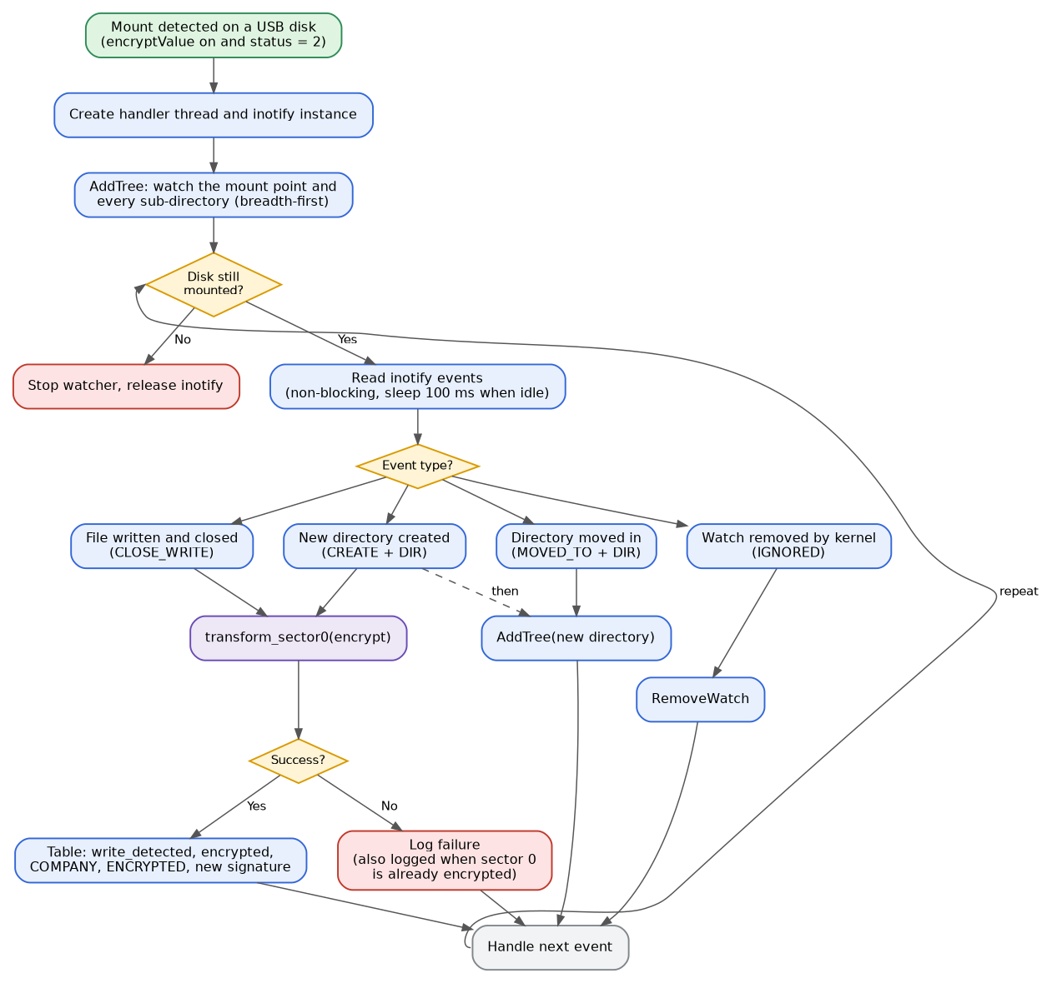
Figure: Mount path handler thread
- The thread is started when a disk is already mounted at registration, or when the mount monitor sees a new mount of a /dev/sd* device.
- New directories are added to the watch list automatically, so nested folders are covered.
- The loop re-checks every pass that the disk is still mounted and registered; when it is not, the thread stops by itself.
- On a successful encrypt, the table is updated (write seen, encrypted, COMPANY, new signature).
Note If sector 0 is already encrypted with our marker, the encrypt call skips the work and returns -1. The write handler logs this as "ENCRYPTION FAILED AFTER WRITE DETECTION" even though the disk is in the expected state.

Plug-out and shutdown
- Plug-out: nothing is written to the disk, because sector 0 is already in its encrypted state. The entry is removed from the table, and the format watcher and mount handler for that disk end on their own when they no longer find it.
- Shutdown: SIGTERM or SIGINT sets the exit flag, removes the PID file and logs "mwencr STOPPED". Loops check the flag and finish.

Data Structures and States
The structures below are declared in main.h (not part of the supplied source file). The descriptions come from how the fields are used in deviceEncryption.cpp.

USB disk table entry
Field | Purpose
disk | Device node of the whole disk, for example /dev/sdb.
vendor, model, serial | Identification read from udev properties.
present | Set to 1 when the entry is created.
mbr_sig | Text of the bytes at offset 510-511, for example 55 AA.
encrypted | Encryption classification: 0 none, 1 company, 2 another company (set by registration). Set to 1 or 0 by later events.
enc_type | NONE, COMPANY or ANOTHER COMPANY.
state | Current life-cycle state (see below).
mounted, mountpoint | Whether a partition of the disk is mounted, and where.
format_detected, format_done | A format tool was seen on the disk; encryption after format completed.
write_detected | A write was seen on the mounted disk.
watch_active, watch_tid | Format watcher thread running, and its thread id.

Disk states
State | Set when
DETECTED | Disk registered and plain, or after it is unmounted.
MOUNTED | A partition of the disk is mounted.
ENCRYPTED | Disk found encrypted at registration, or encrypted after a format or a write.
DECRYPTED | Sector 0 was decrypted at plug-in (before the immediate re-encrypt).
FORMATTING | A format tool is currently working on the disk.

Other structures
Structure | Purpose
MOUNT_ENTRY | Device name and mount point read from /proc/mounts; used by the mount monitor to compare snapshots.
MountWatcher | Hand-over object for a mount path handler thread: pointer to the disk entry, the mount path and the cached table index.
WatchArg | Hand-over object for a format watcher thread: disk path and table index.

Threads and Synchronisation
Thread | Started by | How many | Cycle | Ends when
Main (udev loop) | Process start | 1 | Blocks waiting for udev events | Stop signal
Mount monitor | Main | 1 | Every 1 s | Stop signal
Format watcher | register_disk() when encryptValue is on | One per disk | Every 500 ms | Disk leaves the table, or stop signal
Mount path handler | register_disk() or mount monitor, when encryptValue is on and status is 2 | One per mount | Every 100 ms when idle | Disk unmounted or removed, or stop signal

- The mutex usb_lock protects the usb_disks table and the log buffer.
- Worker threads are detached; they clean up themselves and are not joined.
- The sector read-modify-write inside transform_sector0() is not covered by usb_lock.

Logging and User Notifications
Events are written through rc4Log(level, message) and also printed to the console. Messages use levels 1 to 4. In this file, level 1 is used for configuration, start-up, stop and the outcome of encryption and decryption, and level 4 for the detailed watch and unwatch messages. The configured rc4:loglevel (default 1) sets the verbosity; the filtering itself is implemented in rc4Log, which is outside this file.
The service writes a table summary ("USB TABLE") after registration, after mount and unmount events, and after each successful encrypt, with the disk name, state, encryption type, format and write flags, vendor, model, serial and mount point.
GuiPopup | What the user sees when a disk cannot be decrypted
0 | No popup. The event is only logged.
1 | /opt/MicroWorld/bin/notify.sh is started in the background with the message.
2 | A popup window is shown through popupInfo.

