**COURSE**: BACHELOR OF TECHNOLOGY (B. Tech)-DESIGN

**UNIT NAME**: INTERACTIVE MEDIA DESIGN

**TOPIC**: CLADI WEBSITE

**ADM**: ACDI/01789/2015

**COURSE CODE**: ACDI/2015

**Design and functionality**

The website is designed to help users shop for clothes at the comfort of their living rooms using either their computer or mobile device. The website is designed to work with established companies which are registered so as to help filter and monitor the data being displayed. By working with registered companies, it helps users to identify with them in their shopping experiences something which might promote repeated purchases. The notion of bringing competitive brands together on a single platform also helps to avail a wide selection for the user without the need to waste effort and time in physically moving to the physical stores so as to window shop. Users also get to see the best at the cheapest prices since all in one website.

Cladi aims at simplifying the shopping experience something which would increase the demand for clothes and create an environment for cheap retailers hence reducing the prices of clothes. The application tries to achieve this by focusing on clothes and availing simple filters to help filter the data being displayed. The main filters are for filtering preferences based on gender. The other category is the categories in which the clothes belong such as trousers and sweaters. Such help to reduce the time that would have otherwise been spent scouring the website for something the user desires, it also reduces the interwork utility and hence saves on cost.

The website will also be built using react js with the possibility of integrating with native react which is a cross platform native code for all of the three major mobile operating systems. React also provides caching capabilities and a virtual DOM which helps to reduced complete reload of whole pages which saves on hardware utilization which includes network and time.

Some of the benefits of using react being

* It boosts productivity and facilitates further maintenance

This component structure is the answer to the question “why to use React?” for many companies and Walmart is one of them.

* It ensures faster rendering

It is essential to consider how the structure will impact the overall app performance. Even latest platforms and engines can’t ensure the absence of annoying bottlenecks, because DOM (document object model) is tree-structured and even small changes at the upper layer can cause awful ripples to the interface. To solve the issue Facebook development team has introduced Virtual DOM – currently, one of the benefits of using React for heavy loaded and dynamic software solutions.

As the name suggests, it is a virtual representation of the document object model, so all the changes are applied to the virtual DOM first and then, using diff algorithm, the minimal scope of necessary DOM operations is calculated. Finally, the real DOM tree is updated accordingly, ensuring minimum time consumed. Something which guarantees better user experience and higher app performance.

* It guarantees stable code

To make sure that even small changes that take place in the child structures won’t affect their parents, React uses only downward data flow. Changing an object, developers just modify its state, make changes, and, after that, only particular components will be updated.

* It is SEO friendly

Another React js benefits is its ability to deal with a common search engine failure to read JavaScript-heavy apps. As a solution, React can run on the server, rendering and returning the virtual DOM to the browser as a regular webpage.

* There is React Native for mobile app development

React can be boldly called a “learn once – write anywhere” library, since in both web and mobile application development it follows the same design patterns, facilitating the transition process. Using plain JavaScript and React one can be able to build rich UI for native apps, supported by both iOS and Android platforms.

**Concept designs**

**Home**

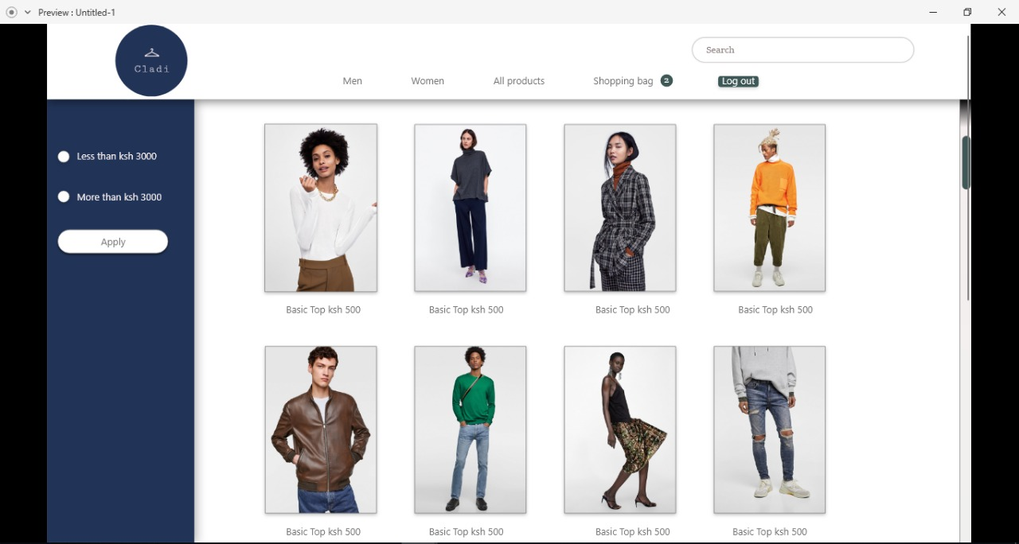

The first page users see would have a navigation sample data arranged in a grid view which would default to a linear view on smaller devices and some filters.

**Details**

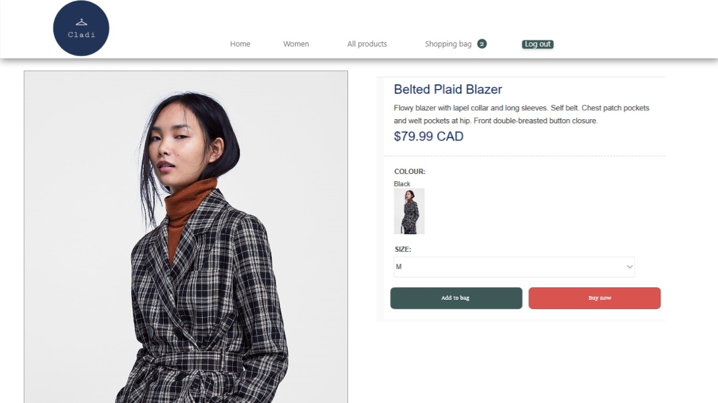

Upon selecting an item which one views as pleasurable, one would be directed to another component which showcases the particular items details. This would include a short description of the product, the name, the manufacturer or retailing shop which owns it and the ability to purchase it. The component would also have contact details in case one might need to make an inquiry or even visit the premises to physically inspect the product.

**Log in**

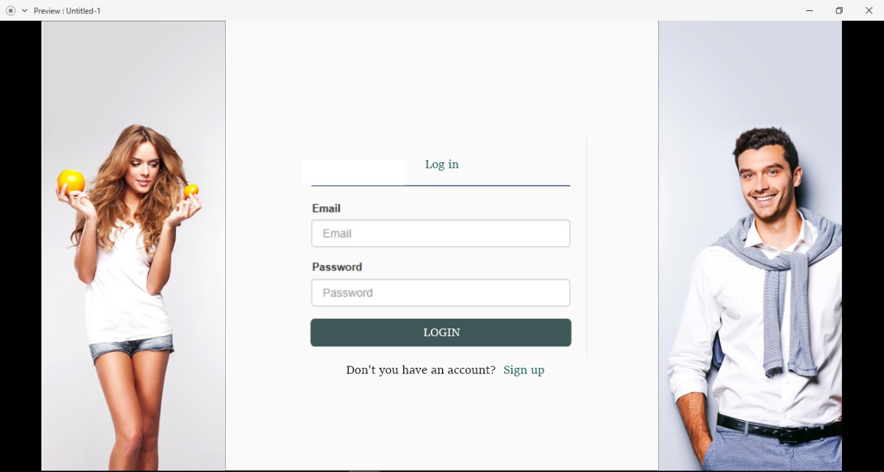

In case one needs to reach out to through the contacts provided one would need to log in so as to authenticate users and prevent bots from infiltrating sensitive information. The sign up form would also prove helpful in storing and maintaining user data such as the products the user has decided to purchase.

**Sign up**

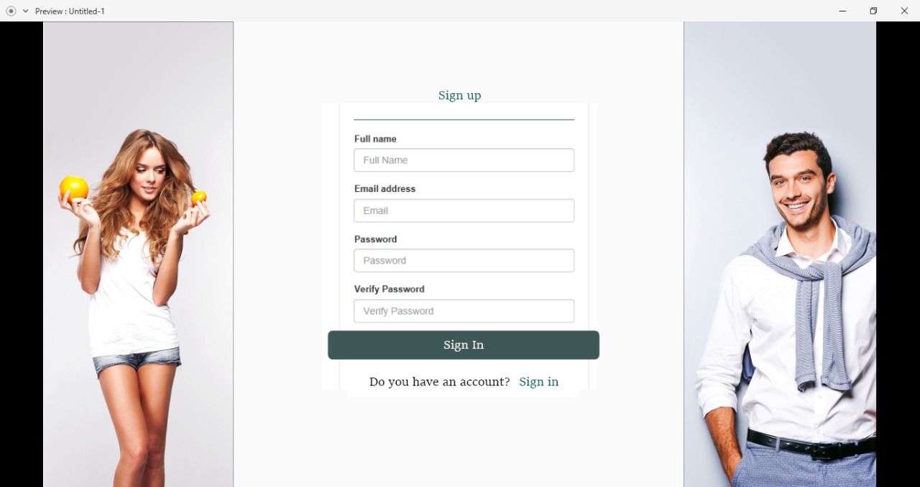

In the event a user does not have an account one would be provided an avenue for which one might attain an account through the sign-up component. The account information would be encrypted and

**Check out**

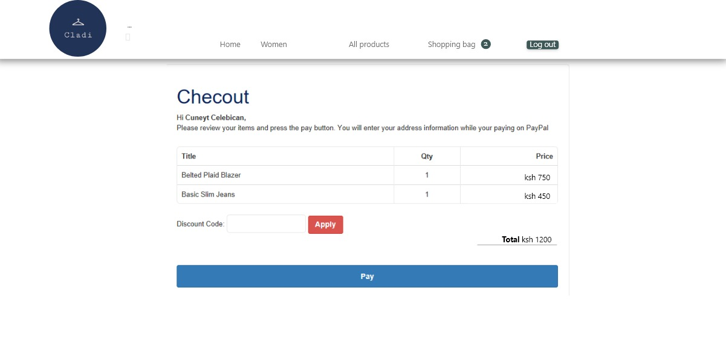

If one desires then one might complete the checkout process whereby, he or she would purchase the product online with the help of an assistant. This would prove most helpful for new users who might not be well versed with the purchasing process.

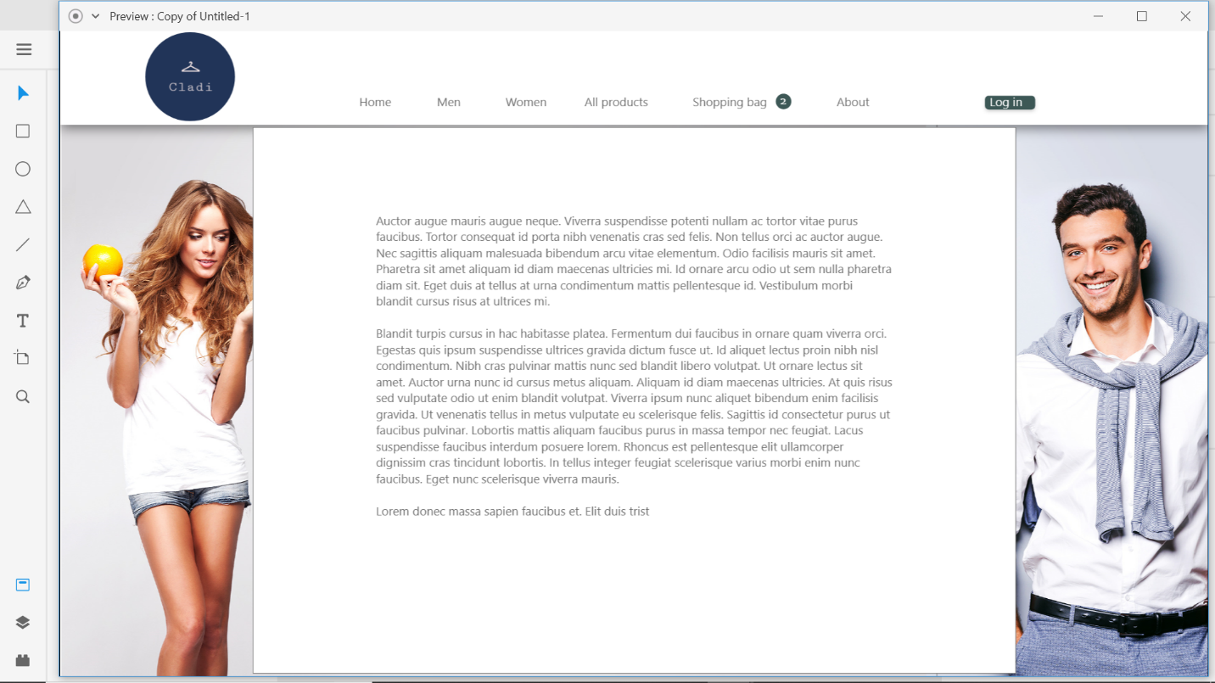**About**

This screen will help to provide insightful information on how the website works. This might help to answer questions which users might have about the shopping process.

